B1 Cell structure and transport mastery booklet
Part 1- Animal and plant cells
All living things are comprised (made up of) cells. Cells can be broadly categorised into two main areas: eukaryotic and prokaryotic cell. All eukaryotic cells have a nucleus and no prokaryotic cells do. Animal cells and plant cells are examples of eukaryotic cells. All complex multicellular life is made of eukaryotic cells as they are more sophisticated.
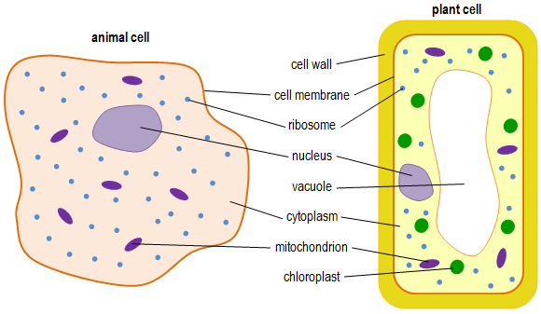
1. Label the organelles in the cells below. You must include the function of each organelle. 1 has been completed for you

Mitochondria: Energy released from respiration

2. Complete the table below:
Organelle | Found in Animal cells | Found in plant cells
Nucleus
Cell membrane
Cell wall
Permanent vacuole
Ribosome
Chloroplast
Mitochondria
Cytoplasm

3. Answer the questions below in your exercise book.
- Define the term eukaryotic cell
- List the structures found in a human cell.
- What is the function of the nucleus and mitochondria?
- The Krebs cycle is an important part of aerobic respiration. Where does the Krebs cycle take place?
- What three cell structures are found only in plant cells and not in animal cells?
- What cell structure is responsible for making proteins?
- Salivary cells produce amylase, which is a type of protein, what type of cell structure will they have a lot of?
- Muscle cells are likely to have large amount of what cell structure and why?
- The root hair cell is a plant cell, but it has no chloroplasts why is it not considered an animal cell?
4. Complete the following sentences:
- Plant and animal cells are eukaryotic because……..
- Plant and animal cells are eukaryotic but……..
- Plant and animal cells are eukaryotic so……..
5. Suggest why the nucleus and mitochondria are so important in all cells (4)
6. The pancreas cell makes enzymes. Enzymes are proteins. Describe how the ribosomes and mitochondria help the cell to make enzymes. (3)
7. Compare a plant and animal cell (4)
Part 2 Prokaryotic cells
As previously mentioned, animal and plant cells are eukaryotic cells because they have a nucleus. However, they are not the only cells to be eukaryotic both fungi and Protista are also eukaryotic. In a eukaryotic cell DNA is found in large linear structures called chromosomes in the nucleus. Bacteria are examples of prokaryotic cells they are 10 times smaller than eukaryotic cells being only 0.2 μm-2 μm long. They do not have a nucleus.
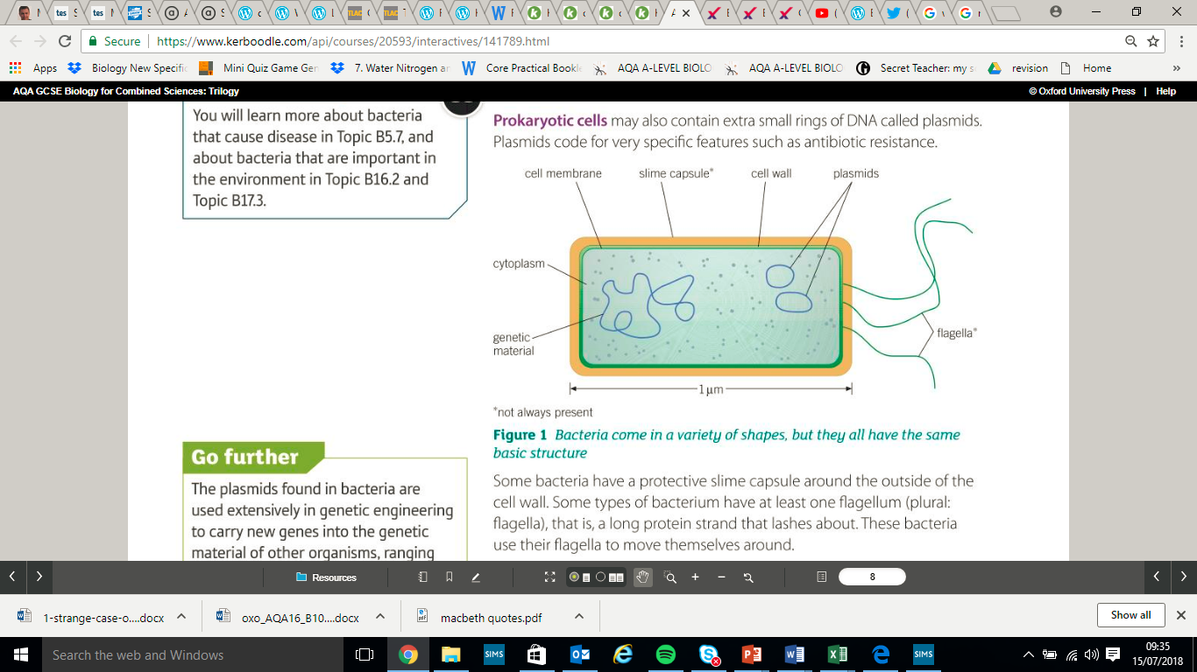
The cell wall of a bacterial cell is not made of cellulose. The bacterial chromosome is a single loop of DNA found free in the cytoplasm. A bacterial cell also has plasmids. These are small rings of DNA that carry useful genes eg antibiotic resistance. Some bacteria have a flagellum which is a strand of protein that acts like a propeller to move them forwards. Some bacteria also have a slime capsule which protects them.

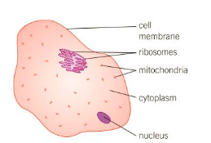
- Answer the questions below in your exercise book.
- What is the difference between eukaryotic and prokaryotic cells?
- Give two examples of eukaryotic cells
- Give an example of a prokaryotic cell
- Why can’t you see prokaryotic cells with a light microscope?
- List all the structures that could be found in a bacterial cell
- What is a plasmid?
- What are two differences between an animal cell (right) and a bacterial cell (above)
- Where is the DNA found in a bacterial cell?

- Complete the Venn diagram below to compare the features of eukaryotes and prokaryotes. Use the words for the organelles in the last 2 sections to help you
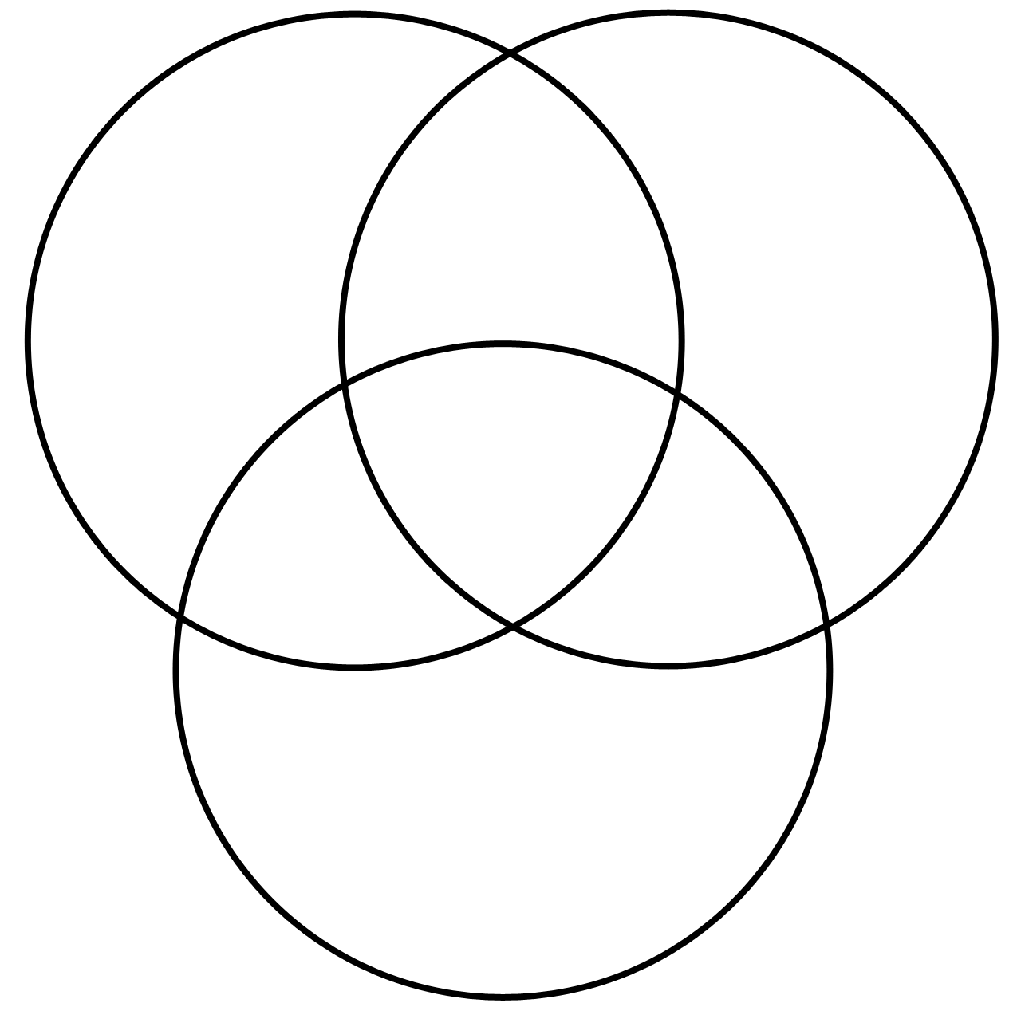
Bacteria (prokaryote)
Animal cell (eukaryote)
Plant cell (eukaryote)

- Contrast plant cells and bacterial cells (5) (contrast means tell me differences)
- Compare animal cells and bacterial cells (5) (compare means both similarities and differences)
- The diagrams show the structures of a yeast cell and a bacterial cell.

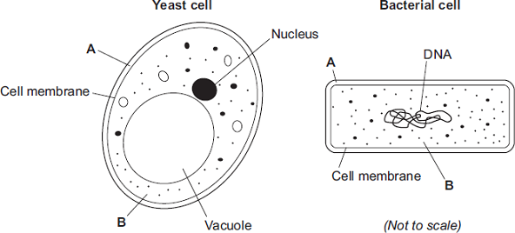
a) Both the yeast cell and the bacterial cell have structures A and B.Name structures A and B.

b) The yeast cell and the bacterial cell have different shapes and sizes. Give one other way in which the structure of the bacterial cell is different from the structure of the yeast cell. (1)
c) Suggest whether a yeast cell is a prokaryotic cell or a eukaryotic cell and why? (2)
- What is the function of the nucleus, ribosomes and mitochondria?
- Why can a bacteria not pass antibiotic resistance to a yeast cell?
Part 3 Microscopes and Magnification
Cells are too small to be seen with the naked eye. Instead microscopes have to be used. The first light microscopes were made in the 17th century. They use a beam of light to form an image of an object and can only reach magnifications of x2000. They are relatively cheap, easy to use and can magnify live specimens. The invention of electron microscopes in the 1930’s allowed scientists to see cells in more detail and discover new sub cellular structures. Electron microscopes have a higher magnification and resolution. They use a beam of electrons and can magnify up to 2 000 000. Electron microscopes are large, very expensive, must be kept in special conditions and cannot use live specimens. Resolution is the ability to distinguish between two objects as separate points.
- Label the microscope below with the following words: (Objective lens, Eyepiece, Stage, Stage Clips, Fine Focus, Course Focus, Light, Base, Arm)

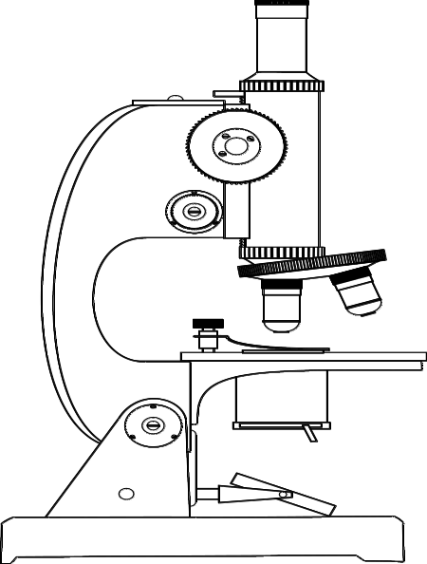

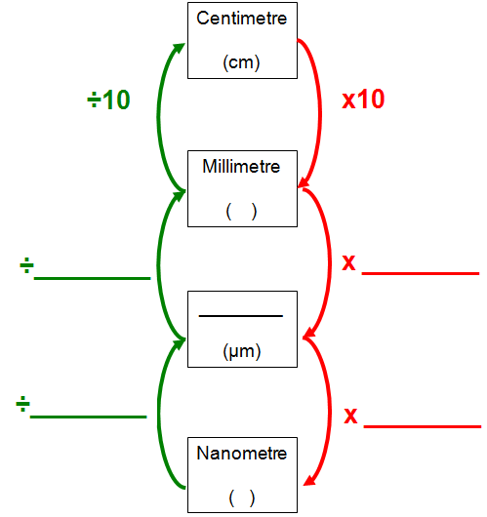
1000
1000
1000
1000

- Complete the table below to show the corresponding value nanometres, micrometres and millimetres for the measurements given in each row. The first row has been completed for you. Ensure that your answers use the correct unit symbols.
Nanometre (nm) | Micrometre (µm) | Millimetre (mm)
5 | 0.005 | 0.000005
1
 | 1
 |  | 1
 | 3
7
 |  | 0.5

Magnification of a light microscope can be calculated very easily.
Total magnification = eyepiece lens magnification x objective lens magnification
- Calculate the overall magnification
Eyepiece Magnification | Objective Magnification | Overall Magnification
X10 | X4
X10 | X10
X10 | X40
X10 | X100

Below is a table that shows the differences between Light Microscopes (the ones we have in school) and electron microscopes.

Optical/light Microscope | Electron microscope
Used for hundreds of years | Very recently invented
Uses light rays | Uses electron beams of high energy
Specimen can be living | Specimen is dead
×1000 to 2000 magnification | About ×2 000 000 magnification
Not possible to see internal structures inside the cytoplasm | Internal structures inside the cytoplasm are possible to see
Quite cheap | Very expensive
Anyone can use this and observe images | Highly trained scientists needed to operate and analyze results
Not much space needed | Lots of space required
2D image only | 3D image can be produced
Not possible to get better magnification with this technology | Technology can be improved over time

- Which microscope is more expensive?
- What is the magnification on an electron microscope?
- What is the magnification on a light microscope?
- What part of the microscope would you use to make an image bigger?
- What part of the microscope would you use to make an image clearer?
Using a Light microscope: Follow the demonstration of how to prepare your slides and use the instructions on the next page to focus your microscope
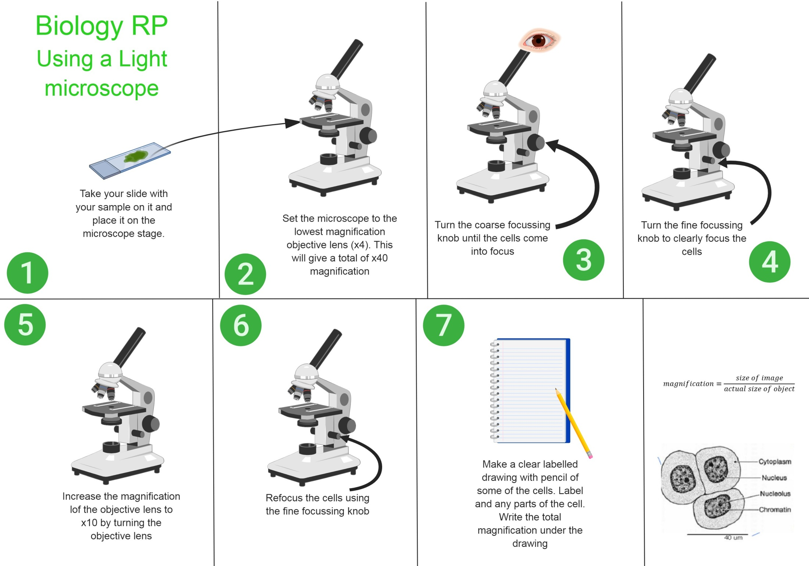
- How do you improve the focus of a microscope?

- How do you increase the magnification of an image?
Using the magnification formula

People find the magnification formula hard, but that is because they don’t practise enough.
$Magnification= \frac{Image size}{Actual size}$ or $M=\frac{I}{A}$
Example 1: Magnification  Calculate the magnification of an object that is 0.01mm long but looks 10mm long in the image  - Write out Equation  M=I÷A  - Write out Values check units are the same  M=? I=10mm A=0.01mm  - Enter values into equation  M=10 ÷ 0.01  - Result  M=10 ÷ 0.01= 1000  - (Y)UNITS (if needed)  Magnification = x1000 | Example 2: Magnification  Calculate the magnification of an object that is 0.25mm long but looks 50mm long in the image  - Equation  - Values  M=_____ I=_____ A=______  - Enter values  M=______ ÷ _________  - Result  M=________÷ _________  - (Y)UNITS (if needed)  Magnification = ________ | Example 3: Magnification  Calculate the magnification of a fruit fly that is 3mm long but looks 3cm long in the image  E  V  E  R  Y

- Calculate the magnification of an object that is 400mm long but has an image 8000mm long
- Calculate the magnification of an object that is 0.005mm long but has an image 20mm long
- Calculate the magnification of an grain of sand that has an image of 2.5cm but is actually 0.25mm long (hint: UNITS)
- Pritesh finds a photo of a yellow shield bug. He measures the photo and the bug is 11.3cm long. He goes online and finds the average length of the beetle to be 7mm. What is the magnification of the image?
Example 1: Actual size  Calculate the size of an amoeba which is 75mm long under x100 magnification.  - Write out Equation  M=I÷A  - Write out Values check units are the same  M=x100 I=75mm A=?  - Enter values into equation  100 =75 ÷ ?  - Result (rearrange if needed)  ?=75÷100 = 0.75  - (Y)UNITS (if needed)  Actual size = 0.75mm | Example 2: Actual size  Calculate the size of a sperm which is 50mm long under x1000 magnification.  - EQUATION  M=I÷A  - VALUES  M=_______ I=_____ A=_____  - ENTER values  ______ =______ ÷ ______  - RESULT  ______ =______ ÷ ______  - (Y)UNITS  Actual size = _______ | Example 3: Actual size  Calculate the size of a pollen grain that looks 3cm long in the image under x100 magnification  E  V  E  R  Y

- What is the actual size of an object that looks 24mm under a x10 magnification?
- What is the size of an object that looks 0.1m in a x500 magnification? What is that number in mm?
- Owen is using a microscope to look and pond water. Under the x400 magnification the fresh water shrimp look 1.8cm long. How long are they in real life?
- A gemstone is viewed by an eyepiece of x25 magnification. It looks to be 0.1m wide how wide is it in real life? Give your answer in µm using standard form.
- A student is looking at a diagram of a red blood cell. The diagram tells him that the cell has a magnification of x5000. The student then measures the size of the image and finds that it is 7mm long.
- What equation would the student need to use in order to calculate actual size?
- Calculate actual size in nm

Example 1: Image size  Calculate the size of an image made of an amoeba which is 0.7mm long under x100 magnification.  - Write out Equation  M=I÷A  - Write out Values check units are the same  M=x100 I=? A=0.7mm  - Enter values into equation  100 =? ÷ 0.7  - Result (rearrange if needed)  ?=0.7x100 = 70  - (Y)UNITS (if needed)  Actual size = 70mm (7cm) | Example 2: Actual size  Calculate the size of an image of a sperm which is 0.05mm long under x1000 magnification.  - EQUATION  M=I÷A  - VALUES  M=_______ I=_____ A=_____  - ENTER values  ______ =______ ÷ ______  - RESULT  ______ =______ x ______  - (Y)UNITS  Actual size = _______ | Example 3: Actual size  Calculate the size of the image a pollen grain that is 0.06mm long if viewed under x1000 magnification  E  V  E  R  Y

- An object 4.5mm wide is viewed under a x600 magnification. How wide is the image?
- An object that is 200µm long is viewed under an x2000 microscope. How long is the image?
- A sample of food infected with bacteria is viewed under the microscope. The bacteria are 0.5µm long. How big will they look when using a light microscope which has a magnification of x1500? Explain if this is a good use of the microscope.
- An atom is 0.1nm wide. When viewed under an electron microscope with a magnification of x10,000,000 how wide will it look? Give your answer in metres using standard form. Explain if this is a good use of the microscope
- Why do we need to use microscopes to view cells?
- What are some of the advantages of light microscopes?
- What are the disadvantages of light microscopes?
- What are the advantages of electron microscopes?
- What are the disadvantages of electron microscopes?
- Outline the method that a student would need to follow in order to prepare an onion slide. Include the following terms: Iodine, Onion, Upper Layer, tweezers, Glass slide, Cover Slip, Pipette
- A student says:
“In school we use electron microscopes because they are less expensive and smaller.”
- Is this student correct?
- Explain why electron microscopes are not commonly found in school labs but light microscopes are (6 marks)

Part 4 Specialised animal cells
Reading: Humans and other animals are multicellular organisms meaning they are made up of multiple cells, in fact the average human is made of 37 TRILLION cells! The animal cell you have learnt about in the past is the general animal cell but animal cells have to be specialised for the body to function correctly. When a cell specialises it adapts to suit it’s function. This process is called differentiation. Early on in a cells life is will differentiate to become a specialised cell. The sub-cellular structures (organelles) like nucleus, mitochondria etc and shape of a cell can change. When an organism is growing the rate of cell growth and differentiation is high. Once fully grown the rate of cell growth and differentiation is equal to the rate of cell death.
Below are some examples of specialised animal cells.
Type of specialised cell | Function | Adaptations
Nerve cell | 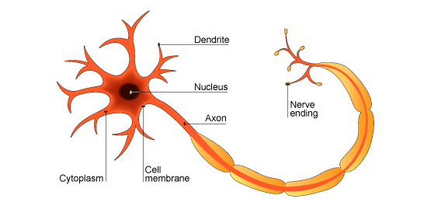  Carry electrical impulses around the body | - Lots of dendrites to make connections to other cells  - A very long axon that carries the electrical impulse from one place to another  - Synapses to pass the impulse between nerve cells  - Synapses contain lots of mitochondria to provide the energy needed to make special transmitter molecules
Muscle cells | Contract and relax to allow movement | - Contain special fibres that can slide over one another to allow the fibres to contract  - Contain lots of mitochondria to provide energy for contraction  - Store glycogen which can be converted into glucose for respiration
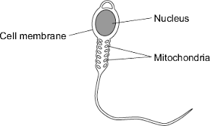  Sperm cells | Fertilise an egg cell | - A tail for movement  - Middle section full of mitochondria to provide energy for tail to move  - Digestive enzymes in acrosome to break through egg  - A large nucleus containing half the genetic information needed to make a human.

Answer the questions below in your exercise book

- Why does the nerve cell have lots of dendrites?
- What is a specialised cell?
- What is the function of the cell membrane?
- What do muscle cells contain a store of?
- What does differentiate mean?
- What is the function of the nucleus?
- Why do muscle cells contain a store of glycogen?
- What other adaptation of a muscle cell links to the store of glycogen?
- What do ribosomes do?
- A nerve cell’s axon is 7µm wide. How big will it look when viewed under x1000 magnification?
- What is the function of a nerve cell
- Give two adaptations of a nerve cell
- Why do nerve cells contain lots of mitochondria?
- Olga is 30 years old. She had been the same height for 15 years. Suggest how the rate of cell division and differentiation compare to the rate of cell death.
- If you are in your exam and are unsure of an adaptation of an animal cell, what one do they all share?

- Complete the sentences below:
The sperm has a tail because……
The sperm has a tail but……
The sperm has a tail so….

- A whale’s sperm is roughly 75µm long.
- What is its length in m? use standard form
- If a human sperm is roughly 40µm long what is the percentage increase in length from a human to a whale sperm cell?
- A student is asked how a muscle cell is adapted to its function. She writes:
A muscle cell is a specialised animal cell. It has lots of mitochondria to help it move. It also stores glycogen for energy.
This answer got her 2 marks out of a possible 4.
Rewrite this sentence using key scientific terminology and adding more detail so that she can get 4 marks.

- Cone cells are specialised nerve cells found in the eye. They make a pigment that allows them to detect light and see colour. Once the pigment detects light another nerve signal is sent along another nerve cell to the brain. Cone cells contain lots of mitochondria. Suggest why this is an important adaptation. (4)
- What does the number of mitochondria and the presence of flagella tell you about a cell? (2)
- Describe and explain how the adaptations of a sperm cell assist it with its function (5)
Part 5 Specialised plant cells
Reading: Plants, like animals, are multicellular organism and as such contain many specialised cells. Just like animal specialised cells these plant cells contain certain features and adaptations that make them successful at their function. While animal cells differentiate early on and permanently become specialised cells, plant cell always have the ability to differentiate. This means that they can change and adapt. A good example of this is how a plant responds to pruning. If a branch is chopped off some of the cells of the stem will differentiate and a new leaf and flower will grow.
Specialised cell | Function | Adaptations
Root hair cell | - Absorb water and minerals | - Large surface area available for water to move into cell by osmosis  - Large permanent vacuole that speeds up osmosis  - Lots of mitochondria that carry out respiration to provide the energy needed for active transport
Photosynthetic cells (For example a palisade cell) | - Carry out photosynthesis | - Contain lots of chloroplasts containing chlorophyll that trap light  - Usually found in outer layers of leaf and stem to absorb as much light as possible
Xylem cells | - Transports water and mineral ions from the roots to the highest leaves and shoots | - When first formed xylem cells are alive but due to build-up of lignin the cells dies and form long hollow tubes that allow water and mineral ions to travel up the plants  - The lignin makes the xylem cells very strong and help them withstand the pressure of water moving up the plant
Phloem cells | 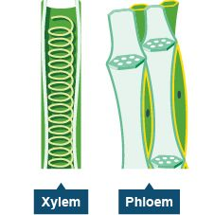  - Transports glucose around the plant | - Cell walls between cells break down to form sieve plates that allow water carrying dissolved glucose to move up and down the phloem  - Supported by companion cells that keep them alive. Phloem cells don’t have cell structures like mitochondria instead they rely on companion cells for their energy needs

- What is the function of root hair cells, xylem cells and phloem cells
- A palisade cell of a leaf is viewed under x400 magnification. The image is 1.2cm long. How big is the cell in µm?
- The build up of what chemical causes xylem cells to die?
- Why do root hair cells have lots of mitochondria?
- What cell structure do photosynthetic cells have lots of?
- Why must xylem cells be strong?
- What is the purpose of sieve plates?
- What is the name given to the type of cells that keep phloem cells alive?
- Complete the sentences below
The phloem have companion cells because….
The phloem have companion cells but…..
The phloem have companion cells so…..
- Suggest why a cell within the trunk of a tree cannot carry out photosynthesis (Hint: what can’t it get)
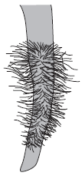
- Suggest why root hair cells don’t contain chloroplasts (Hint: think about their location)
- The image to the right shows part of a plant root.

The plant root is adapted for absorbing water from the soil.

Use information from the diagram to explain how this plant root is adapted for absorbing water.

- The drawing shows part of a root hair cell.

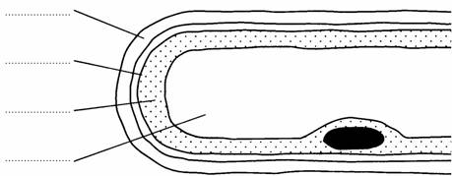

(a) Use words from the list to label the parts of the root hair cell.

cell membrane cell wall cytoplasm nucleus vacuole

(4)
Part 6. Culturing microorganisms TRIPLE ONLY
Bacteria multiply by simple cell division (we call this binary fission) as often as once every 20 mins if they have enough nutrients and a suitable temperature. If we grow bacteria in a lab we can use agar gel to provide the nutrients needed. If this sample is uncontaminated we can use it to investigate the action of disinfectants and antibiotics.

Condition | What is required for bacteria growth
Temperature | 37°C – BUT in a school lab we never use this, as it may allow harmful pathogens to grow. Therefore, we use 25°C.
Food | Agar gel – a nutrient rich gel containing glucose for respiration and nitrogen so the bacteria can make its own proteins and DNA
Oxygen | Make sure oxygen is able to diffuse into the petri dish to allow the bacteria to aerobically respire

- What is binary fission?
- A student uses agar gel to investigate bacteria ……..
- Because………..
- Therefore………..
- But…….
- What type of respiration does the bacteria carry out?

- A student says
“Making sure oxygen is available is really important in bacteria growth”
- Is the student correct?
- Why?

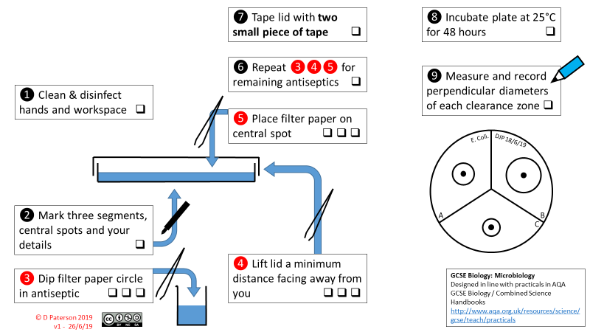

- Look at the data below from a students practical investigating different leaning fluids.
Filter paper disc | Diameter of circle with no bacteria growing (cm) | Radius of circle (cm) | Area around disc with no growth (cm²)
Water | 0
Cleaning liquid A | 3.7
Cleaning liquid B | 4.1
- Complete the table. Give all answers 2sf
- Why did the student run an experiment with water?
- Which was the best cleaner? (assume cost and volume are equal)
- Why did the student incubate the petri dish for 48hours at 25ºC?
- Why did the student destroy the agar jelly and disinfect the petri dishes after the practical was complete?
- [HT] At 25ºC bacteria divide every 20 mins. If there was 1 bacteria transferred to the petri dish at the start how many bacteria will be on the plate after the 48hours? Give your answer in standard form
Part 7 Cell division
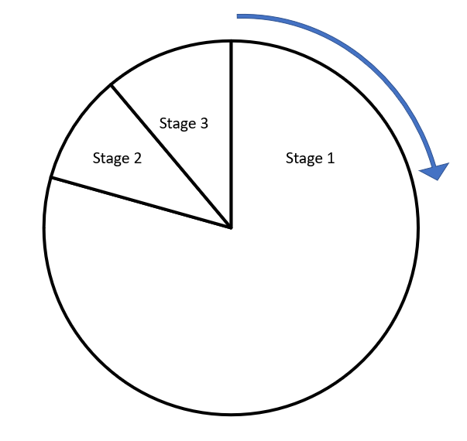
Cells, like all life, go through a life cycle. I the case of cells this cycle is called the cell cycle. The cell cycle has 3 distinct phases:
Stage 1
- Cell growth: When the organelles inside the cell are copied
- Copying of chromosomes: Here the DNA replicates to form two copies of each chromosome
Stage 2 (mitosis)
- One set of chromosomes moves to each end of the cell
- Nucleus divides
Stage 3
- Cytoplasm and cell membrane divide to for two identical cells
Inside each nucleus is all the DNA needed for a cell to differentiate into any specialised cell. DNA molecules are large and complex. They carry the genetic code that determines the characteristics of a living organism. DNA is found in X shaped structures called chromosomes in the nucleus of each cell. There are 23 pairs of chromosomes (46 chromosomes altogether).
Body cells divide in a series of stages known as the cell cycle. Cell division in the cell cycle involves a process called mitosis and it produces two identical cells. Mitosis is vital for growth, repair and replacement of worn out cells. Mitosis is a form of asexual (does not need a male and female) reproduction.
- What is a chromosome?
- Are chromosomes normally in pairs or single?
- What is Mitosis?
- What happens when cells differentiate?
- Why is Mitosis important?
- What does Asexual mean?
- How many chromosomes does a normal body cell have?
- What happens in the first stage of Mitosis?
- Why is this stage important?
- What happens in the second stage of Mitosis?
- What happens in the third stage of mitosis?

- Below is a diagram which shows the stages of the cell cycle in order. Add labels to the spaces from the information above
Stage 3:
Stage 2:

Stage 1:
This normal body cell has four chromosomes in two pairs

- What does identical mean?
- Why is it important that these cells are identical?
- Henry says:
“DNA is a large molecule that is large and simple. It carries the genetic code of an organism. This is what makes an animal look the way it does.”
  - Correct Henry’s statement so that it uses more scientific terminology.
  - Henry also says that “DNA is found in X shaped structures called chromosomes in the nucleus of each cell. There are 23 chromosomes in a cell.”
He has made a mistake somewhere. Correct his statement.
- This question is about the cell cycle. Figure 1 shows information about the cell cycle.
- Which stage of the cell cycle in Figure 1 takes the most time?
- During mitosis cells need extra energy. Which cell structures provide most of this energy?
Part 8 Stem cells
Earlier in the course we learnt that humans were made of trillions of cells and that these cells became specialised through a process known as differentiation. But where di all these new cells come from? Mitosis explains how 1 liver cell can become 2 liver cells but where did the first liver cell come from?
Stem cells are the undifferentiated (non-specialised) cells that all other specialised cells come from. They are incredibly important as they can divide many times and produce cells which can differentiate into any kind of specialised cell.
Stem cells ability to make any kind of cell has made them an important way to treat health problems. Currently stem cell therapy is a new technique which has two main approaches:
Embryonic stem cells
Embryonic stem cells are stem cells that are taken from embryos. The advantages of using embryonic stem cells are:
- Can create many embryos in a lab
- Painless technique
- Can treat many diseases
- Can become any type of cell (whereas bone marrow can treat a limited number).
However there are disadvantages to using embryonic stem cells:
- Harm / death to embryo
- Embryo rights / embryo cannot consent
- Unreliable technique / may not work
Adult stem cells
Adult stem cells are another way to treat disease. An example of these are bone marrow stem cells, these can also be used for treating diseases. The advantages of this method are:
- No ethical issues / patient can give permission
- Can treat some diseases
- Procedure is (relatively) safe / doesn’t kill donor
- Tried and tested / reliable technique
- Patients recover quickly from procedure
However, the disadvantages of this method are:
- Risk of infection from procedure
- Can only treat a few diseases
- Procedure can be painful

- What is a stem cell?
- What are embryonic stem cells?
- A student argues that stem cells shouldn’t be used in scientific research.
- “It is wrong to use embryonic stem cells because it harms the embryo and embryos can’t give consent! It’s not even a reliable technique to you might be causing the death of an embryo for no reason!”
- Another student wants to argue back that that using embryonic stem cells in research has lots of advantages. What could he say?
- What is an adult stem cells?
- State 3 advantages of using adult stem cells
- Using adult stem cells is not necessarily positive………..
Because……..
Therefore……….
But………….
Plant Stem cell
Most plants keep all their stem cells where they are growing. This means they are often found at the tips of the roots or at the meristems (the tip of the shoots). The stem cells from plant meristems can be used to make clones of the mature plant. This is important as it allows us to produce a large amount of plants quickly. This could help us save plants from extinction or produce large amounts of identical plants for scientific research. It can also be used in horticulture to create identical plants to sell.
- Where can meristems be found in a plant?
- Why are meristems important?
- Explain the use of meristems in plants for human benefits (hint: agriculture).
- Complete the sentences below
- Meristem tissue is important because……….
- Meristem tissue is important therefore……..
- EXAM STYLE QUESTION:
Stem cells are used to treat some human diseases.
Stem cells can be collected from early embryos. These stem cells have not begun to differentiate, so they could be used to produce any kind of cell, tissue or organ. The use of embryonic stem cells to treat human diseases is new and, for some diseases, trials on patients are happening now.
Stem cells can also be collected from adult bone marrow. The operation is simple but may be painful. Stem cells in bone marrow mainly differentiate to form blood cells. These stem cells have been used successfully for many years to treat some kinds of blood disease. Recently there have been trials of other types of stem cell from bone marrow. These stem cells are used to treat diseases such as heart disease.

a) Evaluate the use of stem cells from embryos or from adult bone marrow for treating human diseases. You should give a conclusion to your evaluation. (6) (Hint: Evaluation should be pros and cons of each then your opinion to conclude)
Part 9 Diffusion
Diffusion is the movement of particles from an area of high concentration to an area of low concentration. This goes down the concentration gradient. It is a passive process and therefore does not require energy:

Imagine a ball on a slope. The ball will not require you to add energy in order for it to roll down the slope
High Concentration

Concentration gradient

Low Concentration

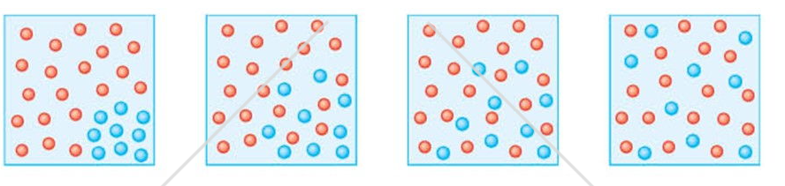
This of when you spray perfume. At first you can’t smell it and then gradually the particles diffuse across the space until they are evenly spread out and you can smell it.


There are a few different conditions that will speed up the rate of diffusion. If the concentration gradient is very small (there is only a slight difference in the amount of particles) then the rate of diffusion is slower. If the temperature is higher, the rate of diffusion increases because the kinetic energy store of the particles increases and the particles move faster.

Your cells need to take in substances like glucose and oxygen to survive and remove substances like urea and carbon dioxide. Dissolved substances and gases can move in and out of cells by diffusion. The bigger the difference in concentration between two areas the faster diffusion will occur. The oxygen you need for respiration passes from the air into your lungs. From here it diffuses into red blood cells to be transported round the body to where it is needed, for example in muscle cells. Carbon dioxide will diffuse from the blood into the lungs.
The single most common adaptation to improve diffusion is to increase the surface area of a cell. This is commonly done by folding the cell membrane.

- What substances commonly enter cells?
- What substances are commonly removed by cells?
- Define diffusion
- What is the function of the cell membrane?
- State two factors that can affect diffusion
- Why does increased temperature increase diffusion?
- What diffuses from your lungs into red blood cells?
- What diffuses from your red blood cells to your muscle cells?
- Explain why so many cells have folded membranes along at least one surface. (2)
- Describe the process of diffusion including any adaptations for the following statements:
  - Carbon dioxide moves from the blood in the capillaries of your lungs to the air in the lungs (3)
  - Male moths can track down a mate from up to 3 miles away because of the special chemicals produced by the female (3)
- Diffusion is an important process in animals and plants.

The movement of many substances into and out of cells occurs by diffusion.

Describe why diffusion is important to animals and plants.

In your answer you should refer to:

• animals

• plants

• examples of the diffusion of named substances (6).
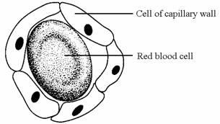
- Capillaries are blood vessels in the body which join the arteries to the veins. They have walls which are one cell thick and so are able to exchange substances with the body cells.

a) Name two substances that travel from the muscle cells to the blood in the capillaries.

b) Glucose is one substance that travels from the blood in the capillaries to the body cells. Explain how this happens.

Part 10 Osmosis
Reading
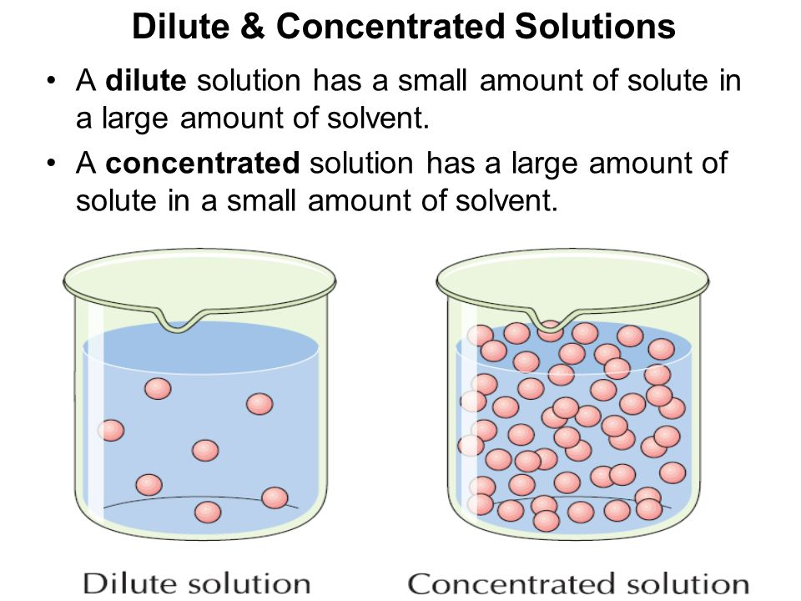
Osmosis is defined as the movement of water from an area of high concentration to low concentration through a semi-permeable membrane. This is a special case of diffusion. It is important to realise that a solution that has a high concentration of water is called a dilute solution, because it has a low concentration of solute dissolved. Conversely, a low concentration of water is found in a concentrated solution as there is less water and more dissolve solute.
Water moves from Dilute Solution to Concentrated solution

Concentrated solution- Lower concentration of water
Dilute solution- Higher concentration of water

If the water concentration outside the cell is equal to the water concentration inside the cell the solution is termed isotonic. A hypotonic solution has a higher water concentration that the cell this means water moves from the solution into the cell. Finally, a hypertonic solution is one in which the water concentration in the solution is lower than the cell causing water to move from the cell into the solution.
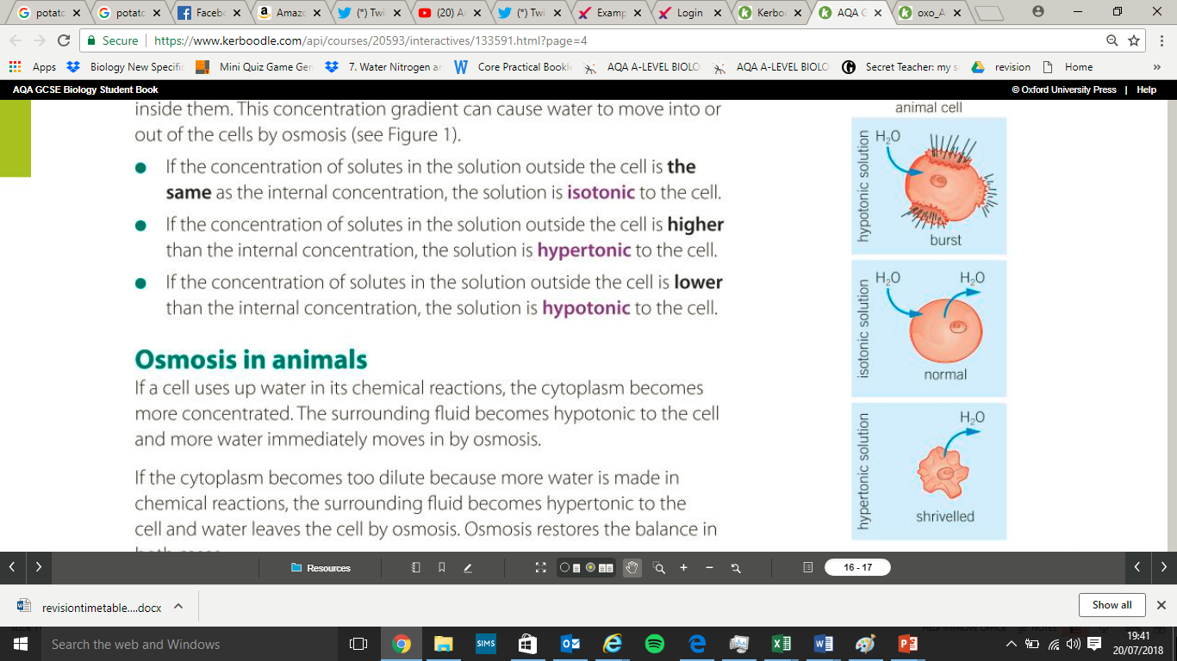

If an animal cell absorbs too much water it can burst conversely it can shrivel if it loses too much water. Plant cells do not do either of these as they have a cell wall that keeps them rigid and supports them.
Plant cells have a cell wall that prevents them from bursting or shrivelling when put in different solutions. Instead when in a hypotonic solution water moves into a plant cell and causes them to swell and appear turgid. When in a hypertonic solution the plant cell will lose water and appear plasmolysed. A plant cell is described as plasmolysed when a plant cell membrane pulls away from the cell wall.
Plant cell is…
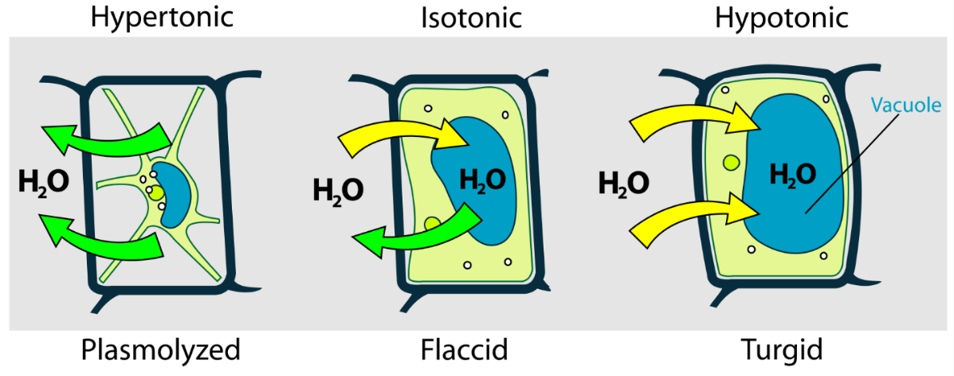
- What moves in Osmosis?
- Define Osmosis
- What does semi-permeable mean?
- A student wants to investigate osmosis. A carrot was placed in a dilute solution.
- What will happen to its mass? Explain your answer.
- The carrot was placed in 0.4 mol/dm 3 solution. Its mass did not change. Explain why this happened.
- What does this tell us about the concentration of the carrot?
- The carrot was placed in a concentrated solution. What will happen to its mass? Explain your answer.
- What is the formula to calculate percentage change in mass?
- Why is percentage change used instead of change in mass?
- What does Isotonic mean?
- If the solution is isotonic to the cell what is happening to the water?
- What does hypotonic mean?
- If the solution is hypotonic to the cell what is happening to the water?
- If this keeps happening what could happen to the cell?
- What does hypertonic mean?
- If the solution is hypertonic to the cell what is happening to the water?
- If this keeps happening what could happen to the cell?
- Animals that live in fresh water have a constant problem with their water balance. The single celled organism amoeba has a special vacuole that fills with water and then moves to the outside of a cell to burst. A new vacuole starts forming straight away. Explain in terms of osmosis why amoeba need vacuole

- The table below shows the results of a students’ experiment into osmosis.

 | Concentration of sugar solution in mol dm⁻³ | Starting  mass in g | Final mass  in g | Change of  mass in g | Percentage  (%) change
 | 0.0 | 1.30 | 1.51 | 0.21 | 16.2
 | 0.2 | 1.35 | 1.50 | 0.15 | X
 | 0.4 | 1.30 | 1.35 | 0.05 | 3.8
 | 0.6 | 1.34 | 1.28 | −0.06 | −4.5
 | 0.8 | 1.22 | 1.11 | −0.11 | −9.0

(a) Calculate the value of X in the table above.
(b) Why did the student calculate the percentage change in mass as well as the change in grams?
(c) Complete the graph using data from the table above.
  - Choose a suitable scale and label for the x-axis.
  - Plot the percentage (%) change in mass.
  - Draw a line of best fit.
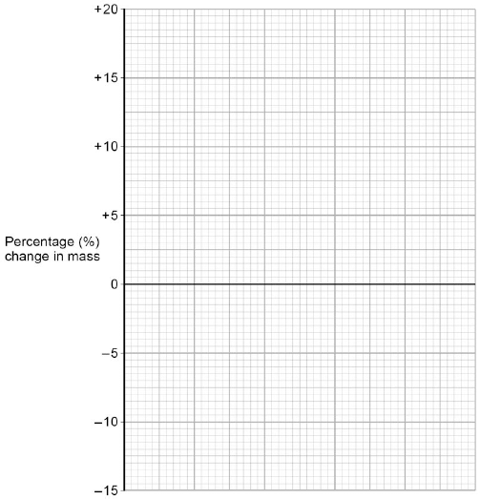
(d) Use your graph to estimate the concentration of the solution inside the potato cells.

Part 11 Active transport

Active transport is the movement of substances from a low concentration to a high concentration through a semi-permeable membrane. This means moving against the concentration gradient and therefore requires energy. The energy is provided by respiration in the mitochondria. This means active transport is only used in vital processes. Like diffusion and osmosis a high surface area is used to increase the rate of active transport

High Concentration
Imagine a ball on a slope. The ball will not roll up the slope unless you give it energy.
Concentration gradient

Low Concentration

Active transport has many important roles. Two examples are below:
- Allow mineral ions to be absorbed into plant root hair cells from very dilute solutions in the soil. Plants require ions for healthy growth, so this movement is vital
- Allow sugar molecules to be absorbed from lower concentrations in the gut into the blood which has a higher sugar concentration. Sugar molecules are used for cell respiration, which is needed to produce energy.
DIFFUSION
OSMOSIS
ACTIVE TRANSPORT
- Movement of water
- Movement of particles
- From a high concentration to a low concentration
- Requires energy
- Does not require energy
- Requires a partially permeable membrane
- Does not require a partially permeable membrane
- From a low concentration to a high concentration
- Cells that do this have a lot of mitochondria

- What is active transport?
- Describe how root hair cells use active transport
- Why is this movement important in the plant?
- A student uses a pipette to add 3 drops of indicator to a beaker of acid. She watches the colour change and swirl through the liquid. Is this osmosis, diffusion or active transport?
- Explain your answer to the question above
- Explain why cells performing active transport require a lot of energy.
- Describe how the gut uses active transport.
- Why is this important?
- Compare active transport and diffusion (6)
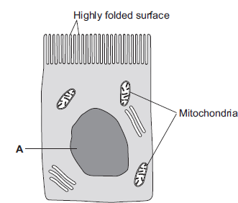
- The cells of the small intestine have many mitochondria. Explain why they this helps them to function properly.
- The image to the right is an epithelial cell from the lining of the small intestine
    - Name organelle A
    - Why does the cell have a many folded membrane?
    - Why does the cell need many mitochondria?
    - What process allows the cell to absorb water?
    - Name one food molecule absorbed by active transport.
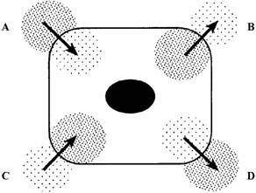
- Look at the diagram below. Label A,B,C,D with the correct keywords (diffusion osmosis active transport)

