Atoms, elements, compounds and the periodic table
Lesson 1: Elements and the periodic table
Atoms are the smallest unit in Chemistry and are made up of protons, neutrons and electrons. The protons and neutrons are found in the centre of the atom in the nucleus and the electrons are found orbiting the nucleus in shells. Elements are made up of only one type of atom, an example is oxygen. All known elements can be found within the periodic table. Compounds are formed from two or more different types of atoms which are chemically bonded together, for example carbon dioxide – made of one carbon atom and two oxygen atoms. Mixtures are formed from two or more different types of atoms which are not chemically bonded together, an example is sandy water.
The periodic table of elements developed as scientists tried to classify elements. It arranges them in an order in which similar elements are grouped together. The periodic table is so named because of the regularly repeating patterns in the properties of elements. The modern periodic table was formed by a Russian scientist called Mendeleev in 1869. He was aware that not all elements had yet been discovered and so he left gaps in his table for unknown elements, which when they were later discovered matched his predictions and so his table was accepted by the scientific community. Groups within the periodic table are the vertical columns – there are groups 1-7 plus group 0 and the transition metals. The group number tells you the number of electrons which you find in the outer shell. Periods within the periodic table are the horizontal rows – there are 7 periods. The period tells you the number of shells of electrons which are present.

- What are atoms made up of?
- Where are makes up the nucleus of an atom?
- What do you find orbiting the nucleus?
- What is an element?
- Where can you find all known elements?
- What is the difference between a compound and a mixture?
- Is magnesium oxide an element or a compound?
- Who formed the modern periodic table?
- Why is it called the periodic table?
- Why did Mendeleev leave gaps when he formed his periodic table?
- What does the group number tell you in terms of electrons?
- What does the period number tell you in terms of electrons?
- Draw the particle diagram for chlorine (gas)
- Draw the particle diagram for sodium (solid)
- Complete the table
Name | Chemical symbol | Group number | Metal or non-metal
Oxygen
Lithium
 | Mg
Phosphorus
 | Po
 | Mn
Silver

- Sort the following into the correct category in the below table:
- Water
- Salt and oil
- Ammonia
- Nitrogen
- Calcium
- Methane
- Sandy water
- Ice cubes in a drink
- Cement (sand, water and gravel)

Element | Compound | Mixture

Lesson 2: Atomic model and electron configuration
An atom is the smallest unit in Chemistry and is made up of protons, neutrons and electrons. The nucleus of an atom contains the protons and neutrons and the electrons orbit the nucleus in electron shells. Protons are positively charged, electrons are negatively charged and neutrons are neutral in charge.
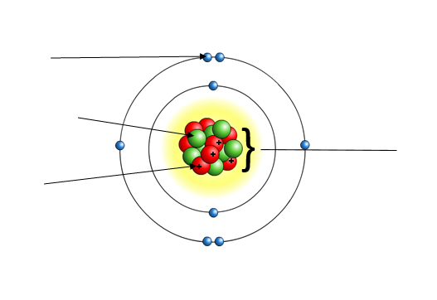

When looking at an element within the periodic table, you can see that there is a number above the chemical symbol which is the relative atomic mass and there is a number underneath the chemical symbol which is the atomic number. The atomic number tells you the number of protons and therefore also the number of electrons in the atom. This is because atoms have no overall charge and therefore in an atom, there must be an equal number of protons and electrons as protons are positively charged and electrons are negatively charged and therefore, they cancel each other out in terms of charge. The relative atomic mass tells you the number of protons plus the number of neutrons in the atom.
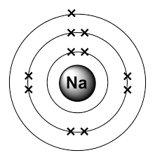
Electrons are found orbiting the nucleus in electron shells. The first shell, which is closest to the nucleus holds 2 electrons. The 2nd, 3rd and 4th shell all hold 8 electrons. When drawing electron configuration diagrams, we draw electrons as crosses. Electrons are negatively charged and so they will repel each other to be as far away as possible before they then start to pair up. An electron configuration diagram has been drawn for you below.

- What do you find within the nucleus of an atom?
- What charge do electrons have?
- What is meant by atomic number?
- What is the atomic number of carbon?
- How many protons does lithium have?
- How many electrons does aluminium have?
- Why is there always an equal number of protons and electrons in an atom?
- How many electrons can the first shell of electrons hold?
- How many does the 2nd, 3rd and 4th shell of electrons hold?
- Why do electrons repel each other?
Electron configuration drawing practice:

- Beryllium (teacher draws)
- Nitrogen
- Oxygen
- Helium
- Neon
- Sulphur
- Aluminium
- Silicon
- Carbon
- Lithium
Lesson 3: Properties of the elements and the periodic table
There are two different types of elements – metals and non-metals. Metals have many important uses in everyday life such as jewellery, cars, electrical wiring and saucepans. The reason why they are so useful is due to the properties which they have. Metals can conduct electricity as they have free electrons which are able to move and therefore carry charge. As metals can conduct electricity, they are often used to make wires and parts of electrical circuits. Metals are also able to conduct heat which is why they are used for saucepans. Metals are strong and tough, which makes them good for building materials, and this is because there are strong forces between the metal atoms that hold them together. Metals have high melting and boiling points because of the strong forces between the metal atoms, for example copper has a melting point of 1085 degrees and a boiling point of 2562 degrees. The melting point of a substance is the temperature at which a solid changes into a liquid. The boiling points of a substance is the temperature at which a liquid changes into a gas. Metals are also malleable which means they can be easily shaped and ductile which means they can be bent and stretched to form wires.

In contrast, non-metals are poor conductors of electricity. This is because there are no free electrons and hence charge is unable to be carried throughout the metal structure. Non-metals are also poor conductors of heat and so can be said to be insulators. They also have low melting and boiling points, and this is due to the forces which hold the atoms together being very weak and so not much energy is needed to overcome them. For example, the melting point of oxygen is -218 degrees and its boiling point is -183 degrees, hence we find oxygen as a gas. Non-metals are also weak and brittle and again this is due to the forces between the atoms being weak.
The most reactive metals are found within group 1 and 2 of the periodic table. These groups can be referred to as the alkali metals. This is because when any of the metals within these groups react with water, they will form an alkaline solution.
- Complete the table below to show the differences in properties between metals and non-metals
Properties of metals | Properties of non-metals
- What is the definition of melting point?
- What is the definition of boiling point?
- Why are group 1+2 referred to as the alkaline metals?
- Why can metals conduct electricity?
- Why do metals have high melting and boiling points?
- What is meant by ductile?
- Why are non-metals referred to as insulators?
- Why can’t non-metals conduct electricity?
- Why do non-metals have low melting and boiling points?
- Why are non-metals weak?

Lesson 4: Chemical reactions and compound formation
A mixture is when you have two or more different types of atoms which are not chemically bonded together, which therefore means you can separate the different types of atom easily. In contrast, a compound is when you have two or more different types of atoms which are chemically bonded together, which therefore means you can’t separate them easily.
The demonstration which you have seen involved sulphur (yellow powder) and iron filings. Sulphur is a non-metal and iron is a metal. Iron is one of three magnetic metals – iron, nickel and cobalt. It was clearly a mixture, as you could use the magnet to separate out the iron filings from the sulphur.

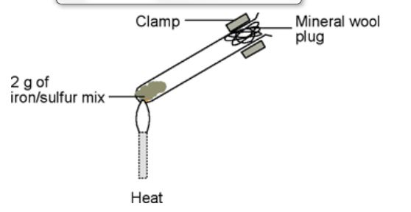
Practical work – heating a mixture of iron filings and sulphur powder

Observation | Colour | Separate easily using a magnet?
Before heating
After heating

Once a chemical reaction has taken place, a word equation to show what has happened may be written. The reactants are found on the left-hand side of the arrow and are what you started with. The products are found on the right-hand side of the arrow and are what you made during the reaction.
Reactants Products
Magnesium + oxygen Magnesium oxide
When you are naming the compound which has been formed, the metal (if there is one) will always go first e.g. in the example above Magnesium is a metal. The second part of the compound will be the non-metal. If there are only 2 elements in the compound, the ending for the non-metal is shortened and changed to –ide.
- Complete the following word equations in your exercise book
- Lithium + oxygen
- Aluminium + oxygen
- Sodium + oxygen
- Iron + sulphur
- Copper + sulphur
- Calcium + chlorine
- Magnesium + bromine
- Lithium + fluorine
- What is the difference between a mixture and a compound?
- What are the metals which are magnetic?
- Which side of the arrow will the products go?
- Give 3 properties of metals
- What is meant by boiling point?
- Draw a picture to show the difference between a compound, element and mixture (use different colours to help you show different types of atoms)

Lesson 5: Compounds formulae
Chemical formula is the shorthand way of writing compounds names. Chemical formulae is useful as it also tells you how many of each atom you have in the compound. You work out the chemical formula of a compound using symbols from the periodic table. When using the periodic table to write formula, capital letters must always be used, unless there are two letters, in which case the second one is in lower case. For example, Aluminium is Al.
Complete the table below:
Name of compound | Atoms which it contains | Chemical formula
Carbon monoxide | 1 carbon and 1 oxygen | CO
Carbon dioxide | 1 carbon and 2 oxygens | CO2
Hydrogen chloride | 1 hydrogen and 1 chlorine
Sodium chloride | 1 sodium and 1 chlorine
Methane | 1 carbon and 4 hydrogens
 |  | MgO
Water | 2 hydrogens and 1 oxygen
 |  | LiBr
 |  | KCl
 |  | CaO
 | 2 potassium and 1 oxygen
 | 2 aluminium and 3 oxygen

A compound has no overall charge and therefore any atoms which are joining together must balance each other out so that they equal zero. For example, lithium chloride is made up of 1 lithium atom which has a charge of +1 and 1 chlorine atom which has a charge of -1. Overall lithium chloride has no overall charge and has a chemical formula of LiCl. Another example is magnesium chloride. Magnesium has a charge of +2 and chlorine has a charge of -1, therefore 2 chlorine atoms will be needed to balance out the +2 charge of magnesium, so magnesium chloride has a formula of MgCl2. The numbers will always go on the bottom right of the atom which they apply to.

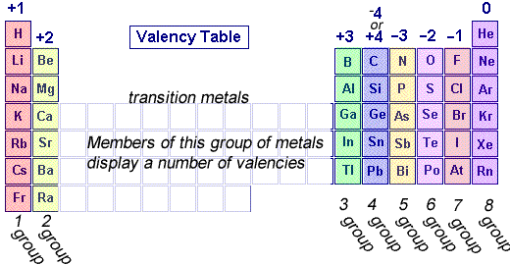

Compound Name | Elements contained | Chemical Formula
Magnesium chloride | Magnesium chlorine | MgCl₂
 | potassium, chlorine
Potassium Iodide
 | Calcium, fluorine
Calcium Oxide

 | Lithium, Nitrogen
Potassium Sulphide
 | Aluminium, chlorine
Aluminium Oxide

Lesson 6: Conservation of mass
In a chemical reaction, no mass is lost or gained when the reactants turn into products. This is because the total number of atoms is the same before and after the reaction. Chemical reactions involve a change in energy for examples reactions that give out or take in energy. This is usually heat energy and causes the temperature in a reaction to go up or down. Visible changes can also occur in the reaction mixture and this shows that a chemical reaction has taken place. For example, a gas may be produced, a solid may be made or the colour of a solution changes.

Practical – the reaction of magnesium and oxygen
Aim/introduction:
You are going to burn some magnesium ribbon and investigate what happens to its mass.

Prediction
I think when magnesium is burned the mass will increase/decrease/stay the same
because.....................................................................................................
...............................................................................................................

Method
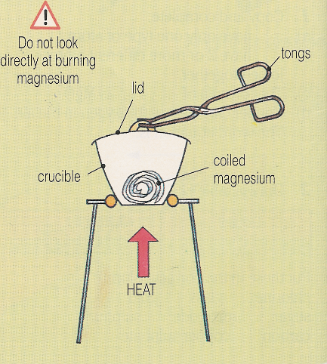
- Set up the apparatus as below.
- Weight the crucible and lid together and record their mass
- Weigh the strip of magnesium you are given and record the mass
- Stand the crucible securely in a pipe clay triangle on a tripod and heat with a Bunsen, gently at first and then using a roaring flame.
- Use the tongs to lift the lid a little during the reaction.
- When the reaction is complete, allow the apparatus to cool, then weigh the crucible, lid and the product.

Results
A. Mass of crucible + lid = ………………………….. g
B. Mass of magnesium = ………………………….. g
C. Mass of crucible, lid and product = ……………. g
D. Mass of product (C – A) = ……………. g

Conclusion
- Write the word equation for the reaction you have carried out
- The reaction can be represented using the diagrams below.
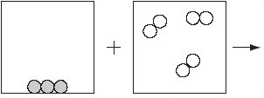

Complete the third box to represent the product you made.
- Look at your results. Is the mass of the product (D) greater than the mass of the magnesium (B) you started with?
- Do your results match your prediction?
- Where has the ‘extra’ mass come from? Try to describe and explain what has happened.
- How do the diagrams show that mass is conserved?
Lesson 7: Conservation of mass continued
A substance can either be a solid, liquid or gas. Substances can change between these different states of matter and their mass won’t change. Physical changes are different to chemical changes because there is no actual reaction taking place and no new substances are made. The particles stay the same, they just have a different arrangement and the amount of energy.
During a chemical change, there is a reaction taking place and new products being formed – however the atoms have simply been rearranged. When mass appears to be gained or lost, gases are involved. Gases can be produced as a product and would be given off, hence the mass observed would have decreased. Gases can be taken in as a reactant and would be transferred to the products, hence the mass observed would have increased.

- Sort the below statements into the table
- Frying an egg
- Dissolving sugar into water
- Burning magnesium in oxygen
- Reacting iron and sulphur together
- Melting an ice cube
- Puddles drying up
- A candle burning
- Mixing ethanol and water

Chemical change | Physical change

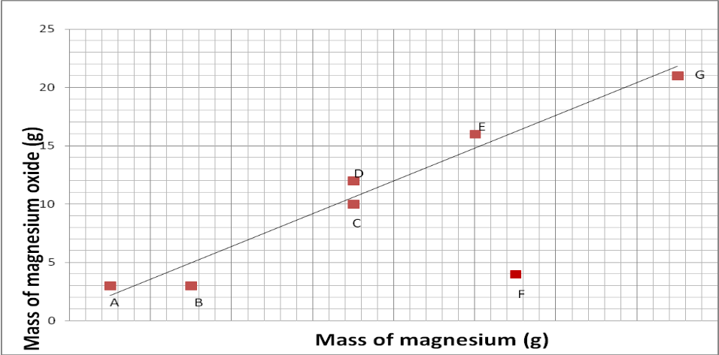
Interpreting data:

- Which group had a strange result?
- What do you think might have caused this?
- Which 2 groups started with the same amount of magnesium?
- What is the general pattern of the results? (Point, Evidence)
- Do the results support the hypothesis?

Lesson 8: Group 1
Group 1 are also called the alkali metals – this is because when they react with water, they form an alkaline solution. Group 1 metals are very reactive and so they are all stored in oil to prevent them from reacting with oxygen in the air. Their reactivity increases as you move down the group. So lithium is the least reactive metal and francium is the most reactive metal. All of the alkali metals have a very low density for metals – so much so, that lithium, sodium and potassium will all float on water as seen in the demo. The alkali metals are also very soft, so they can be cut with a knife. They have the silvery, shiny look of typical metals when we first cut them. However, they quickly go dull as they react with oxygen to form a layer of oxide. The group 1 metals also melt and boil at relatively low temperatures. As you move down group 1, the melting and boiling points get lower and lower.
The reason why group 1 metals have these unusual properties is because of their electronic structure. They all have one electron in their outer shell and so this makes them very reactive as they only need to lose one electron to get a full outer shell.
When group 1 metals react with water, they form hydrogen which is a gas and also a metal hydroxide. For example:
Lithium + water Lithium hydroxide + hydrogen
Demo – complete this table with your observations
Metal | Observation
Lithium
Sodium
Potassium

- What is meant by melting point?
- What is meant by boiling point?
- What is the trend in melting and boiling points as you move down group 1?
- What is the trend in reactivity as you move down group 1?
- Draw the electronic configuration of sodium
- How many electrons are found in the outer shell of group 1?
- Why are group 1 also called the alkali metals?
- Why does lithium and potassium float on water?
- What precaution is taken when storing group 1 metals due to their reactivity?
- Why do group 1 metals quickly go dull once they are cut?
- Sodium + water
- Potassium + water

Lesson 9: Group 7
Group 7 are also called the Halogens. They are a group of poisonous non-metals which all have coloured vapours. They are typical non-metals as they have low melting and boiling points and they are also poor conductors of heat and electricity. The boiling points increase as you go down the group.
The halogens all look different. At room temperature, fluorine is a very reactive, poisonous, pale yellow gas. While chlorine is a reactive, poisonous, dense green gas. Chlorine has a very distinctive smell and it is used as a sterilising agent and hence it is used in swimming pools.
As elements, the halogens all exist as molecules made up of pairs of atoms hence, they are called diatomic molecules. Di meaning two.
The electronic structure of the halogens determines the way they react with other elements. They all have seven electrons in their outer shell and so they need to gain only one more electron to have a full shell. When they react with non-metals, they gain an extra electron by sharing a pair of electrons with another atom and forming a covalent bond. The halogens get less reactive as you go down the group.

Trends in group 7
- The colours of the group 7 elements are shown below:
Element | Colour
Fluorine | Yellow
Chlorine | Yellow/green
Bromine | Red/brown
Iodine | Purple

- Describe the trend in colour in group 7.
- What colour do you think Astatine would be?
- Some of the physical properties of the halogens are given below:
Halogen | Melting point (°C) | Boiling point (°C)
Fluorine | -220 | -188
Chlorine | -101 | -35
Bromine | -7 | +58
Iodine | +114 | +183

- Describe the trend in melting points of the halogens
- Name the halogen that will be a liquid at room temperature (approx. 20°C)
- Predict the melting point of astatine. Use your periodic table to help you.

- What are group 1 also called?
- What are group 7 also called?
- What happens to the reactivity of group 1 as you go down the group?
- What happens to the reactivity of group 7 as you go down the group?
- Why are group 7 molecules referred to as being diatomic?
- How many electrons do group 7 have in their outer shell?
- What happens to the boiling point as you go down the group?
- What would the chemical formula be for lithium chloride?
- What would the chemical formula be for potassium bromide?
- What would the chemical formula be for sodium iodide?
- Draw the electronic configuration for chlorine
- Draw the electronic configuration for bromine
REVISION
- What is an element?
- Why are Lithium, Sodium and Potassium all in group 1 of the periodic table?
- Give two properties that chlorine, fluorine and iodine have in common
- Write a word equation for the reaction of any of the group 1 metals with water.
- What happens to the reactivity of group 1 metals as you come down the group?
- Predict what you would see if Caesium reacted with water. Name the products of the reaction.
- Some information about the elements in group 1 is given below:
Halogen | Melting point (°C) | Boiling point (°C)
Lithium | 180 | 1342
Sodium | 97 | 883
Potassium | 63 | 759
Rubidium | 39 | 688

- Describe the trend in the boiling points of the group 1. Use data to back up your statements.
- Which metal shown would be a liquid at 50°C?
- Suggest a value for the melting point of Caesium.
- Complete the following sentence:
“Some people think water is an element. They are wrong. In fact…”
- Explain why we keep the group 1 metals under oil in the chemical prep room
- A piece of lithium reacts in 12 seconds. An identical piece of potassium reacts in 3 seconds. calculate how many times faster the potassium reacts.
- Bobeck places 80g of chlorine in a jar. He reacts it with sodium to form sodium chloride. The mass of the product is 131g. How much sodium was in the jar?

Incorrect statement | Correct statement
There are two types of element – metals and gases

The formula for carbon dioxide can be written as CO²

If you repeat your own experiment and get the same results then you can say your data is reproducible

If other people do the same experiment as you then the data is reproducible

Elements in the same group have the same number of electrons

Elements in the modern periodic table are ordered by atomic mass

Compounds are made when two or more elements are mixed together

All metals rust

All metals are magnetic

All non-metals are gases

