Cells, Tissues and Organs
Lesson 1: Microscopes
Cells are the basic building blocks of all animals and plants. They are so small; you need to use a light microscope to see them. A light microscope uses a series of lenses to produce a magnified image of an object:
- the object is placed on a rectangular glass slide
- the slide is placed on a stage with a light source below
- light shines through the object and into the objective lens
- the light passes through the eyepiece lens and from there into your eye
- Use the coarse and fine focus to focus the image in view
Microscopes have three objective lenses. Always start observing an object using the lowest magnification lens first. You may need to adjust the focus and the amount of light as you move to higher magnifications. While a light microscope uses light to illuminate specimens and glass lenses to magnify images, an electron microscope uses a beam of electrons to illuminate specimens and magnetic lenses to magnify images. The resolution (the level of image detailing) is the main difference between these two microscopes
Practical: Investigate a variety of prepared slides using proper microscope etiquette. Practice finding the object in view on the lowest magnification and then increase the magnification and refocus.

- Correctly label the Microscope diagram below:
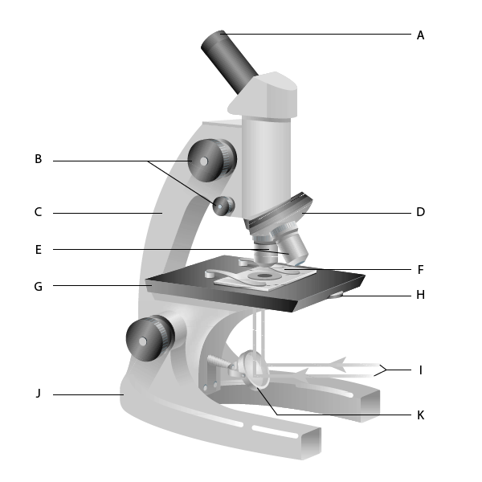

- Write a list of instructions to use a microscope. Complete in workbook.
In your instructions use scientific language. Refer to your labelled microscope diagram to include the correct names of microscope parts.
Calculating Magnification: In science you will be asked to calculate the Total Magnification. This is a combination of the eyepiece magnification (10x) and the objective lens (4x, 10x or 40x).
Total Magnification:

Eyepiece Magnification x Objective Magnification = Total Magnification
Example:
If a pupil is using a microscope with an objective lens of 4x magnification and an eyepiece of 10x magnification. What would the overall magnification be?
10 X 4 = 400x
- Complete the table below:
Eyepiece Magnification | Objective Magnification | Overall Magnification
X10 | X4 | 40
X10 | X10
X10 | X40
X10 | X100

- Which objective lens should you always start with when viewing a slide?
X4 x 10 x100

- Below are some sentences on how to use a microscope. Put them into the correct order.
____ Put the slide onto the stage
____ Turn the focusing knob to bring the cells into focus
____ Look down the eyepiece lens
____ Turn the objective lens to the lowest power
____ Move the slide to find some cells
____Increase the magnification to view the cells in more detail

You will also be asked to calculate for magnification using the equation below. This equation uses the measurements of both the Image Size and the Actual Size of an object.
Image Size: The size of the object with the magnification, this can be found by measure the object under the microscope.
Actual Size: The size of the object, in real life, without magnification. This can be calculated for I you know the magnification and image size.
Magnification Equation: Image Size = Actual Size x Magnification
Magnification = Image Size / Actual Size

Actual Size = Image Size / Magnification

Example 1: Magnification  Calculate the magnification of an object that is 0.01mm long but looks 10mm long in the image  - Write out Equation  M=I÷A  - Write out Values check units are the same  M=? I=10mm A=0.01mm  - Enter values into equation  M=10 ÷ 0.01  - Result  M=10 ÷ 0.01= 1000  - (Y)UNITS (if needed)  Magnification = x1000 | Example 2: Magnification  Calculate the magnification of an object that is 0.25mm long but looks 50mm long in the image  - Equation  - Values  M=_____ I=_____ A=______  - Enter values  M=______ ÷ _________  - Result  M=________÷ _________  - (Y)UNITS (if needed)  Magnification = ________ | Example 3: Magnification  Calculate the magnification of a fruit fly that is 3mm long but looks 3cm long in the image  E  V  E  R  Y
Example 1: Actual size  Calculate the size of an amoeba which is 75mm long under x100 magnification.  - Write out Equation  M=I÷A  - Write out Values check units are the same  M=x100 I=75mm A=?  - Enter values into equation  100 =75 ÷ ?  - Result (rearrange if needed)  ?=75÷100 = 0.75  - (Y)UNITS (if needed)  Actual size = 0.75mm | Example 2: Actual size  Calculate the size of a sperm which is 50mm long under x1000 magnification.  - EQUATION  M=I÷A  - VALUES  M=_______ I=_____ A=_____  - ENTER values  ______ =______ ÷ ______  - RESULT  ______ =______ ÷ ______  - (Y)UNITS  Actual size = _______ | Example 3: Actual size  Calculate the size of a pollen grain that looks 3cm long in the image under x100 magnification  E  V  E  R  Y
Example 1: Actual size  Calculate the size of an amoeba which is 75mm long under x100 magnification.  - Write out Equation  M=I÷A  - Write out Values check units are the same  M=x100 I=75mm A=?  - Enter values into equation  100 =75 ÷ ?  - Result (rearrange if needed)  ?=75÷100 = 0.75  - (Y)UNITS (if needed)  Actual size = 0.75mm | Example 2: Actual size  Calculate the size of a sperm which is 50mm long under x1000 magnification.  - EQUATION  M=I÷A  - VALUES  M=_______ I=_____ A=_____  - ENTER values  ______ =______ ÷ ______  - RESULT  ______ =______ ÷ ______  - (Y)UNITS  Actual size = _______ | Example 3: Actual size  Calculate the size of a pollen grain that looks 3cm long in the image under x100 magnification  E  V  E  R  Y

- A cell measures 112mm. The actual size is 0.28mm. Calculate the magnification.
- A cell measures 230mm. The actual size is 0.12mm. Calculate the magnification.
- A cell measures 345mm. The actual size is 0.65mm. Calculate the magnification
- If an object has an actual size of 5mm long but you magnify it by 100x, what will the image size be?
- A cell has a magnification of 400x. The actual size is 1.85mm. Calculate the image size.
- A cell has a magnification of 200x. The actual size is 0.34mm. Calculate the image size.
- A cell has a magnification of 100x. The actual size is 0.24mm. Calculate the image size.
- A cell is magnified x2000 and measures 6mm. Calculate the actual size in mm.
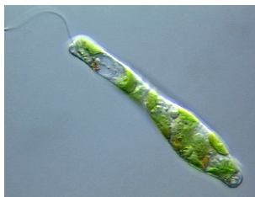
- A cell is magnified x1000 and measures 4mm. Calculate the actual size in mm
- A cell is magnified x6000 and measures 7mm. Calculate the actual size in mm.
- Some students measured the size of a cheek cell on a scaled diagram. It was 78 mm long. The magnification used was 400X. Calculate the actual size of the cell. Give the unit.
- The picture below shows an image of a euglena at 150x magnification. Calculate the actual size of the Euglena. Give the unit.

Lesson 2: Unicellular Organisms
A unicellular organism is a living thing that is just one cell. One type of unicellular organism that you may have heard of is bacteria. You may know bacteria as something that cause illness and infection, but bacteria can also have lots of useful functions too. For example, some bacteria lives in your gut and can help you to absorb important nutrients from your food. There are many different types of unicellular organism, including: bacteria, protozoa, and unicellular fungi.
You might be tempted to think that these organisms are very simple, but in fact they can be very complex. They have adaptations that make them very well suited for life in their environment.
In KS2 you would have learned that there are 7 life processes that all living things can do. These life processes have the acronym MRS GREN which means: Movement, Respiration, Sensitivity, Growth, Reproduction, Excretion and Nutrition. Unicellular Organisms are living which means they carry out each process in some way.
Look at the diagrams of Unicellular Organisms below and see if you can work out which parts allow them to carry out each process:
- Bacteria (left picture) are very tiny, unicellular organisms. The structure of a bacterial cell is different to an animal or plant cell. For example, it does not have a nucleus.
- Yeast Cells (right picture) are a unicellular fungi organism. Yeast have a cell wall, like plants do but do not have chloroplasts.
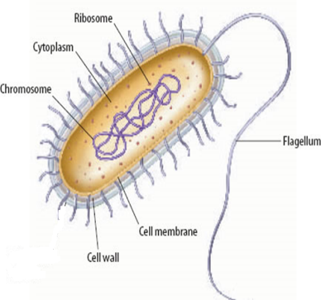
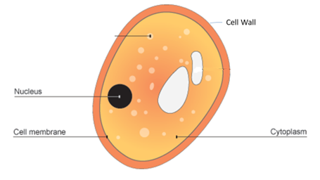

Functions of Cell Parts
Chromosome | Controls the cells features and allows respiration
Flagellum | A tail like structure which allows the bacteria to move
Cell Membrane | Allows nutrients in (nutrition) and waste products out (excretion)
Ribosome | Makes protein to support growth
Cytoplasm | Where many reactions take place

Reproduction of Unicellular Organisms:
Like all living things, unicellular organisms must reproduce. This is done through simple binary fission where they just make copies of themselves and then divide into two.
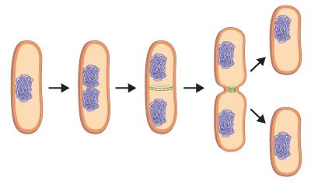
Practice Questions:
- Label the cell below:
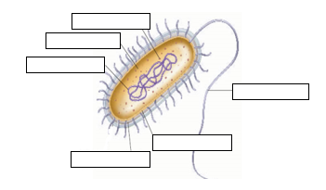

- Name one organelle that a bacteria cell does not have that a plant and animal cell do have.
- What is the function of the flagellum?

- Label the cell below:
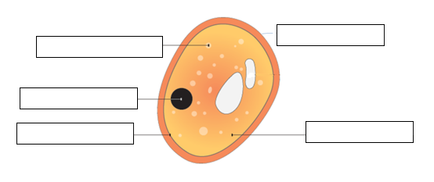
- Name one organelle that is in both a yeast cell and a plant cell.
- What is the function of a ribosome?
- State the three types of unicellular organisms.

- State below whether each function of unicellular organisms is a use or a danger:

____Use__ Bacteria can be added to sewage to break down harmful chemicals
__________ Bacteria live in the gut and help our digestive system
__________ Bacteria and fungi digest dead organisms releasing useful nutrients
__________ Bacteria can infect wounds on the skin after surgery causing infection
__________ Fungi such as yeast are used in brewing and baking
__________ Bacteria can reproduce in the body and release toxins causing disease
__________ Fungi can infect parts of the body causing athletes foot and thrush
__________ Fungi make antibiotics which can be used to treat bacterial infections
Lesson 3 + 4: Diffusion
Diffusion is the movement of substances. You can see diffusion happens when you make a cup of tea or a glass of squash. You can smell diffusion when you spray perfume or burn a piece of toast.
Diffusion always moves substances from areas of high concentration to an area of low concentration. When you put a tea bag into boiling water, the high concentration of tea in the tea bag spreads out to a lower concentration which is the water. Diffusion only happens in liquids and gases because their particles randomly move from place to place.
Diffusion is an important process for living things as it allows substances to move into and out of cells.
Imagine the diagrams below are a tea bag in a cup of boiling water:
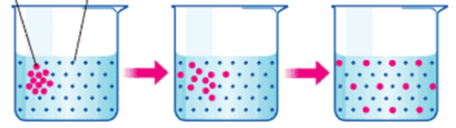

Figure 1: High concentration of tea particles in the top left corner
Figure 3: The particles are now spread out in equal concentration throughout the cup
Figure 2: high concentration of particles has started to spread throughout the water particles in the rest of the cup

Rate of Diffusion
The rate of diffusion is linked to how fast and easily the particles can move. How quickly particles move depends on three factors outlined below:
- Concentration Gradient – The greater the difference in concentration, the quicker the rate of diffusion
- Temperature – The higher the temperature, the more kinetic energy the particles will have, so they will move and mix more quickly
- Surface area of the cell membrane- The greater the surface area, the faster the rate of diffusion
Practical: Agar Jelly Experiment
Agar jelly can be coloured with an indicator that is pink but that turns colourless on contact with an acid. We can observe diffusion happening, as the colour will disappear from the cube as the acid diffuses inwards.
- Hypothesis: The more concentrated a substance is, the faster it will diffuse. Complete the variables below:
Independent variable:
…………………………………………………………………………………………………………………………………………………………………………….

Dependent variable
…………………………………………………………………………………………………………………………………………………………………………….
Control variables:
……………………………………………………………………………………………………………………………………………………………………………
- How could you check if your results are reproducible (def: able to be reproduced or coped)?

…………………………………………………………………………………………………………………………………………………………………………….

Concentration of the acid (M) | Time for the colour to disappear (s)
Concentration of the acid (M) | 1 | 2 | 3 | Average

- Now that you have completed the practical calculate the average (or mean) for the three results collected at each concentration of acid. To find the mean use the follow steps:
- Add together all 3 of the results for 1 of the concentrations of acids
- Divide the total by 3 – as there were three trails included
- Round the answer to the nearest 3 significant figures

- Plot your data on the graph paper
- Correctly label the x and y axis using the independent variable on the x-axis and the dependent variable on the y-axis.
- Use a correct scale
- Plot points appropriately
- Draw a line of best fit to show the pattern of your data

- Complete the sentence below to describe the relationship between concentration and time to diffuse.
As the concentration ________________ (increases/decreases) the time to diffuse ____________ (increases/decreases.
Remember! When describing a graph, you should start by stating what is happening to the independent variable, then state what is happening to the dependent variable.
Comprehension Questions:
- Write a definition for diffusion. Your definition must include the concentration gradient and the two substances that diffusion can move.
- Which of the three factors that effect the rate of diffusion is being tested in the practical?
- True or False: Diffusion happens in all states of matter.
- What are the two factors at effect the rate of diffusion?
- Complete the following sentence:
Some people think that diffusion can’t happen in solids because they don’t move. They are wrong. In fact……………………..
However, diffusion is faster in liquids because…………
Lesson 5: Animal Cells
Animals and plants are made of cells. Tissues are made from cells of a similar type. Organs are made from tissues, and systems are made from several organs working together. Animal cells usually have an irregular shape. This s because animal cells do not have a cell wall. Animal cells contain cell membrane, cytoplasm, nucleus, ribosomes and mitochondria.
- Label the animal cell below using the keywords from the paragraph above:
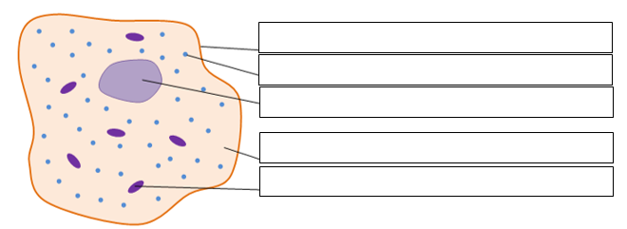
Cell Membrane

- Complete the table below to identify the functions of each animal organelle:
Organelle | Function
Cell Membrane
Cytoplasm
Nucleus
Mitochondria
Ribosomes

Practical: Cheek Cells
Instructions:
- Take a clean cotton swab and gently scrape the inside of your mouth
- Smear the cotton swab on the centre of the microscope slide for 2 to 3 seconds.
- Add a drop of methylene blue solution and place a coverslip on top. ...
- Remove any excess solution by allowing a paper towel to touch one side of the coverslip.
- Put the slide onto the stage and use low power to find the cells and then focus on them
- Increase the magnification

- Draw a diagram below of the cells you observed under the microscope. Draw one diagram for each magnification you used:
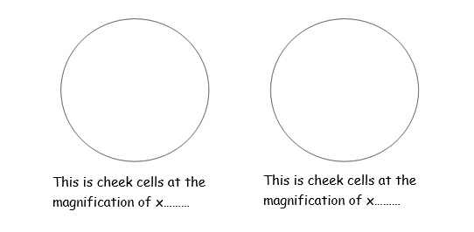
We can calculate the actual size of the cells if we know the size of the image in the microscope and the total magnification. Remember the magnification equation from lesson 1:
Magnification = Image size / Actual size

- List the organelles that are in both plant and animal cells.
- What are 2 structural differences between a plant and an animal cell?
- When preparing the onion and cheek slides, what is the purpose of using iodine?
- What is the function of the mitochondria?
- List the hierarchy of organisation in living organisms starting with organelle and working up to organism.
- Explain why animal cells have an irregular structure.
- Calculate the actual size of the onion cell by taking the measurement of the image size from the cells in your diagrams.
- Complete the questions below to solve for the size of the cells.
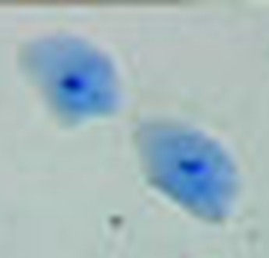
Some students measured the size of a cheek cell on a scaled diagram. It was 39 mm long.
Calculate the actual size of the cell. Give the unit.

X 2600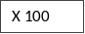
39 mm
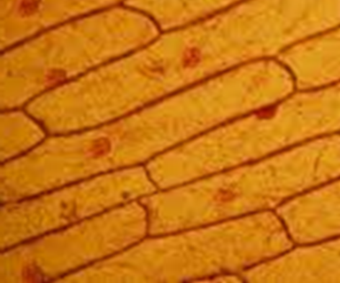
Some students measured the length of an onion cell on a scaled diagram. It was 30mm long.
Calculate the actual size of the cell. Give the unit.

X 100

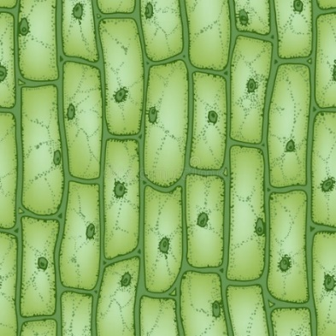
A plant cell in a photograph measures 15 mm across. If the actual size of the cell is 0.015 mm, what is the magnification in the photograph?

Lesson 6: Plant Cells
Like all living things, plants are made up of cells. Plant cells have a very regular shape because they, unlike animal cells have a cell wall which provides structure and support. Plant cells are made up of smaller parts called organelles.
- Label the plant cell below:
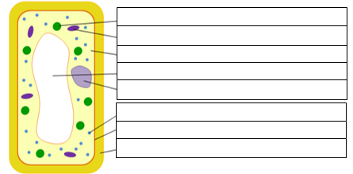
Chloroplast
- Complete the table below to list the function of each of the organelles contained in Plant Cells:
Organelle | Function
Cell Membrane
Cytoplasm
Nucleus
Mitochondria
Ribosomes
Vacuole
Cell Wall
Chloroplast

Onion Cell Practical
Instructions:
- Take a piece of onion and gently peel off a single layer (very thin).
- Lie the onion onto a clean slide.
- Cover the onion with a small drop Iodine to dye it.
- Gently place a cover slip over the onion and iodine being very careful not to get any air bubbles in.
- View your slide under the microscope starting on the lowest magnification.

- Complete the diagram below by drawing what you see in the microscope at x40 magnification and x100 magnification. Use a pencil and use the stippling technique to accurately draw your onion cells. Label the organelles that you can identify.
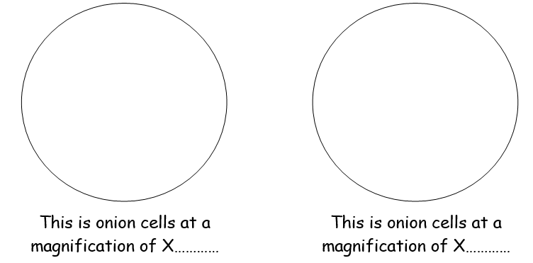

Comprehension Questions
- Which organelle in the plant provides structure to the cell.
- Which organelles are only present in plant cells?
- What is the function of the nucleus?
- Calculate the actual size of the onion cell by taking the measurement of the image size from the cells in your diagrams.
- Explain why plant cells have a rigid regular structure.

Lesson 7: Plant Tissues and Organs
Animals and plants are made of cells. Tissues are made from cells of a similar type. Organs are made from tissues, and systems are made from several organs working together.
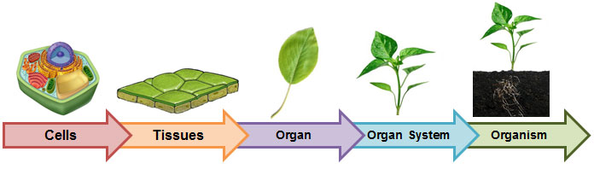

In a plant the organs are the roots, leaves, stem and flower. Each organ in a plant is adapted to carry out a specific function as listed below:
- Root – absorb minerals and water from the soil
- Leaf- absorbs light needed to carry out photosynthesis
- Stem- transports nutrients and water around the plant
- Flower – carries out reproduction of the plant
Photosynthesis is a vital process that occurs in the leaves of a plant. During photosynthesis, the leaves use light energy to convert carbon dioxide and water into oxygen and glucose. The glucose acts as a source of food for the plant. Leaves have several adaptations that play an important role in photosynthesis:
- A large surface area helps the leaf to absorb as much sunlight as possible
- Leaves are thin, minimising the distance for carbon dioxide to travel into leaf cells
- Chlorophyll is the green pigment that absorbs sunlight
- Veins transport water and glucose around the plant.
- Stomata are tiny openings or pores, which allow carbon dioxide to enter and oxygen to exit the leaf.
- Label the structure of a leaf below:
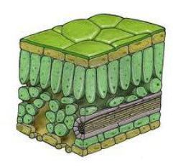

- Complete the table below for the functions of each leaf structure:
Structure | Function

59. On the line after each one, write the organ the sentence refers to. Choose from: flower, leaf, root, stem.
a) Has petals. ................... b) Where photosynthesis happens. ...................
c) Holds the leaves in place. ................... d) Makes the plant’s food. ...................
e) Takes in water. ................... f) Takes in minerals ...................
g) Contains the sex organs. ................... h) Carries water up the plant. ...................
i) Keeps the plant in the ground. .............. j) Produces fruits. ...................
60. What do you think these ‘pores’ are for?
61. Why are there lot of gaps in the mesophyll tissue on the underside of the leaf?
62. Describe 4 ways the leaf is adapted for its job. You can refer to the tissues, but you should also include other features. Try to use all the keywords from lesson.
63. State the organs in the plant that would use diffusion to move substances into or out of the cell.

Lesson 8: Comparison of Animal and Plant Cells
64. Label the diagrams to show the names of the parts in each cell.

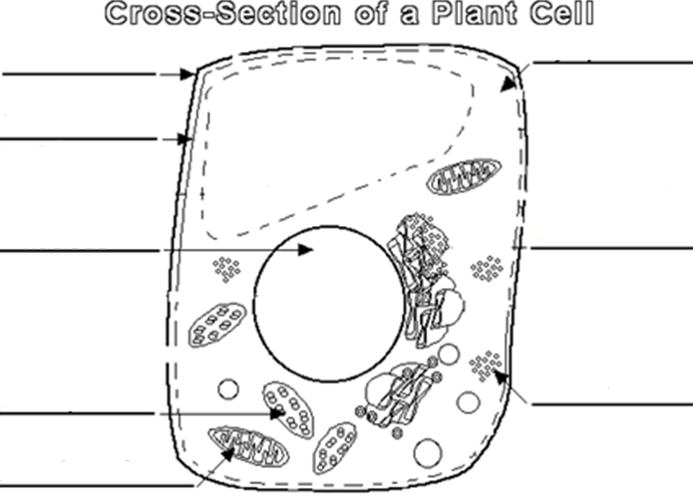

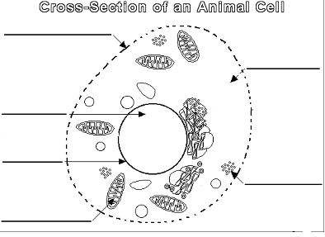

65. Complete the table to give the function of each organelle. The first one has been done for you.
Feature | Function
Cell membrane | Controls what enters and leaves the cells
Nucleus
Cytoplasm
Ribosomes
Mitochondria
Chloroplasts
Cell wall
Vacuole

66. Describe and explain the differences and similarities between plant and animal cells.
67. Where in a plant would you find cells that contain lots of chloroplasts? Explain your answer.
68. Name a type of cell that might contain lots of mitochondria. Explain your answer.

Lesson 9: Specialised Cells
Humans are multicellular. That means we are made of lots of cells, not just one cell. The cells in many multicellular animals and plants are specialised, so that they can share out the processes of life. They work together like a team to support the different processes in an organism.
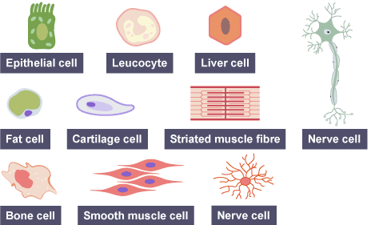
The diagrams show examples of some specialised animal cells. Notice that they look very different from one another.

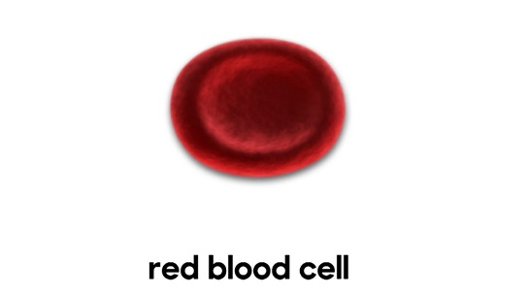
Most cells share features such as having a nucleus, a cell membrane, cytoplasm and mitochondria. There are differences between cells, too. Each type of cell has its own job to do. These cells have special features that allow them to perform their functions effectively. Here are some examples of specialised cells and the features they have to help them with their role:
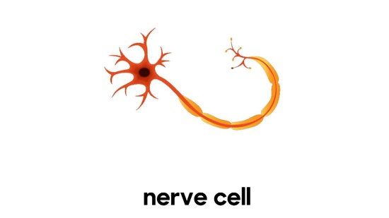
Red blood cells: carry oxygen around the body. They are well suited to this function because they contain haemoglobin, which carries oxygen molecules. They don't have a nucleus, allowing more space to carry oxygen. They are a flat disc shape (bi-concave) which gives them a large surface area, and the best chance of absorbing as much oxygen as they can.
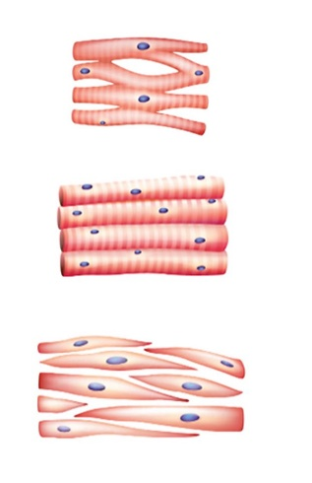
Nerve cells: transmit electrical signals. They are well suited to their function because they are thin and can be more than 1 metre long. This means they can carry messages up and down the body over large distances. Nerve cells have branched connections at each end. These join to other nerve cells, allowing them to pass messages around the body. They have a fatty (myelin) sheath that surrounds them. The fatty sheath increases the speed at which the message can travel.
Muscle cells bring parts of the body closer together. Muscle cells are adapted to have a large number of mitochondria. Remember! Mitochondria is where respiration occurs, and respiration transfers energy in the body. There are different types of muscle cell, each perfectly adapted to its function:
- Cardiac (heart) muscle cells are branched, and they join to make a net. Cardiac muscle cells contract rhythmically, even outside the body. They never get tired.
- Skeletal muscle is joined to bones. Its cells contract to make bones move and joints bend.
- Smooth muscle cells make up thin sheets of muscle, such as the stomach lining. They can also be arranged in bundles, or rings, like that in the anus.
- Label the muscle cell below using the list organelles you learned in the previous lesson:
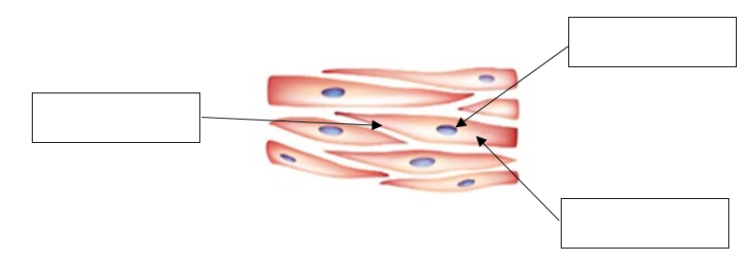
Comprehension Questions:
- What are the common organelles in each specialised cell?
- Why is it important that red blood cells do not have a nucleus?
- Which organelle is found in a large amount in a muscle cell? Why is this helpful?
- What is the purpose of nerve cells?
- Humans are multicellular, meaning they are made of more than one cell. List two types of unicellular organisms.
- What special name does a Red Blood Cell have for its structure?
- Where would cardiac muscle be found in the body?
- List two places that smooth muscle can be found in the body.
- What is the purpose of having specialised cells?

Specialised Cells in Plants
Each organ of a plant is made up of specialised cells and tissues. The roots are composed of root hair cells which absorb nutrients and water from the soil. The stem is made up of the xylem and phloem which help to transport water and nutrients throughout the plant. The leaf is composed of palisade cells, these have lots of chloroplasts to maximize light absorption for photosynthesis.
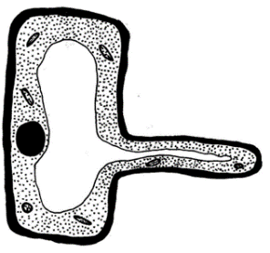
Root Hair Cell: absorbs minerals and water from the soil. Adapted to have a long hair like structure that increases the surface area of the cell membrane to allow for the uptake of minerals and water to take place more efficiently. Root hair cells have a thin cell wall so it easier for particles to diffuse. These cells also have no chloroplasts, if you recall chloroplasts function is to absorb sunlight for photosynthesis, as roots are located underground, they do not perform photosynthesis and therefore have no use for chloroplasts.
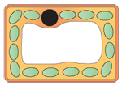
Palisade Cell: function to enable photosynthesis to be carried out. They are located at the top of the leaf to maximise the amount of light absorbed. They are also adapted to have a lot of chloroplasts which absorb light energy used in photosynthesis.
Comprehension Questions:
- List the structures that are missing from the root hair cell compared to a regular plant cell.
- What are the adaptations of a root hair cell?
- Why does a root hair cell not have chloroplasts?
- What adaptations does a palisade cell have?
- What is the function of the chloroplast?
- How do minerals from the soil move into the cell?
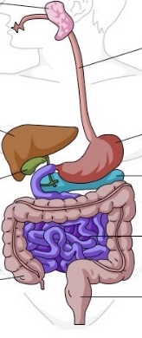
Lesson 10: Organ Systems
85. Label the diagrams. Use these terms: Organ system tissue cell organ
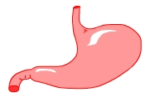
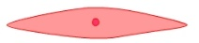
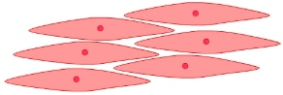

_________________ _________________ _________________ ________________

86. a) Label the organs shown.
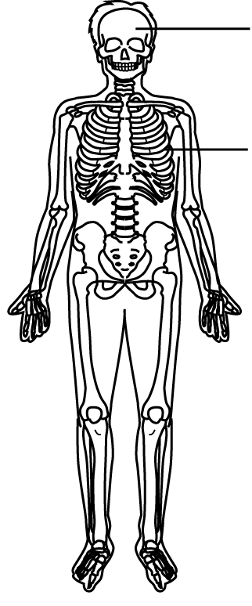
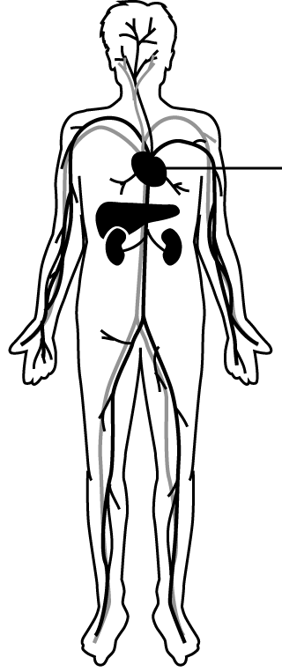
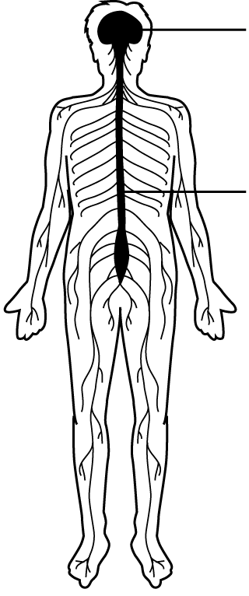

b) Name the organ systems
A. ………………………… system B. ……………………….. system C. ………………… system
c) Describe the function of each of the organ systems shown above.
87. Name one other organ system in the body and describe its function
88. The lungs are part of the respiratory system. Their job is gas exchange – oxygen into the body and carbon dioxide and water out of the body. Explain how the tissues in the lungs are adapted to make sure this happens efficiently. Complete in your workbook.

Lesson 11: Digestive System
The digestive system is the organ system that breaks food down into small molecules that are absorbed into the bloodstream. Digestion is helped by enzymes, which are biological catalysts. The food we eat has to be broken down into smaller substances that our bodies can use. This is called digestion. Without digestion, we could not absorb food into our bodies and use it.
Digestion happens in the digestive system, which begins at the mouth and ends at the anus.
- Label the diagram below using the following keywords: Liver, Stomach, Anus, Mouth, Oesophagus, Small Intestine, Large Intestine, Pancreas.
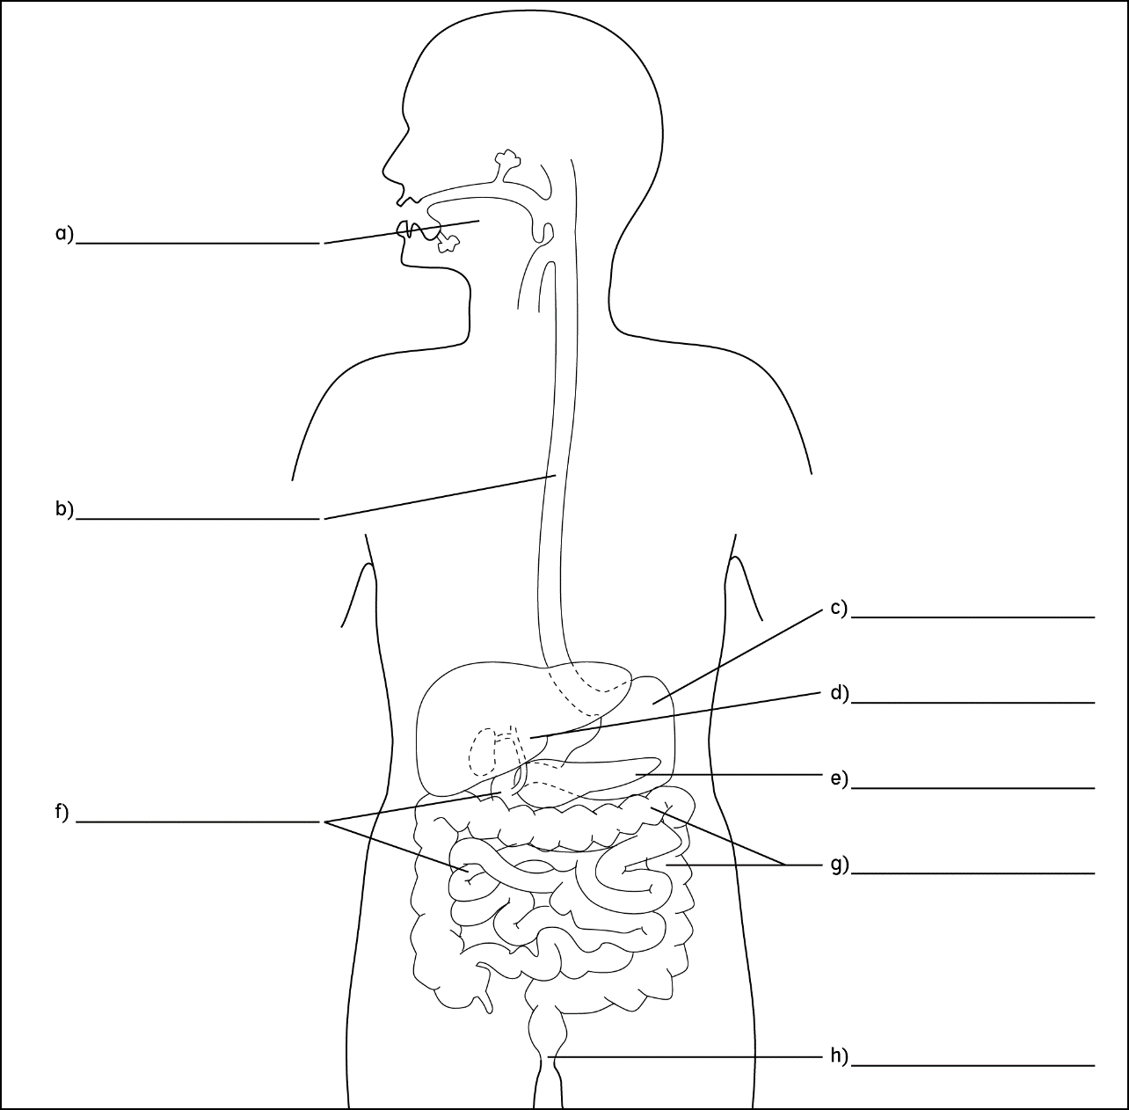
After we swallow, our food passes through these organs in turn: oesophagus or gullet, stomach, small intestine, large intestine. Different things happen to food as it passes through the digestive system:
- food is digested in the mouth, stomach and small intestine
- digested food is absorbed into the bloodstream in the small intestine
- excess water is absorbed back into the body in the large intestine
- any undigested food passes out of the anus as faeces when we go to the toilet
The liver and the pancreas play an important part in digestion. The liver produces bile, which helps the digestion of lipids (fats and oil). The pancreas produces biological catalysts called digestive enzymes which speed up the digestive reactions.

- Complete the table below with the functions for each organ of the digestive system:
Organ | Function
Mouth
Oesophagus
Stomach
Small Intestine
Large Intestine
Liver
Pancreas
Anus

Why does food need to be digested?
Out food is a mixture of big, insoluble molecules. Large molecules such as proteins, fats and carbohydrates need to be broken down into smaller molecules that can pass through the walls of the small intestine. From the small intestine these small molecules diffuse into the blood stream to be transported to different areas of the body. Large molecules wouldn’t be able to do this.
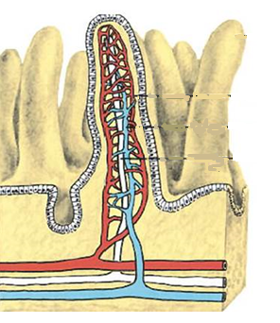
Small Intestine Adaptations:
If you can believe it, when outstretched the small intestine is up to 20 feet long! That means the small intestine has a very large surface area which increases the efficiency of molecules diffusing into the blood stream. It takes hours for the food you eat at breakfast to be fully digested by the small intestine. The membrane of the small intestine is also adapted to have many folds, these fold help to further increase the surface area of the membrane.

- What features of the small intestine make it good at getting digested food into the blood stream?
- Why is it necessary for large food molecules to be broken down in digestion?
- What happens in the large intestine?
- List the order of the digestive system from mouth to anus.
- What is the other name for an enzyme?
- What is the definition of digestion?
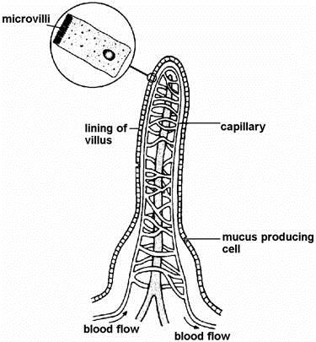
The diagram below shows a villus. There are several thousand villi in every square centimetre of the lining of the small intestine. The cells in the lining of each villus have folds called microvilli on their outer surfaces. One of these cells is shown magnified in the diagram.
- Explain two ways in which the structure of the villus enablesthe products of digestion to be absorbed efficiently.

- Mucus is produced by some cells in the lining of the small
intestine. One function of mucus is to protect the lining of the small intestine against the action of certain chemicals.

- Give the name of one type of chemical present in the small intestine which would otherwise damage the lining.

- Suggest one other function of mucus produced in the small intestine.

- Describe how digested food moves from the intestines into the blood

Lesson 12: Breathing System
The human breathing system, also know as the respiratory system, is adapted to allow air to pass in and out of the body, and for efficient gas exchange to happen. Exercise and smoking both affect the lungs and circulatory system.
- Label the diagram below using the following keywords: Abdomen, Thorax, Diaphragm, Bronchiole, Bronchi, Alveoli, Rib Muscle, Rib, Trachea.
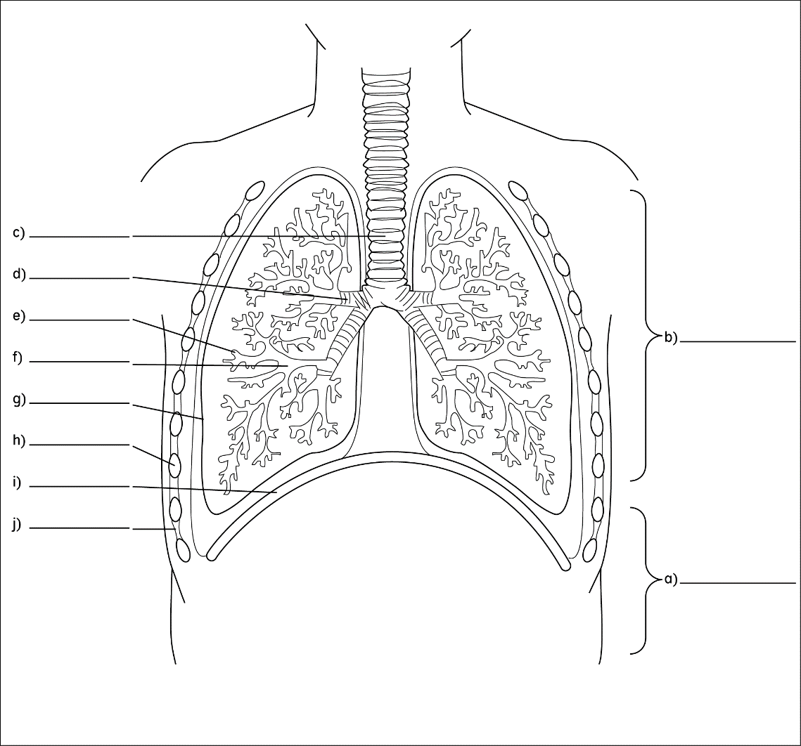

The trachea branches into two bronchi (one to each lung). Pleural membranes surround each lung. Cartilage rings in the walls of the trachea help to keep it open. The bronchi split into smaller and smaller tubes called bronchioles. These end in microscopic air sacs called alveoli, the alveoli is highly folded which provides a large surface area for molecules to diffuse. The alveoli are also surrounded by capillaries which provide a good blood supply so that gases can exchange into the blood.

- Complete the table below with the adaptations of the respiratory structures:
Structure | Features | Reason
Trachea | Rings of C shaped cartilage
Alveoli | Thin membrane
Alveoli | Good blood supply
Alveoli | Highly folded membrane

Gas Exchange in the alveoli:
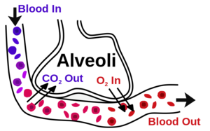
We need to get oxygen from the air into the blood, and we need to remove waste carbon dioxide from the blood into the air. Moving gases like this is called gas exchange. The alveoli are adapted to make gas exchange in lungs happen easily and efficiently. Here are some features of the alveoli that allow this:
- they give the lungs a really big surface area
- they have moist, thin walls (just one cell thick)
- they have a lot of tiny blood vessels called capillaries
The gases move by diffusion from where they have a high concentration to where they have a low concentration: oxygen diffuses from the air in the alveoli into the blood, carbon dioxide diffuses from the blood into the air in the alveoli.
Comprehension Questions:
- Describe how air gets from the room into your lungs.
- Describe what happens to the oxygen in the air and the carbon dioxide in your blood.
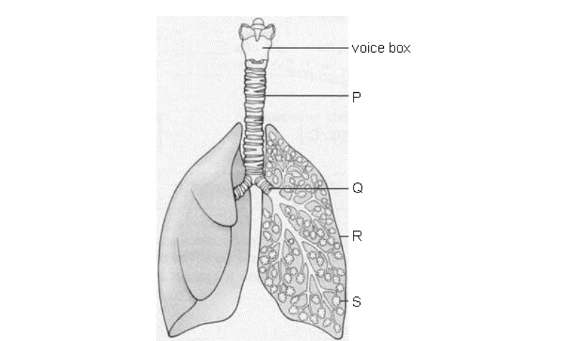
- What features does the alveoli have that enables it to exchange carbon dioxide and oxygen.
The diagram below shows part of the respiratory system.
- From the diagram, give the letters which label: the trachea; alveoli
- Which gas passes into the blood from the alveoli?
- Which gas passes out of the blood into the alveoli?
- The walls of the capillaries and the alveoli are very thin. Why do they need to be thin?
- There are millions of alveoli in the lungs. They provide a very large surface area.
Why is a large surface area necessary?

Jasmine was trying to find out how much air she breathed out in one breath. She poured water into a bell-jar and placed it upside down in a trough of water. The bell-jar had a scale marked in cm³.

before Jasmine breathed into the bell-jar
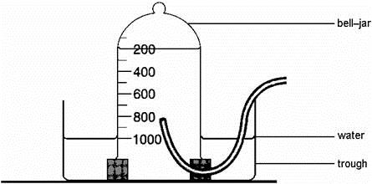
after Jasmine breathed into the bell-jar
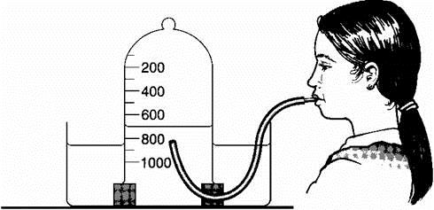
- How much air did Jasmine breathe out?
- Air contains carbon dioxide, nitrogen, noble gases, oxygen and water vapour. Give three differences between the composition of the air Jasmine breathed in and the air she breathed out.
In the diagram below, tube A connects the lungs to the mouth. Part B is a part of the lung where gas exchange takes place.
- On the diagram, write the names of tube A and part B.
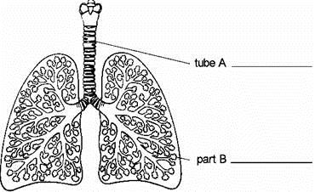
- In the wall of tube A there are 'rings' of a stiff material called cartilage. Suggest one function of the 'rings' of cartilage.

Lesson 13: Inhaled and Exhaled Air
- Compare the inhaled and exhaled air. Compare means to identify what is the same and what is different.
Gas | Inhaled Air (%) | Exhaled Air (%)
Oxygen | 21 | 17
Carbon Dioxide | 0.04 | 4
Nitrogen | 78 | 78

Do you notice that the percentage of nitrogen is the same in both the inhaled air and exhaled air. Did you notice that there is less oxygen and more carbon dioxide in the air we breath out than in the air we breath in. Why would this be?
The air we breathe in is different than the air we breathe out – but only in terms of oxygen and carbon dioxide. This is because we are producing carbon dioxide and need to get rid of it and because we absorb oxygen when we breathe in. The concentration of nitrogen doesn’t change.
Candle Practical
We can test the difference in oxygen concentration by burning a candle to see when there is oxygen present. We can compare ho long a candle will burn for with inhaled air versus exhaled air. We can collect the air from inside someone’s lung as ‘exhaled air’.
- Complete the sentences below to identify the variables involved in this practical:
The independent variable is what we will change, in this practical we will change the
…………………………………………………………………………………………………………………………………………………………………
The dependent variable is what we will measure, we will measure
…………………………………………………………………………………………………………………………………………………………………
The control variable is what we will keep the same, we will keep the
…………………………………………………………………………………………………………………………………………………………………
  - Use the table below to record your results:
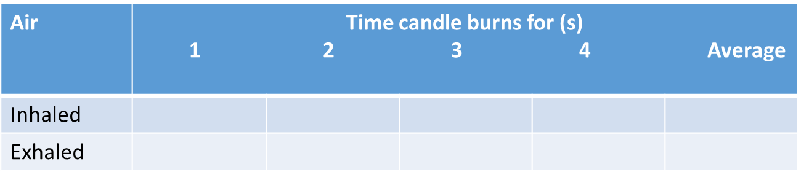
Are there any results that look odd? Sometime results can produce anomalies. An anomaly is a piece of date that doesn’t fit in with the pattern of the rest of the data.
Circle those – we will not include them in the average. They are anomalies
To calculate the average, add up the repeat readings for inhaled air, press = and then divide by the number of numbers you’ve entered

Lesson 14: Revision
- Label the Bacteria Cell below:

- Label the yeast cell below:

- Label the plant cell below:

- Label the animal cell below:

- Label the structure of a leaf:
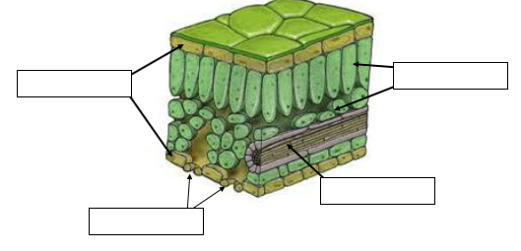

Revision Comprehension Questions:
- What are the functions of the cell membrane?
- What is the role of the mitochondria?
- What is the function of ribosomes in a cell?
- _____________________: Controls the activities of the cell and stores genetic material.
- What do plant cells have that animal cells do not have?
- Groups of cells are known as ________________________.
- Tissues are organised into __________________________.
- What is the job of the digestive system?
- ____________________ are found in the nucleus and code for different characteristics.
- Which magnification should you start with on a microscope?
- What organelle do bacteria cells not have?
- Where is chlorophyll found in a plant cell?
- Name two types of cells that have a cell wall.
- Name the process by which particles move into and out of cells.
- How do folded surfaces inside the body help to speed up diffusion?
- Describe the difference between inhaled and exhaled air.
- Describe the pathway of oxygen through the respiratory/breathing system.
- List the adaptations of the alveoli that allow for efficient gas exchange.
- Describe the pathway of food through the digestive system.
- What is the name for the substance that turns large insoluble molecules into smaller soluble molecules?
- Name three specialised cells.
- How is a red blood cell adapted to carry oxygen?
- List the adaptations of the root hair cell that help it to absorb water and nutrients.
- Complete the table below with the missing functions and state whether it is in a plant or animal:
Organelle | Function | Plant or Animal?
Ribosomes
Cell Membrane
Cell Wall
Nucleus
Mitochondria
Vacuole
Cytoplasm

Misconception/inaccurate language | Correct statement
The nucleus is the brain of the cell

We make cells easier to see by zooming in

We breathe to live

Muscles contract and expand

The cell wall in plants controls what enters and leaves the cell

Plants breathe in carbon dioxide

Plants take in water in the leaves when it rains

The air we breathe out has no oxygen in it

