Chemical reactions Mastery booklet
Lesson 1- Chemical Reactions V Physical changes
In the last chemistry topic “Particles” we studied physical changes – e.g melting, freezing, boiling etc. Physical changes are easily reversed.
These physical changes can useful to separate substances – e.g distillation, evaporation etc.
A chemical reaction is different from a physical change. In a chemical reaction new substances are made and the reaction cannot be easily reversed.
A good analogy for a chemical reaction is baking a cake. We take the ingredients (eggs, flour, sugar) combine them and add heat. Once the cake is baked it is hard to turn it back into the ingredients. In chemistry instead of the word ingredients we call them reactants. The cake would be the product of the chemical reaction. We show a reaction has happened by using an arrow instead of an = sign.
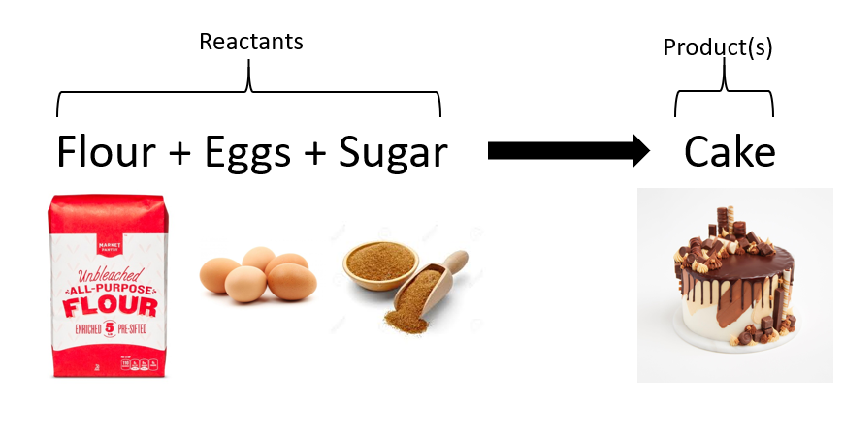
Evidence for a chemical reaction
Chemical reactions result in new substances being made.
Evidence for a chemical reaction can be:
- A temperature change (energy taken in or released)
- A colour change
- Gas given off
- List 4 physical changes
- List two ways to separate substances using physical processes
- How is a chemical reaction different from a physical change?
- Judy says “Melting is a chemical reaction because once a chocolate bar is melted it wont go back to the same shape?” Is she correct? Give a reason for your answer.
- Name three things you could observe that tell you a chemical reaction is happening.

Demo: Lead iodide and potassium nitrate
Lead nitrate and potassium iodide are both clear and colourless solutions. When mixed, there is clearly a chemical reaction. New substances are made.
We can represent this with a word equation:
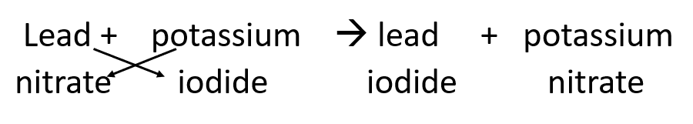

Mass of beakers and reactants before mixing (g)
Mass of beakers and products after mixing (g)

- Explain how you know a reaction took place
- Explain how this experiment proved that mass stays the same in reactions
- Why does mass stay the same? Use the idea of particles to explain.
- What is an atom?
- What do we call the change from a liquid to a gas?
- What do we call the change from a gas to a liquid?
- Are the two changes above physical or chemical changes? Give a reason for your answer
- What separation technique would be used to remove sand from water?
- What separation technique would be used to remove salt from water?
- Suzi looks at the candles on her birthday cake. How can she tell it is a chemical reaction?

Practical: Observing chemical reactions
In any reactions that are completed in a test tube, place a thermometer in the liquids for at least a minute before the reaction to get a starting temperature.
Experiment Description | Temperature at start (°C) | Temperature at end (°C) | Observations
Add 5cm³ citric acid and a spatula of sodium bicarbonate
Add 5cm³ dilute sulphuric acid + 2cm strip of magnesium ribbon into the test tube.
Add 3cm³ copper sulphate solution + 1 spatula measure of iron filings into the test tube.

Conservation of Mass
In our demo we saw the mass of the reactants was equal to the mass of the products. This is called the conservation of mass
In a chemical reaction, no mass is ever lost or gained. The mass of the chemicals put into the reaction is equal to the mass of the chemicals produced. Sometimes, a gas is given off or a gas from the air is joined with the reactants, so it can seem as though the mass has changed.
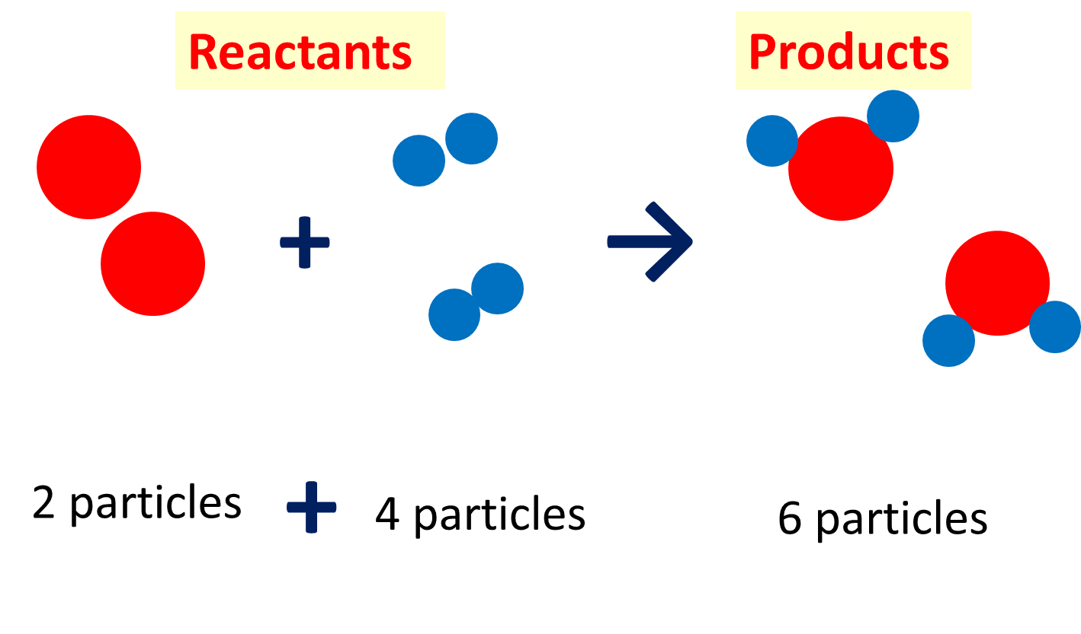
In the reaction above the number and size of the particles has not changed. Just the bonding between them.
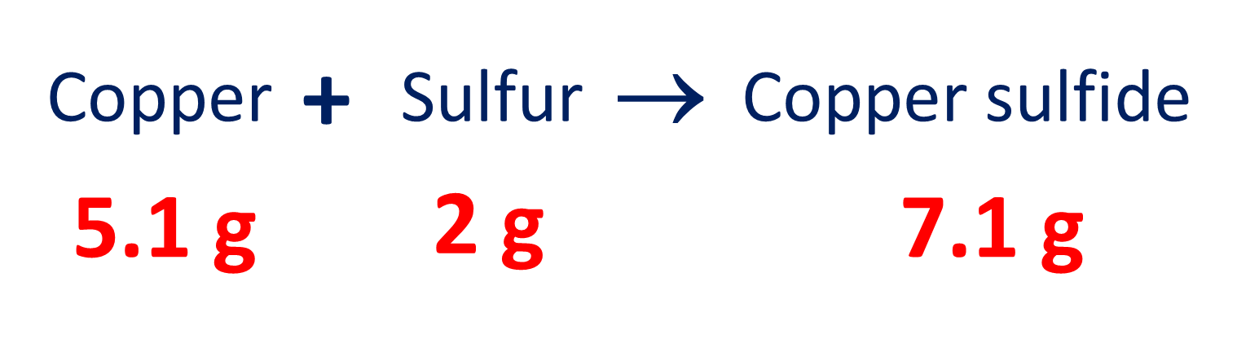
In this example we can see that the total mass of the reactants is equal to the mass of the product

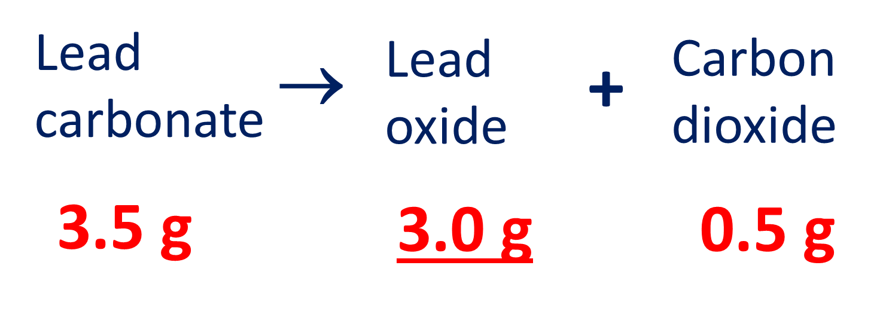
In this example lead carbonate is breaking up into lead oxide and carbon dioxide. When one reactant breaks up into more than one product, we call it a decomposition. Still the conservation of mass is obeyed

- Name 3 things you may observe in a chemical reaction
- Atul reacts 3g of sodium with 2g of oxygen. How much sodium oxide was made?
- Make a table like the one below and put the examples below in the correct column:
Fireworks, baking a cake, melting ice, cooking some chicken, freezing some yogurt, bike wheel rusting, boiling some water, combustion of petrol in a car

Chemical reaction | Physical change

- Define the law for the conservation of mass
- Longer answer question- describe the differences between a chemical reaction and physical change
Key words: reversible , irreversible, observation, reactant, product

Lesson 2 Oxidation reactions
During a chemical reaction substances can react together. These substances are called reactants.
When they react, they form new materials and these are called products.
This can be simplified in a word equation:
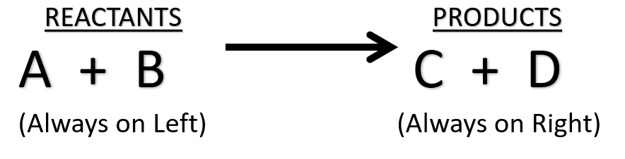

Oxidation reactions are a special type of chemical reaction where a substance reacts with the oxygen in the air. There are many different chemicals which will react with oxygen. The product of an oxidation reaction is called an oxide. A good example is Iron. Iron reacts very slowly to form iron oxide. It turns from a grey shiny metal into an orange brittle substance we call rust. The word equation for the formation of iron oxide would be:
iron + oxygen iron oxide
Remember when writing an equation:
All reactants and products on one line
An arrow is used, NOT an = sign
Practical: To find out id copper reacts with oxygen
Method:
- Collect a heat proof mat, Bunsen, tongs, goggles and the pieces of metal from the side.
- Write down your description of the starting material.
- When the practical starts, you will hold the metal in the roaring flame of the Bunsen using the tongs for 2 minutes.
- Put the product onto heat proof mat, allow to cool and then see if you have any evidence for a chemical reaction.

Diagram of copper before- add labels | Diagram of copper after heating- add labels

- What happened to the copper, why?
- Write an equation for this- label the reactants and products
- Add a particle diagram to show how the particles rearrange
- For the questions below complete the missing names of the substances and add in the missing masses. (hint: remember the conservation of mass)
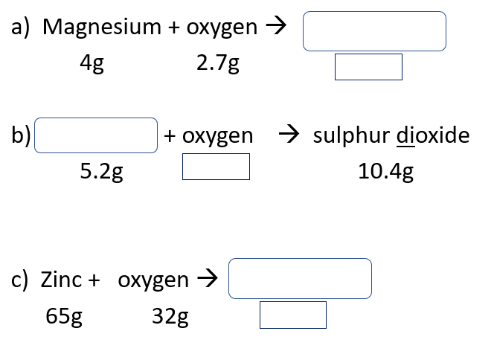
Combustion
Fire is one of the most important discoveries in human history. Combustion is the scientific name for burning. In KS2 you will have looked at burning as an example of a chemical reaction. A substance that we burn for heat is called a fuel. Fuels generally contain carbon. This is one of the reactants. They also contain hydrogen. Oxygen is also needed, so is another reactant.
- What is the scientific name for burning?
- What is a fuel?
- Why are fuels useful?
- Name the two reactants needed in a combustion reaction
- Give 3 examples of fuels from your own knowledge

Demo: Investigating the products of combustion
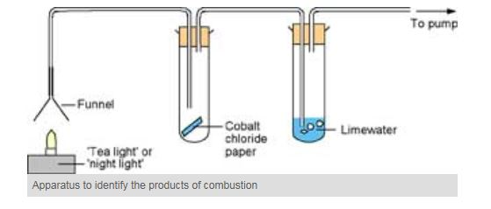
5.
4.
3.

2.
The products of combustion are usually carbon dioxide and water. This is because most fuels contain carbon and hydrogen. Carbon dioxide is a green house gas and is a cause of climate change.
- What is a reactant?
- What is a product?
- What is wrong with this word equation: Iron + oxygen = Iron oxide
- What is an oxidation reaction? give an example.
- You burn magnesium in oxygen, write the word equation for this
- Make a list of 4 fuels and describe where we use them
- What is combustion?
- Write an equation for the reaction of charcoal when it’s is burnt on a BBQ to release heat energy
- What is the test for carbon dioxide?
- How did we know water was a product of combustion in our demonstration?
- What environmental issues can burning fuels cause for our environment?
- Complete the sentences below
Fuels are useful because…..
Fuels are useful but….
Fuels are useful so….

Explaining the products of combustion using particles
When the carbon in the fuel reacts with the oxygen 2 oxygen particles bond to the carbon. This is why we call it carbon dioxide. The ‘di’ means two.
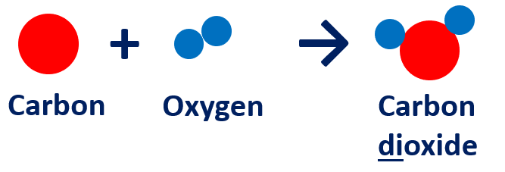
When the hydrogen in the fuel reacts with oxygen 2 hydrogen particles bond to one oxygen particle. We don’t call it ‘dihydrogen oxide’ we just call it water.
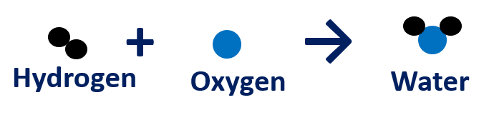
- Using the particle diagrams above explain why combustion is an example of an oxidation reaction.
- Is oxygen an element? Give a reason for your answer
- Draw the particle diagram for a container of hydrogen. Include 6 hydrogen molecules.
- George used the apparatus below to find out what substances are produced
when methanol burns.
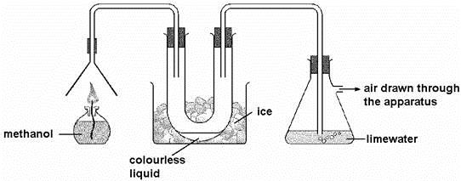
(a) As the methanol burned, two different gases were produced.
(i) One of these gases condensed in the U-tube to give a colourless liquid. Give the name of this liquid.
(ii) The other gas turned the lime water cloudy. Give the name of this gas.

(b) Methanol is sometimes used in antifreeze. It can be added to water in car
windscreen wash-bottles to prevent the water from freezing in cold conditions.
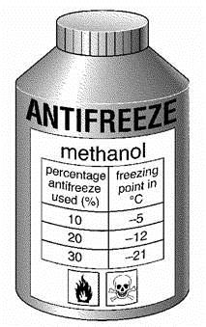
(i) The label on the bottle of antifreeze has two hazard warning symbols. What two precautions would you need to take when using this antifreeze?
(ii) Water freezes at 0°C. The label on the bottle shows how the freezing point changes when different amounts of antifreeze are added to water.
Terry put a mixture containing 10% antifreeze into the wash-bottle of his car. During the night the temperature dropped to –14°C. The wash-bottle burst. Explain why the wash-bottle burst.

- Simon made two candles from the same amount of wax. He drew lines on both candles.
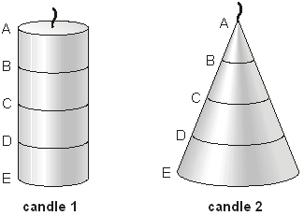
(a) What would Simon use to measure the distance between the lines?
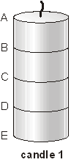
(b) He timed how long candle 1 took to burn.
His results are shown below.
(i) How long would it take for candle 1 to burn from C to D?
Write your answer in the table.
part that burned | time for candle 1  to burn (minutes)
A to B | 30
B to C | 30
C to D
D to E | 30
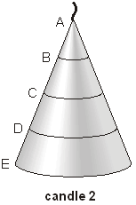
(ii) Simon timed how long candle 2 took to burn.
How long would it take for candle 2 to burn from A to B and from D to E?
Write your answers in the table.

part that burned | time for candle 2  to burn (minutes)
A to B
B to C | 20
C to D | 40
D to E
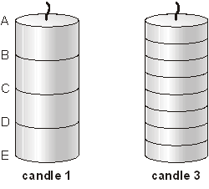
(c) Simon wanted to use a candle to measure time.
He made candle 3 the same size as candle 1.

Why is candle 3 more useful than candle 1 for measuring time?

- A student set up the experiment below and used a stopwatch to measure the time taken for the candle to go out. He then repeated the experiment using beakers of different sizes.
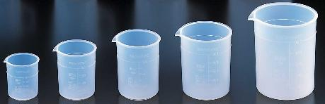
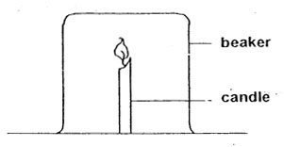
Here are his results:
Size of beaker (cm³) | Time the candle burned for (seconds) |  |  | Mean burning time (seconds)
100 | 10.2 | 29.9 | 9.4 | 9.8
200 | 20.2 | 19.8 | 21.1
300 | 31.2 | 29.3 | 30.1
400 | 42.4 | 67.6 | 40.2
500 | 52.3 | 50.9 | 51.2

For the data above;
- Highlight any anomalous results
- Calculate mean time for each beaker. The first one is done for you.
- Describe the relationship shown in the data
d) Explain the relationship, in terms of combustion.
e) describe two pieces of evidence that a candle burning is a chemical reaction

Lesson 3 How are acids and alkalis different?
Acids and alkalis are two important groups of chemicals. Acids were originally named due to their sour taste. In fact the Greek word ‘acidus’ is latin for “sour-tasting”. Everyday examples of acids are vinegar, lemon juice and oranges. Alkali’s often taste soapy or chalky. Examples of everyday alkalis are milk of magnesia, toothpaste, indigestion powder and oven cleaner. Acids and alkalis react together and cancel each other out and form water. This is called neutralisation.
Indicators are chemicals which are used to check if a substance is acidic or alkaline. Originally people just tasted them, but this is very dangerous. Indicators can be in solution or on paper strips.
Acids and Alkalis may be chemical opposites, but they are equally dangerous!
In science labs and other industrial places there are laws on how chemicals must be labelled and handled. This is to prevent minor and major injuries. Hazard symbols are globally used symbols that tell people the dangers linked to the chemical inside the container.
Below is a summary of the symbols their names and the precautions that need to be taken when using them.

International Hazard Symbol | Meaning | Safety precautions when handling substances that have this symbol
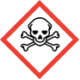 | Toxic | Wear goggles  Wear a mask over the nose and mouth
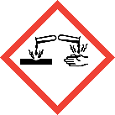 | Corrosive | Wear goggles to stop splashes in the eyes  If any gets on skin or in eyes, wash with lots of water
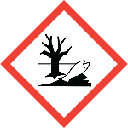 | Dangerous for the environment | Do not dispose of down the sink
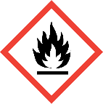 | flammable | Keep away from flames
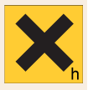 | harmful | Wear goggles to stop splashes in the eyes  If any gets on skin or in eyes, wash with lots of water
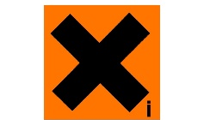 | Irritant | Wear goggles to prevent the chemical getting into the eyes.  If any gets onto the skin, wash with plenty of water
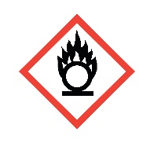 | oxidising | Keep away from flames and flammable substances
- What is the most common safety precaution?
- What does oxidising mean?
- Which three symbols have the same safety precautions?
- Copper sulfate is not allowed to be poured down the sink. What symbol must be on the bottle?
- Lead nitrate will kill you if you drink it. What is the hazard and the precaution?
- Name 2 flammable substances
- Look at the symbol for corrosive. What might a corrosive substance do if it got on your skin?

Investigating indicators
You are going to use 4 different indicators in the practical work:
vimto, red cabbage juice, litmus and universal indicator.
Test each indicator with the hydrochloric acid, water (neutral) and sodium hydroxide (alkali)
Record the colour change. E.g ‘changes from red to green’ not just ‘goes green’ in the table

 | Chemicals to test
Indicators | Hydrochloric acid | Vinegar | Water | Sodium Hydroxide
Red cabbage
Litmus
Vimto
Universal indicator
- Did all the indicators work?
- Complete the definition below
- Indicators are chemicals which….
- What colour are acids in universal indicator?
- What colour are alkalis in universal indicator?
- Sinead put some litmus indicator into some lemon juice. What colour change would she observe?
- Why do we need to use indicators on acids and alkalis?
- Boris put some toothpaste into a drop of universal indicator. What colour change would be observed?
- Describe the difference in observations of vinegar with litmus and universal indicator
- Describe the difference in observations of hydrochloric acid with litmus and universal indicator

Our observations from universal indicator show us that different acids and alkalis can have different strengths. A strong acid is more acidic than a weak acid. Similarly, a strong alkali is more alkaline than a weak alkali. To allow us to compare the relative strengths of acids and alkalis we use the pH scale. The pH scale gives each substance a number to explain how acidic or alkaline it is.
- Substances with a pH of 0-6 are acids
- Substances with a pH of 7 are neutral
- Substances with a pH of 8-14 are alkaline.

The pH scale also allows us to measure the relative strength of an acid and alkali. A strong acid is more acidic than a weak acid. The strongest acids have a pH of 0 or 1, whereas the strongest alkalis have a pH of 14. Weak acids usually have a pH from 3 to 6 and a weak alkali has a pH of 8-12.
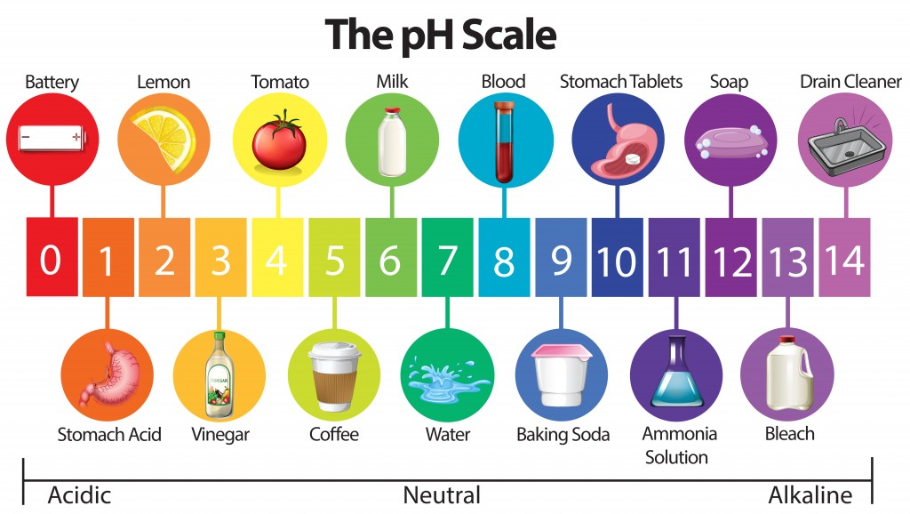
- Complete the table below
Substance | pH | Strong or weak? | Acid or Alkali?
Stomach acid
Coffee
Water
Baking soda
Soap
Bleach

Investigating pH in the home
You are going to test the pH of around 10 household substances, and classify them as strong or weak.
Substance | Colour with universal indicator | pH | Strong or weak? | Acid or Alkali?

- Water from red cabbage can be used to find out if a liquid is acidic, alkaline or neutral.

Type of liquid added to  the cabbage water | colour of  the cabbage water
acidic | red
alkaline | blue
neutral | purple
John added three different liquids to the cabbage water.
(a) Use the information above to complete the table below.
Liquid added to the  cabbage water | colour of  the cabbage water | Is the liquid  acidic, alkaline or  neutral?
water | purple
lemon juice |  | acidic
washing up liquid | blue

(b) What word describes chemicals which change colour in acids or alkalis?
- pH paper is used to show whether a solution is acidic, neutral or alkaline.
One type of pH paper shows the following range of colours.

colour of pH paper | red | orange | yellow | green | blue | purple
pH value | 0 - 4 | 5 | 6 | 7 | 8 - 10 | 11 - 14
Some solutions were tested with pH Paper. The results are shown below.
(a) Complete the following table by placing a tick in the correct column for each substance.

substance | colour of pH paper | acidic | neutral | alkaline
orange juice | red
egg white | blue
oven cleaner | purple
milk | yellow

(b) Which substance was the most alkaline?
(c) Equal amounts of egg white and milk are mixed. What is the most likely pH of the mixture?
- Matthew measured the pH of different soils.
(a) Tick one box in each row to show if each soil is acidic, neutral or alkaline.

soil | pH of soil | acidic | neutral | alkaline
A | 4.5
B | 5.5
C | 6.3
D | 7.0
E | 7.8

(b) A hydrangea is a flowering plant. Matthew notices that the colour of hydrangea flowers is different for plants grown in different places. He records the colour of the flowers on each plant. His results are shown in the table below.

soil | pH  of soil | colour of flowers
soil | pH  of soil | blue | violet | light pink | dark pink
A | 4.5
B | 5.5
C | 6.3
D | 7.0
E | 7.8
Look at Matthew’s results.
Do his results support the statement that the colour of hydrangea flowers depends on pH? Explain your answer.

(c) Matthew measured the pH of the soil near hydrangea plants found in different places.
Suggest one other variable Matthew could not control in his investigation.

- A pupil used a sensor to record the change in pH of 10 cm³ of an acid solution when an alkali solution was added a little at a time. The concentrations of the alkali and acid solutions were fixed.

Her results are shown in the table below.

volume of alkali added (cm³) | pH of resulting mixture
0.0 | 5.0
2.0 | 5.0
4.0 | 5.0
6.0 | 5.5
8.0 | 6.0
10.0 | 7.0
12.0 | 8.0
14.0 | 8.5
16.0 | 9.0
18.0 | 9.0
20.0 | 9.0
(a) Use his results to draw a graph on graph paper and stick in your exercise book.
• Label the axes.
• Plot the points.
• Draw a smooth curve.

(b) Look at the graph.
What would be the likely pH of the solution if the pupil added a further 2 cm³ of alkali solution?

Lesson 5 What happens when metals react with acids?
Acids are very useful chemicals, that is why we learn about them in year 7. One of the most important features of acids is they react in very predictable ways. The first reaction we are going to investigate is the reaction between acids and metals. When an acid and a metal react bubbles of a gas are released. If we place a lit splint above the test tube we hear a squeak pop noise. This tells us the gas produced is hydrogen. The other product of the reaction is called a salt. In everyday life we use the word salt to describe table salt (sodium chloride) which is one example of a salt. In chemistry a salt is the product made when an acid is neutralised. Most salts are soluble in water so we do not observe them form during the reaction. The reaction can be summarised in a word equation like the one below.
Metal + Acid Salt + Hydrogen

- Name the reactants in the word equation above
- Name the products in the word equation above
- Why are acids so important to study?
- What will you observe if a metal does react with acid?
- What is the chemical test for hydrogen gas?
- Define soluble
- Acids are irritants and often corrosive. What safety precautions should we take when using them?
- What is the pH range of an acid?
- If an acid completely reacts with metal so that it is neutralised what colour will universal indicator go and what pH would it be?
- Stuart has a piece of magnesium and a piece of silicon, but he can’t remember which is which. They are both shiny and grey. He knows magnesium is a metal and silicon is not. What simple test could he do to determine which piece is magnesium?

Investigting acids and metals
- You are going to see how metals react with acid. ​
- You need to place around 3cm depth of acid into a test tube and add 1-2 pieces of one metal. ​
- Note evidence for a reaction. ​
- If there is no reaction, you should use test tube holders and warm the acid GENTLY for 10-15 seconds. DO NOT get the acid boiling. ​
- Look at where the end of the test tube is pointing – do not point it towards anyone or yourself. ​
- Test for hydrogen gas using a lit splint if there is a gas given off. ​

Metal​ | Acid​ | Evidence for a reaction​ | Test for Hydrogen ​
​  ​ | ​ | ​ | ​
​  ​ | ​ | ​ | ​
​  ​ | ​ | ​ | ​
​  ​ | ​ | ​ | ​
​  ​ | ​ | ​ | ​

- Did all the metals react? ​
- If they reacted, did they all give off hydrogen?​
- How did you test for hydrogen and what was the result if it was present?​
The salt formed depends upon the acid and the metal used. Salts are a chemical ‘family’ and, just like members of our families, they have two names – a first name and a second name. Like our surname, the last name of a salt tells us which ‘family’ it belongs to. The surname comes from the acid used. If we use:
- Hydrochloric acid we get a chloride salt
- Sulphuric acid we get a sulphate salt
- Nitric acid we get a nitrate salt
The first name comes from the metal that reacts with the acid.
E.g. Zinc + hydrochloric acid zinc chloride + hydrogen
- For each word equation below use the rules above to complete the missing reactants or products
- magnesium + hydrochloric acid ____________________________ + hydrogen
- iron + hydrochloric acid _______________________ + __________________
- zinc + sulphuric acid _________________________+___________________
- magnesium + sulphuric acid ____________________+ __________________
- calcium + ___________________ calcium chloride + ___________________
- _____________________ + __________________ zinc sulphate + hydrogen
- _____________________+___________________ sodium chloride + hydrogen
- Ruby is investigating metals and acids. She places some led into sulphuric acid. After a few moments she does not notice any bubbles. Describe the steps she should take next to check if lead reacts with sulphuric acid.
- Shania says “when you put sodium chloride into hydraulic acid you get bubbles of hydrogen and sodium metal produced” Is she correct? If not write the correct version of the sentence
Lesson 6 What happens when acids and alkalis react?
Acids and Alkalis are chemical opposites. When they react together they cancel each others chemical properties. They form water and a salt, both of which are neutral. We call this reaction neutralisation and the word equation is summarised below
Acid + Alkali Salt + Water

DISCUSS PRACTICAL WITH COLETTE
- Name the two reactants in the word equation above
- Name the two products in the word equation above
- Will this reaction produce bubbles? Give a reason
- What is the pH of the salt solution?
- What colour will universal indicator go when the solution is neutralised?
- How could we separate the salt from the water?
- What is common about the names of all the alkalis?
- If we add an alkali to an acid what happens to the pH?
- Rupert says “When I added sodium hydroxide to hydrochloric acid the pH dropped” Is he correct? Explain your answer.
- Use the rules from the previous lesson on naming the salts to complete the following word equations
- Hydrochloric acid + Sodium Hydroxide _______________________+ water
- Sulfuric acid + Sodium Hydroxide ___________________________ + water
- Nitric acid + Sodium Hydroxide _____________________________+________
- Hydrochloric acid + Potassium hydroxide ______________________ + _______
- _______________ + Potassium hydroxide Potassium Nitrate + ____________
- Sulfuric acid + ______________________ Calcium Sulfate + ______________
- ________________+ ___________________ Magnesium Chloride + Water
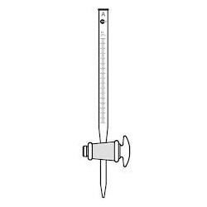
- ________________+___________________ zinc nitrate + water
Lesson 7 Investigating neutralisation using titrations
We now know enough about the reactions of acids and alkalis to investigate the volumes required of each reactant to ensure neutralisation. We are going to complete a titration. This is a practical technique that sues specialist equipment. They are design to very precisely measure the volumes of liquids delivered into a flask.
Hypothesis: We always get a neutral solution if we react equal volumes of acid and alkali​
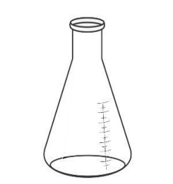
You are going to test this hypothesis.We need a different piece of equipment to be able to add acid a little at a time and measure it accurately. ​This is called a burette. ​We are also going to use a conical flask​

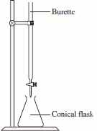
- Acid goes in the burette
- Alkali in the conical flask.
- You are going to take repeated readings to measure the volume of acid needed to neutralise the alkali.
- What will you control?

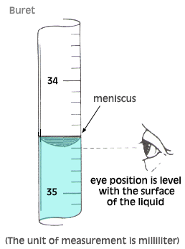
When reading the scale on a burrette it is important to remember three things:
- Count from the TOP and go down
- Make sure you look at the bottom of the meniscus at eye level
- Each line has a value of 0.1 cm³
In the example to the right the volume is 34.6 cm³

Method
- Use the measuring cylinder to measure out 10cm³ of the alkali sodium hydroxide.
- Pour this into the conical flask.
- Add 3 drops of phenolphthalein.
- Fill the burette with hydrochloric acid, making sure the tap is closed, the burette is as low as you can get it and you have goggles on at ALL times.
- Stand the conical flask on a white tile and position the burette above it.
- Open the tap and allow the acid to flow into the conical flask, swirling constantly until the solution is neutral.
- Read the volume of acid needed to neutralise.
- Repeat, keeping the volume of alkali and the number of drops of indicator the same.
- List two control variables from the titration experiment
- What would happen to the volume of acid needed to neutralise if you accidently put only half the volume of alkali into the conical flask?
- List two safety precautions you followed during the titration
- Look at the example results below
titration number | 1 | 2 | 3 | 4 | 5 | Mean
Volume of acid added (cm³) | 25.1 | 25.6 | 29.2 | 25.2 | 25.5

- Are the results repeatable?
- Which result is the anomalous result?
- Calculate the mean of the non-anomolous results. Give your answer to 1 decimal place
- Do your results support the hypothesis? Give a reason.
- Look at the bottles of reactants. What property of the reactants might explain your findings?

- Complete the table below:
Substance | Colour of UVI | pH | Acid/alkali/neutral
Shampoo | Yellow | 6
Vinegar | Orange |  | Weak acid
Toothpaste | Blue
Lemonade | red |  | Strong acid
Washing powder | Blue
Water | Green
Oven cleaner |  | 13
Milk |  | 5

- Describe what is meant by the term ‘neutralisation’.
- State the general word equation for the reaction between an acid and an alkali
Complete the word equations:
hydrochloric acid | + | sodium hydroxide |  |  | +
magnesium | + | sulphuric acid |  |  | +
lithium hydroxide | + | hydrochloric acid |  |  | +
potassium | + |  |  | potassium sulfate | +
calcium hydroxide | + | hydrochloric acid |  |  | +
 | + |  |  | iron chloride | + | hydrogen
magnesium hydroxide | + |  |  | magnesium chloride | +
 | + |  |  | potassium sulfate | + | water
lithium | + | hydrochloric acid |  |  | +

- Using the axes below, sketch what happens to the pH of hydrochloric acid as sodium hydroxide is added to it.

pH

Volume of sodium hydroxide added (cm³)

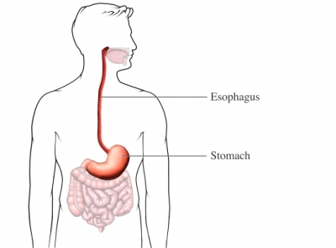
Lesson 9 investigating antacids
Indigestion is caused by too much acid in the stomach. The acid bubbles up into the esophagus and causes a burning sensation. What could be used to treat it?
Hypothesis – Does the type of antacid affect the volume of acid that can be neutralised?
Discuss which variables you will Change (Independent), Measure (Dependent), Control (keep the same)
- volume of acid
- type of powder
- Mass of powder
- volume of indicator
- volume of acid
- pH of acid after reaction with tablet
- Read the two methods below. Method B is better than method A. Give a many reasons why it is better as you can

Method A
- Measure out 10cm³ of Sodium Hydroxide into a beaker
- Add 3 drops of universal indicator, the solution should be purple in colour
- Add a squirt of hydrochloric acid using a pipette and stir.
- Observe and record the colour
- Continue to add squirts recording the colour after each one.
- Stop when you have a green solution.

Method B
- Use the measuring cylinder to measure out 10cm³ of the alkali sodium hydroxide.
- Pour this into the conical flask.
- Add 3 drops of phenolphthalein.
- Fill the burette with hydrochloric acid, making sure the tap is closed, the burette is as low as you can get it and you have goggles on at ALL times.
- Stand the conical flask on a white tile and position the burette above it.
- Open the tap and allow the acid to flow into the conical flask, swirling constantly until the solution is neutral.
- Read the volume of acid needed to neutralise.
- Repeat, keeping the volume of alkali and the number of drops of indicator the same.

Writing your own method
A good method would allow someone else to carry out your investigation without having been in the lesson.
It should contain:
- Named equipment
- Volumes/masses of all chemicals
- Step by step instructions
- What will be changed and measured
- What will be kept the same (control variables)
- Write your method in your exercise book. Also draft a results table for your experiment
- Write a conclusion to your investigation
“The _________________ antacid was the best. This was because…”
- Evaluate your investigation. What were the problems? Did the results fit a pattern? How would you improve the experiment if you repeated the experiment?

Lesson 9 Revision
Poor statement | Better statement
The test for hydrogen is the squeaky pop

Magnesium + oxygen = magnesium oxide

We can make our results repeatable by doing repeats

We would keep the amount of antacid the same to make sure there is a fair test

Some chemical reactions give off light and sound energy

Acid + alkali [Symbol] water

To calculate a mean you add all of your results together

When you’ve calculated a mean, write down all of the numbers on the calculator screen

