Digestion Mastery booklet
Part 1 - What is a healthy diet?
A good diet is important for our health and can help us feel our best - but what is a good diet? Apart from breastmilk as a food for babies, no single food contains all the essential nutrients the body needs to stay healthy and work properly. We also do not need to eat equal amounts of all the food groups. For this reason, our diets should contain a variety of different foods, to help us get the wide range of nutrients that our bodies need.
- Complete the table below
Nutrient group | Example foods | Needed for

- Comprehension Questions

- In which food groups would you place cheese, egg and pasta?
- Why are fats needed in the diet?
- What foods could you eat in order to try and give yourself more energy?
- List some foods a person should avoid if they are trying to reduce their fat intake?
- Which food group is likely to take up the most space on your dinner plate?
- How much water should a person aim to drink per day?
- What is water used for in the body?
- Which food group does fish belong to?
- What are proteins needed for in the body?
- What is the daily recommended number of calories for an adult man and an adult woman?

- Complete the following sentences:
Fats are needed in the diet because…
Fats are needed in the diet but…
Fats are needed in the diet so…
- The card shows the amounts of fat and fibre in some types of food and drink from a café.
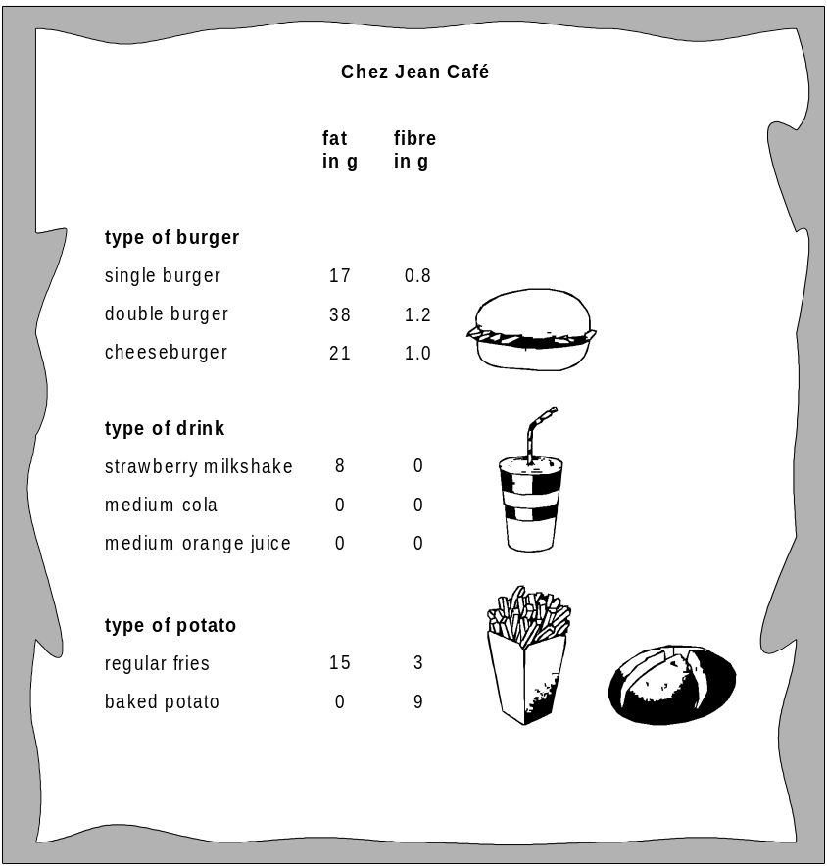

a) From the card above, choose a meal consisting of a burger, a drink and some potato, to give:
(i) the least fat;
(ii) the most fibre.
Write your answers in the table below.
Food and drink | meal with the least fat | meal with the most fibre
type of burger
type of drink |  | the drinks do not  contain fibre
type of potato
(b) A person orders a double burger, fries and a strawberry milkshake. Calculate the fat content of this meal. Give the unit

(c) Draw a line from each nutrient to the main reason why it is needed.
nutrient main reason why the nutrient is needed
fat • • to keep the intestine working properly
calcium • • for healthy teeth and bones
fibre • • for insulation
protein • • to provide energy
sugar • • for growth and repair

d) Some people have unbalanced diets. This can give them problems with their health.
Draw one line from each unbalanced diet to the health problem it can cause.
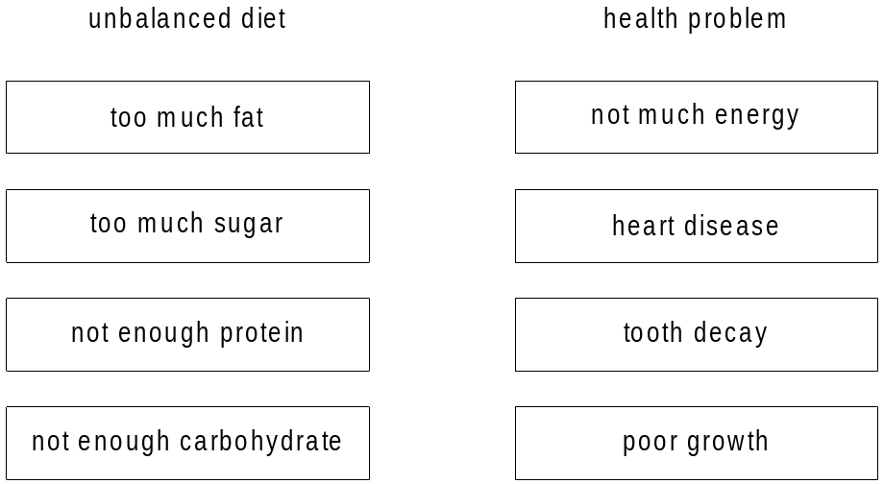

e) The ‘average’ recommended daily intake is around 2000 calories per day. Explain why the following people may need different amounts.
An office worker

A construction worker

f) A 9 month old baby needs approximately 700 calories a day. A two year old needs approximately 1200 calories a day. Give two reasons why the 2 year old needs more calories?

Part 2 – Diet and Disease
There are many diseases linked with poor diet. Some of these are deficiency diseases. This means disease is caused when there is not enough of a nutrient in the diet. Deficiency diseases can lead to symptoms and changes will need to be made to the diet to manage/treat the disease and stop it from reoccurring.

A goitre (sometimes spelled "goiter") is a swelling of the thyroid gland that causes a lump in the front of the neck. The lump will move up and down when you swallow.

Scurvy is a disease resulting from a lack of vitamin C (ascorbic acid). Early symptoms of deficiency include weakness, feeling tired, and sore arms and legs. Without treatment, decreased red blood cells, gum disease, changes to hair, and bleeding from the skin may occur. Scurvy is easily treated by adding some vitamin C to your diet, such as fresh fruit and vegetables. A GP may also recommend taking vitamin C supplements until you feel better

Rickets is a condition that affects bone development in children. It causes bone pain, poor growth and soft, weak bones that can lead to bone deformities. A lack of vitamin D or calcium is the most common cause of rickets. Vitamin D largely comes from exposing the skin to sunlight, but it’s also found in some foods such as oily fish and eggs. Vitamin D is essential for the formation of strong and healthy bones in children.

Iron deficiency anaemia is caused by a lack of iron, often because of blood loss or pregnancy. It is treated with iron tablets prescribed by a GP and by eating iron rich foods. Foods that contain iron include red meat, eggs, quinoa, pumpkin seeds and green vegetables. Symptoms of anaemia include tiredness and lack of energy, shortness of breath, pale skin.

The term Obesity describes someone who is very overweight and has a high percentage of body fat. Obesity is generally caused by consuming more calories, particularly those in fatty and sugary foods, than you burn off through physical activity. The excess energy is stored by the body as fat. The best way to treat obesity is to eat a healthy, reduced-calorie diet and exercise regularly.

Coronary heart disease (CHD) is a major cause of death both in the UK and worldwide. Coronary heart disease is the term that describes what happens when your heart’s blood supply is blocked or interrupted by a build up of fatty substances in the coronary arteries. Over time, the walls of your arteries can become furred up with fatty deposits. Heart disease can be caused by lifestyle factors and other conditions such as: smoking, high cholesterol, high blood pressure, diabetes. Treatment can include lifestyle changes such as regular exercise and stopping smoking, medication and surgery.

Disease | Causes | Symptoms | Advice for changes to diet
Scurvy

Rickets

Anaemia

Obesity

Coronary Heart disease

Complete the table below:

- Answer the questions below in your exercise book:

- Which disease often occurs in people who spend a lot of time indoors? Why?
- What foods could someone eat to try and increase the amount of vitamin D in their diet?
- What are the symptoms of scurvy?
- What vitamin is found in sunlight?
- What builds up in the arteries of someone suffering with coronary heart disease?
- What are the symptoms of Rickets?
- What food group is someone suffering with obesity likely to eat a lot of?
- How could someone avoid getting anaemia?
- How could someone avoid getting coronary heart disease?
- What is an alternative name for vitamin C?
- How can coronary heart disease be treated?
- Jennie has been diagnosed with anaemia – What symptoms is Jennie Likely to show?
- The doctor has advised Jennie to make some changes to her diet - What foods should Jennie introduce to her diet? Suggest a one-day breakfast, lunch and dinner meal plan for Jennie.
- Sam has Ricketts, Sam’s grandmother explains that he should drink plenty of orange juice. Is this good advice for Sam? Explain why/why not.
- In the 18th century, men working on Navy ships used to regularly be affected by Scurvy, why do you think this was? Explain?
- James Lindt is famous for finding a simple cure for Navy men suffering with Scurvy,
Suggest what Mr Lindt might have advised for the Navy men to do?
- Laura is 5 years old. Her dad has just been diagnosed with coronary heart disease. What advice would you give to Laura, regarding lifestyle choices, to help her avoid also getting CHD when she is older?
Q5. Read the magazine cutting about research into heart disease.
More heart disease in older women.
Heart disease amongst British women in the 60-79 age group is more common than previous research suggested. A recent study of 4,286 British women in that age group indicated that one in five showed signs of heart disease.

(a) Why can the results of this research not be used to draw any conclusions about
heart disease amongst women across the world?
(b) Give one reason why the data collected in this study is likely to be reliable.

Part 3 – Energy release

Asleep, awake, eating, bathing, grooming, working or engaging in pursuits, you need energy, which is supplied from your diet in the form of calories. Energy fuels your body’s internal functions, repairs, builds and maintains cells and body tissues, and supports the external activities that enable you to interact with the physical world. Energy also maintains your body temperature. Water, your body’s most important nutrient, helps facilitate the chemical reactions that produce energy from food.
Respiration is a chemical reaction that happens in all living cells, including plant cells and animal cells. It takes place in the mitochondria. It is the way that energy is released from glucose so that all the other chemical processes needed for life can happen. Do not confuse respiration with breathing (which is properly called ventilation). The respiration equation is:
glucose + oxygen carbon dioxide + water.

6.Comprehension Questions
- Where do we as humans get our energy from?
- Suggest some reasons why your body needs energy?
- What is respiration?
- Respiration takes place in the mitochondria, which is present in both plant and animal cells. Name 3 other organelles which are present in both animal and plant cells.
- Which product in food is energy released from during respiration?
- What is the respiration equation?
- What are the products of respiration?
- What are the reactants of respiration?

7. Complete the following sentences:
Respiration is similar to breathing because…
Respiration is similar to breathing but…
Respiration is NOT the same as breathing so…

8. Screaming Jelly Baby demonstration
Watch your teaching do the “screaming Jelly Baby” demonstration and answer the following questions in your book:
- When you watched the demonstration, describe how did you know that a chemical reaction was taking place?
- What substance was burning in the jelly baby to cause the reaction?
- How was the demonstration you saw similar to the respiration reaction that takes place in your body? Explain.
- How was the demonstration different to the respiration reaction that takes place in your body? Explain.
Food is a store of chemical energy; this practical is designed to test how much food is contained in food.
This can be done simply by burning the food under water and seeing how much the water’s temperature goes up by, the more energy stored in the food the higher the temperature rise.
Hypothesis ‘Different foods release different amounts of energy when burned’
Prediction – which food do you think will release the most energy and why?
______________________________________________________________________________________
______________________________________________________________________________________
Results
Food | Temperature of the water (°C)
Food | Start | End | Rise

Diagram of equipment

Conclusion: “we discovered that…..released the most energy. This was because…..”
Part 4 – Food Tests – Testing for Sugar and Starch
Starch is a carbohydrate which is made of long chains of identical small sugar molecules. Long chains of repeating molecules are known as polymers. The small molecules from carbohydrates are used by the body to release energy to allow muscle contraction. The test for starch is always to add iodine solution. Iodine solution is normally orange-brown. It will turn blue-black if starch is present

Sugars react with Benedicts reagent to turn it from blue to orange-red. But it is a slow reaction, so needs speeding up by placing in a water bath.

Food | Does it contain?
Food | Starch | Sugar | Fat | Protein

9. comprehension Questions
a) State some examples of some foods that contain starch
b) State some examples of some foods that contain sugar
c) State the foods that you tested contained starch
d) Describe what carbohydrates are used for in the body
e) State the liquid you added to the foods to test for starch
f) What colour did that liquid turn when starch was present?
g) Name the liquid you added to the foods to test for sugar
h) What colour did that liquid turn when sugar was present?
I) Describe why might a water bath used when testing for sugar
m) What colour is iodine normally (before a reaction)?

Part 5 – Food tests – Testing for Proteins and Fat
Proteins, like carbohydrates, are made of long chains of small molecules. In proteins, these small molecules are not identical. Proteins are made up of chains of small molecules called amino acids. There are over 20 different kinds of amino acid. Proteins are used by the body for growth and repair.

Fats are made up of fat molecules which contain fatty acids and glycerol. Fat molecules have to be broken down by the body so that they can be used for energy storage. Fats are also used by the body to keep heat in and to make cell membranes.

To test for protein, add some food to a test tube and add a few drops of biuret reagent. If the biuret reagent changes from blue to lilac/purple, that is a positive result, meaning there is protein present in the food. If the biuret reagent stays blue, there is no protein present.

To test for fats, add ground food to a test tube, add 2cm3 of ethanol and shake gently, covering the end of the test tube with your thumb, then add 2cm³ of water and gently shake again. Fats will make the clear ethanol turn a cloudy, milky white if they are present.

Practical – Food Tests - Testing for Fats and Protein
Don’t forget to finish completing the table we started last lesson (previous page)
10. Comprehension Questions
a) State some examples of foods that contain fats?
b) State some examples of foods that contain protein?
c) Describe what fats are used for in the body?
d) Name the liquid you added to the foods to test for Protein?
e) Name the liquid you added to the foods to test for Fats?
f) What do Fat molecules contain?
g) What colour does biuret reagent turn in the presence of protein?
h) Describe how the colour of Ethanol changes in the presence of fats?
i) Name the small molecules used to make up proteins
k) State the disease that can result from eating too many fats
l) State some of the symptoms of the disease you stated in question k)
m) Describe how someone could avoid getting the disease you state in question k)
n) What are proteins used for in the body
o) Babies and infants are given lots of milk as part of their diet, why do you think this is? Explain.
p) Jake is 3 years old and allergic to milk, what foods could Jake be given to avoid becoming deficient in protein?
q) As you get older, the amount of drink you are suggested to drink each day decreases – Why do you think this is? Explain.

Part 6 – The Digestive System
Your digestive system is up to 9m long. Digestion happens in the digestive system, which begins at the mouth and ends at the anus. Digestion is the breakdown of large food molecules into smaller ones. This is important because these large molecules are too big to be absorbed into our blood at the small intestine. These organs include the salivary gland and pancreas that produce enzymes, the liver that produces bile which emulsifies, the stomach that produces certain enzymes and hydrochloric acid. The small intestine is a muscular tube that can contract to move food along it. It also produces and secretes enzymes. The large intestine absorbs water and contains bacteria to break down any undigested food. The inside walls of the small intestine are covered in folds these folds are covered in finger-like projections known as villi. Villi increase the internal surface area of the intestinal walls making available a greater surface area for absorption into the blood stream.
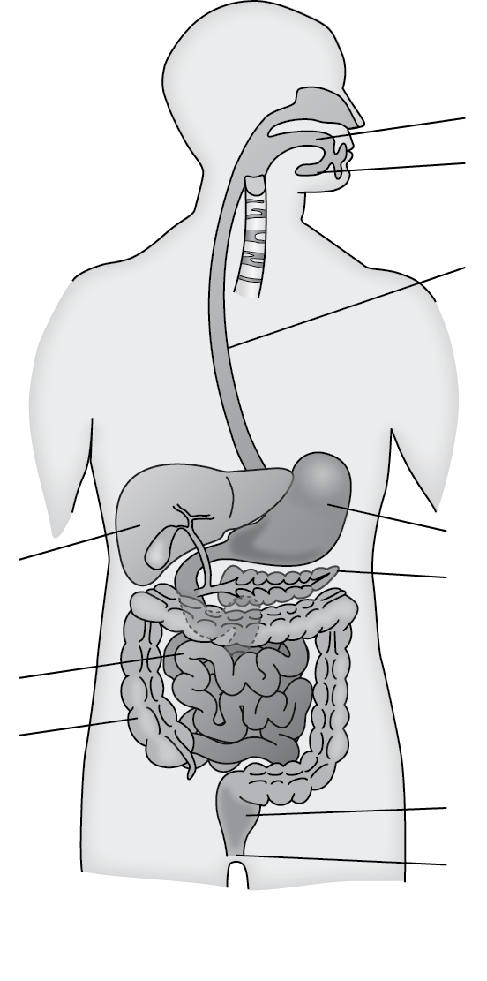
- Label the digestive system with each organ and their function.

- Summarise the information above into the flow chart below:
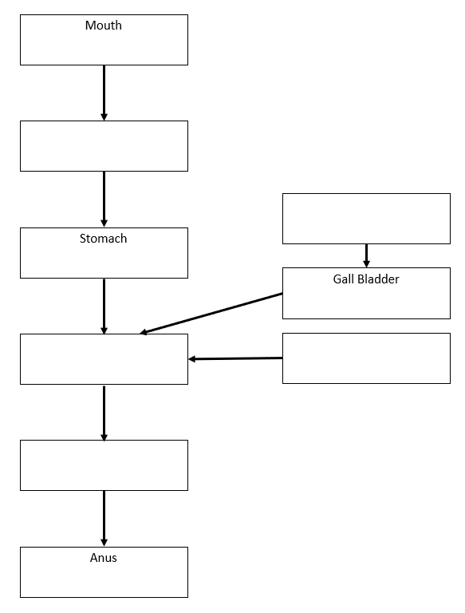

- Comprehension Questions
- What is digestion?
- Why is digestion important to us?
- Describe and explain the adaptations of the small intestine to help with nutrient absorption.
- State the functional difference between the small and large intestines.
- How is the liver important in helping digestion?
- What is the role of saliva in the mouth?
- What is the role of bile?
- Where is bile produced?
- Name the parts of the digestive system that produce enzymes?
- Why does food need to be digested?
- Describe how our food is digested mechanically
- Describe how our food is digested chemically
- Give two ways the bacteria in our gut help us
- Explain why the presence of bacteria in our intestines is referred to as a ‘symbiotic relationship’
- Explain how the small intestine are adapted for efficient absorption of digested food particles
- Are there any organs in your digestive system that you think you could live without? Explain your choice.
- Jenny says that “The liver is a part of the digestive system, even though food doesn’t pass directly through it” Explain why Jenny is correct
- Paul says “Most of the process of Digestion place in the stomach” explain why Paul is wrong. Refer to specific parts of the digestive system in your answer
- Adam says, “Digestion is linked to respiration”. Is Adam right? Explain your answer
- What are the products of respiration?
- What is the respiration equation?
- What are the two types of respiration?
- What are the 7 nutrient groups?

Part 7 – Enzymes part one
Our teeth break food down into small pieces when we chew. This is only a start to the process of digestion, as chewed pieces of food are still too large to be absorbed by the body. Food has to be broken down chemically into really small particles before it can be absorbed. Enzymes are the biological catalysts needed to make this happen quickly enough to be useful. Enzymes are not living things. They are just special proteins that can break large molecules into small molecules. Different types of enzymes can break down different nutrients: Amylase and other carbohydrase enzymes break down starch into sugar. Protease enzymes break down proteins into amino acids. Lipase enzymes break down lipids (fats and oils) into fatty acids and glycerol.
- Comprehension Questions
- Describe what an Enzyme is
- State the name of an Enzyme that breaks down carbohydrates
- Name the substance that sugar is broken down into
- Proteins are broken down into amino acids, what is the name of the enzyme that does this?
- State the name of the Enzyme that breaks down fats
- Name the two products that this enzyme breaks fats down into?
- Why does food need to be further broken down by Enzymes, even after it has been broken down into small pieces through chewing
Practical

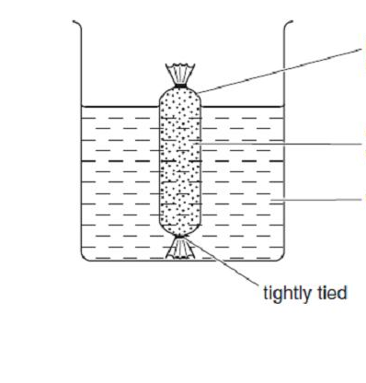
Semi permeable membrane

Starch solution + amylase

Distilled water

- Practical Questions – Answer in your books
- Did you find starch in the solution outside the tube? Why?
- Did you find sugar? Why?
- We didn’t put sugar into the tube – where did this come from?

Chemical digestion

The table below shows the action of enzymes on food molecules.

Large molecule | Enzyme | Small molecules
  Starch | Carbohydrase |   Glucose
      Protein | Protease | 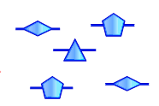  Amino acids
  Fat | Lipase |   Fatty acids  Glycerol 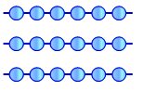

- Use the information in the boxes to DESCRIBE the action of each enzyme. Say which large molecule it digests and what the products are.

Part 8 – Enzymes part two
Practical Instructions – Please complete the table below:
- Use 10cm³ of starch solution
- Add 2-3 drops of iodine
- Add 1cm³ amylase and start the stopwatch
- Record the time taken for the colour to disappear.
- Repeat at different temperatures – 0°C, 30°C and 100°C.
** Please note that the enzyme has been pre boiled so that you do not have to work at 100°C **

Practical table
Temperature of the solution (°C) | Time taken for colour to  disappear (s)
0
20
30
100 (boiled)

- What can you conclude from your results? Is there a pattern or trend that you can see? Write a conclusion in your books.

- Complete these sentences
- Enzymes are not classed as living because…
- Enzymes are not classed as living but…
- Enzymes are not classed as living so…

- Enzyme definitions – Which is better and why?
Definition A
An Enzyme is an organism that is a biological catalyst. Enzymes help speed up the rate of reaction and live inside your body. Enzymes are not used up in a reaction but do die if the temperature of the reaction is too high. Enzymes are produced in the stomach and the pancreas.
Definition B
An Enzymes is a substance produced by a living organism which acts as a catalyst to bring about a specific chemical reaction. Enzymes are not living things. They are just special proteins that can break large molecules into small molecules. Different types of enzymes can break down different nutrients.
- Write your own “perfect” enzyme definition using the information in the above definitions.
Part 9 – Revision
- Revision Questions:
- Name the 7 nutrients required for a balanced diet.

- Label the organs of the digestive system

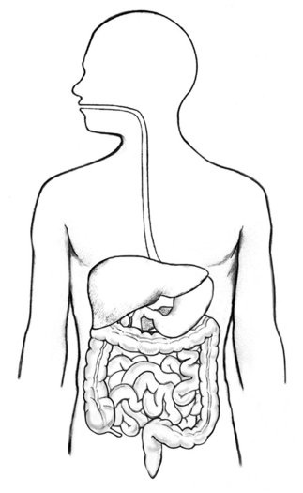

- Describe the test for the following nutrients and their positive results:

Nutrient | Chemical test | Change seen with a positive result
Sugar
Starch
Protein
Fat

- Explain the possible effects of a diet that does not contain enough calcium for a child.
- What is mechanical digestion?
- What is protein needed for in the diet?
- Why is there hydrochloric acid in the stomach?
- Name two diseases linked with unbalanced energy or fat intake.
- Which enzyme digests starch?
- Why do enzymes not work at high temperatures?
- Name three enzymes

- Name two places in the body where enzymes are produced
- State all of the parts of the digestive system in the correct order
- Describe the role of bile in digestion
- State some symptoms of anaemia
- Which Enzyme digests fats
- What products are fats broken down into
- Name 3 deficiency diseases
- Write a definition of an enzyme
- What is the optimum temperature for enzymes in the body?
- Describe how the intestines are adapted for digestion
- What is the optimum temperature for enzymes in the human body?
- Dan says that “enzymes die above 30ºC”. Explain why dan is wrong.

Poor statement | Correct statement
People that need to lose weight need a balanced diet

The nutrient groups are carbohydrates, fats, protein, dairy, vitamins, minerals and water

A heart attack is when there is a blockage in the arteries and the heart has to work too hard and gives up

Food is broken down in the stomach by the hydrochloric acid

At high temperatures enzymes are killed

Digestion starts in the stomach

Respiration is the reaction where energy is produced

Respiration is the same as burning

All bacteria are dangerous and can cause disease

- Correct the poor statements in the boxes below by writing an improved, correct statement in the blank box.

- Which nutrient does a pregnant woman need to increase her intake of? Explain your answer

- Some information about a packet of biscuits is shown below:

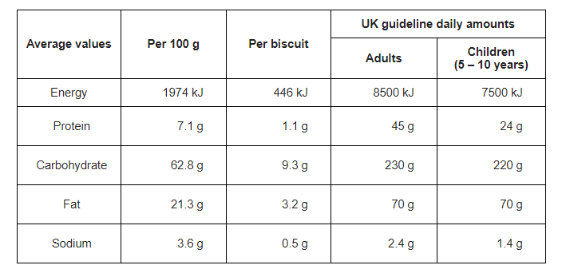
25. One day a ten-year-old child ate a whole packet of the biscuits. The biscuits in the pack had a mass of 400 g.

(a) How many grams of carbohydrate did the child eat?

(b) The amount of carbohydrate you calculated in part (a) was more than the UK guideline daily amount for the child. How much more?

26. New-born mammals produce an enzyme called rennin which clots the protein in milk. New-born mammals can only digest the protein after it clots.

Pat investigated how pH affects the time for rennin to clot the protein in milk.

She put 2 cm³ of milk into each of four test-tubes, A, B, C and D.
She put these test-tubes and a test-tube of rennin into a water-bath at 35°C.

After a few minutes, Pat transferred 4 drops of the rennin into test-tubes
A, B and C. She varied the pH by adding the chemicals shown in the table.
To test-tube D she added 2 drops of hydrochloric acid only.

The table below shows the results of Pat’s experiment.

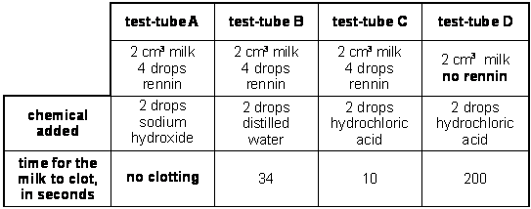
- Use the results of test-tubes C and D to state the function of the enzyme in the clotting process.
- Use Pat’s results to explain why rennin clots milk quickly in the stomach.
- Suggest what happens to the activity of rennin as it passes from the stomach into the small intestine. Explain your answer.

- Pat then investigated how temperature affects the time for rennin to clot milk. She prepared four water-baths, at 0°C, 25°C, 35°C and 60°C.

Into each water-bath she put a test-tube containing 2 cm³ of milk and a test-tube containing rennin plus a chemical to give the correct pH.

In each water-bath, she transferred four drops of the rennin into the test-tube of milk and timed how long it took for the milk to clot. The table shows her results.

temperature of  water-bath, in °C | time for milk to clot,  in seconds
0 | no clotting
25 | 23
35 | 10
60 | no clotting

a) Explain why no clotting occurred in the test-tube at 60°C.

b) Pat took the test-tube out of the water-bath at 0°C and put it into the water-bath at 35°C. The milk clotted.
Why was clotting still possible in this test-tube?

c) Raising the temperature from 25°C to 35°C made the milk clot more quickly.
How could Pat change her experiment to show more precisely how temperature affects the time it takes for milk to clot?

d) After rennin clots milk protein, a different enzyme helps to digest the protein. What are the products of protein digestion?

