Materials of the Earth
Lesson 1: Structure of the Earth
The Earth has three main layers. We live on the outer layer, the crust, and are surrounded by a mixture of gases, the atmosphere.
The Earth is almost a sphere. These are its main layers, starting with the outermost: crust (relatively thin and rocky), mantle (has the properties of a solid, but can flow very slowly), core (made from nickel and iron).
The radius of the core is just over half the radius of the Earth. The Earth’s atmosphere surrounds the Earth. The Earth’s crust, its atmosphere and oceans are the only sources of the resources that humans need.
- Label the earths structure below using the keywords from the reading above:

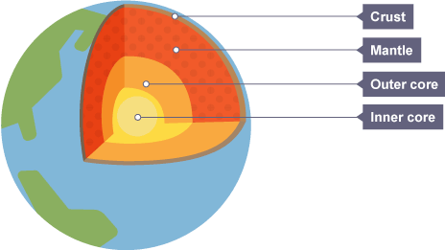

Earthquakes and volcanoes tend to happen in the same places. This is because the Earth’s surface is split into pieces called “tectonic plates”. Where these plates meet are known as tectonic plate boundaries. The plates are always moving. They are moving very slowly, but they are moving, and every now and again, a build-up of pressure is released in the form of a sudden slip of the plates (earthquake) or an explosion of lava (volcano).
Reading Comprehension Task:
The Earth’s crust contains a lot of silicon, aluminium and magnesium. The crust is solid, rigid and ranges in temperature form 20-500ºC. Continental crust is about 50 km thick, ocean crust is about 5-10 km thick. The average density of the crust is 2.9 g/ml.
The Earth’s mantle contains a lot of iron and magnesium silicates. The mantle is soft and consists of semi-molten rock called magma. The temperature of the upper mantle is about 1000°C and the temperature of the lower mantle is about 2500°C. The mantle is about 2900 km thick. The average density of the mantle is about 3.6 g/ml.

The Earth’s core contains a lot of nickel and iron. The inner core is solid. It has a density of about 9.5 g/ml and a temperature of about 4700°C. The outer core is liquid and the temperature is about 4000°C. The radius of inner core is 1230 km and the thickness of the outer core is 2250 km.
Complete the questions below in your workbook:
- Which is the thinnest layer?
- Which is the thickest?
- Which part is the solid bit that we stand on?
- What state is the mantle?
- Why is the core liquid even though it is made of iron?
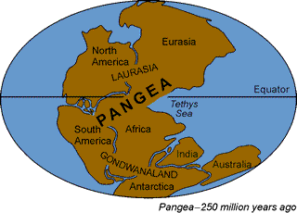
Pangea
Pangaea is a hypothetical supercontinent that included all current land masses, believed to have been in existence before the continents broke apart during the Triassic and Jurassic Periods. There is some evidence to support this theory:
- Rocks that are very similar were found on coasts now separated by oceans
- Fossils of similar plants and animals were found on these coasts
- Some continents looked like they fit together like a jigsaw puzzle
This force is the one that is responsible for the way the Earth looks today and for the fact that we have earthquakes and volcanoes.
Why do plates move?
The hot mantle nearest the core rises. As it rises it cools. This process is called convection. The convection currents move the tectonic plates.
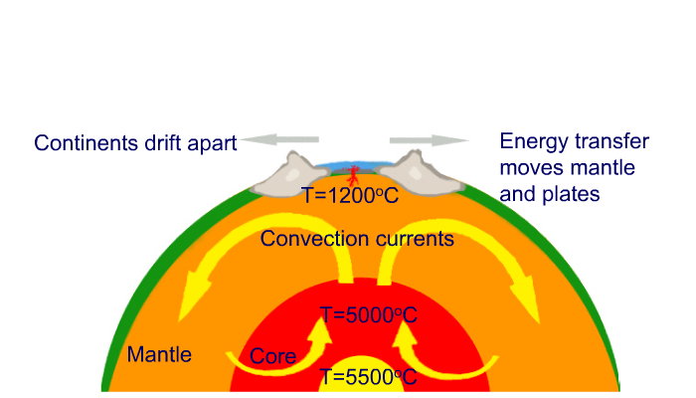

Comprehension Questions:
- What does the fact that earthquakes and volcanoes occur at the boundaries tell us about the plates?
- What force could possibly be big enough to move whole continents?
- Which is the hottest part of the earth?
- What happens to the density of liquids when they are heated?
- Explain how the continents move.
- Describe the evidence of the theory that the earth’s continent once fit together as Pangea.
- Explain how we have the earthquakes and volcanoes?
Lesson 2: Igneous Rocks
Rocks are continually cycled. There are three main types of rock: igneous, sedimentary and metamorphic. They are formed in different ways and have different properties.
Igneous rocks are formed from molten rock that has cooled and solidified. The inside of the Earth is very hot - hot enough to melt rocks. Molten (liquid) rock is called magma. When the magma cools enough, it solidifies and igneous rock forms.
Examples of igneous rocks include:
- obsidian (glasslike, very fast cooling on surface)
- pumice (gas bubbles, fast cooling on surface
- basalt (small crystals, moderate cooling near surface)
- gabbro/granite (large crystals, slow cooling in the Earth
Igneous rocks contain randomly arranged interlocking crystals. The size of the crystals depends on how quickly the molten magma solidified:
- magma that cools slowly will form an igneous rock with large crystals
- lava that cools quickly will form an igneous rock with small crystals
Extrusive igneous rocks form from magma that erupted onto the surface as lava, where it cooled quickly. On the other hand, intrusive igneous rocks form from magma that cooled slowly, deep underground.
- Recall from last lesson: What is convection?
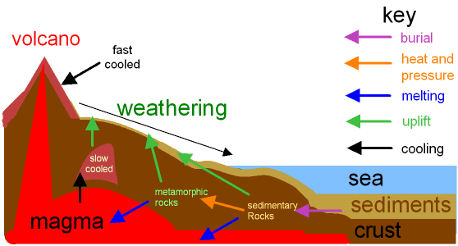
Volcanic Eruptions:
Sometimes the pressure of the rising molten rock results in a sudden eruption. Molten rock is known as magma. If it is forced out of the volcano, it is known as lava. As the molten rocks are formed.
Practical 1: Rock Investigations
Follow the instructions below and record your findings:
- Use the hand lens to look at the structure of each rock
- Try to scratch it with your nail
- Wrap it on a paper towel and try to crush it by standing on it (don’t stamp on it)
- Put one or two on a watch glass and drop a little sulphuric acid onto it – is there a reaction?
Follow up questions:
- Describe the physical properties of the igneous rock.
- For instruction 4 – if a reaction took place, how did you know? What did you see?
Practical 2: Investigate why some igneous rocks have larger crystals than others
Follow the instructions below and record your findings:
- Collect the warmed solution
- Use a pipette to drop a few drops of it onto a warmed slide
- Do the same with a se that been cooled
- Use the hand lens to look at the size of the crystals
Theory: The liquid solution represents magma, by adding the magma to a cool slide and a warm slide we can see what happens when magma cools slowly or quickly.
Questions:
- What are the 3 sections of the Earth called?
- What happens in the mantle to move the tectonic plates?
- Why do regions of hot liquids rise?
- What is the name of the supercontinent that existed millions of years ago?
- Name two pieces of evidence we have that the continents were once together in this way.
- What was the purpose of using a warm slide and a cool slide in practical 2.
- Name two examples of igneous rocks and list their characteristics.
- Describe and explain your results from practical 2.
- Label the diagram below:

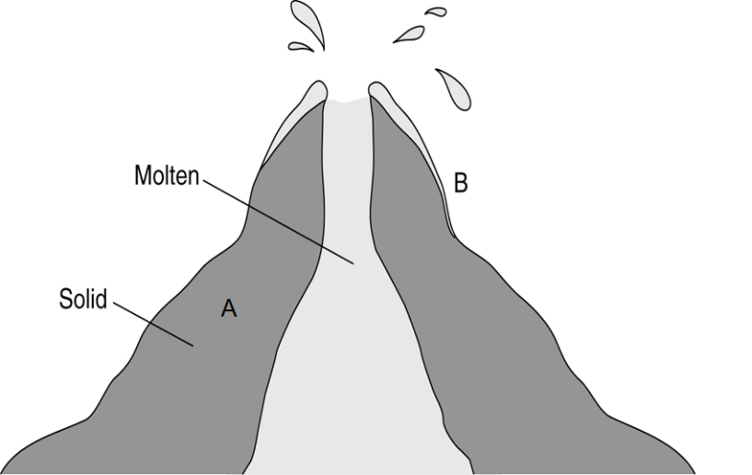
Intrusive igneous rock:
Extrusive igneous rock:

Lesson 3: Sedimentary Rocks
Sedimentary rocks are formed from the broken remains of other rocks that become joined together.
A river carries, or transports, pieces of broken rock as it flows along. When the river reaches a lake or the sea, its load of transported rocks settles to the bottom. We say that the rocks are deposited. The deposited rocks build up in layers, called sediments. This process is called sedimentation.
The weight of the sediments on top squashes the sediments at the bottom. This is called compaction. The water is squeezed out from between the pieces of rock and crystals of different salts form. The crystals stick the pieces of rock together. This process is called cementation.
Transport 🡪 Deposition 🡪 Sedimentation 🡪 Compaction 🡪 Cementation
Transportation: the movement of rock fragments from one place to another. Rock fragments may be transported by strong winds, by rivers or by glaciers.
Deposition: occurs when pieces of weathered rock sink to the bottom of the riverbed or sea forming sediment. Dead creatures can get trapped in sediment and form fossils.
Sedimentary Rocks Characteristics
These rocks contain rounded grains in layers. The oldest layers are at the bottom and youngest are at the top. Sedimentary rocks may contain fossils of animals and plants trapped in the sediments as the rock was formed. Examples: chalk, limestone, shale and sandstone.

Practical 1: Rock Investigations
Follow the instructions below and record your findings:
- Use the hand lens to look at the structure of each rock
- Try to scratch it with your nail
- Wrap it on a paper towel and try to crush it by standing on it (don’t stamp on it)
- Put one or two on a watch glass and drop a little sulphuric acid onto it – is there a reaction?
Follow up questions:
- Describe the physical properties of the sedimentary rock.
- For instruction 4 – if a reaction took place, how did you know? What did you see?

Comprehension Questions:
- What are the three main sections of the Earth in order from the centre?
- Which is the biggest section?
- Why is the mantle liquid?
- What causes the mantle to move?
- Why are the crystals in extrusive igneous rock smaller than the ones in intrusive rock?
- Describe how igneous rocks from the top of a volcano can be weathered and eventually become new sedimentary rocks on a river or sea bed.
- Explain why sedimentary rocks are layered.
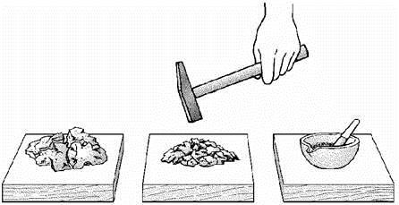
- Linda had a piece of red sandstone. She hammered it into pieces and then ground them into a powder using a pestle and mortar.
She put the powder into a measuring cylinder with water and shook the mixture. The
contents settled.
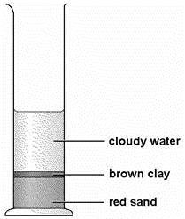
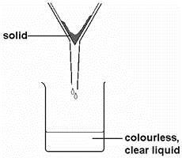
- Linda said her results showed that sandstone is a mixture of two substances. How could she tell, from the results, that sandstone is a mixture of substances?

- Linda then poured the cloudy water from the measuring cylinder through filter paper in a filter funnel. She said there might be salts dissolved in the colourless, clear liquid that came through the filter.

- What could Linda do to find out if there were salts dissolved in the colourless, clear liquid?

- What would she see if there had been salts dissolved in the colourless, clear liquid?
.............................................................................................................
.............................................................................................................
(b) Sandstone is a sedimentary rock. Four stages in the formation of sedimentary rock are listed below.
They are not in the correct order.
compacted deposited weathered transported
Put these stages in the correct order. One has been done for you.
stage 1 ................weathered...................
stage 2 .....................................................
stage 3 .....................................................
stage 4 .....................................................

- Igneous rock such as granite can become sedimentary rock. A model of this process is shown in the following sequence.
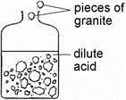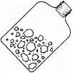
Step 1 Step 2
Half fill a plastic jar with pieces of Shake the jar vigorously
granite and dilute acid. Leave for for a few minutes.
one week then pour off the acid.

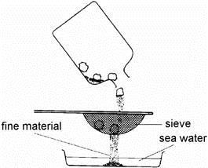
step 3 step 4
Sieve the contents of the jar Leave the dish to stand
into a dish of water. for a few hours.

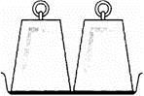
step 5
Press the wet, fine material
for many weeks with heavy weights.
(a) Step 1 represents chemical weathering in the rock cycle.
Which part of the rock cycle is represented by step 2?
(b) A river carries pieces of granite from a mountain to the sea. Describe two ways in which the pieces of granite change as they are carried.
(c) Which two parts of the rock cycle are represented by step 4 and step 5?

Lesson 4: Metamorphic Rocks
Metamorphic rocks have been subjected to tremendous heat and/or pressure, causing them to change into another type of rock. They are usually resistant to weathering and erosion and are therefore very hard-wearing. Examples of metamorphic rocks include marble, which originates from limestone and slate, which originates from clay.
Characteristics of Metamorphic rock:
- These are formed when either igneous or sedimentary rocks are changed.
- Heat and/or pressure will cause the elements in the original rock to react and re-form.
- Metamorphic rocks are highly resistant to erosion and are often used in building materials.
Practical 1: Rock Investigations
Follow the instructions below and record your findings:
- Use the hand lens to look at the structure of each rock
- Try to scratch it with your nail
- Wrap it on a paper towel and try to crush it by standing on it (don’t stamp on it)
- Put one or two on a watch glass and drop a little sulphuric acid onto it – is there a reaction?
Questions:
- Describe the physical properties of the metamorphic rock.
- For instruction 4 – if a reaction took place, how did you know? What did you see?
- What happens to the temperature of the earth as you get further underground?
- What does ‘density’ mean?
- Name the sedimentary rock found in the white cliffs of Dover.
- What type of rock is formed inside a volcano from magma?
- Which is the thinnest section of the Earth?
- Describe how metamorphic rocks are made from sedimentary rocks.
- Helen weighed three pieces of rock and soaked them in water.
The next day, she weighed them again.
Her results are shown below.
rock | mass before  soaking in water (g) | mass after  soaking in water (g)
granite | 26.3 | 26.3
marble | 20.4 | 20.4
sandstone | 25.5 | 27.6
Rocks that have lots of small spaces are described as porous.
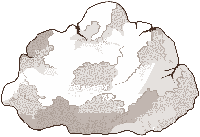
- What evidence is there in the table that sandstone is porous, but granite and
marble are not porous?
- Helen put the soaked sandstone into a freezer for 24 hours.
- Water in the spaces in the sandstone froze and expanded. What would happen to the sandstone as the water froze and expanded?
- In the winter this process happens in rock in the countryside. What is the name of this process?
- Helen placed fresh pieces of granite, marble and sandstone in beakers of dilute
sulphuric acid. Only the marble reacted with the acid.
Only the marble reacted with the acid.
- Use Helen’s results to explain why granite is more suitable than marble for a
statue in a city centre.
- Draw a line from the name of each rock below to the group of rocks it
belongs to.
- Draw a line from each group of rocks below to the way the group of rocks
was formed.
name of group of way the group of
rock rocks rocks was formed
granite |  | sedimentary |  | the effect of high  temperature and  pressure on limestone
marble |  | igneous |  | formed when magma cools
sandstone |  | metamorphic |  | particles are deposited in layers

- The list below gives some processes which occur in the rock cycle.

1. Grains of sediment collect in layers on the sea bed.
2. Large crystals form as molten magma cools deep below the Earth’s surface.
3. A glassy rock forms as molten magma erupts into sea water.
4. Grains of sediment are cemented together as they are buried deep under thick layers of other sediments.
5. New crystals form in layers as rocks are affected by high temperature and increased pressure deep in the Earth’s crust.
6 New minerals form with flat crystals when layers of mudstone are squeezed.
- Give the number of one metamorphic process.
- Give the number of one igneous process.
- Give the numbers of the two steps which could lead to the formation of sandstone ......................….. and then ......................……
- Limestone and sandstone are two different rocks. Limestone is mainly calcium carbonate. It reacts with dilute hydrochloric acid to produce bubbles of gas.

Complete the word equation for the reaction.
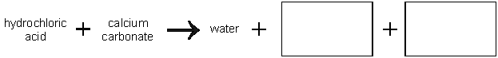
- Sandstone is mainly silicon dioxide. Glass for test tubes is also made from silicon dioxide.Suggest what, if anything, will happen when dilute hydrochloric acid is added to a piece of sandstone.
- When sedimentary rock is buried it may change into metamorphic rock.
Describe two causes of this change.
1. .........................................................................................................
2. .........................................................................................................
65. Name a rock formed by the metamorphism of limestone
66. Metamorphic rock can be changed to form igneous rocks. Give two main processes which are involved in this change.
1. ..................................................................................................................
......................................................................................................................
2. ..................................................................................................................
......................................................................................................................
67. Igneous rock may be changed back into sedimentary rock. The list shows four of the processes involved in this change.
burial weathering deposition transport
These processes must take place in a particular order.
Place the four processes in the correct order.
1. ............................................................
2. ............................................................
3. ............................................................
4. ............................................................
68. The table gives the names of three different rocks and how they are classified.

name of rock | class of rock
granite | igneous
marble | metamorphic
shale | sedimentary
69. In the table below, draw lines to connect the name of each rock to the description of how the rock was formed and then to the correct description of features of the rock.
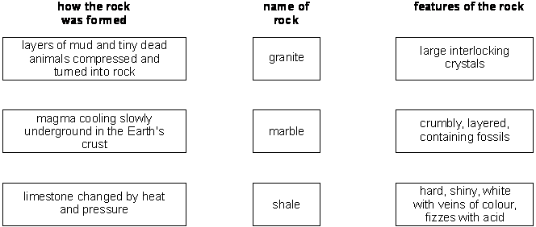
70. The diagram shows a section through a limestone cliff.
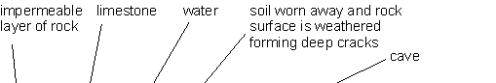
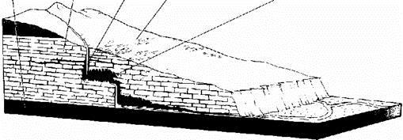
There are caves in the limestone.
70. Explain how chemical weathering causes caves to form in limestone.
Limestone is a porous rock. Water can enter the spaces in limestone.
71. Describe how this causes physical weathering of the limestone.

Lesson 5: Fossils
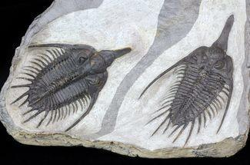
A fossil is the preserved remains or traces of a dead organism. The process by which a fossil is formed is called fossilisation. It is very rare for living things to become fossilised. Usually after most animals die their bodies just rot away and nothing is left behind. However, under certain special conditions, a fossil can form.
After an animal dies, the soft parts of its body decompose leaving the hard parts, like the skeleton, behind. This becomes buried by small particles of rock called sediment. As more layers of sediment build up on top, the sediment around the skeleton begins to compact and turn to rock. The bones then start to be dissolved by water seeping through the rock. Minerals in the water replace the bone, leaving a rock replica of the original bone called a fossil.
Fossils display evidence of evolution. Fossils of the simplest organisms are found in the oldest rocks, and fossils of more complex organisms in the newest rocks. This supports the theory of evolution which states, that simple life forms gradually evolved into more complex ones.
Comprehension Questions:
72. What is a fossil?
73. Which type of rock would fossils be most likely to be found in?
74. What are the two conditions needed for sedimentary rock to become metamorphic rock?
75. What are the two types of igneous rock?
76. How can mountains grow or islands appear overnight?
77. What is the theory of evolution?
78. How do fossils provide evidence to the theory of evolution?

Practical:
- Imitate an animal that has died and falls into sediment by using your hand in a pushing action into the plasticine. As the plasticine spreads the it demonstrates how the layers of sediment bury the animal.
- Over time, the animal will then rot away (remove your hand from the plasticine.
- The impression left in the plasticine will then be filled in by minerals and sediments, in our case it will be Calcium Sulphate
- Leave your Calcium Sulphate to dry and later remove the plasticine to uncover your fossil.
- Label the diagram to show the structure of the Earth.

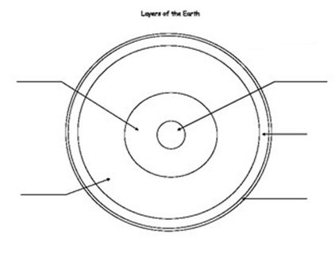

- Complete the table by describing how each type of rock is formed:
Type of rock | How its formed
Sedimentary
Metamorphic

Igneous

- Explain how rock from hills and mountains can become sediment in a river bed
- Explain how sedimentary rocks can become metamorphic rocks, and igneous rocks
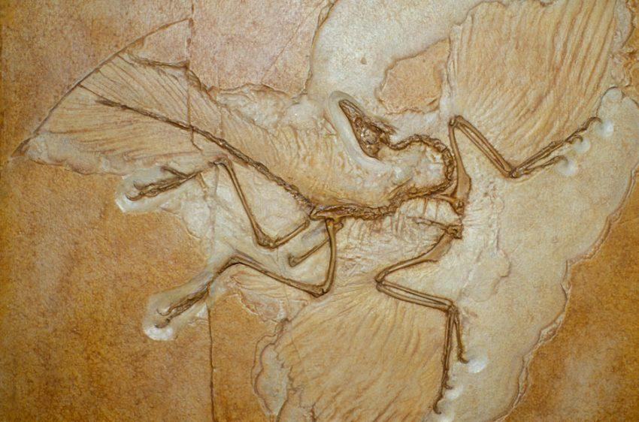
- The diagram shows a fossil of a creature called ‘archaeopteryx’

Which type of rock would this have been found in?
- What do fossils tell us about life on Earth?
- Explain why the fossil record is incomplete and is unlikely to ever give a complete record of living things on Earth.
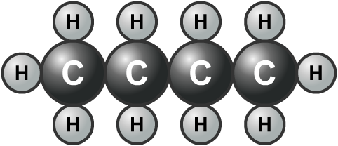
Lesson 6: Fossil Fuels
Oil is extracted from deposits very often under the sea bed.
Crude oil is a mixture of molecules made of carbon and hydrogen oil. Together they are called hydrocarbons.

Advantages | Disadvantages
Creates jobs | Oil spills during transport
Products like plastic can be made from oil | Oil is a finite resource
Countries with good oil supplies can sell it and help their economy | Burning fossil fuels releases carbon dioxide
Petrol, diesel and airplane fuel all come from oil | Not all countries have oil supplies

Practical: Making Hydrocarbons
Use the molymold kits to build hydrocarbons:
- Each Carbon atom is bonded to another Carbon
- The remaining bonds on the Carbon atom will be Hydrogen atoms
- Build: the smallest possible alkane, an alkane with 2 Carbons, 3 Carbons and 4 Carbons
Follow Up Task:
- Practice drawing your hydrocarbons on a white board. Use the diagram above as an example.
- Write the chemical formula for each underneath
Alkanes
Alkanes are a family of hydrocarbon compounds with the general formula CnH2n+2. Hydrocarbons are saturated, meaning each carbon atom is fully bonded with hydrogen.
The simplest alkane is methane. It has a formula of CH4:
The next simplest alkane is ethane. It has a formula of C2H6:
The third simplest alkane is propane. T has a formula C3H8.
Comprehension Questions:
- What word means a resources that will run out?
- What is a fossil fuel?
- What is coal made from?
- What is oil made from?
- Which gas is given off when fossil fuels are burned?
- Where do we find crude oil?
- How did it get there? How do we get it out?
- What do we use crude oil for?
- Complete the table below:
Name | Formula | Drawing
methane | CH₄
- Explain why alkanes are known as hydrocarbons.
- Evaluate the advantages and disadvantages of extracting and using oil.
Lesson 7: Atmosphere
Use the chart below to compare the earth’s atmosphere today to the early earths atmosphere.
Gas | Levels in Earth’s Early Atmosphere | Percentage in air today
Nitrogen | None | 78%
Oxygen | None | 21&
Others – CO2 and Argon | Very High | 1%
Water Vapor | Very High | Varies – But approx. 10%
Ammonia | High | None

The early atmosphere had much higher levels of carbon dioxide and argon and higher levels of water vapour too. The early atmosphere had no oxygen or nitrogen, but today the atmosphere has around 21% oxygen and 78% nitrogen.
Over time, the earth has cooled, and the earth’s crust has turned solid. Volcanoes have erupted, releasing water vapour into the air. This water vapour has condensed, fallen as rain which has created our oceans and rivers. Large amounts of carbon dioxide were absorbed into the oceans. Plants eventually evolved and took in carbon dioxide during photosynthesis and released oxygen. With evidence of this process we can understand how the levels of carbon dioxide have dropped dramatically between 4500 million years ago and 3500 million years ago. Since, the concentration of carbon dioxide has stayed fairly stable.
The Carbon Cycle
For a long time on earth, the percentage of carbon dioxide in the atmosphere remained stable. This is because the volumes of carbon dioxide being released where largely the same as those being taken in. There are seven processes involved in the recycling of carbon dioxide in the atmosphere: photosynthesis, respiration, feeding, excretion, death and decay, fossilisation and combustion.
- Describe the Earth’s early atmosphere.
- Complete the table below:
- Explain the main process in the evolution of the modern atmosphere.
- By what process is carbon dioxide taken out of the air by plants?
- What substances do plants make with the carbon dioxide (and water)?
- By what process can these substances be transferred into the body of an animal?
- What is the name of the process in both plants and animals that releases energy from glucose?
- What is the waste product of this process?
- When an animal or plant dies, what process releases carbon dioxide?
- What is the name of the process of burning fuels?
- By which process is carbon dioxide taken out of the air by plants?
- Which substances do plants make with the carbon dioxide (and water)?
- By which process can these substances be transferred into the body of an animal?
- If the animal uses them for energy, what is breathed out?
- When an animal or plant dies, what process releases carbon dioxide?
- Which process releases energy from fossil fuels?
- Use the words above to help label the diagram of the carbon cycle below:
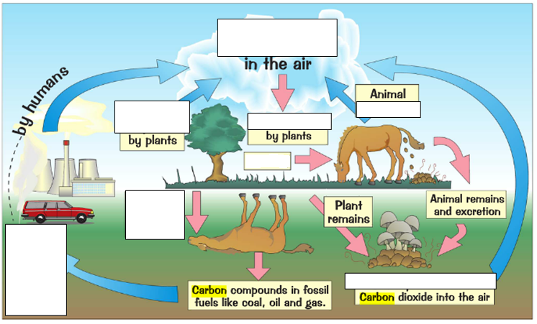

- Look at the graph below
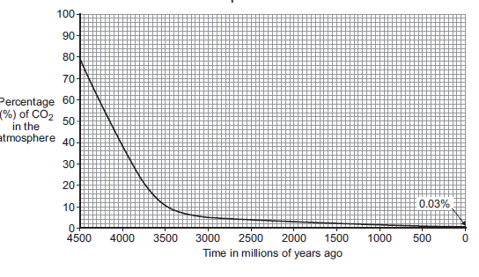
- Describe the trends shown in the graph. Use data from the graph.
- Suggest two reasons for the changes you have describe.
- The diagram shows part of the carbon cycle.
CO₂

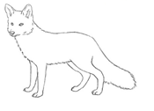
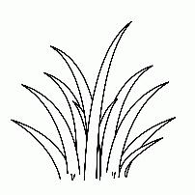


- Describe, as fully as you can, how carbon is cycled from the air, through the living organisms and back to the air.
Lesson 8: Climate Change
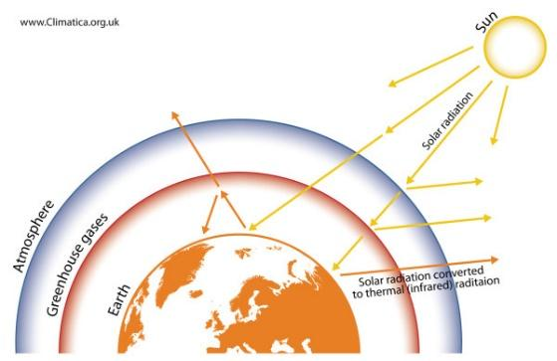
The Greenhouse Layer
The earth has layers of gases in the atmosphere, one of which is the greenhouse layer. This layer is made up mainly of co2 and methane. This is not to be confused with the ozone layer.
The Greenhouse Effect
When the light from the sun reaches the earth infrared rays are reflected, some of the rays release heat. With the thickening greenhouse layer made up of carbon dioxide and other gases the heat becomes trapped in the atmosphere, therefore keeping the earth warm.
The greenhouse effect has been essential for the development of life on earth. Without it, the earth would be colder, approximately -18 degrees Celsius. The problem that we currently face with global warming is because the greenhouse effect increasing as the layer of gases thickens.
Climate Change
As more heat is being trapped inside the earth is leading to climate change. The polar ice caps are melting, seas are getting warmer and weather patterns around the world could change.
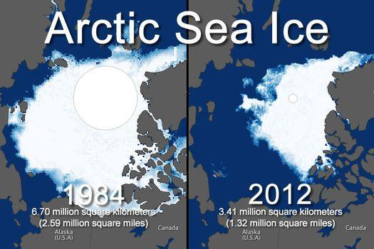
Comprehension Questions:
- Describe how the greenhouse effect affects the earth’s temperature.
- Explain the problem that is caused by the additional carbon dioxide released into the atmosphere.
- Compare the image in figure 1, use your understanding of the greenhouse effect to explain the change in the arctic sea ice.
Figure 1
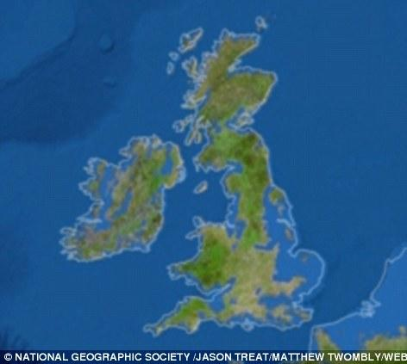
- Describe and explain how climate change has lead to the rising sea levels seen in the image in figure 2.
Figure 2
- Describe and explain how the greenhouse effect has impacted the warming of oceans bleaches and coral, refer to the image in figure 3 to compare.
- Describe how climate change could affect humans and other living things. Discuss the effect on habitat, food supplies and physical dangers (i.e. severe weather, changing land masses)

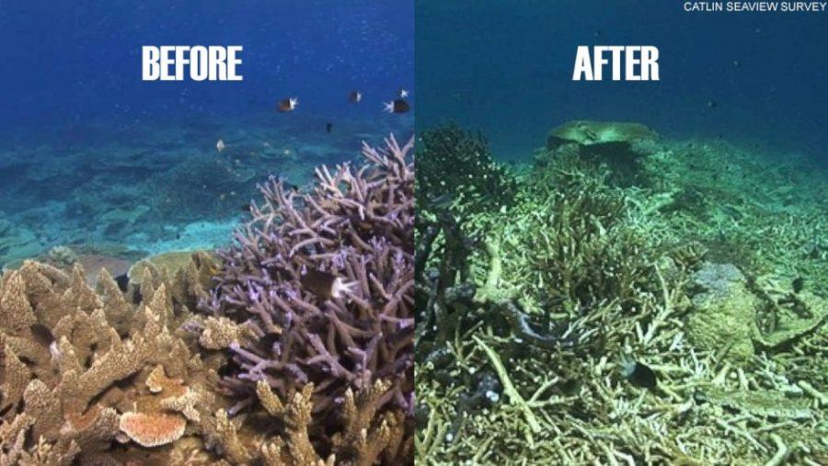
- This question is about carbon. The graph shows the mass of carbon added to and removed from the atmosphere each year.
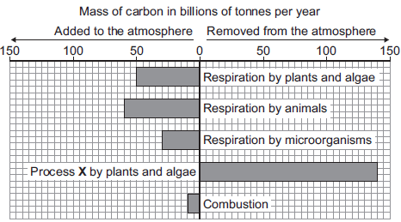
Figure 3
- Name process X.
- Calculate the mass of carbon dioxide removed from the atmosphere each year
- Calculate the mass of carbon dioxide added to the atmosphere each year
- Why are scientists concerned about these figures?
- Suggest one strategy that would bring the cycle back into balance

Lesson 9: Resources and Recycling
The earth has a limited supply of all materials and it is important to try and ensure the future supply of materials. Recycling plays an important part in this. General waste gets dumped in landfill. This can take many years to rot down. Plastics and rubbers can take hundreds of years to rot.
Reduce, Reuse and Recycle
Recycling materials plays an important role of ensuring future supply. But even recycling has its limits, and efforts to reduce things like plastic packaging are now becoming more important. Objects like plastic straws and single use plastic cups are now being cut down on.
Different materials have different properties. Ceramics are hard and strong, but brittle. Polymers are strong and tough, and often flexible. Composite materials combine two or more materials.
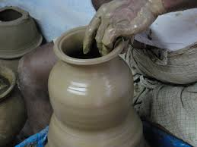
Ceramic means “pottery”. It is made out of clay soil that has been dug out of the ground and heated in a kiln over. Clay can be easily shaped, and ceramics have excellent strength and hardness properties. However, clay can often be brittle in nature. Examples of ceramics include sinks, floor tiles, mugs and even fillings in your teeth.

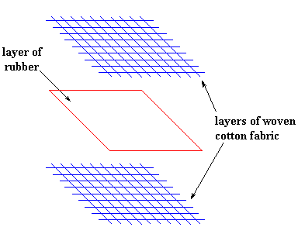
Composite is any material made of at least two other materials. Charles Macintosh sandwiched two layers of cotton fabric around natural rubber to make a three-layered sandwich. This made for good raincoats because the rubber made it waterproof and the cotton layers made it comfortable to wear.
Therefore we make composites, to make a material that acts like both of its parts. In this case, we combine the water-resistance of rubber and the comfort of cotton.
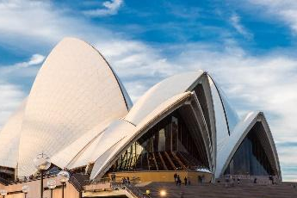
Concrete is a common composite material, it is a mixture of cement, sand, stones and water. It is so useful because it is strong and has been used to build millions of structures all over the world, like the Opera House in Sydney, Australia.
Polymers:
Some small molecules called monomers can join to make very long molecules called polymers. This is process is known as polymerisation. Many polymers are made from chemicals that are obtained from crude oil.
- Label the diagram below to indicate a monomer and a polymer:
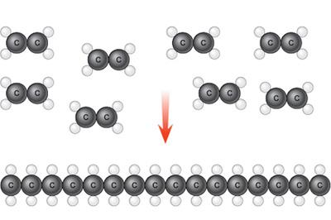

Natural Polymers | Synthetic Polymers
Cotton  Sheep’s Wool  Silk | Plastics – Water bottles, bags  Teflon – Non-Stick Cooking Pans  Nylon -Rope, seat belts

- Complete the table to describe the properties and uses of ceramics, polymers and composites.
Material | How it’s made | Properties | Uses
Ceramics

Composites

Polymers

- Explain why recycling of materials is necessary.
- Summarize each material: ceramics, polymers and composite materials by listing how its made, the physical properties and uses.
- Why is plastic recycling so important? Think of where we get the monomers from?
- In the UK, railway sleepers are often made from concrete. Concrete is a composite material.
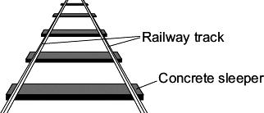
A scientist was asked to find the best concrete mixture to use so that railway sleepers would not break easily.The scientist made:
• a mould to make small models of concrete sleepers
• concrete mixtures using crushed rock, sand, cement and water
• the equipment shown to add 0.1 kg masses until the model sleeper broke.
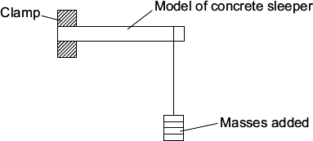
The scientist’s results are shown in the table.

Concrete mixture  in % by volume |  |  | Total mass added to break the model sleeper  in kg
Cement | Sand | Crushed  rock | Test 1 | Test 2 | Test 3 | Mean
10 | 70 | 20 | 1.1 | 1.3 | 1.2 | 1.2
20 | 60 | 20 | 2.6 | 2.5 | 2.4
30 | 50 | 20 | 3.3 | 3.3 | 3.3 | 3.3
40 | 40 | 20 | 3.8 | 4.0 | 3.3 | 3.9
50 | 30 | 20 | 4.5 | 4.2 | 4.3 | 4.3
- Calculate the mean total mass added to break the model sleeper that has 20% cement by volume. Mean = ______________ kg

- Choose one result in the table that the scientist should check and test again.

Result: % cement by volume ____________ Test number ____________Explain why you chose this result.
- What is the relationship between the total mass to break the model sleeper and the percentage (%) of cement by volume in the concrete mixture?
- Suggest one other variable that the scientist should have recorded in the table of results.
- The scientist thought that full-size railway sleepers should be made from 30% cement,
50% sand and 20% crushed rock.
- What other information about these three materials is needed before the scientist recommends using this mixture to make a full-size railway sleeper?
- The graph shows changes in temperature and in carbon dioxide concentration in the earth’s atmosphere between 1860 and 1990.
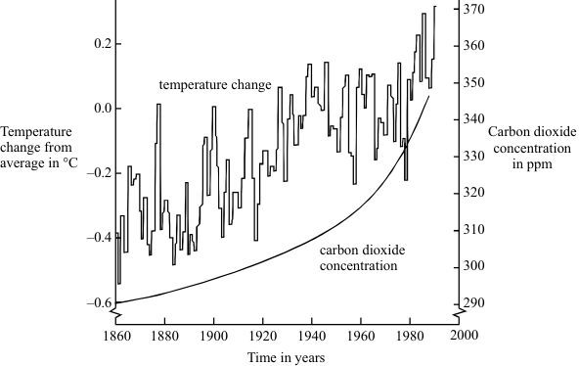
- Give two human activities which may have helped to increase the concentration of carbon dioxide in the atmosphere.
1 ........................................................................................................
2 ........................................................................................................
- Describe the changes in temperature shown by the graph between 1860 and 1990.
- Do the data in the graph prove that increased carbon dioxide concentrations in the atmosphere caused the changes in temperature you described in Q 13?
Give a reason for your answer.
- Describe one way in which a change in temperature such as that shown in the graph might affect living things.

Lesson 10: Revision
Questions:
- What are the three parts of the earth called?
- What are the regions of rising hot liquid in the mantle called?
- Which type of rock is formed from liquid magma inside a volcano?
- Which rocks are formed when lava is cooling quickly outside a volcano?
- Which rocks are formed from layers of sediment?
- Which two conditions are needed to turn sedimentary rocks into metamorphic rocks?
- Complete the table below:

Type of rock | How its formed
Sedimentary
Metamorphic

Igneous

- What is a fossil?
- Why are fossils not found in igneous or metamorphic rocks?
- Which two gases make up the majority of the greenhouse layer?
- Which waves get trapped in the greenhouse layer?
- What is a hydrocarbon?
- How is crude oil made?
- What is a polymer?
- What is the name of the process carried out by plants that removes carbon dioxide from the atmosphere?
- What is the name of the process that all living things carry out to release energy from food?
- Label the diagram of the Carbon Cycle below:
- Which gases were present in the earth’s early atmosphere?
- Give two reasons carbon dioxide levels fell in the earth’s early history.
- Give two reasons carbon dioxide levels in the atmosphere have been increasing over the last 100 years.
- Complete the table below to correct the common misconceptions:

Poor statement | Correct statement
Convection is when heat rises

The continents are now no longer moving

Earthquakes result from tectonic plates crashing together

Infrared rays are reflected off the Earth and get trapped by the ozone layer

Light waves get trapped in the greenhouse layer making the earth hotter

Earth’s atmosphere is mostly oxygen

A hydrocarbon is a compound of hydrogen and carbon

During the carbon cycle, plants take in carbon dioxide during photosynthesis and release oxygen for animals to breathe

- Describe the properties and uses of ceramics, composites and polymers.
- Describe some potential impacts of climate change.
- Explain why recycling is so important in terms of supply of materials.

