Photosynthesis mastery booklet
Your life is completely dependent on the existence of plants. This is a broad but true statement. The oxygen you breathe and food you eat all come from plants. Something to consider the next time you pick the petals of a daisy!
In this topic we will answer the following questions:
- What is photosynthesis?
- Where does photosynthesis occur?
- What are the reactants and products of photosynthesis?
- How is the plant adapted to make photosynthesis as efficient as possible?
- How does the leaf get all the carbon dioxide it needs it needs?
- How does the leaf get all the water it needs it needs?
- How does the plant transport glucose and water up and down the stem?
- What does the plant make with the products of photosynthesis?
- How can we increase the rate of photosynthesis?
- Why are bees important to our future food security?
What is photosynthesis?
Photosynthesis is a chemical reaction that happens in plants and green algae. It is one of the most important chemical reactions in the history of life on this planet. It was responsible for creating an oxygen-rich atmosphere approximately 2.3 billion years ago and the evolution of humans, and most other complex life, would not have been possible without it.
The word photosynthesis means “putting together using light”. Light from the sun (or artificial lights) is the energy source which powers photosynthesis. This is why you often see it written above the arrow in the word or symbol equation for photosynthesis.
Where does photosynthesis occur?
Plants carry out photosynthesis in their leaves to create their own food. Photosynthesis occurs in the chloroplast of these cells. The chloroplasts contain chlorophyll which absorbs light. The chlorophyll also gives a leaf its distinctive green colour. Algae can also photosynthesise if they contain chloroplasts. Photosynthesis is an endothermic reaction meaning it requires an input of energy from the environment.
Symbol Equation
6CO2 + 6H2O C6H1206 + 6O2
What are the reactants and products of photosynthesis?
The reaction for photosynthesis can be written as a word equation of a formula equation.
Word Equation
light
carbon dioxide + water glucose + oxygen

Symbol Equation
light
6 CO2 + 6 H2O C6H1206 + 6 O2

It is easy to tell when photosynthesis is happening in water-based plants as the oxygen they produce is visible as bubbles in the water. For land-based plants it is harder to tell because we can’t see or smell oxygen. We can test for the presence of oxygen (a glowing splint will re-light) or we can test for the presence of glucose or starch, which is how the glucose is stored.

- Label the plant cell below to show the organelles. Next to each label write the function of that part of the cell.
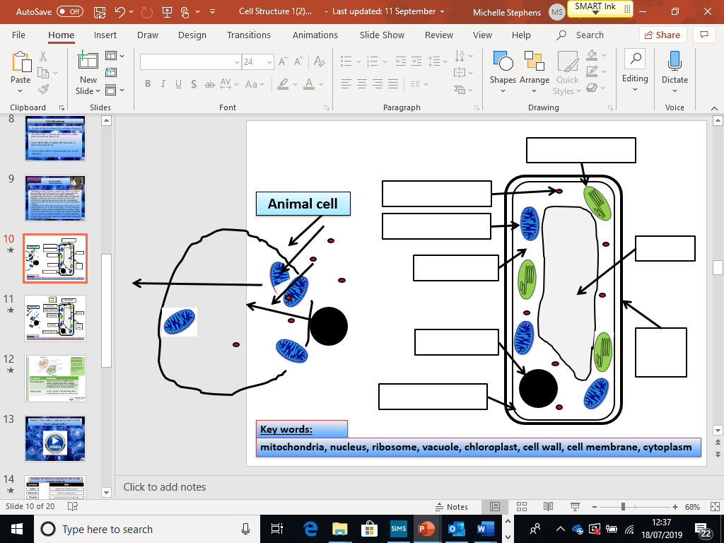

- Name the two reactants of photosynthesis
- Name the two products of photosynthesis
- Name the organelle responsible for photosynthesis
- What colour is chlorophyll?
- What is the chemical formula of glucose?
- What colour will the algae in my pond be if it can photosynthesise?
- Complete the sentences below
Leaf cells can photosynthesise because…..
Leaf cells can photosynthesise but…..
Leaf cells can photosynthesise so…..

How is a leaf adapted to make photosynthesis as efficient as possible?

Photosynthesis is the primary purpose of a leaf. This means leaves are well adapted to achieve two things: collect as much sunlight and carbon dioxide as possible.
- To collect as much sunlight they a wide, long and angled towards the sun. This gives them a large surface area to absorb as much light as possible.
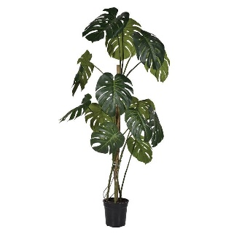
- To collect as much carbon dioxide as possible they are thin and have stomata. The thin leaves make it easy for carbon dioxide to diffuse into the cells. Stomata are small holes in the underside of the leaf which allow the carbon dioxide in from the atmosphere.
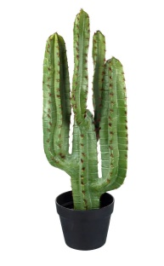
- Why is the leaf wide?
- Why is the leaf thin?
- Cacti don’t have leaves, but have a green fat stem, called a succulent stem. Cacti live in deserts. Explain why cacti can still photosynthesise even though they don’t have leaves.
- Would a cactus be able to photosynthesise as much as a rubber plant if placed outside? Explain your answer using the keyword surface area.

Tissue structure of the leaf: The leaf is made of a number of tissues, each with its own purpose.

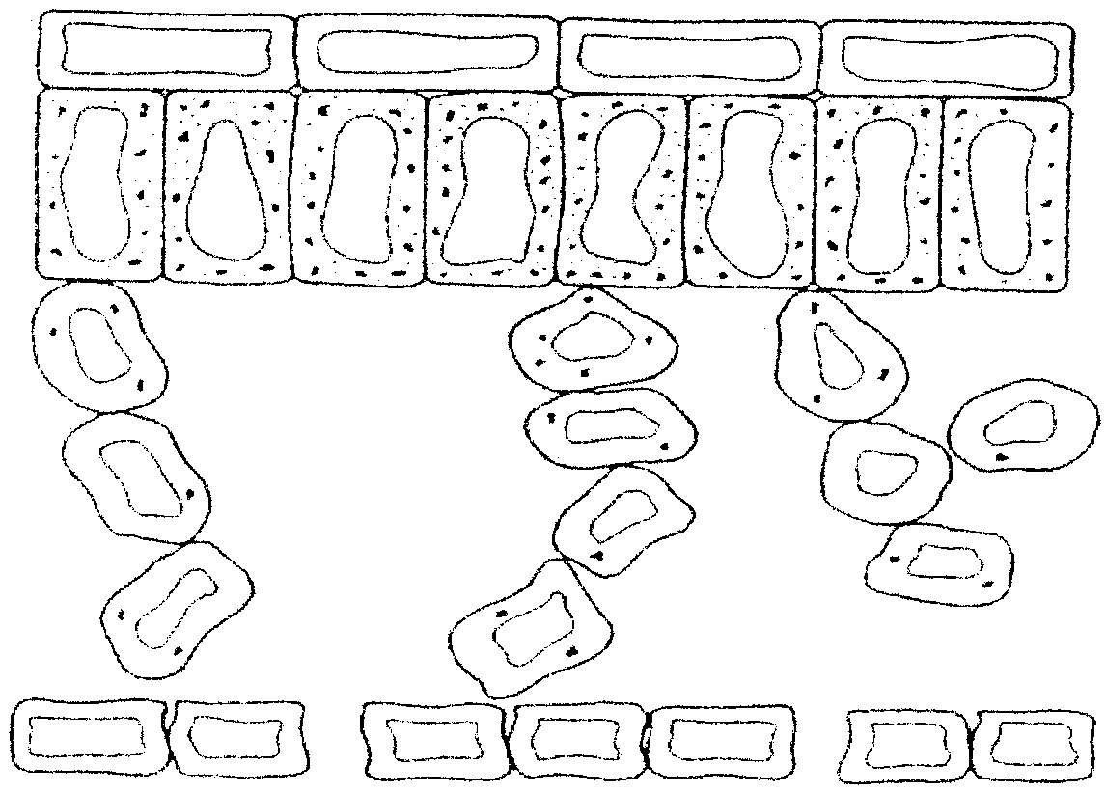

- Which tissue provides a protective layer?
- Why does the spongy mesophyll contain air gaps?
- Which layer has the highest number of chloroplasts?
How does the leaf get all the carbon dioxide it needs?
Carbon dioxide is one of the raw materials needed for photosynthesis to occur. It exists as less than 1% of the earths atmosphere but this is enough to allow plants to grow. The underside of the leaf has tiny holes called stomata. These allow gas exchange to happen. Gas exchange is the name for the diffusion of carbon dioxide into the leaves and the recently made oxygen out of the leaves through the open stomata. The stomata are controlled by guard cells. These cells open and close the stomata to control the diffusion of the gases
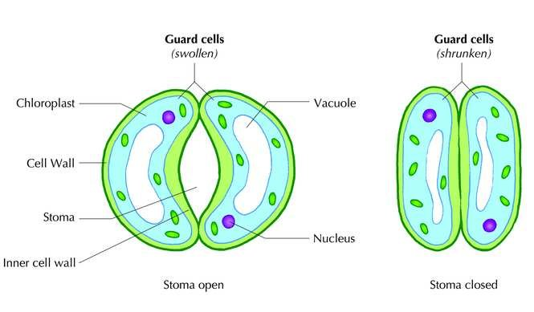
- What controls the shape of the stomata?
- What is the role of the chloroplast?
- Which two of the labelled cell organelles would be found in a nerve cell?

Key Stage 3 Required Practical:
Leaf structure

Aim/introduction: To view stomata and observe the differences between the top and bottom of the leaf.
Method
1. Paint a thin film of clear nail varnish on the top and bottom surface of a leaf such as laurel
2. Whilst it dries, sketch your leaf below and note it’s physical characteristics (thin, veins, colour difference between top and bottom?
3. When it has dried, put a piece of sellotape over the top of the nail varnish and press firmly.
3. Unpeel the sellotape, bringing the nail varnish with it, and stick it down onto a clean microscope slide.
4. Make two slides – one for the top of the leaf and one for the bottom. Make sure you know which is which.
5. Observe the slide from the bottom first. Focus on the stomata and sketch and label a few of the surrounding guard cells.
6. Observe the top slide for comparison.

Diagrams
Sketch of the underside of leaf under microscope with labels.
Sketch of whole leaf with labels of visible features

- Which magnification did you start with to view the leaf impressions? Why?
- The structure of the inside of a leaf is shown below.
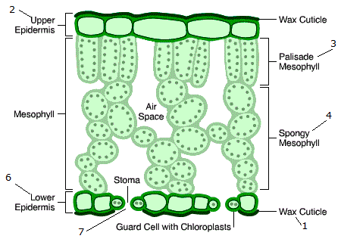

a) Use a blue pencil to show the path that carbon dioxide takes through the leaf during a sunny day
b) Use a red pen to show the path oxygen takes through the leaf during a sunny day.
c) By what process do both of these gases move through the leaf?
d) Why do you think there are air spaces in the mesophyll tissue?
e) What else can escape through the stomata?
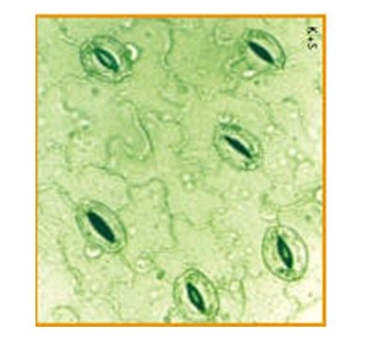
- What did you observe about the number of stomata on the top side of the leaf?
- Why do you think this is?
- An image of some stomata is shown below. The area of the field of view is 0.2mm². How many stomata will be on a leaf with an area of 10mm²? Show your working.

How does the leaf get all the water it needs?
It’s common knowledge that plants need water. If you don’t water a plant its leaves begin to droop and eventually the plant dies. Plants need water for many different reasons but two of the most important are;
- To provide a raw material for photosynthesis
- To provide pressure in the vacuole to give the plant strength.
Plants absorb water through specially adapted cells in their roots. These cells are called root hair cells. Root hair cells cover the roots of the plant. They have special finger-like ‘hairs’ that stick out f the side of their cell wall. These ‘hairs’ increase the surface area of the rot hair cell. By having a large surface area, the roots are well adapted to absorb the water from the soil. Water moves from areas where there is a large volume of it to areas where there is less. This is a special form of diffusion called osmosis. Large surface areas allow osmosis to happen faster than small ones. Looking at the labelled diagram of the root hair cell you can see it has n chloroplasts. This is because the roots are usually under the ground. As no light hits them the chloroplasts would be useless, so the root hair cell does not waste energy in building them.
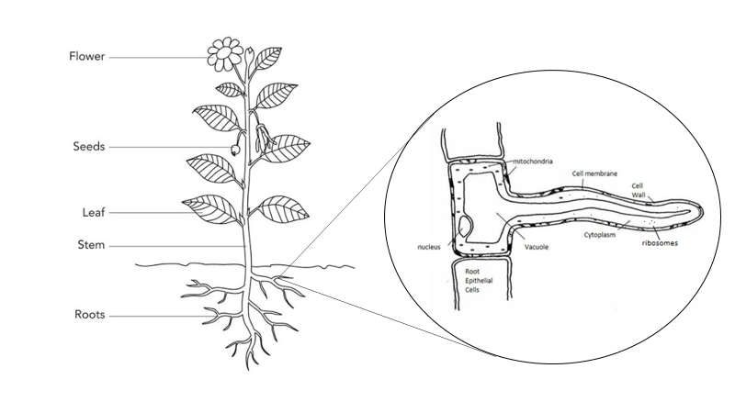

The roots also absorb small amounts of minerals from the soil. These are used to form important chemicals, like chlorophyll, that help the plant stay healthy. These minerals are in low concentration in the soil so the plant cannot absorb them by diffusion. Instead they need to use energy to pump them in by a process called active transport.
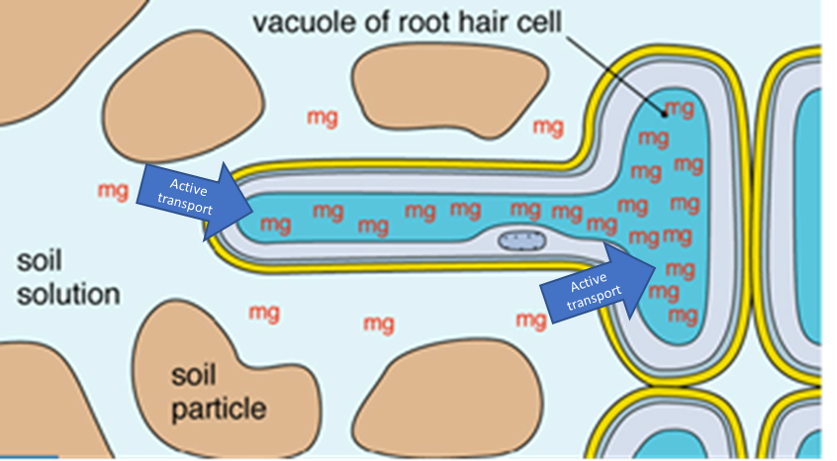
- Name two differences between the root hair cell and the leaf cell
- Name three organelles that are common between a leaf cell and a root hair cell. Give the function of each.
- What is the name for the process where water moves from an area of high concentration to an area of low concentration?
- Define diffusion.
- What organelle is needed to release energy by respiration?
- List two ways active transport is different to osmosis.
- Complete the Venn diagram below with the following words:
Chloroplasts, nucleus, cell wall, cell membrane, mitochondria, vacuole, cytoplasm, hair like finger,

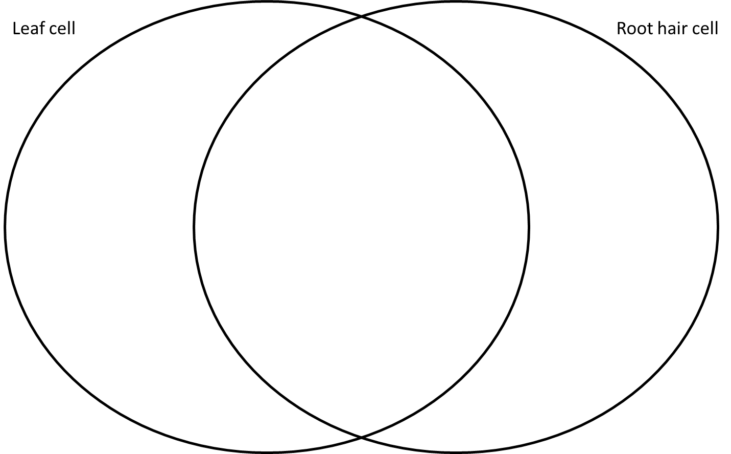

- Compare a root hair cell to a typical plant cell.
Explain the similarities and the differences in terms of the jobs the parts of the cell do.
For example: Both the typical plant cell and the root hair cell have a cell wall for structure and support. Use the Venn diagram from q30 to help you.
How does the plant transport glucose and water up and down the stem?
Plants have a problem. All their leaves need to be near the sun, but their roots need to be near the water. The leaves make glucose. The roots can’t make glucose as they have no chloroplasts. Conversely, the roots have all the water, but the water needs to be transported up to the leaves so they can use it to photosynthesise. To solve this problem the plant has veins. These veins are bundles of two types of tissue; Xylem and phloem
Xylem: Specialised to carry water from the roots to the leaves.
Phloem: Specialised to carry glucose from the leaves to the roots.
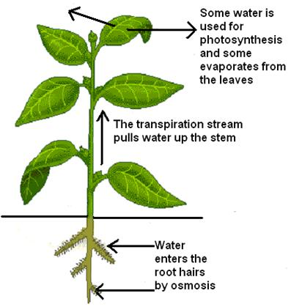
Explaining how the phloem work is easy, gravity pulls the glucose down to the roots. Water going up has to overcome this force. To do this the plant uses its stomata.
- During the day the stomata are open. Oxygen made from photosynthesis diffuses out as carbon dioxide diffuses in. While this happens water vapour also escapes.
- The water loss from the leaves causes water to move out of the xylem by osmosis.
- Water is then pulled up the xylem by the surface tension of the water, like how a straw works.
- The water from the xylem is then replaced by water moving from the roots which in turn is absorbed from the soil by the root hair cells.
This process is called the transpiration stream.

- Name the two types of tissue in a plants vein
- What is the role of the phloem?
- What is the role of the xylem?
- Name two gases which leave the stomata during the day
- Water loss from plants is faster in dry hot and windy climates. Why would a desert plant have much smaller leaves than one found in a rain forest?
What does the plant make with the products of photosynthesis?
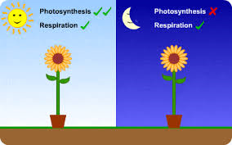
The equation for photosynthesis tells us that there are two products from the reaction; oxygen and glucose. It’s quite easy to understand what the oxygen does. The plant uses some of the oxygen to respire and release energy from its mitochondria. The extra oxygen is released int the atmosphere and all other life, including ours uses this oxygen to respire. The fate of the glucose is more complex.
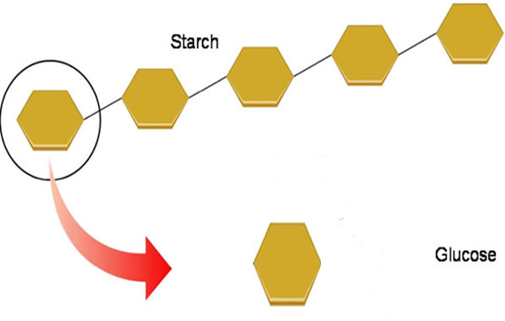
The most important role of glucose is in the plant cells respiration. Plants must respire all the time to ensure they survive, just like all other living things. In the daytime photosynthesis is much faster than respiration so an excess of glucose and oxygen is built up. In the night-time photosynthesis stops but respiration continues.
Spare glucose is stored as starch. Starch is a polymer of glucose. A polymer is a long chain molecule made of many repeating smaller molecules. Some of the glucose is used to make cellulose, which is tough and found in cells walls.
Plants can also turn the glucose into proteins and fats. This allows the plants to make all the structures and compounds needed to help the plant grow and reproduce.
Key Stage 3 Required Practical:
Testing for starch

Aim/introduction:
Leaves produce glucose during photosynthesis. When tested, leaves contain very little sugar. We are aiming to find out if the leaves contain starch – which is a polymer of glucose
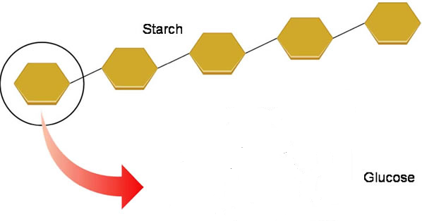

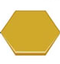

Method
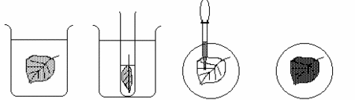

1. Set up a water bath containing no more than 100cm³ of water and get it on a roaring flame.
2. When the water is boiling, put the leaf you are testing into the hot water for around 30 seconds.
3. Turn off the Bunsen.
4. Using forceps, remove the leaf from the hot water and transfer it to a boiling tube. Cover the leaf with ethanol.
5. Put the boiling tube into the beaker of hot water The Bunsen should NOT be on at this point.
6. Leave the leaf for around 10 minutes, then tip the ethanol away and put the leaf back into the hot water just to soften it.
7. Spread the leaf as flat as possible onto a white tile or petri dish and cover it with iodine.

- Complete the risk assessment below
Hazard | Risk | Safety precautions

Results.
- Sketch your results below:

- Describe your results. Use all of the terms below.
Leaf, iodine, starch, glucose, brown, blue-black, photosynthesis
- Why did the leaf have to be put into ethanol?
- Why are leaves green?
- Why is it important to remove the colour from the leaf before applying the iodine?
- What is a polymer? Give two examples
- What is the most important use for glucose?
How can we speed up the rate of photosynthesis?
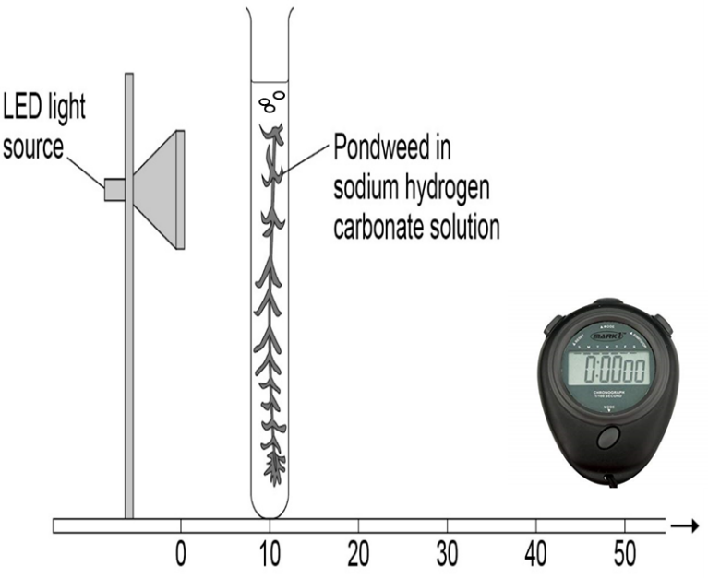
Measuring the rate of photosynthesis of a garden plant is tricky. You can’t see the oxygen being made and the glucose formed is hidden inside cells. However, if we look at pond plants, we can see bubbles of oxygen produced as they photosynthesise.
Hypothesis: Changing the light intensity will change the rate of photosynthesis
- What are the independent, dependent and control variables of this investigation? Use the diagram to help
- Draw a results table to collect the data. Make sure you use a ruler and allow space for repeats.
Method
- Set up the experiment as shown in the diagram.
- Switch the lamp on a wait 60s for the pondweed to acclimatise.
- Count the number of bubbles produced in 60 seconds
- Move the pondweed to 20 cm away from the lamp and repeat the previous steps.
- Plot a graph with the distance of the lamp from the lamp on the x axis and average number of bubbles on the y axis.
- Plants produce oxygen when they make food during the process of photosynthesis. Jean set up the investigation shown below.
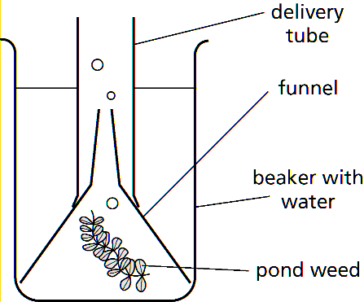
She then pointed a spotlight at the apparatus from a distance of 10 cm and counted the number of bubbles of gas that were released in 2 minutes. She then moved the spotlight so that it was first 20 cm and then 30, 40 and 50 cm away and counted the number of bubbles produced in 2 minutes for each distance.
The investigation was repeated three times at each distance.
Her results are shown below:
Distance away from spotlight (cm) | Number of bubbles released in 2 minutes
Distance away from spotlight (cm) | Test 1 | Test 2 | Test 3
10 | 12 | 11 | 13
20 | 9 | 3 | 8
30 | 5 | 5 | 4
40 | 2 | 2 | 3
50 | 1 | 1 | 2
- Identify any results in the table that look unlikely.
- Explain you reason for your selection in part a).
- If you had got these results, what would you do before calculating averages and plotting a graph?
- What will increasing the intensity of light do to the rate of photosynthesis?
- What will happen to the rate of photosynthesis if the concentration of carbon dioxide decreases?
Why are bees important to our future food security?
Plants are the foundation of nearly all food chain on the planet. Plants are producers, they absorb sunlight and use it to power the combination of carbon dioxide and water into glucose. The starch that is stored is the main source of carbohydrates for all living things. Furthermore, plants make stores like fats with can also be used as a food supply. Animals eat all parts of various plants, from the roots (carrots and potatoes), the leaves (cabbage and spinach), the fruits and seeds (strawberries, rice, wheat etc..)
Most plants need pollinators to reproduce. Pollinators are insects which transfer pollen between flowers to help produce fruits and seeds. The most important pollinators are bees. Most of the crops grown around the world rely on bees to pollinate the crops.

- Why are plants known as ‘producers’?
- Below are the conditions needed for virtually all animal life on the Earth. Describe the role of plants in providing these conditions. Use the equation for photosynthesis to help you.
Condition for animal life | How plants contribute to this
Low levels of carbon dioxide
Oxygen needed for respiration
Availability of food

- The graph below shows some data collected on the number of bee hives in the US. The solid line shows the overall trend.
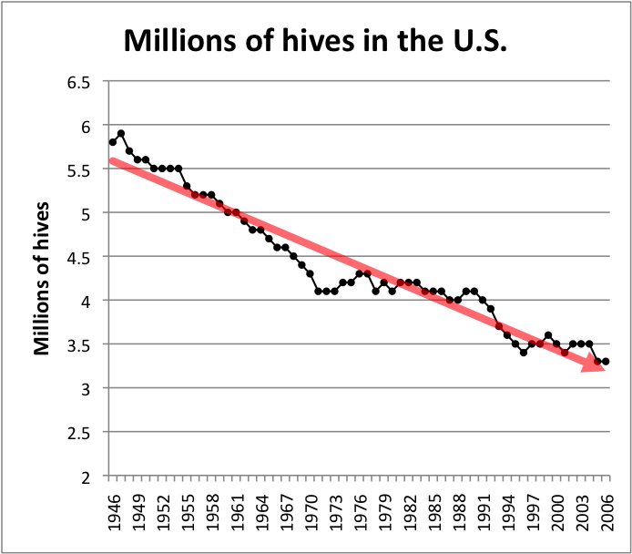

a) Approximately how many hives were there in 1946?
b) Calculate the decline in hives between 1946 and 2006
c) Explain how a decline in pollinating insects could affect food supplies across the world.

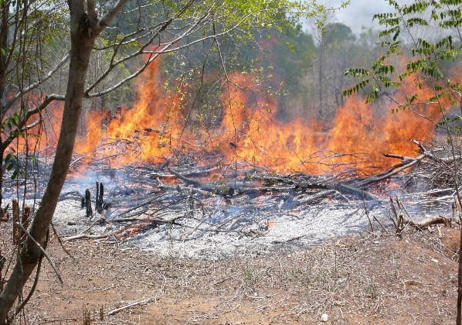
- In many parts of the world, trees are cut down to make way for farmland. The trees are often burned to get rid of them. This technique is known as ‘slash and burn’.
Explain two ways this technique increases carbon dioxide levels.

- Calculate the percentage decrease in bee hives between 1946 and 2006 shown by the graph above. Give your answer to 2 significant figures.
- Explain why it is important that this sort of data is collected by:
a) independent scientists
b) scientists in more than one country
Revision and extended practice
- The drawing shows an experiment to investigate photosynthesis in weed from a pond.
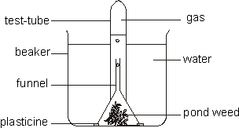
Bubbles of gas produced during photosynthesis were given off from the pond weed and collected in the test tube.
(a) Name the gas given off in photosynthesis
(b) What two substances are taken in by the plant and used for photosynthesis?
Light of different intensities was shone onto the pond weed. The number of gas bubbles given off in one minute at each light intensity was counted. The results are shown in the graph.
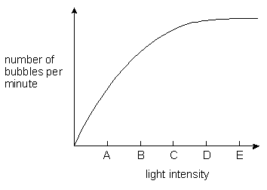
(c) Which letter on the horizontal axis shows the light intensity at which the rate of photosynthesis first reaches its maximum?

Blue, green and red light were then shone, in turn, onto the pond weed. The number of bubbles of the gas given off in one minute was counted. The results are shown in the table.
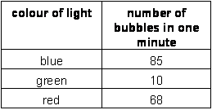
The leaves of the pond weed contain a green pigment which absorbs light for photosynthesis
(d) (i) Name this pigment.
(ii) Using the information in the table, tick a box by one colour of light which is strongly absorbed by the pigment.
blue 
green
red
(e) Sugar is also produced during photosynthesis.
Give two ways in which the plant uses sugar.
- In the seventeenth century a Belgian scientist, Van Helmont, planted a young willow tree in a tub of dry soil.
During the next five years he watered the plant with rain water but he did not add anything else to the tub.
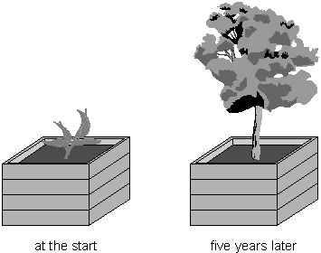
After five years Van Helmont removed the willow tree from the tub and weighed the tree.
He also dried and weighed the soil. Results from Van Helmont’s experiment are shown in the table.
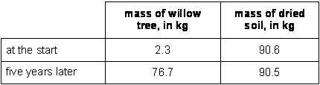
(a) Van Helmont concluded that the increase in the mass of the willow tree was due only to a gain in water.
(i) What two pieces of evidence did Van Helmont use to reach his conclusion?
(ii) We now know that Van Helmont’s conclusion is not correct.
Explain why the mass of the willow tree increased by such a large amount.
(b) Van Helmont believed that a plant would always grow faster if it was given more water.
We now know that this is not true.
Give two environmental conditions which can slow down the growth of a plant, even when it has plenty of water.
(c) The fresh mass of a plant includes water. To measure plant growth accurately, scientists calculate the increase in the dry mass rather than the increase in the fresh mass of a plant.
Why is finding the increase in fresh mass not a reliable way to measure plant growth?

- What is the function of the leaf?
- Write the word equation for photosynthesis. Identify the reactants and the products.
- A cross section of a leaf is shown below:
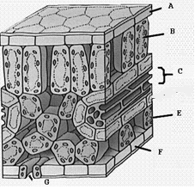

&D

Complete the table to show the name and function of the parts shown. The first one is done for you.
Letter on diagram | Name | Function
A | Waxy cuticle | Stops water loss from the leaves
B
C
D
E
F

G

- Below are three adaptations of leaves. Explain how these features make the leaf well adapted for its job
Leaves are wide and flat
The spongy layer contains air spaces
The palisade cells contain lots of chloroplasts

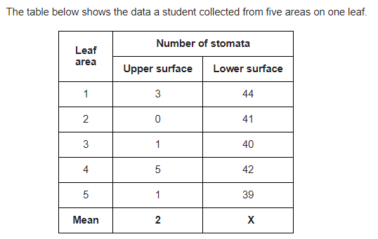

a) Calculate X
b) Explain why having few stomata on the top of the leaf is an advantage to the plant

Accurate scientific language

Poor/incomplete statement | Correct statement
Plants absorb food from the soil

Plants absorb water through the stomata in the leaves

Plants absorb mineral ions from the soil by diffusion

When measuring the effect of light intensity on the rate of photosynthesis, the temperature must be controlled by using a thermometer

Plants photosynthesise when its light and respire when its dark

Carbon dioxide levels are increased by deforestation because CO₂ is released when trees are cut down.

Plants need oxygen and water for photosynthesis

Plants have most stomata on the bottom of the leaf because this means water can drop onto the ground

