Rates and Energetics Mastery Booklet
Lesson 1: How can we measure the rate of a chemical reaction?
A chemical reaction is a chemical change that is difficult to reverse. For a chemical reaction to occur the particles need to collide with enough energy. The reactants break their bonds between their atoms and form new chemicals, called products. In a chemical reaction the bonding between atoms changes but the number and types of atoms remains the same. This is called the conservation of mass. Some chemical reactions happen spontaneously, this means they happen as soon as the reactants mix. Magnesium in hydrochloric acid is a good example. As soon as the magnesium touches the hydrochloric acid it begins to fizz, releasing hydrogen gas and forming magnesium chloride solution. Some reactions need extra energy to make the reaction work. Often we use heat to increase the energy. The amount of energy needed for a reaction to start is called the activation energy. Iron undergoes a spontaneous reaction with oxygen. Iron oxide forms, we call it rusting. The rate of iron rusting is much slower than magnesium and acid. To measure the rate of reaction we need to measure a change in the reaction over a time period.
Possible ways of measuring a rate of reaction are:
- Time it takes a solid to disappear
- Time it take a solid to form (precipitation)
- Time it takes for a volume of gas to be produced
- The volume of gas produced in a fixed time

- The change in mass of a solid in a fixed time

- What is a chemical reaction?
- Define reactants?
- Define products?
- What do we mean when a reaction is spontaneous?
- State the conservation of mass
- Define activation energy
- Write a word equation for the reaction of magnesium with hydrochloric acid
- Write a balanced symbol equation for the word equation above
- Write a word equation for rusting

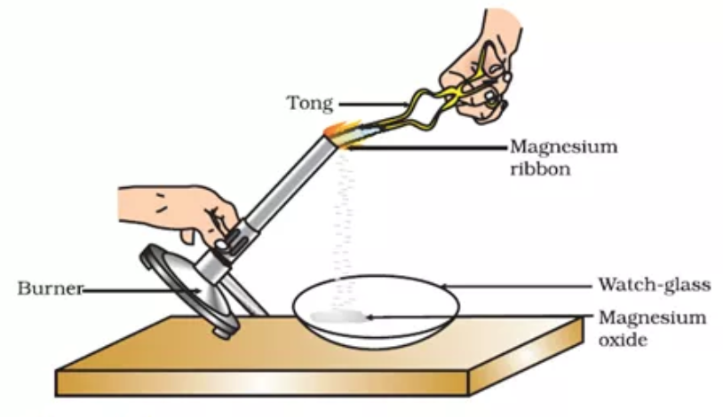
Demo: Burning magnesium
- How could we tell there was a chemical reaction occurring?
- Why is this reaction called an oxidation?
- Why did the reaction need to be heated?
- Write a word equation for the reaction
- Is this reaction spontaneous? Give a reason for you answer

In each reaction we need to choose the easiest method that will give us the most reliable values and reduce the chance of anomalous results.
Sybil places an iron nail in some water. After 5 minutes she says “My iron is not rusting as it looks normal” Explain why she is wrong
- For each of the diagrams list possible ways of measuring the rate of reaction. There may be more than one possible answer.
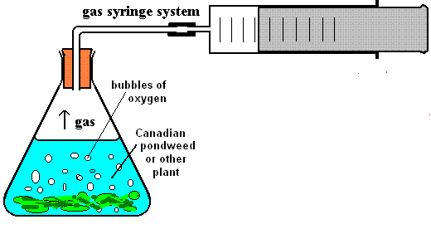
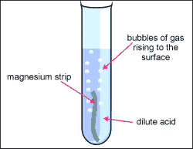
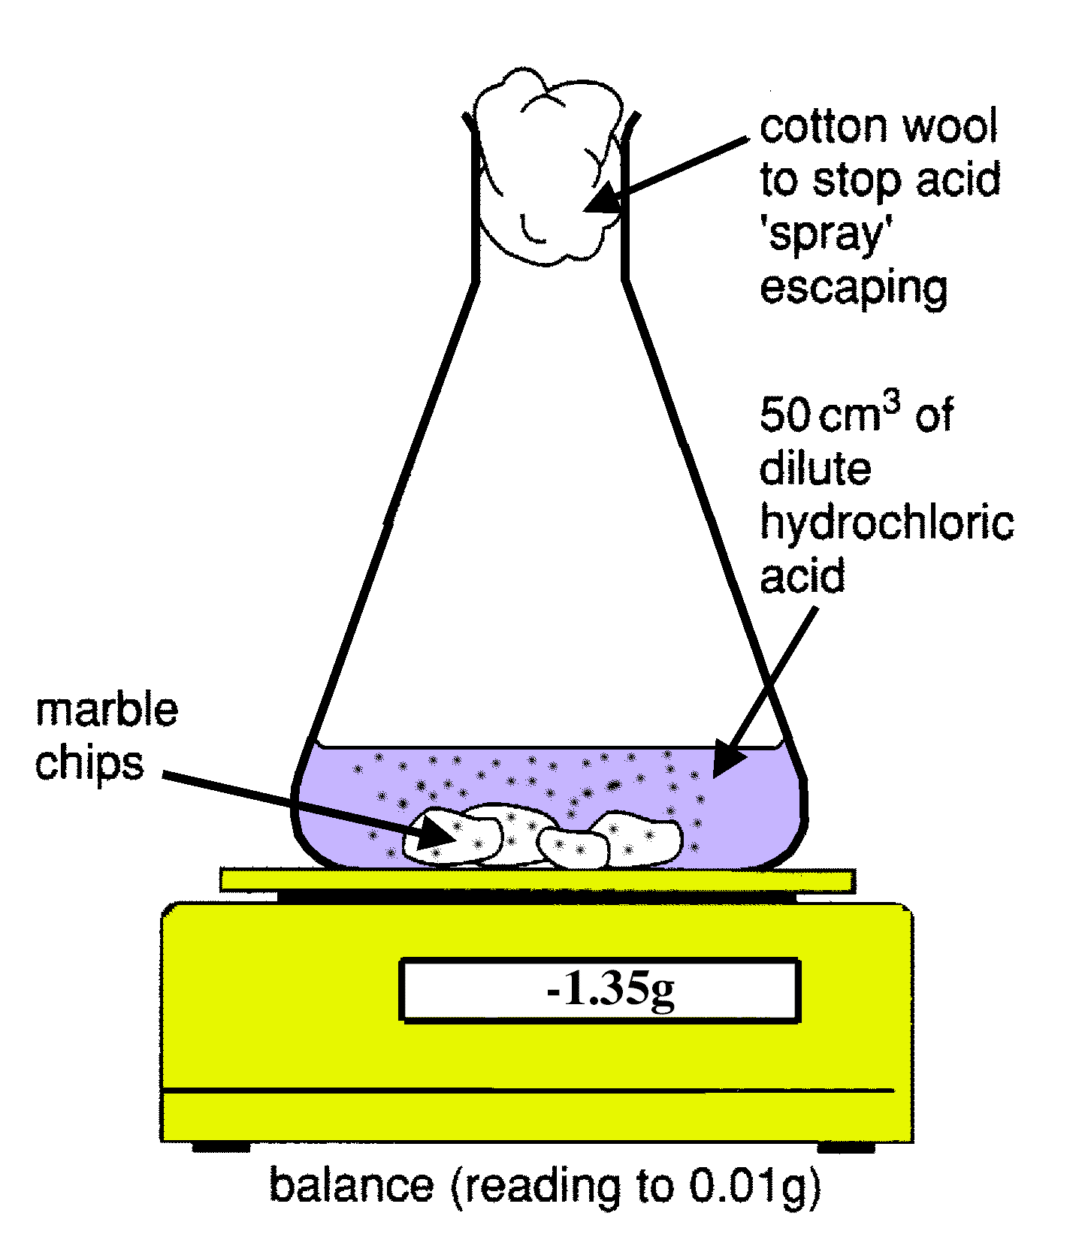
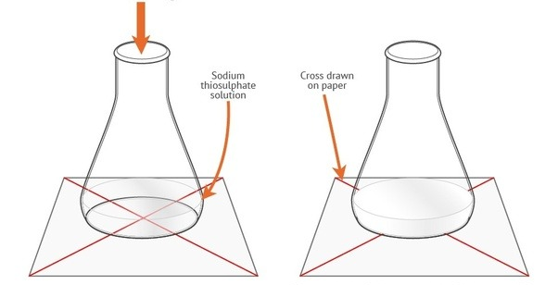
Practical: Measuring the rate of reaction of marble chips and hydrochloric acid
- Measure 25cm³ of hydrochloric acid and add to the conical flask.
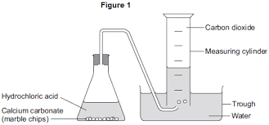
- Place four marble chips into the conical flask and put the bung into the tube.
- Measure the volume of gas in the syringe every 30 seconds for 3 minutes.
- Record the results in a table of your own design
- Plot the graph on graph paper
- X – axis: Time (secs)
- Y-axis: Volume of gas produced (cm³)
- Correct plots using X not dots
- Smooth curve – no hairy bits or joining anomalies in – starting at the origin.
- When was the reaction the fastest?
- How do you know?
- At what point did the reaction start to slow down?
- When did the reaction stop? How do you know?
- Why do you think the rate changes?

Reactions do not proceed at a steady rate. They start off at a certain speed, then get slower and slower until they stop. As the reaction progresses, the concentration of reactants decreases. This reduces the frequency of collisions between particles and so the reaction slows down. We can tell the rate of reaction by the gradient (steepness) of the line on the graph.
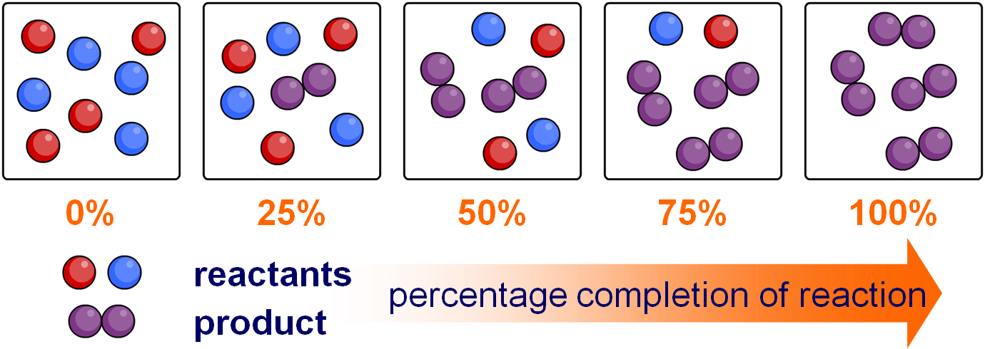
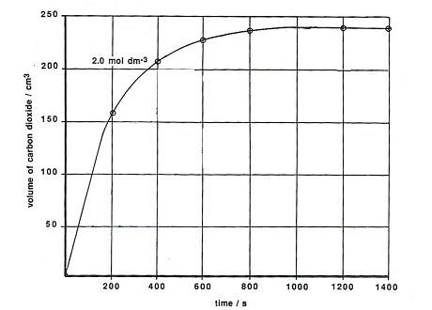
- Look at the graph and answer the following questions:
- When was the reaction fastest?
- When did the reaction stop?
- Describe what happened to the rate during the reaction.
Include data to back this up – e.g volume of gas collected in different time periods
Explain why the reaction rate changes.
- Key terms: Collisions, frequency, concentration, reactants, products
- Look at the data in the table below
Experiment | Volume of gas collected in 100s (cm³) | Rate of reaction (g/cm³)
A | 250
B | 100
C | 50
- Which reaction was the fastest?
- Calculate the rate of reaction (volume of gas ÷ time)
- Which reaction had the least frequent collisions?
- In a reaction the mass of a reactant decreases by 58g in 233 seconds. What is the rate?
- In a reaction the mass of a reactant decreases by 0.43g in 80 seconds. What is the rate?
- In a reaction the mass of a product increases by 3kg in 210 seconds. What is the rate?
- In a reaction the mass of a reactant decreases by 41g in 2 seconds. What is the rate?
Lesson 2: How does changing the concentration affect the rate of reaction?
Collision theory is used to explain why chemical reactions occur. As mentioned before we need the particles to collide with an energy above the activation energy.
Concentration is the number of particles in a given volume. In the box below there is a low concentration of particles

- In the empty box draw what a high concentration of particles would look like
Practical
The rate of the reaction between HCl and marble chips depends on the concentration of the acid. We saw last lesson that the rate of a reaction varies as it progresses.
But what effect does changing the concentration of one of the reactants have?
Magnesium and hydrochloric acid react to produce magnesium chloride and hydrogen gas. The gas can be collected in a method like the one in the diagram. The rate of the reaction can be measured simply by timing how long it takes to collect a certain volume of gas.
Hypothesis: The rate of a reaction between magnesium and hydrochloric acid depends on the concentration of the hydrochloric acid.
Concentration of HCl | Time to collect 30cm³ hydrogen (s)
Concentration of HCl | 1 | 2 | 3 | Average

When a scientist investigates a hypothesis it is vital they accurately report their method so that other scientists can check their findings reproducibility.
- Below is a worked example of how to write an accurate method for a different practical. Use it to complete the blank table and then write your method up in a paragraph in your book.
Step | Apply to your question
What is the independent variable? | Temperature
State the range and interval you’ll use | 10 – 50 °C in 10° intervals
What is the dependent variable? | The rate of reaction
How are you going to measure this? | Time it takes to go cloudy
Control variables?  Do NOT use the word ‘amount’ | Volume of acid  Volume of thiosulphate
Start by describing the set up of your first experiment.  Include volumes and equipment | Measure 50cm³ sodium thiosulphate into a conical flask  Measure out 5cm³ of hydrochloric acid
Say how to start the experiment and if this means starting measuring (e.g a stopwatch) | Add the HCl to the flask, stand on a cross and start a stopwatch
Describe how you’ll know when to stop | Stop timing when the cross has disappeared
State which measurement you will write down | Write down the time
Say ‘repeat steps 1-6 using….’ Insert your range and interval for the IV here | Repeat steps 1-5 but use thiosulphate and acid at 20, 30, 40 and 50°C
Describe 2-3 control variables.  Do NOT use the word ‘amount’ – use ‘volume’ or ‘mass’ | Keep the volume of acid the same, as well as the concentration. Always use 50cm³ thiosulphate.

Step | Apply to your question
What is the independent variable?
State the range and interval you’ll use
What is the dependent variable?
How are you going to measure this?
Control variables?
Do NOT use the word ‘amount’
Start by describing the set up of your first experiment.
Include volumes and equipment
Say how to start the experiment and if this means starting measuring (e.g a stopwatch)
Describe how you’ll know when to stop
State which measurement you will write down
Say ‘repeat steps 1-6 using….’ Insert your range and interval for the IV here
Describe 2-3 control variables.
Do NOT use the word ‘amount’ – use ‘volume’ or ‘mass’
- Calculate the mean time, making sure you ignore any anomalous results
- Plot a line graph (X axis=concentration, Y axis=time to collect 30cm³ )
- Describe how changing the concentration affects the rate of reaction (Hint: say how it changes, use numbers as evidence)
- Explain why increasing the concentration increases the rate of reaction (Hint: use collision theory)
- Give one source of error from the practical.
- Marjorie says “increasing the concentration of the acid speeds up the reaction because there are less frequent collisions so more reactant is formed” There are two mistakes. Re-write with the corrections.
Lesson 3 How does increasing the surface area increase the rate of reaction?
By increasing the surface area of a substance, you are increasing the number of particles available to react
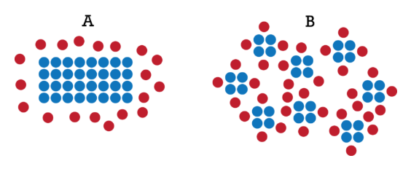
In this diagram, a lump of metal is being reacted with a solution. In image A, only the particles at the very edge of the metal can collide with particles from solution. Particles from inside the metal cannot collide.
In image B, particles from the inside are now on the edges of the material and are free to collide with the solution. This results in more frequent collisions and a greater rate of reaction. In order to increase the surface area of a solid, it can be crushed up into smaller pieces. We can say the particles in image B have a higher surface area.
Practical: Investigating how changing the surface area of rhubarb affects the rate of reaction
- Cut three 5 cm lengths of rhubarb.
- Leave one piece as it is, cut one piece in half lengthways, and cut the third piece into 4 evenly-sized pieces.
- Measure 30 cm3 of acidified potassium manganate(VII) solution into a beaker. Pour the same quantity of water into another beaker.
- Place the beakers on a white tile. Put the whole 5 cm long piece of rhubarb into the potassium manganate(VII) and start the timer. Stir the solution containing the rhubarb until the purple colour disappears. If you are not sure, briefly remove the rhubarb and compare the colour of the solution to the beaker of water. When they look the same, stop the timer.
- Rinse out and dry the reaction beaker.
- Repeat the experiment using the piece of rhubarb cut into 2 (use both halves). Rinse and dry the beaker.
- Repeat the experiment again, this time using the piece of rhubarb cut into 4.
Size of rhubarb | Time to decolourise solution (s) | Relative rate (s⁻¹)
Whole
Halved
Quartered
- Calculate the relative rate by 1÷ time
- Which had the largest surface area?
- Which had the fastest rate?
- Describe the link between surface area and the rate of reaction
- Explain the link between surface area and rate of reaction using collision theory
- If 10g of rhubarb was placed in 40g of potassium permanganate what would the total mass of the products be?
- Rhubarb contains oxalic acid. Suggest a pH and colour of universal indicator for rhubarb juice.
Time (s) | Mass of flask and reaction(g)
Time (s) | Small surface area  (________________) | Medium surface area | Large surface area  (___________________)
0 | 0 | 0 | 0
30 | 25 | 44 | 65
60 | 44 | 71 | 78
90 | 70 | 80 | 94
120 | 85 | 92 | 95
150 | 92 | 95 | 95
180 | 95 | 95 | 95
A different experiment was completed using different sized marble chips in similar method to last lessons practical. The following data was collected.

- In the two spaces on the table write small chips and big chips. Get this answered checked before moving onto q below.
- Plot the three lines on graph paper. Draw a smooth curve of best fit for each one.
- Which reaction had the fastest rate? How could you tell from the graph?
- At what time did the medium surface area chips finish reacting? How could you tell?
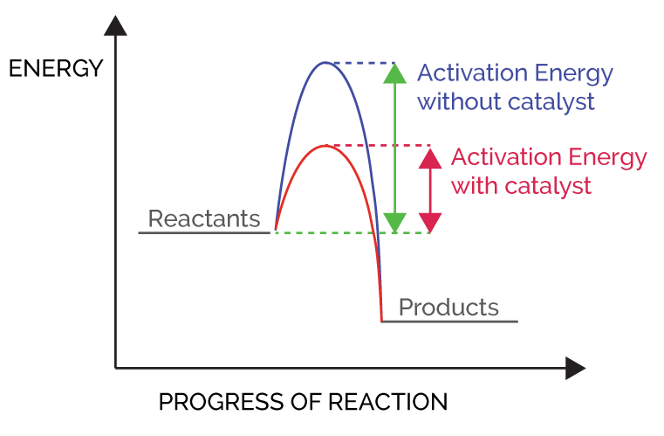
Lesson 4 Catalysts
A catalyst is something which is added to a reaction to increase its rate. It is not used up as part of the reaction. It works by lowering the activation energy of the reaction, so when particles with less energy collide a reaction can still occur.

Most of the chemical reactions that occur in the human body and in other living things are high-energy reactions that would occur slowly, if at all, without the catalysis provided by enzymes. For example, in the absence of catalysts, it takes several weeks for starch to break down into glucose. Some enzymes increase reaction rates by a factor of one billion or more.
Industrial Catalysts
Catalysts are very important in industry. Finely divided precious metals, such as platinum and gold, or metal oxides are often used as catalysts. They are hugely expensive, but, as they are not used up in the reaction, they can be used again and again. Other commonly used surface catalysts are copper, iron, nickel and palladium.
Catalysts tend to be fairly specific; that is, they catalyze only one reaction of one particular reactant (called the substrate). This means that very often, more than one catalyst may be needed in a chemical plant.
Catalysts work by lowering the activation energy for a reaction, i.e., the minimum energy needed for the reaction to occur. This is accomplished by providing a new mechanism or reaction path through which the reaction can proceed. When the new reaction path has a lower activation energy, the reaction rate is increased and the reaction is said to be catalyzed. This very often results in lower temperature being used in industry, saving money and cutting the use of fossil fuels and their subsequent emissions.
One example of everyday catalysts is the ones in a catalytic converter in a car. They have a honeycomb construction inside, which contain precious metals like gold, platinum and so on. As the exhaust gases pass through, the construction then removes all the harmfulness in the gases.
- What is a catalyst?
- How do they work?
- Why are they used in industry?
- Why do you only need a small amount of a catalyst?
- Over the past 10 years, there have been a large number of catalytic converters stolen from the underside of cars. Why do you think people steal them?
Hydrogen peroxide decomposition demonstration
Watch the demonstration the hydrogen peroxide (H₂O₂) decomposes to form water and oxygen
- Which catalyst was best? Give a reason for your choice
- Write a word equation for the reaction
- Write a balanced symbol equation for the reaction
- Lloyd watches the demonstration and says “That was a waste of catalyst. Now it’s used up we will need to throw it away.” Explain why Lloyd is wrong
- Why is the reaction called a decomposition?
- What was the independent variable?
- Name 2 control variables for this investigation
- How did we prove it was oxygen gas being released?
- How could we have made sure the surface area of the liver was the same as the powders?
- Define ‘reactant’
- Define ‘product’
- How would the result be different if we cooked the liver first? Give reason for your answer
- Respiration ‘burns’ glucose at body temperature (37ºC). In a lab glucose burns once it reaches 144ºC.
- Why is the word ‘burns’ in inverted commas?
- Calculate the percentage decrease in the temperature the reaction happens at inside the body.
- Why can the reaction happen at such a low temperature? Make sure you include the words activation energy in your answer
Lesson 5: Exothermic and Endothermic reactions
The law for the conservation of energy states “Energy cannot be created or destroyed, only transferred from one store to another”. In any substance there is a store of energy. When chemical reactions occur the amount of energy in the chemical store of the products is different to the reactants. Before we go into this in more detail we need to make two things clear:
- The chemicals (reactants or products) are very small and impossible to see
- The test tube, water they are dissolved in, thermometer, air around them are all part of the surroundings
In the case below the products have less energy in their chemical store. The excess energy has been released and absorbed by the surroundings. This increases the thermal store of the surroundings. Our thermometer will show a temperature rise. This is an exothermic reaction because the surroundings have increased in temperature. Exothermic means ‘releases heat’. Examples of exothermic reactions include combustion, repisration, neutralisation, acids and metals.
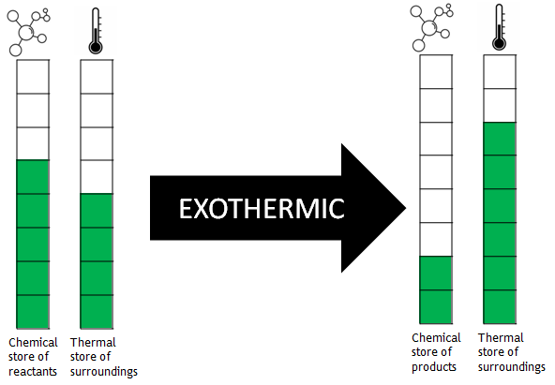
In the second example the chemical store of the products is much larger than the reactants. For this reaction to happen the reactants need to absorb energy from the surroundings thermal store. This means the surroundings have less energy and the thermometer shows a drop in temperature. This is an endothermic reaction. Endothermic means ‘takes in heat’. Examples of endothermic reactions include thermal decomposition, citric acid and sodium hydrogen carbonate, sports related cold-packs.
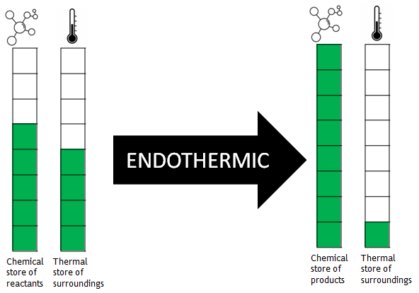
Investigating exothermic and endothermic reactions
For each of the reactions below read the instructions carefully and complete the practical. Make sure you wait at least 1 minute before adding the final reactant to get a reliable starting temperature.
Exp | Reaction | Start temp (°C) | End temp (°C) | Temp change (ºC)
1 | Demo: Measure out 10cm³ NaOH into the polystyrene cup and add 10cm³ HCl
2 | Demo: Barium hydroxide and ammonium chloride
3 | Add 1 spatulas of iron filings to  5cm³ copper sulphate in a test tube
4 | Measure out 5cm³ water from  the tap into a test tube and add a spatula of ammonium nitrate
5 | Measure out 10cm³ NaOH into  A beaker and add 10cm³ HCl
6 | Measure out 5cm³ of distilled water into a test tube. Add a spatula of sodium hydrogen  carbonate and stir, take the temperature then add a spatula of citric acid

- List the numbers of the reactions which were exothermic
- List the numbers of the reactions which were endothermic
- Compare your answers to exp 1 and 5. Which result is more reliable? Give a reason for your answer.

- Complete the table below
 | Exothermic | Endothermic
Energy
Temperature of surroundings
Examples
- Dora says “an exothermic reaction is a reaction where energy is taken into the reactants causing a temperature change” she has made two mistakes. Re-write the correct definition into your books
- The following experiment was used to compare how much heat energy three different fuels gave out when they were burnt.
Thermometer
Metal can

Fuel burner
100g water

Here are the results when 1.0 g of each fuel was burnt.
fuel | temperature of water at start | temperature of water at end
ethanol | 19ºC | 36ºC
paraffin | 20ºC | 47ºC
white spirit | 18ºC | 41ºC

Are the reactions exothermic or endothermic?
- Explain how you know your answer to Q42.
- What was the temperature change when 1.0 g of ethanol was burnt?
- Which fuel released the most energy when it was burnt?
- Why it is important to burn 1.0 g of each fuel in each experiment?
- The temperatures of reactions of zinc, magnesium and nickel with hydrochloric acid were measured.

The results are shown in the table.
metal | Temp at start ºC | Highest temp reached ºC | Temp change  ºC
nickel | 19 | 24 | 5
calcium | 19 | 57
zinc | 19 | 30 | 11
  - Calculate the temperature change for the calcium reaction.
  - Magnesium is more reactive than zinc but less reactive than calcium. Predict the temperature change for a reaction between magnesium and hydrochloric acid.
  - What name is given to reactions which give out heat?
- What temperature change will be observed for an endothermic reaction?
- Complete the table to identify ways of improving our results
Source of error during practical work​ | Suggestion for improvement​ | How this would improve results​
Energy transfer through the beaker​ | Use a polystyrene cup or insulate the beaker​ | Reduce energy transfers through the beaker and therefore improve the accuracy of the temperature change​
Energy transfer at the surface of the liquids​ | ​ | ​
Misreading the thermometer​ | ​ | ​
Thermometer only reads to whole numbers​ | ​ | ​

Lesson 6: Combustion
Fire is one of the most important discoveries in human history. Fire has provided warmth through the cold winters of our ancestors. Fire has cooked our food and fired our clay pots. Fire has allowed us to extract metals from the ground to make the machines of the industrial revolution. Fire has allowed us to release energy from fuels like coal, oil and natural gas. This energy was used to power steam and, more recently, the internal combustion engine. It is safe to say that the story of human civilisation is the story of fire.
Fire itself is the product of combustion. Combustion is an oxidation reaction. It happens when organic molecules (made mainly of carbon and hydrogen) are reacted with oxygen. The products of combustion are carbon dioxide and water. There is also a large amount of energy released to the surroundings.
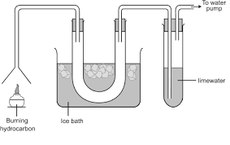
A common type of fuel is an alkane. These saturated hydrocarbons are found in the ground as crude oil. They are made of only carbon and hydrogen and they release huge amounts of energy when they combust. Examples include natural gas (methane) which is used for cooking and heating
Products of combustion demo
- What did you observe happen in the U tube?
- What conclusion can be made?
- What did you observe happen to the limewater?
- What conclusion can be made?
Complete combustion
Complete combustion is when there is an excess of oxygen present. A roaring blue Bunsen flame is an example of complete combustion. As there is more than enough oxygen every single atom of carbon and hydrogen can bond with oxygen. Complete combustion forms carbon dioxide and water. Because so many new bonds are made it releases the most amount of heat. Carbon dioxide is a greenhouse gas and rising levels have been thought to be the main cause of climate change through global warming
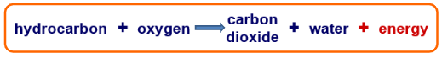
Incomplete combustion
In complete combustion is when there is a limited amount of oxygen. A yellow Bunsen flame is from incomplete combustion. There is not enough oxygen to form carbon dioxide (CO₂) so instead carbon monoxide (CO) or soot (C) form. The soot causes smoke and soot which can give people trouble with breathing. It has also caused smog and blackened buildings. The carbon monoxide is an odourless and colourless gas. It is toxic because it sticks to red blood cells in the place of oxygen, suffocating the person. By law all rented properties are required to have a carbon monoxide detector by their gas boiler to prevent carbon monoxide poisoning. Incomplete combustion releases less heat as fewer bonds are formed.
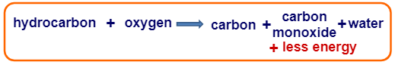
- Complete the table below to summarise the differences in the types of combustion

​ | Complete combustion​ | Incomplete combustion​
Oxygen supply​ | ​  ​ | ​
Colour of flame​ | ​  ​ | ​
Energy released​ | ​  ​ | ​
Smoke/soot produced​ | ​  ​ | ​
Environmental issue​ | ​  ​ | ​

- Use the venn diagram below to compare complete and incomplete combustion
Incomplete combustion
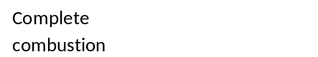

- (Extended response) Compare complete and incomplete combustion
Hint: Compare means mention how they are the same and different
Useful vocab: Contrastingly, however, similarities
Keywords: oxidation, energy, flame, products, oxygen​, smoke, soot, greenhouse, toxic
- This apparatus can collect the products of a combustion reaction. Label the diagram using words from the box.
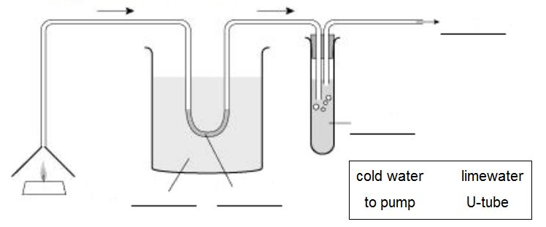

- Which two gases rise from the candle and enter the delivery tube?
- What collects in the U-tube?
- Why is the U-tube cooled?
- Blue cobalt chloride paper is placed in the U-tube. What is seen and what does it prove?
- What happens to the limewater? What does this prove?
- Candle wax contains the hydrocarbon pentacosane. What is meant by the term hydrocarbon?
- Write the word equation for the combustion of pentacosane:
Balancing complete combustion equations is easier than it seems if you follow these simple rules:
- If the fuel has an odd number of carbons (e.g., CH₄, C₃H₈) you need one molecule of fuel in the equation.
- If the fuel has an even number of carbons (e.g., C₂H₆) you need two molecules of fuel in the equation.
- Each carbon in the reactants makes one molecule of CO₂ in the products.
- Every two hydrogens in the reactants make one molecule of H₂O in the products.
- Then all you need to do is count up the oxygen atoms in the products and balance this in the reactants.

- Note: this only works for complete combustion of alkanes.

- Try writing balanced equations for combustion of:

- Propane (C₃H₈)
- Ethane (C₂H₆)
- Pentane (C₅H₁₂)
- Decane (C₁₀H₂₂)
- Pentacosane – candle wax (C₂₅H₅₂)

- When carbon burns it combines with oxygen to form carbon dioxide. The diagram shows some carbon atoms reacting with some oxygen molecules.
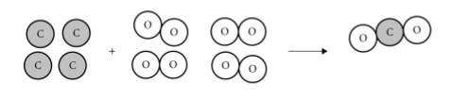
- Finish the diagram by drawing the correct number of carbon dioxide molecules. One has been done for you.
- Write ‘reactants’ and ‘products’ under the correct sides of the diagram.
- 12 g of carbon reacted with 32 g of oxygen. What mass of carbon dioxide was formed? Circle the correct answer.
12 g 24 g 32 g 44 g 64 g
- This diagram below shows the reaction between marble chips and acid.
This is the word equation for the reaction:
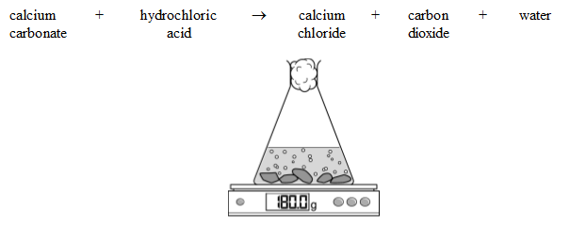
- Is carbon dioxide a solid, a liquid or a gas?
- What would you expect the balance to read when the reaction has finished? Circle the correct answer. 179 g 180 g 181 g
- Explain your answer to part b.
- If you heat a piece of copper, it combines with oxygen from the air to form a black layer of copper oxide.
- Write a word equation for this reaction.
- How would the mass of your piece of copper change as you heated it?
- Why would this happen?
Lesson 7: Thermal decomposition.

‘Thermal’ means heat. ‘Decomposition’ means breaking down. Thermal decomposition means the breaking down of a reactant using heat. Metal carbonates often undergo thermal decomposition to form a metal oxide and carbon dioxide.
For example:
calcium carbonate calcium oxide + carbon dioxide
CaCO3 (s) CaO (s) + CO2(g)​
As a gas is a product of the reaction there is an apparent loss of mass during the reaction.
- Define ‘thermal decomposition’
- Why is a thermal decomposition an endothermic reaction
- State the law for the conservation of mass
- What causes there to seem to be a drop in mass?
- Write word equations for the following thermal decompositions:
  - Magnesium carbonate
  - Zinc carbonate
  - Copper carbonate
- Write balanced chemical equations for the above reactions

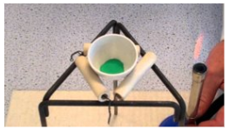
Practical: Decomposition of copper carbonate.
- Weigh your empty crucible – record this mass​ in a table of your own design
- Add two spatulas of copper carbonate and reweigh. ​
- Sit it on a tripod and clay pipe triangle and heat with a roaring flame until the reaction is over.​
While the reaction completes: ​Draw and label your equipment in a correct scientific diagram. Calculate the mass of copper carbonate you started with​.
- Reweigh your evaporating dish. ​
- Calculate the mass of copper oxide in the dish. ​
- What mass of carbon dioxide must have been given off? ​
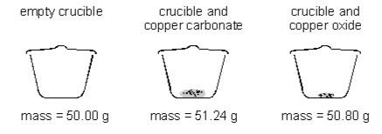
- ​Write the equation for the reaction and the masses you’ve worked out underneath each substance. ​
- Two pupils heated some copper carbonate in a crucible. They recorded the mass of the crucible and contents before and after heating.
(a) The word equation for this reaction is:
copper carbonate → copper oxide + carbon dioxide
- What mass of carbon dioxide is given off in this reaction? Give the unit.
- What is the name of this type of chemical reaction?
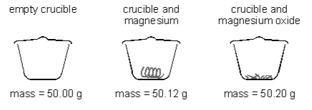
(b) The pupils then heated some magnesium in another crucible. They worked carefully and did not lose any of the magnesium oxide which formed. They recorded the mass of the crucible and contents before and after heating.
- Write a word equation for the reaction.
- Why does the mass of the contents of the crucible increase in this reaction?
- What is this type of chemical reaction called?
- Complete the table

Type of reaction | Definition
Oxidation
Thermal decomposition
Combustion

- For each reaction, identify the type of reaction (the equations are not balanced).

a) CH₄ + O₂ CO₂ + H₂O

b) Mg + O₂ MgO

c) CaCO₃ CaO + CO₂

- Explain why combustion is also an oxidation reaction
- In the following reaction:
CuCO₃ CuO + CO₂
247g of copper carbonate was heated and 88g of carbon dioxide was given off. Calculate the mass of copper oxide produced

- Balance the symbol equations for the reactions below:

a) ____CH₄ + ____O₂ ____CO₂ + ____H₂O

b) ____Mg + ____O₂ ____MgO

c) ____CaCO₃ ____CaO + ____CO₂

d) ____C₆H₁₂O₆ + ____O₂ ____CO₂ + ____H₂O

e) ____Na₂S₂O₃ + ____HCl ____NaCl + ____S + ____SO₂ + ____H₂0

f) ____ LiNO₃ + ____ CaBr₂ ____ Ca(NO₃)₂ + ____ LiBr
- Describe two ways to measure the rate of a reaction involving a gas being given off
- What is concentration?
- What is an anomaly?
- What do you do with anomalies?
- What is the test for oxygen?
- What is a catalyst?
- What does a catalyst do to the overall amount of product made?
- Why are catalysts used in industry?
- How can the surface area of a substance be increased?
- When does a reaction stop?
- What would you expect to see happen to the temperature during an exothermic reaction?
- Why does the rate of reaction increase when the concentration is increased?
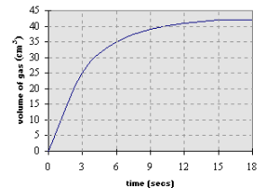
- For the graph:
- What is the maximum volume of gas collected?
- How long does it take for the reaction to complete?
Incorrect or poor statement | Correct statement
A reaction happens when reactants collide
Increasing the concentration increases the rate of reaction because there are more collisions
The test for oxygen is to put a blown out splint into the gas and if it relights, its oxygen
Complete combustion produces more energy than incomplete combustion
2 control variables when testing the effect of surface area on the rate of reaction between HCl and calcium carbonate are:
The amount of carbonate
The amount of acid
The test for carbon dioxide is to put a lit splint inside it and if the flame goes out, it’s carbon dioxide

When investigating endothermic reactions a polystyrene cup is better because it stops energy being lost to the environment

