Reactivity booklet
Lesson 1: Atomic structure and reactivity
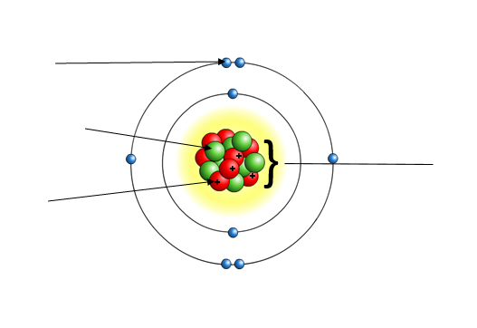
An atom is the smallest unit in Chemistry and is made up of protons, neutrons and electrons. The nucleus of an atom contains the protons and neutrons and the electrons orbit the nucleus in electron shells. Protons are positively charged; electrons are negatively charged and neutrons are neutral in charge.

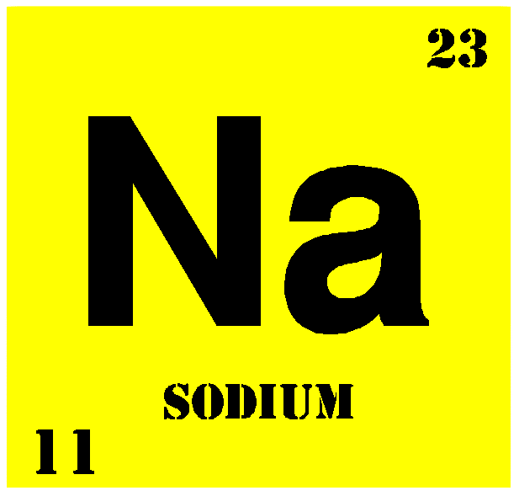
When looking at an element within the periodic table, you can see that there is a number above the chemical symbol which is the relative atomic mass and there is a number underneath the chemical symbol which is the atomic number. The atomic number tells you the number of protons and therefore also the number of electrons in the atom. This is because atoms have no overall charge and therefore in an atom, there must be an equal number of protons and electrons as protons are positively charged and electrons are negatively charged and therefore, they cancel each other out in terms of charge. The relative atomic mass tells you the number of protons plus the number of neutrons in the atom.

Electrons are found orbiting the nucleus in electron shells. The first shell, which is closest to the nucleus holds 2 electrons. The 2nd, 3rd and 4th shell all hold 8 electrons. When drawing electron configuration diagrams, we draw electrons as crosses. Electrons are negatively charged and so they will repel each other to be as far away as possible before they then start to pair up. An electron configuration diagram has been drawn for you below.
Shell number | Electrons
1
2
3
4
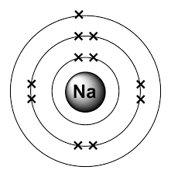

The group (vertical column) which an atom is in tells you the number of electrons in the outer shell and the period (horizontal row) in which an atom is in tells you the number of electron shells which are present. When a chemical reaction takes place, it is the electrons in the outer shell which take part and form bonds. Atoms want to have a full outer shell of electrons as this is the most stable configuration and hence atoms in groups 1,2,3,4,5,6,7 will either gain or lose electrons to get a full outer shell. Group 0 is very unreactive due to it already having a full outer shell and hence doesn’t need to take part in chemical reactions.

- What do you find within the nucleus of an atom?
- What charge do electrons have?
- What is meant by atomic number?
- What is the atomic number of carbon?
- How many protons does lithium have?
- How many electrons does aluminium have?
- Why is there always an equal number of protons and electrons in an atom?
- How many electrons can the first shell of electrons hold?
- How many does the 2nd, 3rd and 4th shell of electrons hold?
- Why do electrons repel each other?
- What does the group number tell you about the number of electrons?
- What does the period tell you about the number of electrons?
- Why is group 0 very unreactive?
- Why do atoms in groups 1,2,3,4,5,6,7 gain or lose electrons?

Electron configuration drawing practice:

- Beryllium (teacher draws)
- Nitrogen
- Oxygen
- Helium
- Neon
- Sulphur
- Aluminium
- Silicon
- Carbon

- Complete the table below:
Element | Element symbol | Number of protons | Number of electrons | Number of neutrons
Lithium | Li | 3 | 3 | 4
Sodium |  | 11 |  | 12
Magnesium | Mg | 12
Carbon |  |  |  | 6
Phosphorus
 | Al |  | 13
 |  | 34 | 34 | 45
 |  | 27 | 27 | 32
 | Ca
 | Fe
 | Cu
 | Br

- Debra tells the class “Sulfur has 16 protons, 32 neutrons and 16 electrons” Explain the common mistake Debra has made and write out the correct sentence
- Copy and complete the sentences below:
- An atom has to have equal numbers of protons and electrons because…
- An atom has to have equal numbers of protons and electrons but…

Lesson 2: Reactions and bonding
As we know from the previous lesson, atoms want to have a full outer shell of electrons as this is the most stable electron configuration. Electrons are negatively charged particles. When an atom loses an electron to get a full outer shell (like in group 1 of the periodic table) it becomes a positively charged ion. As it has lost 1 electron, it becomes a 1+ ion. If an atom was to lose 2 electrons to get a full outer shell (group 2), then it would become a 2+ ion. When an atom gains an electron to get a full outer shell (group 7), it becomes a negatively charged ion as it has gained an extra negative electron. It would become a 1- ion. The same thing happens if an atom gains 2 electrons in the sense that it would become a 2- ion.
1+
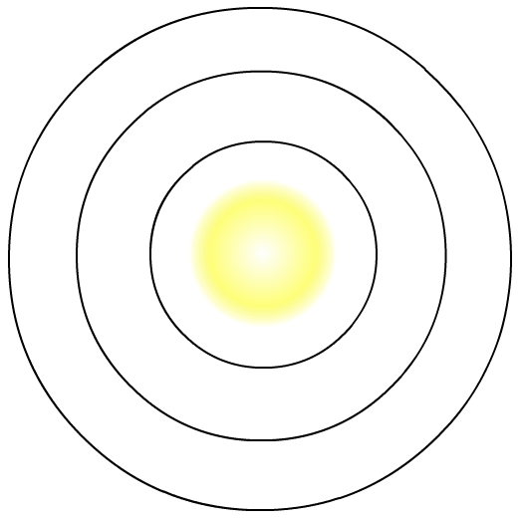

Na
+
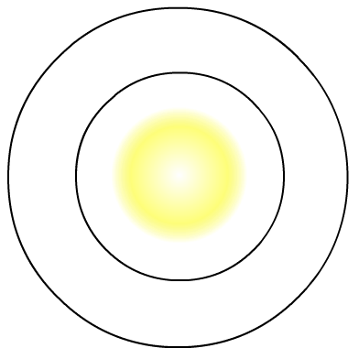
Na
loses 1 electron

- Complete the table, the first one has been done for you
Group number | In terms of electrons | Ion formed
1 | Loses 1 electron | 1+
2
3
5
6
7

- Draw annotated diagrams like above to show how the below atoms become ions:
- Potassium
- Magnesium
- Chlorine
- Bromine
- Oxygen
- Sulphur

An ionic bond is able to form between metals and non-metals where there has been a transfer of electrons in order for both atoms to get a full outer shell. For example, sodium needs to lose one electron to get an outer shell, and chlorine needs to gain one electron to get a full outer shell. Sodium loses its outer shell electron and becomes a 1+ ion. Chlorine gains the electron from potassium and becomes a 1- chloride ion. There is a strong force of attraction between the positive and negative ions and it therefore forms a compound called sodium chloride. This is shown below.

1-
Na
1+

-
Cl

- Draw the bonding diagrams to show the ions formed in the following compounds:
- Lithium + bromine lithium bromide
- Sodium + fluorine Sodium fluoride
- Beryllium + oxygen beryllium oxide
- Magnesium + oxygen Magnesium oxide

- What is the type of ion formed when an atom loses an electron?
- What is the type of ion formed when an atom gains an electron?
- What does an ionic bond happen between?
- What charge do electrons have?
- Why do atoms have no overall charge?
- How many electrons can the first shell hold?
- How many electrons does the 2nd, 3rd and 4th shell hold?
- What type of ion would a group 6 atom form?
- What type of ion would a group 2 atom form?
- Why do atoms want a full outer shell of electrons?

Lesson 3: Atomic and formula mass and balancing equations
Relative formula mass (Mr) Is the mass of a substance made up of different elements. To calculate this, we simply add together the atomic masses of all the atoms shown in the formula. Remember that the atomic mass of an element is the top number in the periodic table, and this is the number which we use.

For example, carbon dioxide (CO₂) is made of 3 atoms and 2 elements. The relative mass of carbon dioxide (CO₂) is 12 + 16 + 16 = 44.
An alternative way to write this is 12 + (16x2) = 44.
Another example is lithium chloride (LiCl), which is made of 2 atoms and 2 elements. Its Mr is 7 + 35.5 = 42.5

- For each of the questions below identify the number of elements and atoms and then find the relative formula mass (Mr) of the following compounds Show your workings clearly:
- Magnesium oxide (MgO)
- Magnesium chloride (MgCl₂)
- Calcium oxide (CaO)
- Sodium fluoride (NaF)
- Potassium bromide (KBr)
- Carbon monoxide (CO)
- Aluminium oxide (Al₂O₃)
- Hydrogen chloride (HCl)
- Nitric acid (HNO₃)
- Sulphuric acid (H₂SO₄)
Another key skill in Chemistry is the ability to balance equations. It is important to remember that no atoms are lost or created during a chemical reaction. This means the number of atoms must be the same on both sides of the equation.
Worked examples
Na + Cl₂ NaCl

K + O₂ K₂O

- Balance the below equations:
- H2 + Br2 HBr
- Ca + O2 CaO
- MgCO3 + HCl MgCl2 + H2O + CO2
- Fe + O2 Fe2O3
- Fe + Cl2 FeCl3
- C2H6 + O2 CO2 + H2O
- K + H2O KOH + H2
- NaNO3 NaNO2 + O2
- CH4 + O2 CO2 + H2O
- Pb(NO3)2 PbO + NO2 + O2

Lesson 4: Acids and metals
An acid is a substance that has a pH below 7. This will turn universal indicator red/orange/yellow. They all react in predictable ways. Most metals will react with acid to form a salt and hydrogen gas. This is shown in the equation below:
Acid + metal Salt + hydrogen
The type of salt produced depends on the metal and the type of acid involved in the reaction.
- When a metal reacts with hydrochloric acid (HCl), the salt produced will be a metal chloride
- When a metal reacts with sulphuric acid (H₂SO₄), the salt produced will be a metal sulphate
- When a metal reacts with nitric acid (HNO₃), the salt produced will be a metal nitrate
You can test for hydrogen using the ‘squeaky pop’ test. To do this, you can place a burning splint next to the mouth of a test tube. A ‘squeaky pop’ as the gas ignites shows that hydrogen is produced.
Practical – metals and acid
Method
- Add approximately 2cm depth of hydrochloric acid to 4 test tubes
- Add 1 piece/spatula of one metal to one of the test tubes
- Observe and record what happens – is there a reaction? How do you know?
- Trap some of the gas produced by placing your thumb over the top of the tube
- Insert a lit splint into the test tube. Is hydrogen produced?
- If there is no visible reaction at first, gently heat the acid and metal for a max of 15-20 seconds in and out of the flame and record observations. Then try and catch the gas and light the splint – is there a squeaky pop?
- Repeat for different metals in hydrochloric acid
- Repeat for the same metals but in sulphuric acid

Results table
Name of metal | Observation with hydrochloric acid | Observation with sulphuric acid | Hydrogen gas test
Magnesium
Iron
Zinc
Copper

Word and symbol equations for the reactions above:
Example :
Magnesium + hydrochloric acid Magnesium chloride + hydrogen
Mg + 2HCl MgCl₂ + H₂

Magnesium + sulphuric acid Magnesium sulphate + hydrogen
Mg + H₂SO4 MgSO₄ + H₂
- Complete the word equations below
- Iron + hydrochloric acid ? + ?
- Iron + sulphuric acid ? + ?
- Zinc + hydrochloric acid ? + ?
- Zinc + sulphuric acid ? + ?
- Copper + hydrochloric acid ? + ?
- Copper + sulphuric acid ? + ?
- What type of salt is made if hydrochloric acid is used?
- What type of salt is made if sulphuric acid is used?
- How do you test for hydrogen?
- What type of salt is made if nitric acid is used?
- What’s the formula for hydrochloric acid?
- What’s the formula for sulphuric acid?
- What’s the formula for nitric acid?
- What is the relative formula mass for hydrochloric acid?
- What is the relative formula mass for nitric acid?
- What is the relative formula mass for sulphuric acid?
- Why do atoms want to have a full outer shell of electrons?
- How many electrons fill the 2nd shell?
- Debra tells the class during her practical “I don’t need to do the pop test to prove its hydrogen because I can see the bubbles” Explain why Debra is wrong

Lesson 5: Acids and metal oxides
Some metals are too reactive to add straight to acid. Instead of using a pure metal, we can use a metal oxide – which is just a metal which has reacted with oxygen. Many metal oxides are insoluble in water but will neutralise an acid. We call chemicals which will neutralise an acid, bases. The product of the reaction of any acid with any base is a salt and water.
Acid + metal oxide Salt + water

Although many metal oxides are insoluble in water, they will dissolves when added to an acid. You know when you have added enough of the metal oxide because it stops dissolving.
Practical – making copper sulphate
Method
- Measure 25cm³ of sulphuric acid into a beaker
- Warm the acid gently and then remove from the heat
- Add a spatula of copper oxide and stir
- Keep adding copper oxide until it no longer dissolves
- Filter the mixture into a conical flask
- Pour the contents of the conical flask into an evaporating dish
- Gently heat the evaporating dish until blue crystals start to appear (turn off the Bunsen burner if it starts to spit)

- Complete the word equations below:
- Calcium oxide + sulphuric acid
- Magnesium oxide + hydrochloric acid
- Sodium oxide + hydrochloric acid
- Potassium oxide + nitric acid
- Zinc oxide + hydrochloric acid
- Why did you gently heat the acid in the above practical?
- How did you know when you had added enough copper oxide?
- Why did you filter the mixture?
- What is the generic word equation for when a metal reacts with an acid?
- What is the generic word equation for when a metal oxide reacts with an acid?
- What does insoluble mean?
- How do you test for hydrogen gas?
- What is the relative formula mass for calcium oxide? (CaO)
- What is the relative formula mass for potassium oxide? (K₂O)
- How many electrons does zinc have?

Lesson 6: Acids and metal carbonates
Metal carbonates are also bases – which means they will neutralise an acid to form a salt. When a carbonate is mixed with an acid, the products are a salt, carbon dioxide and water.
Acid + metal carbonate salt + carbon dioxide + water
To test for the presence of carbon dioxide we use limewater. Limewater is a clear liquid which turns cloudy when carbon dioxide is present.
Practical – metal carbonates and hydrochloric acid
- Place a spatula of each metal carbonate into separate test tubes (4 test tubes in total)
- Add 10cm3 of hydrochloric acid to the first test tube
- Use a pipette to collect some of the gas given off (squeezing and releasing repeatedly inside the tube)
- Bubble this gas through limewater and record the result
- Repeat steps 2-4 using hydrochloric acid with the different metal carbonates
Metal carbonate | Observation with hydrochloric acid | Test for carbon dioxide
Sodium carbonate
Copper carbonate
Magnesium carbonate
Zinc carbonate

- Complete the below equations:
- Sodium carbonate + hydrochloric acid
- Copper carbonate + hydrochloric acid
- Magnesium carbonate + hydrochloric acid
- Zinc carbonate + hydrochloric acid
- Copper carbonate + sulphuric acid
- Magnesium carbonate + sulphuric acid
- Sodium carbonate + nitric acid
- Zinc carbonate + nitric acid
- What is the general word equation for when a metal reacts with an acid?
- What is the general word equation for when a metal oxide reacts with an acid?
- What is the general word equation for when a metal carbonate reacts with an acid?
- How do you test for hydrogen gas?
- How do you test for carbon dioxide?
- What is the relative formula mass of copper carbonate? (CuCO₃)
- How many protons does zinc have?
- How many electrons does zinc have?
- How many neutrons does zinc have?
- Draw the electronic structure for zinc

Lesson 7: Acids and alkalis
Remember from year 7, that acids are substances which have a pH of 0-6. Neutral substances have a pH of 7 and then alkaline substances have a pH of 8-14. Universal indicator can be added to a substance and will cause a colour change. The colour change can then be compared to the pH scale and a pH for that substance can then be given. When an acid and an alkali are mixed together, they will form a salt and water.
Acid + alkali Salt + water
An alkali is a soluble base. They have the surname ‘hydroxide.’ For example:
Hydrochloric acid + sodium hydroxide sodium chloride + water

- complete the equations below:
- Sodium hydroxide + hydrochloric acid
- Calcium hydroxide + sulphuric acid
- Potassium hydroxide + ? Potassium nitrate + ?
- ? + ? Magnesium chloride + ?

Practical – titration to measure how much acid it takes to neutralise a known volume of alkali
Method
- Measure out 20cm³ of potassium hydroxide using a measuring cylinder and put it into the conical flask
- Add 3-4 drops of universal indicator to the conical flask
- Fill up the burette with hydrochloric acid
- Open the tap of the burette and let acid run into the conical flask, swirling the flask constantly to mix the acid and the alkali
- When the solution turns green, close the tap and read the volume from the burette
- Record your readings
- Rinse your conical flask and repeat until the above method until you have results within 0.1cm³ of each other

Trial number | 1 | 2 | 3 | 4 | Average
Volume of acid (cm³)

- Potassium hydroxide + hydrochloric acid ? + ?
- What is the general word equation for when an acid reacts with an alkali?
- What pH range does an acid have?
- What colours would universal indicator go if an acid was tested?
- What pH does a neutral substance have?
- What colour does universal indicator go when a neutral substance is tested?
- Give an example of a neutral substance
- What is the general word equation for when an acid reacts with metal?
- What is the general word equation for when an acid reacts with a metal carbonate?
- What pH range does an alkali have?
- What colour would universal indicator go if an alkaline substance was tested?
- What is the general word equation for when an acid reacts with a metal oxide?
- How do you test for carbon dioxide?
- How do you test for hydrogen?
- What are titrations used for?

Lesson 8: Salt preparation
As we have seen in previous lesson, there are 4 different ways in which salts can be made in the lab. These are shown in the equations below:

Metal + acid Salt + hydrogen
Metal oxide + acid salt + water
Metal carbonate + acid salt + water + carbon dioxide
Alkali + acid salt + water

Activity – read the two methods below and find any errors and correct them. Which method is better and why?
Method 1
- Measure out some sulphuric acid into a beaker
- Take some pieces of copper metal and add them to the beaker
- There will be a gas given off – it will be hydrogen
- When the reaction has finished, put the solution into an evaporating dish
- Leave it for a few days and you’ll have crystals of copper chloride
Risk assessment :
Be careful not to spill any acid.
Keep the hydrogen away from any lit flames.

Method 2
- Measure out 25cm³ of hydrochloric acid into a beaker
- Heat it gently while adding spatulas of copper oxide and stirring
- When no more will dissolve, the acid is fully neutralised.
- Filter the solution to remove any excess copper oxide using a filter funnel and paper
- Tip the solution into an evaporating dish and put it into a drying oven for a day or two
- The water will evaporate, leaving crystals of copper chloride

Cu + 2HCl CuCl₂ + H₂O

Hazard (what is dangerous?) | Risk (what could happen?) | Safety precautions
Hydrochloric acid | Corrosive and irritant | Wear goggles  Wash it off if spilled on skin
Hot equipment | burns | Only heat for 30-60 seconds. Leave it to cool before putting away

Key things to include when writing a method for an experiment:
- Chemicals listed
- Equipment listed
- Volume and masses included
- Clear and detailed description of what to do with the equipment
- Include diagrams where appropriate
- Any hazards identified, and what the risk of these hazards are
- How to minimise risk from these hazards

Activity – making zinc sulphate:
You need to include in your books
- A method to show how you would produce crystals of the salt
- Name the chemicals and equipment you would need
- Write the word and symbol equation
- Complete a risk assessment with the hazards identified and how to minimise risk from the hazards

- What is the general word equation for when an acid reacts with an alkali?
- What pH range do alkalis have?
- What indicator can we use to test the pH of a substance?
- What is the general word equation for when a metal carbonate reacts with an acid?
- What is a base?
- What common surname do all alkalis have?
- What is the chemical formula for sulphuric acid?
- How many of each type of atom are there in nitric acid?
- Sulphuric acid + magnesium ? + ?
- Hydrochloric acid + calcium carbonate ? + ? + ?

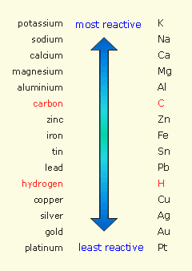
Lesson 9: Reactivity series
The reactivity series places metals in order of their reactivity towards other substances.
Potassium, sodium, calcium, magnesium and aluminium are the most reactive metals. Whilst copper, silver, gold and platinum are the least reactive metals. The reason why some metals are more reactive than others is because some metals lose their outer shell electrons more easily than others and hence become ions more easily than others.

Demonstration:
Reactants | Observations – was there a reaction? | What does this mean?
Magnesium + copper oxide
Magnesium + iron oxide
Zinc + iron oxide
Iron + zinc oxide
Iron + copper oxide

When magnesium reacts with copper oxide, there is release of energy which is transferred by heat and light. It is a very vigorous reaction. Magnesium is more reactive than copper as it sits above it in the reactivity series, and so magnesium has been able to ‘steal’ the oxygen from the copper.
Magnesium + copper oxide Magnesium oxide + copper
Magnesium has gained oxygen and so it has been oxidised. Oxidised just means the addition of oxygen. Copper oxide has been reduced, as it has lost oxygen.

Activity – complete the word equations below and state what has been oxidised and what has been reduced:
- Iron + copper oxide
- Lead + magnesium oxide
- Aluminium + zinc oxide
- Aluminium + iron oxide

Demonstration of the thermite reaction
- Complete the word equation for the reaction you have just seen iron oxide + aluminium
- Where do the reactants sit in relation to each other in the reactivity series?
- What is a practical use for this reaction?

Lesson 10: Uses and extraction of metals in terms of reactivity
Metals are found in the Earth’s crust. Most metals are combined chemically with other chemical elements, often with oxygen or sulphur. This means the metal must be chemically separated from its compound before it can be used. When there is enough of a metal or a metal compound in a rock to make it worth extracting the metal, the rock is called a metal ore. Ores are mined from the ground. Whether it is worth extracting a specific metal depends on:
- How easy it is to extract it from its ore
- How much metal the ore contains
- The changing demands for a specific metal
A metal can be extracted from its ore by reduction using carbon. When are ore is reduced, oxygen is removed from it.
Iron oxide + carbon iron + carbon dioxide.
Only metals which are less reactive than carbon (metals below carbon in the reactivity series) can be extracted from their ore using carbon. In the above reaction, the carbon removes oxygen from iron oxide. This occurs because carbon is more reactive than iron.
Metals that are more reactive then carbon need to be extracted using electrolysis. Electrolysis uses electrical energy to split up the ore into the elements that make it up. Some metals, like silver and gold, are very unreactive and so they are often found in their pure form in the ground. This is called their native state.
Practical – extracting copper from its oxide
- Add a spatula of copper oxide to the boiling tube
- Carefully add 3 spatulas of carbon on top of the copper oxide to form a layer
- Clamp the boiling tube near the top and at an angle and heat on a roaring flame for roughly 5 minutes
- Allow it to cool before tipping it out

Activity – complete the following tasks in your books:
- Draw a labelled diagram of the practical
- Write a word and symbol equation for the reaction
- Identify where oxidation and reduction have happened
- Explain why we can extract copper from its ore using carbon
- How could you prove that carbon dioxide was produced?
- Explain why most metals are not found in their native state
- Explain, with examples, why some metals cannot be extracted using reduction with carbon
- What is an ore?
- Give 3 factors which will be considered before a metal is extracted from its ore
- In which part of the Earth’s structure are metals found?
- What does oxidation mean in terms of oxygen?
- What does reduction mean in terms of oxygen?
- What is the most reactive metal in the reactivity series?
- Why are some metals more reactive than others?
- What chemical elements are metals usually combined with in the ground?

Lesson 11: Displacement
A more reactive metal will ‘displace’ a less reactive metal from a solution of its compound. For example – copper sulphate solution contains copper ions. If iron is added, the iron displaces the copper from the solution.
Copper sulphate + iron Iron sulphate + copper
We would physically see a colour change in the solution from a blue colour to a green colour once displacement has taken place as well as a change in colour of the nail with copper forming as a layer on the outside of the nail.

Practical – testing displacement
Method
- Put 2cm3 of magnesium sulphate into a test tube
- Add 1 or 2 squares of zinc metal
- Observe carefully and write down any evidence for a reaction
- Repeat steps 1-3 with copper, tin and lead
- Repeat steps 1-4 but with zinc sulphate, copper sulphate, tin chloride and lead nitrate.

Solution/metal | Magnesium sulphate | Zinc sulphate | Copper sulphate | Tin chloride | Lead Nitrate
Magnesium | X
Zinc |  | X
Copper |  |  | X
Tin |  |  |  | X
Lead |  |  |  |  | X

Activity – complete the equations below:
- Zinc + copper sulphate
- Magnesium + tin chloride
- Tin + lead nitrate
- Magnesium + copper chloride
- Copper + iron nitrate
- Zinc + lead sulphate
- Copper + silver nitrate
- Potassium + magnesium chloride
- Why was there no reaction when zinc sulphate was added to copper?
- What is meant by oxidation?
- What is meant by reduction?
- Why is gold typically found in its native state?
- What metals is electrolysis used for?
- How does electrolysis work?
- What is a metal ore?
- Give 3 uses of metals in everyday life
- What is meant by displacement?
- Metal + acid ? + ?
- Metal carbonate + acid ? + ? + ?

Lesson 12: Uses of metals and alloys
Metals can be found in the periodic table and they have many useful uses in everyday life. The usefulness of metals is due to the properties which they have. Some of the key properties are listed below:
- Metals conduct electricity due to electrons which are free to move throughout the structure and carry charge
- Metals conduct heat due to particles being close together and so vibrations can be passed on quickly and easily
- Metals have a high tensile strength because there are strong forces between metal atoms that hold them together
- Metals are shiny when polished
- Metals are sonorous
- Metals are malleable because atoms in the metals can slide over each other
- Metals are ductile
- Metals have high densities because they have a lot of atoms tightly packed into a small volume

Alloys are mixtures of metals with at least one other element. Steel is a common example of an alloy. It contains iron mixed with carbon and other elements. Adding other elements to a metal changes its structure and so changes its properties. By changing the amount of each element in an alloy, scientists can custom-make alloys to fit a given job.
Atoms in pure iron are arranged in densely packed layers. These layers can slide over each other. This makes pure iron a very soft material. See the diagram below of pure iron.
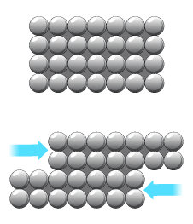

However, when an alloy of iron is made which is called steel, the properties change, and steel is now a strong material. This is because the layers of metal atoms have been disrupted and therefore the atoms cannot slide over each other as easily. See the diagram below for steel.
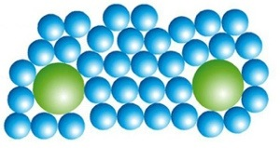

Activity - Linking properties to uses.
- Saucepans are made of copper, iron, steel or aluminium. Why?
- Electrical wires are made of copper. Why?
- Springs are usually made of steel (an alloy of iron). Why?
- A lot of jewellery is made of gold. Why?
- Bells are made of bronze (an alloy of copper and tin) or brass (an alloy of copper and zinc). Why?
- The framework of skyscapers is made of iron or steel girders. Why?
- The filament in light bulbs is made of tungsten. Why?
- Saw blades are made of steel. Why?
- Bridges are made of steel (an alloy of iron). Why?
- Coins are made of an alloy of iron. Why?
- The joins on roofs are waterproofed with sheets of lead. Why?
- What does ductile mean?
- Why does malleable mean?
- Why do metals conduct electricity?
- Why do metals conduct heat?
- What does sonorous mean?
- Metal + acid
- How do you test for hydrogen?
- How do you test for carbon dioxide?
- What is the relative formula mass of carbon dioxide?
- What does oxidation mean?

Lesson 13: Reactivity and voltage
In a circuit, the battery provides the driving force to push the charge round the circuit. This driving force is called the voltage. A voltage can also be produced using two metals in a solution of salt.

Practical
Method
- Pour 100cm3 of sodium chloride solution into a beaker
- Collect a pair of metals and connect them to wires using crocodile clips
- Attach the wires to a voltmeter and turn it on
- Put the two metals into the solution and read the voltage obtained
- Repeat, using different pairs of metals

Metal pairs | Voltage produced (V)

Linked questions:
- Did any pairs give no voltage?
- Which pairs of metals gave you the highest voltage?
- Look at the reactivity series – can you explain why some pairs give bigger voltages?

Lesson 14: Crude oil
Crude oil is a finite resource found in rocks. Finite means that it is non-renewable and one day will run out. Crude oil was formed over millions of years from the remains of tiny, ancient sea animals and plants, mainly plankton, that were buried in mud. Over time, layer upon layer of rock was laid down on top, creating the conditions (high temperature and pressure, in the absence of oxygen) to make crude oil.
The crude oil formed is a dark, smelly liquid. It is a mixture of many different carbon compounds. A mixture contains two or more elements or compounds that are not chemically combined. Nearly all of the compounds in crude oil are compounds containing only hydrogen and carbon atoms. These compounds are called hydrocarbons.
Crude oil straight from the ground is not much use. There are too many substances in it, all with different boiling points. Before crude oil can be used, it must be separated into different substances with similar boiling points. These are known as fractions.
Most of the hydrocarbons in crude oil are alkanes. Alkanes are described as being saturated hydrocarbons. All the carbon-carbon bonds are single covalent bonds, and this means they contain as many hydrogen atoms as possible in each molecule. No more hydrogen atoms can be added. The general formula for an alkane is C_{n}H_{2n}
Prefix (start of name) | Number of carbon atoms | General formula of alkane
 | 1
 | 2
 | 3
 | 4
 | 5

Sort the below statements into the table to show the advantages and disadvantages of extraction and use of crude oil
- Oil is a finite resource
- Creates jobs
- Countries with good oil supplies can sell it and help their economy
- Not all countries have oil supplies
- Oil spills during transport
- Petrol, diesel and airplane fuel all come from oil
- Products like plastics can be made from oil
- Burning fossil fuels releases carbon dioxide
Advantages | Disadvantages
- What is the general formula for alkanes?
- What elements are hydrocarbons made up of?
- What is the formula of pentane?
- What does finite mean?
- What is a mixture?
- Give 3 properties of metals
- Acid + alkali
- What pH range does an acid have?
- Where are electrons found in an atom?
- How many electrons can the first electron shell hold?
Poor statement | Better statement
Sodium and lithium are in group 1 because they have 1 electron

Metals give away electrons to become negative ions

The test for hydrogen gas is to put a splint into the tube and if you get a squeaky pop then the gas is hydrogen

Most metals react with air and water to rust

All metals are magnetic

The test for carbon dioxide is to put a burning splint into a tube of the gas and if the splint goes out, the gas is CO₂

Hydrocarbons are a mixture of hydrogen and carbon

In an investigation on reactivity of metals and acids, it is important to keep the amount of acid used the same.

