B2 Mastery booklet: Organisation
Part 1: Tissues and organs
Cells are the building blocks of life. In the previous topic we learnt how prokaryotic cells differ from eukaryotic cells. Eukaryotic cells are more complex and can form multicellular life forms, like humans, daisies, mushrooms and grasshoppers. To form a multicellular life, cells need to differentiate into specialised cells. This allows groups of cells joined together that perform the same function. A group of specialised cells that work together to do the same job is called a tissue. Examples of tissues include muscle tissue (which contracts), epithelial tissue (which covers the outside of the body or around organs) and glandular tissue (which secrete mucus, enzymes or hormones).
When more than one tissue is working together to complete a specific function, an organ is formed. An example of an organ is the stomach. The stomach is made up of muscular tissue, glandular tissue and epithelial tissue. Other examples of organs include heart, brain, skin, pancreas, and kidney. The pancreas has two important functions creating the hormones that control blood glucose concentration and producing enzymes used in digestion.
A whole multicellular organism is made up of a range of organ systems. These organ systems are made up of many organs. An example of an organ system is the digestive system and it is made up of organs such as the mouth, stomach, small intestine and large intestine to name a few. Other examples of organ systems include reproductive system, circulatory system and respiratory system.
Comprehension questions – each question should be attempted first from memory. Every five questions get your green pen and use the text to check your answers.
- Complete the table (one row has been completed for you)
Increasing size  Increasing complexity | Organisational levels | Definition | Example
Increasing size  Increasing complexity | Cell
Increasing size  Increasing complexity | Tissue | A group of specialised cells the perform the same function | Muscle
Increasing size  Increasing complexity |  |  | Digestive system
Increasing size  Increasing complexity | Organism | A living thing made up of cells | Human

- Define ‘tissue’.
- Define ‘organ’.
- List the organisation levels from the simplest to more complex
- List 4 organs
- What is the difference between an organ an organ system?
- What is the specialised cell that forms muscle tissue?
- True or false: Prokaryotic cells can form multicellular life
- The stomach contains mainly three types of tissues. State their functions.
a.) Muscular tissue
b.) Glandular tissue
c.) Epithelia tissue
- Decide for each of the following if they are a specialised cell, tissue or organ. Explain and state their functions.
a.) Pancreas b.) Neurone c.) Kidney
- Matt says “The skin is an organ because it is made from epithelial, muscle and glandular tissue.” Is he correct? Give a reason.

Part 2 The digestive system
Your digestive system is up to 9m long. The digestive system is an organ system made of many organs that carry out digestion. Digestion is the breakdown of large food molecules into smaller ones. This is important because these large molecules are too big to be absorbed into our blood at the small intestine. These organs include:
- the salivary gland and pancreas (that produce enzymes),
- the liver (that produces bile which emulsifies fat – turns fat into tiny droplets),
- the stomach (that produces certain enzymes and hydrochloric acid),
- The small intestine (a muscular tube that can contract to move food along it. It also produces and secretes enzymes).
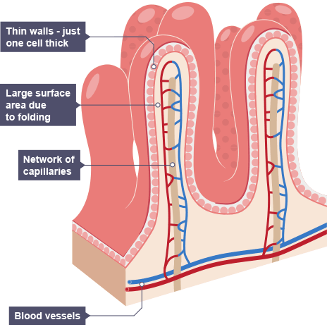
- The large intestine (that absorbs water and contains bacteria to break down any undigested food).
The inside walls of the small intestine are covered in folds these folds are covered in finger-like projections known as villi the folds and finger-like villi increase the surface area inside the small intestine. On the villi are also micro-villi which also increase surface area. Like all exchange surface the small intestine has some common adaptations such as:
- A good blood supply to maintain a steep concentration gradient.
- Thin wall/membranes to provide a short diffusion distance
- Lots of villi and microvilli to increase surface area.
All these adaptations speed up the diffusion of digested food. Additionally, cells in the small intestine may have lots of mitochondria to carry out respiration to release energy that is used for active transport of glucose.
Comprehension questions – each question should be attempted first from memory. Every five questions get your green pen and use the text to check your answers.
- What is digestion?
- Why is digestion important to us?
- Explain why the digestive system is an organ system.
- List all the organs that secrete enzymes.
- What is the name of the muscular tube which absorbs nutrients?
- Why do the intestines have villi?
- What three adaptations do the villi have which help speed up the diffusion of nutrients into the blood?

- Label the digestive system with each organ and their function.
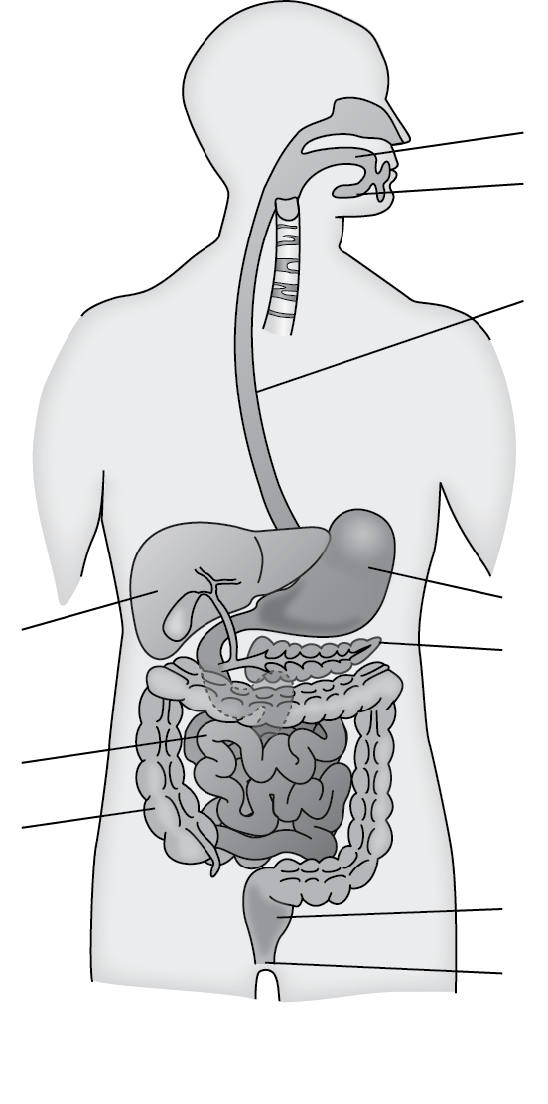

- Summarise the information above in the flow chart below
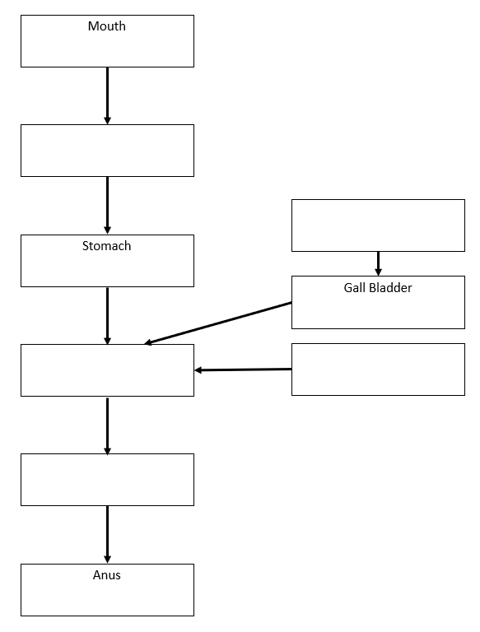
- Define ‘emulsify’?
- State the functional difference between the small and large intestines.
- How is the liver important in helping digestion?
- Complete the sentences below
- The small intestine is long and has a high surface area because….
- The small intestine is long and has a high surface area but….
- The small intestine is long and has a high surface area so….
- What is the role of saliva in the mouth?
Application questions – use your notes from this section and past sections to answer the questions below, but you should try from memory first.

- When someone has diarrhoea they have watery stools when they go to the toilet. What part of the digestive system is most likely not working? Explain your answer
- What is the name of the organelle where respiration occurs?
- After a meal there is a high concentration of amino acids in the small intestine. Which process will cause them to move into the bloodstream? Explain your answer.
- What is the name of the process by which water is absorbed by the large intestine?
- Why does bile improve the digestion of lipids (fats)?
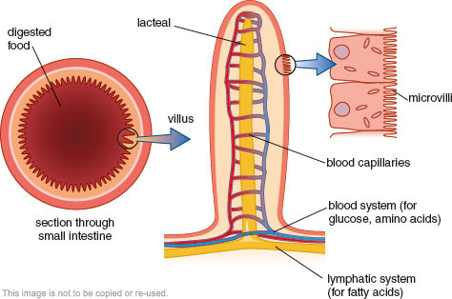
- To help diffusion of nutrients from the small intestine should the blood have a high concentration of nutrients or a low concentration of nutrients as it passes the villi?
- Some people have an illness that needs their gall bladder to be removed. These people can live normal healthy lives. Explain why the gall bladder is not vital for digestion.
- The picture to the right shows a villus. Explain how they are adapted to absorb nutrients as quickly as possible.

Part 3 The chemistry of food
Carbohydrates, lipids and protein make up most parts of a cell. Therefore, it is important we have lots of them. This makes them the main parts of our diet.
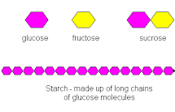
Carbohydrates help provide us with energy. All carbohydrates contain carbon, oxygen and hydrogen. Glucose (C₆H₁₂O₆) is a simple carbohydrate made of a single carbohydrate molecule. Sucrose is also a simple carbohydrate made up of two carbohydrate molecules joined together. Glucose molecules can be combined in long chains to form complex carbohydrates. Examples of this include starch and glucagon which act as energy storage molecules in plants and animals respectively. Carbohydrate rich foods include bread, pasta and potatoes.
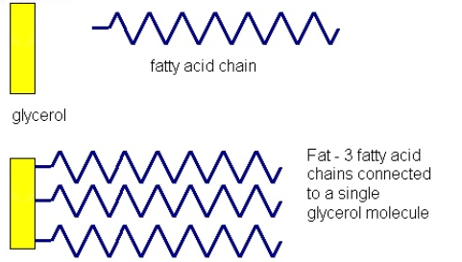
Lipids are fats and oils. They are an energy store in our cells. When combined with other molecules they can be used to make cell membranes. Like carbohydrates they are made up of carbon, hydrogen and oxygen. They are insoluble in water. Each lipid molecule is made up of three molecules of fatty acids combined with a molecule of glycerol. Olive oil, vegetable oil, cheese, butter and margarine are all sources of lipids.

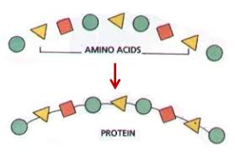
Proteins are polymers made up of amino acids joined together. There are twenty different amino acids which can be combined in different orders to make new proteins. Proteins are used to build our cells and our enzymes. Protein is made up of carbon, hydrogen, oxygen and nitrogen. Protein rich foods include meat, fish and cheese.

Nutrient | Made of | Uses in living organisms | Sources in our diet
Carbohydrate | Carbon, hydrogen and oxygen
Lipids (Fats) |  | Energy store, part of cell membrane
Protein |  |  | Meat, fish, diary

Comprehension questions – each question should be attempted first from memory. Every five questions get your green pen and use the text to check your answers.

- Give two functions of carbohydrates.
- Which atoms make up carbohydrates?
- State the monomer (the basic unit) of carbohydrates.
- Glucose is absorbed by the small intestine no matter how low its concentration in the digested food. Which transport process is used?
- State the chemical formula of glucose.
- Give two examples of complex carbohydrates.
- What types of food contain lots of carbohydrates? Give three examples.
- What are the two types of lipids?
- Which elements make up lipids?
- State two functions of lipids.
- What is the function of the cell membrane?
- What types of food contain lots of lipids? Give two examples.

- What process causes water to move across the cell membrane from a dilute solution to a concentrated one?
- Give two functions of proteins.
- Which atoms make up proteins?
- What makes up proteins?

- Describe how different proteins can be made from the same 3 amino acids
- If a protein shake is 250g in total advertises it is 40% protein how much protein is in the shake?
- Whole milk is 4% protein. What mass of whole milk would need to be consumed to get the same amount of protein?

Testing foods required practical

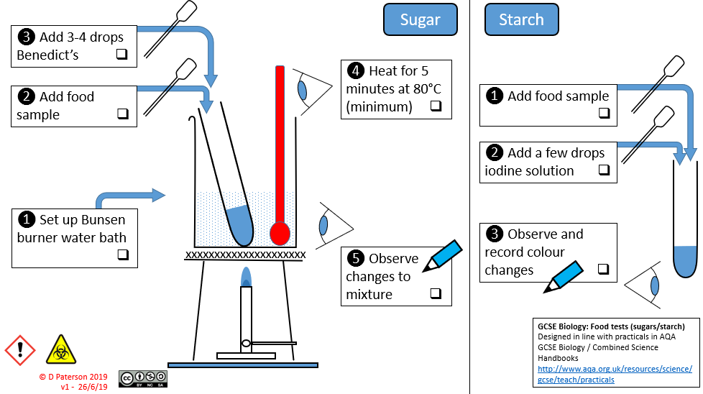
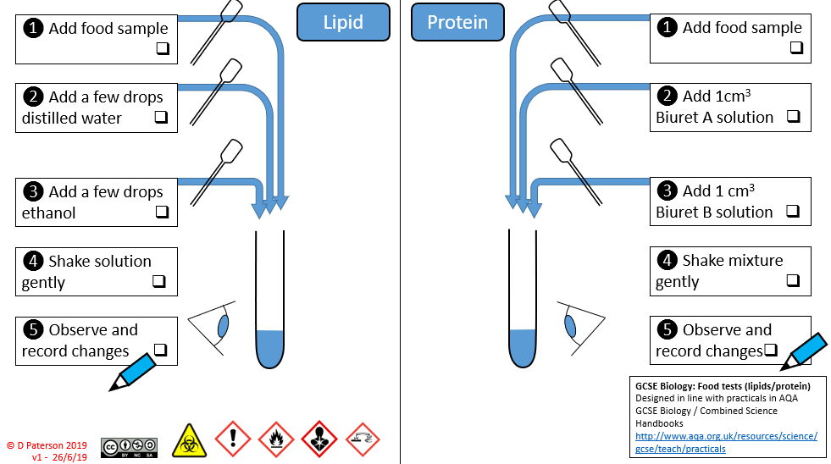

Part 4 Enzymes
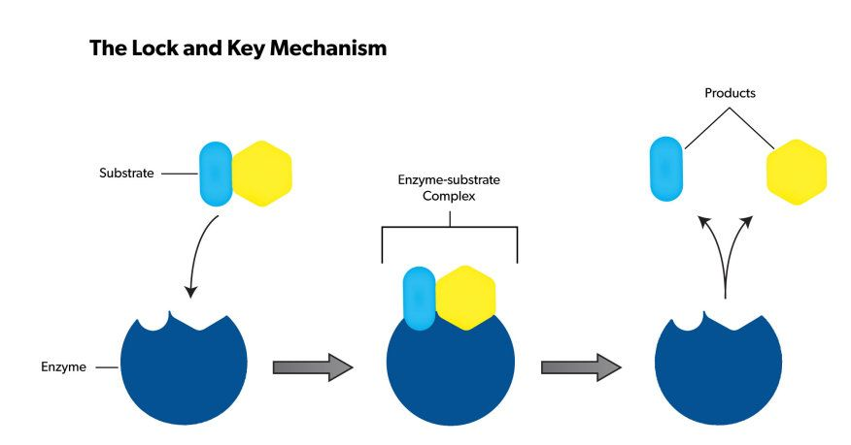
Enzymes are proteins. They are incredibly useful and play a role in every process that keep organisms alive. Enzymes are biological catalysts. A catalyst is a substance that speeds up a chemical reaction but is not used up. Enzymes can catalyse reactions that break large substances down into smaller ones or build large ones from smaller molecules. Enzyme are incredibly good at doing one specific function. An enzyme is able to bind to only specific molecules (known as the substrate). They have an area called the active site when the substrate(s) bind. This has a very specific shape. A model people use to explain this is the idea of a lock and key. The enzyme is the ‘lock’ and the substrate is the ‘key’. The main role of enzymes in the digestive system is in the breakdown of large insoluble molecules into smaller soluble ones.
The main enzymes in our digestive system are carbohydrases (amylase), proteases and lipases.
Carbohydrases digest carbohydrates. Amylase is the carbohydrase which breaks down starch. Amylase is produced in the salivary glands, pancrease and small intestine. Amylase carries out its function in the mouth and small intestine. Protease digests protein into amino acids. Protease is produced in the small intestine, stomach and pancreas. Protease is used in the stomach and small intestine. Lipases digest lipids (fats and oils) into three fatty acids and glycerol. Lipase is made in the small intestine and pancreas but is only used in the small intestine. Fats are insoluble in water, so bile is added from the liver to emulsify the fats. This breaks them into small droplets, increasing the surface area so the lipase can work efficiently.
Comprehension questions – each question should be attempted first from memory. Every five questions get your green pen and use the text to check your answers.
- Use the information above to complete the table.
Enzyme | Substrate | Products | Made in | Works in
Protease | Protein | Amino acids | Small intestine  Stomach  Pancreas | Stomach  Small intestine

- Match the following keywords with their functions.

Catalyst | - The enzyme and substrate bound together.
Enzyme | - The special site in the structure of an enzyme where the substrate binds.
Enzyme-substrate complex | - The energy needed for a chemical reaction to take place.
Activation energy | - A substance which changes the rate of a chemical reaction without being changed itself.
Active site | - A biological catalyst.

- What are enzymes?
- What is the active site of an enzyme?
- Name the types of enzymes that catalyse the breakdown of:
a.) Carbohydrates
b.) Lipids
c.) Proteins
- Which organs in the digestive system produce digestive enzymes?
- Use the lock and key diagram to explain why lipase will not work on a substrate of starch.
- Catalase is an enzyme that speeds up the breakdown of hydrogen peroxide. The enzyme increases the rate of reaction, so it is 700 times faster. If the enzyme reaction took 1.9s how long would the reaction take if there was no enzyme? Convert the answer to minutes. Give your answer to 4sf.

Part 5 Factors affecting enzyme action
Reading
Biological reactions are affected by the same factors as any other chemical reaction: concentration, temperature, and surface area. We are going to focus on the effect of two variables on enzyme-controlled reactions: temperature and pH.
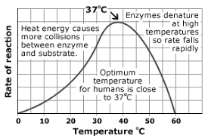
An increase in temperature will increase the rate of an enzyme-controlled reaction up to a certain amount. After about 41^{O}C the enzymes will start to become denatured. When an enzyme is denatured it loses its shape, the active site can no longer bind to the substrate and no enzyme-substrate complexes are formed. When temperature is too low the reaction is slow because the enzymes don’t have much kinetic energy and so rarely collide with their substrate
The graph to the right shows how enzymes in the human body are affected by temperature. But some extremophiles (organisms that live in extreme environments) have enzymes that work at temperatures up to 80^{O}C.
Each enzyme has an optimum pH, outside of this pH the enzyme becomes less effective and eventually can be denatured. This is because the active site can change shape preventing the formation of enzyme-substrate complexes.
Glands in the stomach release a protease known as pepsin. This pepsin is adapted to work at low pH (acidic). The stomach also produces hydrochloric acid to ensure that pepsin can work most effectively. The stomach produces a thick layer of mucus which coats your stomach and prevents the hydrochloric acid from digesting the walls of the stomach. After being digested in the stomach, food moves into the small intestine. The enzymes in the small intestine, such as pancreatic amylase, prefer an alkaline environment. To produce an alkaline environment bile is produced in the liver. Bile is stored in the gall bladder and is then released into the small intestine to neutralise the acidic solution coming from the stomach. Bile has another job. It emulsifies the fats in our food. This increases the surface area of the fat molecules and allows lipase to break down fats faster.
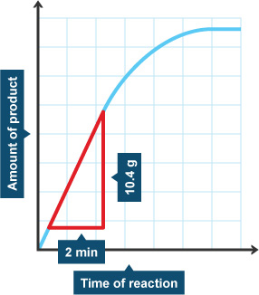
Comprehension questions – each question should be attempted first from memory. Every five questions get your green pen and use the text to check your answers.
- What does denatured mean?
- What happens to enzymes when the temperature is:
a.) Too low
b.) Too high
- Explain the effects of temperature on enzyme action.
- What does the word optimum mean?
- What is the optimum temperature for enzymes in the human body?
- How does a change in pH cause enzymes to denature?
- Using the graph given, calculate the rate of reaction of the enzyme. Remember to include units.
- What is pepsin?
- Where is bile produced?
- State where bile is stored?
- What are two differences between pepsin and pancreatic amylase?
- What is the difference between pepsin and proteases produced by the pancreas?
- What are the functions of hydrochloric acid in the stomach?
- How is the stomach adapted to protect itself from pepsin and the hydrochloric acid?
- Suggest the optimum pH for enzymes to work in the small intestine.
- Suggest the optimum pH for enzymes to work in the stomach
- What happens to an enzyme outside its preferred pH?
- What else can cause enzymes to be denatured?
- Which organ produces bile?
- Describe and explain the functions of bile.
- Why is emulsification important to lipid digestion?
Application questions – use your notes from this section and past sections to answer the questions below, but you should try from memory first.
- Is it correct to say “the stomach produces hydrochloric acid to digest food”? Explain your answer
- Is it correct to say “bile breaks down lipids to glycerol and fatty acids”? Explain your answer
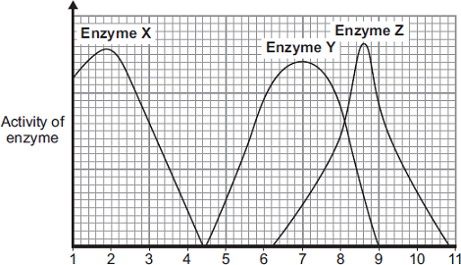
- The graph shows the effect of pH on the activities of three enzymes, X, Y and Z.
These enzymes help to digest food in the human digestive system.
Each enzyme is produced by a different part of the digestive system.
- What is the optimum (best) pH for the action of enzyme Z?
- The stomach makes a substance that gives the correct pH for enzyme action in the human stomach. Name this substance
- Which enzyme, X, Y or Z, will work best in the human stomach?
pH

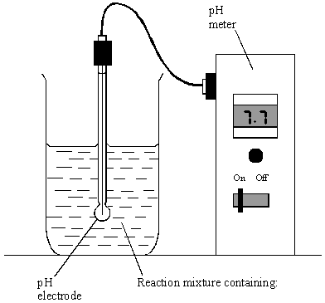
- The diagram shows the apparatus used to investigate the digestion of milk fat by an enzyme. The reaction mixture contained milk, sodium carbonate solution (an alkali) and the enzyme. In Experiment 1, bile was also added. In Experiment 2, an equal volume of water replaced the bile. In each experiment, the pH was recorded at 2-minute intervals.

Either:

Experiment 1 or: Experiment 2

milk (contains fat) milk (contains fat)
sodium carbonate solution sodium carbonate solution
bile water
enzyme enzyme

The results of the two experiments are given in the table.

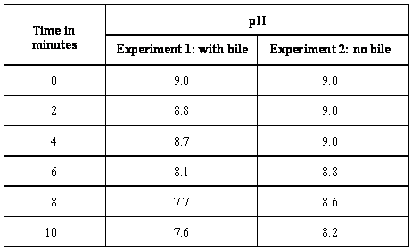
- Milk fat is a type of lipid. Give the name of an enzyme which catalyses the breakdown of lipids.
- What was produced in each experiment to cause the fall in pH?
- For Experiment 1, calculate the average rate of fall in pH per minute, between 4 minutes and 8 minutes. Show clearly how you work out your final answer.
- Why was the fall in pH faster when bile was present?
- Enzymes are made and used in all living organisms.

(a) What is an enzyme?

(b) Many enzymes work inside cells. In which part of a cell will most enzymes work?

(c) We can also use enzymes in industry.

Hydrogen peroxide is a chemical that can be used to preserve milk.

Adding a small amount of hydrogen peroxide to the milk kills the bacteria that cause decay. Hydrogen peroxide does not kill all disease-causing bacteria.

The enzyme catalase can be added later to break down the hydrogen peroxide to oxygen and water.

A different way of preserving the milk is by heating it in large machines to 138 °C for a few seconds.

Suggest one advantage and one disadvantage of using hydrogen peroxide and catalase to preserve milk instead of using heat treatment.

- Lipase is an enzyme that digests fat.

(a) (i) Complete the equation to show the digestion of fat.

fat fatty acids + ___________________

(ii) Name one organ that makes lipase.

(b) Some students investigated the effect of bile on the digestion of fat by lipase.

The students:

1 mixed milk and bile in a beaker

2 put the pH sensor of a pH meter into the beaker

3 added lipase solution

4 recorded the pH at 2-minute intervals

5 repeated steps 1 to 4, but used water instead of bile.

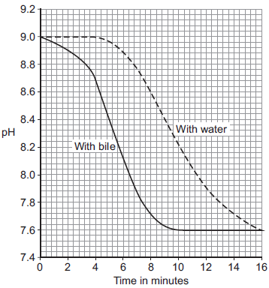
Suggest two variables that the students should have controlled in this investigation.

(c) The graph shows the students’ results.

(i) Why did the pH decrease in both investigations?

(ii) Bile helps lipase to digest fat. What evidence is there in the graph to support this conclusion?

(iii) Suggest one reason why the contents of both beakers had the same pH at the end of the investigations.

Some students investigated the effect of pH on the digestion of boiled egg white by an enzyme called pepsin. Egg white contains protein.

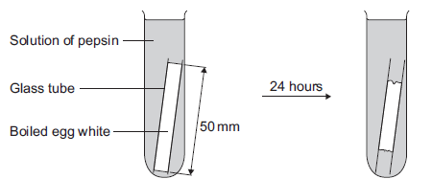
The students:
  - put a glass tube containing boiled egg white into a test tube
  - added a solution containing pepsin at pH 7
  - set up six more tubes with solutions of pepsin at different pH values
  - left the test tubes for 24 hours at room temperature.

(a) (i) Name the product of protein digestion.

(ii) What type of enzyme digests protein?

(b) The egg white in each tube was 50 mm long at the start of the investigation.
The table below shows the students’ results.

pH | Length in mm of boiled  egg white after 24 hours
1 | 38
2 | 20
3 | 34
4 | 45
5 | 50
6 | 50
7 | 50

(i) At which pH did the pepsin work best?

(ii) The answer you gave in part (b)(i) may not be the exact pH at which pepsin works best. What could the students do to find a more accurate value for this pH?

(iii) There was no change in the length of the egg white from pH 5 to pH 7. Explain why.

(c) Pepsin is made by the stomach. Name the acid made by the stomach which allows pepsin to work well.

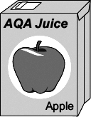
- Fruit is crushed to release fruit juice.

More juice can be collected if the plant cell walls in the fruit are broken down.

Some students tested the effect on the volume of fruit juice that they could collect of:
  - either boiling the fruit
  - or adding the enzyme pectinase to the fruit
  - or adding the enzyme amylase to the fruit.
- In their first experiment the students:
  - crushed 20 g of apple
  - added 10 drops of water
  - measured the volume of fruit juice that they collected.

Diagram 1 shows how they collected the fruit juice.
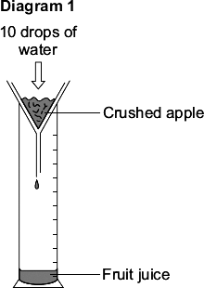

The students did three more experiments.

1 They added 10 drops of amylase solution to 20 g of crushed apple.

2 They added 10 drops of pectinase solution to 20 g of crushed apple.

3 They added 10 drops of water to 20 g of boiled, crushed apple.

Diagram 2 shows these experiments.

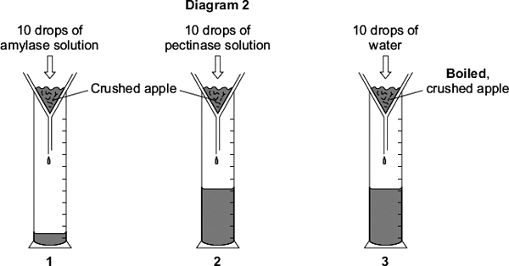

(a) Give one control variable in this investigation.

(b) Using drops to measure the volume of water and enzyme added might lead to inaccurate results. Give one reason why.

(c) The students’ results are shown in the table.

What was added to the crushed apple | Was the apple boiled? | Volume of juice collected  in cm³
10 drops of water | No | 1.2
10 drops of amylase solution | No | 1.2
10 drops of pectinase solution | No | 11.3
10 drops of water | Yes | 11.6

Explain as fully as you can the students’ results shown in the table. Use all the information given to help you answer this question.

(d) One student said:

‘If we add 10 drops of pectinase solution to crushed apple while it is boiling, we should collect more juice than if we add 10 drops of water to boiled apple.’

This is not correct. What volume of juice would you predict the students would collect if 10 drops of pectinase solution were added to crushed apple while it was boiling? Explain your answer.

- A patient has a disease. The disease damages his pancreas.

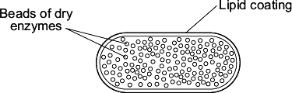
A doctor prescribes a course of treatment for the patient:
‘Take one capsule with each meal.’

Each capsule contains hundreds of small, dry beads.

The beads are made of enzymes. The pancreas normally produces these enzymes.

The outer coating of the capsule is made of lipid.

(a) One enzyme in the beads is lipase. In a healthy person, lipase is made in the pancreas.

Name two other enzymes made in the pancreas of a healthy person.

(b) The lipid coating on the capsule makes sure that the enzymes are not released until the capsule reaches the small intestine. Explain how.

(c) The lipase in the beads does not digest the lipid coating around the capsule. Suggest why.

Part 6 The Blood
Blood has four main components: red blood cells, white blood cells, platelets all of which are carried in a fluid called plasma. Within the plasma dissolved substances like glucose (plus other products of digestion, urea and carbon dioxide will also be carried.
Red blood cells carry the oxygen from the air in our lungs to our respiring cells. Red blood cells have certain adaptations that make them efficient at their job. They are biconcave disks which increases their surface area to volume ratio which increase diffusion. They are packed with haemoglobin which binds to oxygen. They also have no nucleus which makes space for more haemoglobin.
White blood cells form part of the immune system. Some white blood cells (lymphocytes) produce antibodies whilst others produce antitoxins and yet others (phagocytes) engulf and digest invading microorganisms.
Platelets are small fragments of cells without a nucleus. They are involved in the clotting of blood. Blood clotting is a series of enzyme-controlled reactions that results in the conversion of fibrinogen into fibrin. This forms a network of fibres that traps more platelets and red blood cells forming a scan which protects the new skin as it grows.

- Complete the diagram below to summarise the constituents of the blood
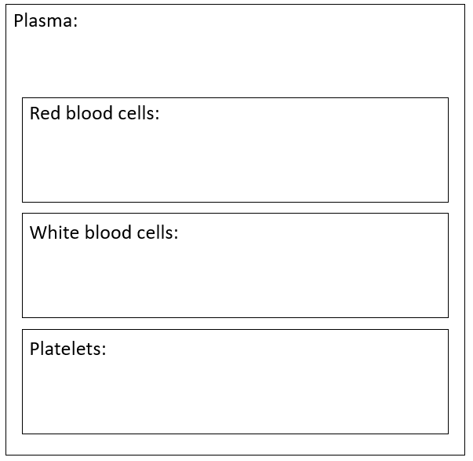
Comprehension questions – each question should be attempted first from memory. Every five questions get your green pen and use the text to check your answers.

- What is blood made up of?
- Name 5 things found in plasma
- What is the job of red blood cells?
- What is the job of haemoglobin?
- State two adaptations of red blood cells
- Explain how being biconcave is useful
- How can white blood cells protect us against infection?
- What type of cell contains 0 chromosomes?
- How do platelets form scabs?

Part 7 – The blood vessels
Blood is carried round our body in three main types of vessel. Each vessel is adapted for a different function.
Arteries carry blood away from the heart to the organs or body. The blood is usually oxygenated with the exception of the pulmonary artery. Blood in the arteries is under high pressure. Arteries have a thick layer of muscle and elastic fibres along with thick walls to allow them to withstand the high pressure and to stretch. Arteries have a small lumen.
Veins carry blood away from organs towards the heart. The blood is low in oxygen, except for the pulmonary vein. veins have a larger lumen and relatively thin muscular and elastic walls. This is because the blood is under less pressure. Veins have valves to prevent blood flowing backwards.
Capillaries connect arteries to veins. Capillaries are very narrow with thin walls. This ensures there is a short diffusion distance the inside of the capillary and surrounding cells. This enables substances such as glucose and oxygen to easily diffuse out of your blood into cells. Conversely carbon dioxide can easily do the opposite. Capillaries have very narrow lumens which only allow 1 cell to pass through at a time and their walls are only 1 cell thick.
- Complete the labels in the diagram using the text above
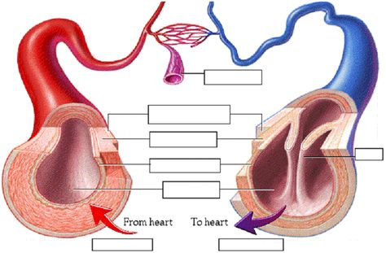
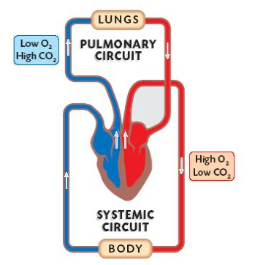
Humans have a double circulation system. One transport system carries blood from your heart to the lungs and back again and the other system carries blood from the heart to all other organs of your body and back again. This double circulation system is advantageous to us as we need lots of oxygen and glucose transported round our body. The double circulation system allows lots of oxygenated blood to be transported quickly where it needs to go.
Comprehension questions – each question should be attempted first from memory. Every five questions get your green pen and use the text to check your answers.
- What are the three types of blood vessel?
- What type of blood vessel carries blood away from the heart
- Why do the arteries have a thick layer of elastic fibres and muscle tissue?
- What is the pressure like inside the arteries?
- Red blood cells have no nucleus, What is the function of the nucleus?
- What do veins have that prevent back flow?
- How is the pulmonary vein different to other veins?
- What process will allow oxygen to move from the red blood cells into the muscle cells.
- Order the blood vessels from largest lumen to smallest lumen
- What is the benefit of the walls of capillaries only being 1 cell thick
- Why is our circulation system described as a double circulation system?
- What diffuses from the capillaries into cells?
Application questions – use your notes from this section and past sections to answer the questions below, but you should try from memory first.

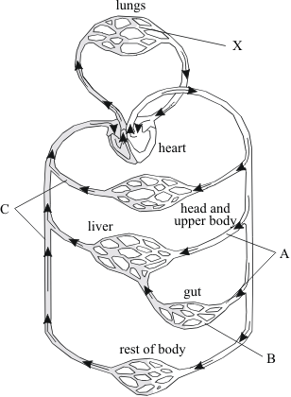
- Name the types of blood vessel labelled A, B and C on the diagram.
- What is the job of the circulatory system?
- Give two ways in which the composition of blood changes as it flows through the vessels labelled X on the diagram.

- The drawings show the structure of three types of blood vessel, A, B and C. They are drawn to the scales indicated.

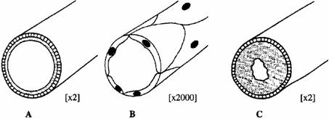
(a) Name the three types of blood vessel.

(b) Describe the job of blood vessel B.

Part 8 The Heart
Your heart is the organ that pumps blood round our body. It is made up of two pumps. The walls of your heart are almost entirely muscle and the blood vessel that supplies the heart with oxygen is called the coronary artery.
Blood enters the right atrium through the vena cava (a vein that brings deoxygenated blood back to the heart). Blood will then travel from the right atrium to the right ventricle. The tricuspid valve will then close to prevent backflow. When the right ventricle contracts deoxygenated blood is forced into the pulmonary artery which travels to the lungs to pick up oxygen. This newly oxygenated blood is returned to the heart by the pulmonary vein into the left atrium. Blood flows into the left ventricle, the bicuspid valve closes to prevent backflow. The left ventricle pumps oxygenated blood around the body via the aorta. Whenever blood enters the aorta or pulmonary artery valves at the beginning of these vessels close. The muscle wall of the left ventricle is thicker than elsewhere. This allows the blood leaving the left ventricle to be under the high pressure needed to pump it round the body.
- Label the heart with the structures and relevant information

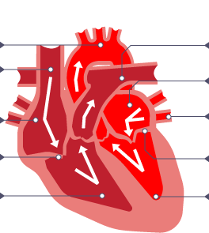

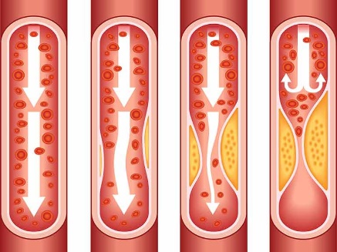
Coronary heart disease is caused by the narrowing the coronary arteries that supply the heart. This is caused by a build-up of fatty material on the lining of the vessels which reduces the supply of oxygen to the heart. Coronary heart disease can be treated with a stent. A stent is a metal mesh placed in the artery.
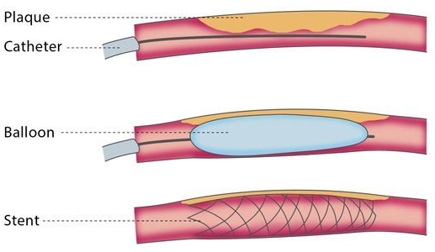
A tiny balloon is then inflated to open the blood vessel and the stent. The balloon is then removed but the stent ensures the blood vessel remains widened. Stents don’t require general anaesthetic and can be placed anywhere in the body.
Another option is bypass surgery where the blocked artery is replaced with bits of veins. This require surgery and general anaesthetic but can be used on extremely blocked arteries where stents can’t help. Another option is to prescribe statins. Statins reduce blood cholesterol levels and slows down the rate at which fatty material is deposited. However, it can’t be used to treat already affected arteries.
Comprehension questions – each question should be attempted first from memory. Every five questions get your green pen and use the text to check your answers.
- Add as much detail as possible to this diagram to show the route of the blood
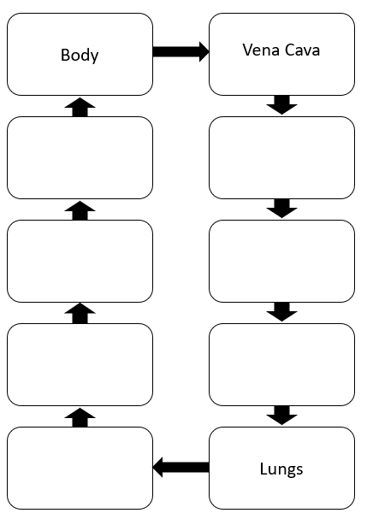

- What is the name of the blood vessels that supply the heart with oxygen?
- What is the name given to the top chambers of the heart?
- What blood vessel supplies the left atrium with blood?
- What blood vessel supplies the right atrium with blood?
- What is special about the pulmonary artery?
- What type of blood is found in the right ventricle?
- What causes coronary heart disease?
- What are three methods of treating coronary heart disease?
- Why does the left ventricle have thick muscular walls?
- What is an advantage of stents?
- How do stents work?
- What is a disadvantage of bypass surgery?
Application questions – use your notes from this section and past sections to answer the questions below, but you should try from memory first.
- Evaluate the use of three methods of combating coronary heart disease (hint: evaluation is pros, cons and then choosing which one is best overall)
- The circulatory system contains arteries and veins.
- Describe how the structure of an artery is different from the structure of a vein.
- A comparison is made between blood taken from an artery in the leg and blood taken from a vein in the leg.
- Give two differences in the composition of the blood.
- LDL is one form of cholesterol found in the blood.
- People with a high concentration of LDL in their blood may be treated with drugs called statins.
- A high concentration of LDL cholesterol in the blood may result in an increased risk of heart and circulatory diseases.
- The graph shows the effects of the treatment of one person with four different statins,
- A, B, C and D, over a period of 8 years. The arrows show when each new treatment was started.
- Each treatment was continued until the next treatment was started.
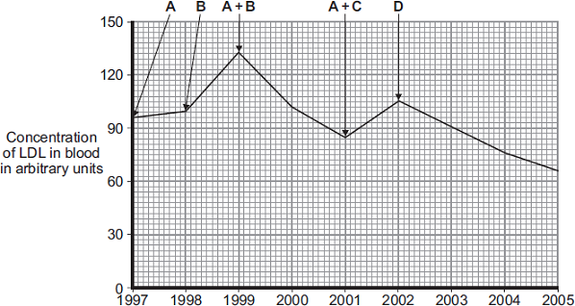
Year
Compare the effectiveness of the five treatments in reducing the risk of heart and
circulatory diseases for this person.
- Describe the journey of an oxygen molecule from the air into a muscle cell. Try to include the names of all the organs and cells involved.
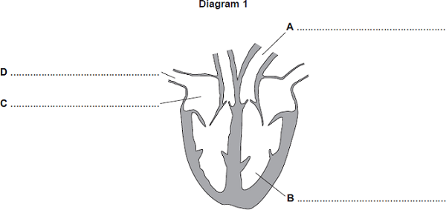
- Diagram 1 shows a section through the heart. Name the parts labelled A, B, C and D.

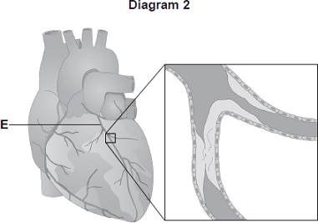
- Diagram 2 shows the blood vessels that supply the heart muscle. Part of one of the blood vessels has become narrower.
- Name blood vessel E.
- Give one method of treating the narrowed part of blood vessel E.
- Explain how the method of treatment works.

- Read Lewis’ answer to the question How does a fatty deposit in the arteries cause a heart attack
“When the fat builds up the blood flow through the pulmonary artery becomes blocked. This means the heart muscle will not get enough carbon dioxide. This means that the muscle will not be able to anaerobically respire so will die, This causes the heart attack”
There are three errors in Lewis’ answer. Find them and write out the correct version in your book

Part 9 – Helping the heart
Heart valve shave to withstand a lot of pressure. As such they may start to leak. Doctors can operate and replace faulty valves with mechanical valves made of titanium. These mechanical valves are long lasting but require medication to prevent blood clotting around it. Biological valves are based on valves from pigs or even human donors. These do not require any medication but only last 12-15 years.
The heart normally beats at 70bpm. The beating of the heart is controlled by a group of cells found in the walls of the right atrium. This cluster of cells can stop working and needs replacing with an artificial pacemaker. If a persons heart beats too slowly they won’t get enough oxygen. The most common disease treated by pacemakers is arrhythmia (abnormal heart rhythm). An artificial pacemaker is an electronic device that weighs between 20-50g and is connected to your heart by two wires. They control when the heart beats by sending strong , regular electronic signals to the heart. Modern pacemakers are very sensitive and only act when something is amiss and can even stimulate the heart to beat faster when you exercise. If you have a pacemaker fitted you will need regular check-ups throughout your life, however, this is a small price to pay when weighed against the increased quality and quantity of life gained by having one.
Artificial hearts are used when a person’s heart stops working completely. It can take a long time for a donor heart to become available, so artificial hearts are used to keep the patient alive in the meantime. There is a risk of blood clotting with artificial hearts.
Comprehension questions – each question should be attempted first from memory. Every five questions get your green pen and use the text to check your answers.
- What two methods of replacing heart valves?
- What is an advantage and disadvantage of each method?
- What is the danger if a persons heart beats too slowly?
- What is a disadvantage of wearing a pacemaker?
- Why are artificial hearts used?
- What is a risk of artificial hearts?
Application questions – use your notes from this section and past sections to answer the questions below, but you should try from memory first.
- In this question you will be assessed on using good English, organising information clearly and using specialist terms where appropriate.

Every year, many patients need to have heart valve replacements.

The table gives information about two types of heart valve.

Living human heart valve | Cow tissue heart valve
• It has been used for transplants for  more than 12 years. | • It has been used since 2011.
• It can take many years to find a suitable  human donor. | • It is made from the artery tissue of a  cow.
• It is transplanted during an operation  after a donor has been found. | • It is attached to a stent and inserted  inside the existing faulty valve.
• During the operation, the patient's chest  is opened and the old valve is removed  before the new valve is transplanted. | • A doctor inserts the stent into a blood  vessel in the leg and pushes it through  the blood vessel to the heart.

A patient needs a heart valve replacement. A doctor recommends the use of a cow tissue heart valve.

Give the advantages and disadvantages of using a cow tissue heart valve compared with using a living human heart valve.

Use information from the table and your own knowledge in your answer. Make sure you give a conclusion.

- The diagram in Figure 1 shows a section through the human heart, seen from the front.

Figure 1

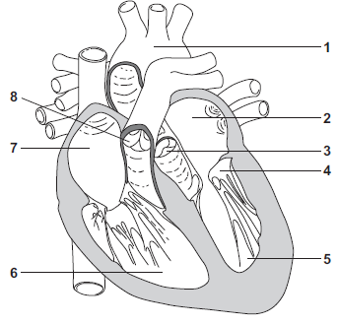
(a)
- What type of tissue is the heart mainly made of?
- The resting heart rate is controlled by the pacemaker. Give the number where the pace maker is located?

(b) Write a number, 2, 5, 6 or 7, in each of the three boxes to answer this question.

Which chamber of the heart:
pumps oxygenated blood to the head and body | 
receives deoxygenated blood from the head and body
receives oxygenated blood from the lungs?

(ii) Give the number, 3, 4 or 8, of the valve that closes when the blood pressure in the aorta is greater than the blood pressure in the left ventricle.

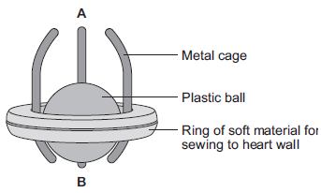
(c) The diagram shows one type of artificial heart valve. The plastic ball is in the closed position.

This type of artificial valve could be used to replace a faulty valve in the heart.

(i) What is the function of valves in the heart?

(ii) The artificial valve could be used to replace valve 4 shown in Figure 1.The artificial valve opens to let blood through when the ball is moved towards A.

Which end of the valve, A or B, should point towards chamber 5?

Explain your answer.

(d) (i) The artificial heart valve may cause blood clots to form on its surface. Describe what happens during blood clotting.

(ii) Read the information in the passage.

Replacing a damaged heart valve can dramatically improve the blood circulation and the supply of oxygen to the body’s tissues. The operation to replace a heart valve is a long one during which the patient’s blood goes through a bypass machine.
Sometimes the artificial valve can fail to work. If the surface of the valve becomes rough, small blood clots can form on its surface then break away and be carried around the body by the blood.

Evaluate the advantages and disadvantages of artificial heart valves.

Part 10 - Breathing and gas exchange
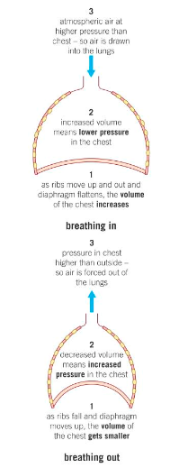
Your lungs are found in your chest or thorax and are protected by your ribcage. They are found above the organs of your digestive system and are separated from by a layer of muscle called the diaphragm. The lungs are a part of the gas exchange or ventilation system and the role of this system is to move air in and out the lungs. The lungs are made up of tiny air sacs called alveoli which increase the surface area for gas exchange. The walls of the alveoli are very thin (only 1 cell thick) to provide a short diffusion distance for gas exchange. The alveoli also have a rich supply of blood capillaries to maintain a concentration gradient. Ventilation of the lungs is controlled by the contraction or relaxation of the intercostal muscles and the diaphragm which changes the pressure of the lungs resulting in the movement of gases like oxygen in and out the lungs. Oxygen is used for aerobic respiration and so is important as without it we could not release energy
Shown to the left is the process of breathing in and out. When you breathe in, oxygen rich air will move into the lungs. This means there is a high concentration of oxygen in the lungs and maintains a steep concentration gradient between the lungs and the bloodstream. Diffusion causes particles to go from a high concentration to a low concentration and therefore oxygen moves from the lungs to the blood by this process. Breathing out removes carbon dioxide rich air from lungs maintaining a concentration gradient between the bloodstream and the lungs with the blood stream having a higher concentration of carbon dioxide resulting in carbon dioxide continually diffusing out of the blood stream.

Comprehension questions – each question should be attempted first from memory. Every five questions get your green pen and use the text to check your answers.

- What protects your lungs?
- What makes red blood cells special?
- What are the names of the airs sacs in the lungs?
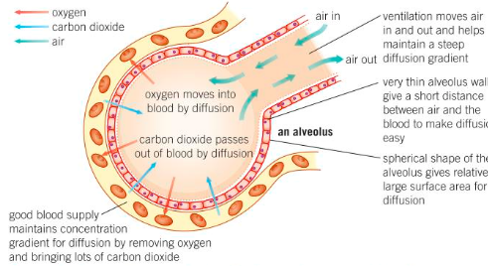
- Give two adaptations of alveoli
- State two gasses that are moved in and out of the lungs by ventilation.
- What two sets of muscles control gas exchange?
- What is the relationship between volume of the chest and pressure?
- Describe the changes that will occur in the lungs when breathing in and out
- Describe the changes that will occur in the lungs when emerging from a dive in water
- If the pressure in the lung is high, am I breathing in or out?
Application questions – use your notes from this section and past sections to answer the questions below, but you should try from memory first.
- Label the table below with % of air breathed in and % of air breathed out
Atmosphere gas
Nitrogen | 80 | 80
Oxygen | 16 | 20
Carbon dioxide | 4 | 0.04

- Draw a bar chart to show the difference between the air you breathe in and the air you breathe out (use table above)
- Describe the changes in the composition gases in inhaled air and exhaled air. (include magnitude of any difference)
- A student says “we breathe in oxygen and breathe out carbon dioxide” explain whether the student is correct. Use data from table 1.
Part 11 – Human health issues
Good health is defined as a state of complete physical, mental and social wellbeing. Things that can reduce a person’s health include disease, diet and stress.
Diseases can interact to create unexpected consequences. Some examples are:
- Defects in the immune system mean that an individual is more likely to suffer from infectious diseases.
- Viruses living in cells can be the trigger for cancers.
- Immune reactions initially caused by a pathogen can trigger allergies such as skin rashes and asthma. Severe physical ill health can lead to depression and other mental illness.
One of the biggest impacts on a person’s life is their diet. If a person takes in more calories than they use they will increase in body mass. IF this gets to an extreme level they can be classified as obese. One of the biggest problems with obesity is the chance of developing type 2 diabetes.
Cancer is uncontrolled cell division. A tumour is a group of cells that are dividing uncontrollably. Tumours come in 2 forms, benign and malignant. Benign tumours are normally located in one place and do not invade other parts of the body. A benign tumour can be dangerous if found near an important organ. However, in general they are less likely to cause death than malignant tumours. A malignant tumour can spread around the body by invading other parts. A malignant tumour is often called cancer. Cells from a malignant tumour can break off from the larger tumour and go into the blood to be transported to other places in the body.
Different cancers can be caused by different things. For example, a genetic mutation passed down from parents causes some breast cancers. Chemicals like tar and asbestos can cause our DNA to mutate which can lead to cancer. These chemicals that cause our DNA to mutate are known as carcinogens. Ionising radiation like UV light and X-rays can also cause mutations that lead to cancer.
Due to how it can spread throughout the body, cancer can be hard to treat. Radiotherapy is one way cancer can be treated. This involves using targeted doses of radiation to treat cancer cells. Radiotherapy works by disrupting mitosis. However, it can also affect healthy cells. Another way to treat cancer is chemotherapy which involves using chemicals to stop the cancer cells dividing or make them ‘self-destruct’.
Comprehension questions – each question should be attempted first from memory. Every five questions get your green pen and use the text to check your answers.
- Define health
- What is the word to describe someone with a large body mass for their height?
- What is the main consequence to obesity?
- Define cancer
- Define a tumour
- Distinguish between the two types of tumour
- State three causes of cancer
- Define a carcinogen
- Describe two ways of treating cancer
- Explain why scientists are still trying to find new ways of treating cancer
Maths Skills
Calculating a mean
Type of cancer | Number of deaths in 2014 | Number of deaths in 2015 | Number of deaths in 2016 | Mean number of deaths | Calculating percentage change
Lung cancer | 12,700 | 10,300 | 13,000
Prostate cancer | 6478 | 7220 | 8001
Leukaemia | 14,300 | 14,678 | 11,000
Bowel cancer | 3678 | 3789 | 4352
Breast cancer | 9,000 | 8423 | 8421
Skin cancer | 766 | 798 | 861

Calculating percentage change (show working in books where necessary)
Model example
Calculate the percentage change in number of deaths between 2014 and 2016 for skin cancer
$\frac{861-766}{766}$x100 = 12.4%
Application questions – use your notes from this section and past sections to answer the questions below, but you should try from memory first.
- Describe the trend in number of deaths by breast cancer over time (2)
- Describe the pattern between number of deaths by bowel cancer and time
- Compare the change in number of deaths over time for leukaemia and lung cancer
- A newspaper runs an article with the headline ‘deaths by cancer are at an all time high!!!’ Evaluate the claims made by this newspaper using the data above

Part 12 – Smoking
There are around 1.1 billion smokers worldwide and about 6000 billion cigarettes smoked each year. About 150 of the chemicals found in cigarettes are linked to disease. Nicotine is an addictive but ‘harmless’ drug found in cigarette smoke. It produces a sense of calm well-being which is what makes people want to keep smoking. Carbon monoxide is a poisonous gas that binds to our red blood cells in the place of oxygen. After a cigarette around 10% of the red blood cells in the body carry carbon monoxide instead of oxygen. This is why smokers get more breathless than non-smokers.
This oxygen shortage is a particular problem in pregnant women that smoke. This oxygen shortage can lead to premature births, low birthweight babies and even stillbirths. There are around 3500 stillbirths in the UK each year and around 20% of these are attributed to smoking.
Some chemicals in tobacco smoke can anaesthetise the cilia in the trachea and bronchi which stops them working and therefore they don’t move mucus, dirt or bacterial away from our lungs. This increases the chance of pathogens getting into the lungs and causing infections. Another chemical found in tobacco smoke is tar. Tar can cause many different diseases including bronchitis and COPD. As well as that tar is also a carcinogen which means tar can cause lung cancer.
Comprehension questions – each question should be attempted first from memory. Every five questions get your green pen and use the text to check your answers.
- State three components of cigarette smoke
- What is the effect of nicotine
- Describe the effect of carbon monoxide
- Describe the effects of tar
- Suggest why oxygen shortage is more of a problem for pregnant woman than a non-pregnant woman
- What can the effects of smoking on a pregnant woman be?
- Explain why smoking before a football match is a bad idea (Hint: relate your answer to respiration)
Math Skills
- How many cigarettes does each smoker smoke on average?
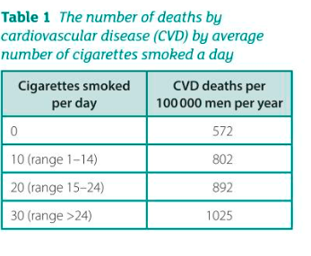
- If 20% of 3500 stillbirths are caused by smoking, how many is this?
- Summarise what the data in table 1 shows
- Calculate the percentage increase in the number of deaths when someone smokes 20 cigarettes instead of not smoking
- Display the date in table 1 in a bar chart

Application questions – use your notes from this section and past sections to answer the questions below, but you should try from memory first.

164. Gases enter and leave the blood by diffusion.

(a) Define the term diffusion.

(b) Name the main gases that diffuse into and out of the blood in the lungs.

(c) Smoking can cause emphysema.

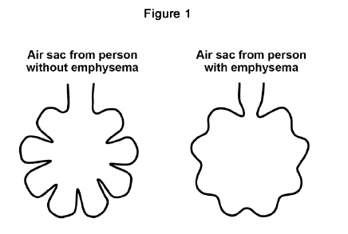
Look at Figure 1.

Emphysema causes the walls of the air sacs in the lungs to break down

Explain how this will affect the diffusion of gases into and out of the blood.

Smoking during pregnancy can cause low birth mass in babies.

Table 1 shows the World Health Organisation categories for birth mass.

Table 1
Category | Birth mass in g
Above normal birth mass | > 4500
Normal birth mass | 2500–4500
Low birth mass | 1500–2499
Very low birth mass | 1000–1499
Extremely low birth mass | < 1000

(d) Complete Table 2.

Use information in Table 1.

Table 2
Baby | Birth mass in g | Category
A | 2678 | Normal birth mass
B | 1345
C | 991

(2)

Figure 2 shows data from a study about pregnancy and smoking in women in the UK.
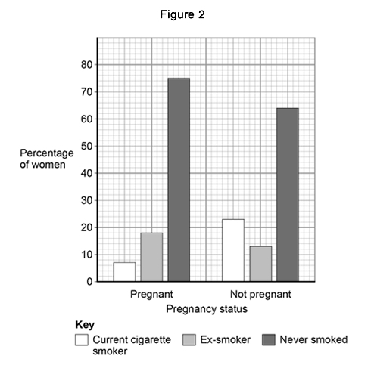

(e) Sampling from the whole UK population would not be appropriate for this study.

Give one reason why.

(f) Give three conclusions that can be made about smoking in pregnant women compared with non-pregnant women.

Use information from Figure 2.

Other factors can also be linked to low birth mass.

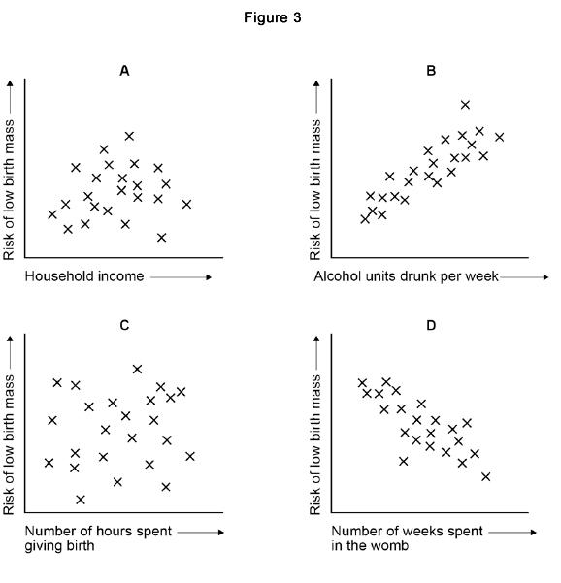
Figure 3 shows the relationship between four of these factors and the risk of low birth mass.

(g) What type of graph is shown in Figure 3?

Choose from: Histogram/Bar/Scatter/Line

(h) Which of the graphs in Figure 3 shows a positive correlation?

(i) A student concluded that the longer a woman spends giving birth, the greater the risk of low birth mass.

Give one reason why the student’s conclusion is not correct.

Use evidence from Figure 3.

Part 13 – Alcohol
Drinking lots of alcohol can increase your chances of getting a non-communicable disease. Alcohol (ethanol) is poisonous but the liver can usually remove it before permanent damage or death. When you drink alcohol it affects your nervous system, making your reflexes and reactions slower. It also reduces inhibition.
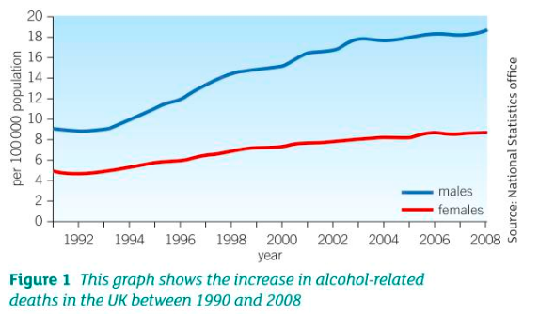
People can become addicted to alcohol which means they need the drug to function. People who drink a lot may develop cirrhosis. Cirrhosis is a disease that destroys healthy cells and replaces them with scar tissue. Alcohol is a carcinogen. Carcinogens are chemicals that cause DNA to mutate. Alcohol can cause lung cancer.
If a pregnant woman drinks alcohol it can pass across the placenta into the developing baby. This can cause miscarriages and still births. The most common disease that babies can get if there parents drink is foetal alcohol syndrome (FAS). Foetal alcohol syndrome may lead to facial deformities, heart and liver problems and learning disabilities.

Comprehension questions – each question should be attempted first from memory. Every five questions get your green pen and use the text to check your answers.
- What organ in the body normally removes alcohol?
- What are the short term effects of drinking alcohol
- What does addiction mean?
- What disease might people who drink a lot develop?
- What is cirrhosis?
- What are carcinogens?
- What disease commonly affects the babies of parents that drink
- What are the symptoms of foetal alcohol syndrome?
Application questions – use your notes from this section and past sections to answer the questions below, but you should try from memory first.
- Apart from removing alcohol, what other functions does the liver perform?
- “Alcohol is dangerous for you so all alcohol should be banned” Evaluate this statement. Make sure you outline the evidence in favour and against before giving your own opinion.

