B5 Homeostasis and Response Mastery Booklet Triple
Part 1- Homeostasis
Humans have been able to colonise most of the earth. Even in extreme environments, like the Arctic Circle and the Sahara desert, humans can live and thrive. Surprisingly, we are actually not very good at surviving in these places without our technology. Humans, like all mammals need to maintain a constant internal environment. If our core body temperature, blood glucose levels, or water levels change too much we can get very ill or even die. If you recall, in the organisation topic, enzymes are very specific. Changes in conditions affect their shape causing them to denature. Enzymes are the main reason for homeostasis.
To prevent this, our body has several systems which it uses to maintain a constant internal environment. Homeostasis is the regulation of the internal conditions of a cell or organism to maintain optimum conditions for function in response to internal and external changes.
Homeostatic mechanisms are so important for your survival that they are automatic. This means your body constantly adjusts without you having to consciously think about it. The all follow the same basic structure.
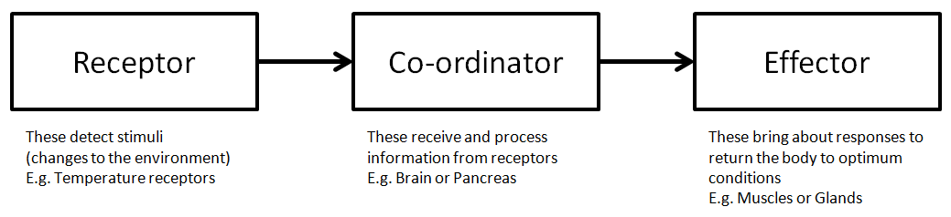
Homeostatic control mechanisms come in two forms:
- Nervous responses: These use nerves to transfer information from the receptors to the brain and spinal cord (co-ordinators) and then to effectors.
- Hormonal responses: These use hormones which are released from various organs and travel through the blood stream to various effectors.
We will look at each in more detail as the topic progresses.
Comprehension questions – each question should be attempted first from memory. Every five questions get your green pen and use the text to check your answers.
- Define ‘homeostasis’
- List 3 things humans, and all mammals, must keep constant to survive.
- What is a receptor? Give an example
- What is a co-ordinator? Give an example
- What is an effector? Give an example
- What are two differences between nervous and hormonal responses?
- What does ‘optimum’ mean?
Application questions – use your notes from this section and past sections to answer the questions below, but you should try from memory first.
- Complete the sentences:
Mammals need homeostasis because…
Mammals need homeostasis but….
Mammals need homeostasis therefore….
- Draw a ‘lock and key’ diagram to show the specific action of enzymes. Include the following labels: Enzyme, substrate, active site, enzyme-substrate complex, product
- Define ‘denatured’ a diagram might help
Part 2- The Human Nervous System
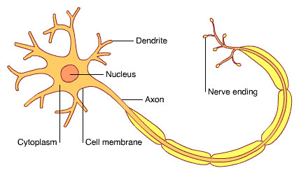
The nervous system is specifically adapted to react to our surroundings and coordinate our behaviour. The nervous system uses electrical and chemical signals so send information rapidly. Some can even reach speeds of over 100m/s!
The nervous system is made of nerve cells (neurones). Neurones are specialised cells which can carry electrical impulses along their long thin cytoplasm, called an axon. Neurones come in 3 main forms sensory neurone, relay neurone and motor neurone.
Sensory neurone | These connect receptors to the coordinator
Relay neurones | These coordinate the correct response to the stimulus
Motor neurone | These send the signal from the coordinator to the effector

The coordinators for the nervous system are the brain and the spinal cord. These are known collectively as the central nervous system (CNS). The CNS is responsible for coordinating all the sensory information around you, all your thoughts and maintaining all your internal systems (e.g. heart and breathing rate). Where a nerve ends and joins to another there is a gap. This gap is known as a synapse. At the synapse, the electrical signal is transferred into a chemical signal that diffuses across the gap. The synapse is important as it allows the nervous system to direct the signal to the right location. A good analogy is the switches on a railway line that move to ensure a train goes along the right track.
The reflex arc
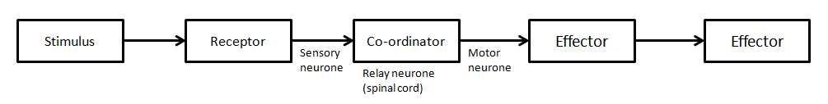
Reflexes are automatic responses hard-wired into your body. This means the signal never goes to your brain. The relay neurones in the spinal cord coordinate the response and your body will respond without the need for you to think about it. A good example is in the eye. When the light levels are low, and it is dark your iris contracts and your pupils get bigger. If you move into the light, your eyes detect the increase in light and automatically your iris will relax, and the pupils will shrink. This happens without conscious thought. Below is a diagram showing the basic structure of a reflex arc.
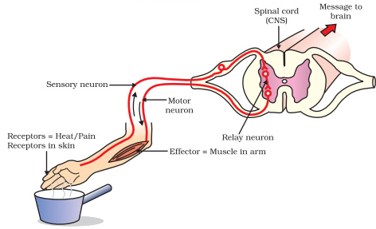
Another example of a reflex arc is in response to pain. Imagine accidently touching something hot or a pin with your hand. Your body will respond by instantly withdrawing your hand.

Comprehension questions – each question should be attempted first from memory. Every five questions get your green pen and use the text to check your answers.
- Complete the table below to show the stages of the reflex arc. The example of the eye has been completed for you
Stages of reflex arc | Moving from a dark room to a light room | Touching a hot saucepan
Stimulus | Increase in light intensity
Receptor | Light receptors in eye
Neurone that sends signal to coordinator | Sensory neurone
Coordinator | Relay neurone in spinal cord
Neurone that sends signal to effector | Motor Neurone
Effector | Muscle (Iris)
Response | Pupil gets smaller

- What is the scientific word for a nerve cell?
- What kind of signal passes along neurones?
- What is a synapse?
- What is the name for the cells which detect changes in the environment?
- Name the 3 types of neurone in a reflex arc
- What are the two coordinators of the nervous system?
- Why is a reflex arc automatic?
- Define ‘effector’
- What type of signal passes through a synapse
- Define ‘diffusion’
- What is the name of the organelle which contains the genetic material in the neurone?
- List 2 ways a neurone is specialised to carry out its function
- How is a motor neurone different from a sensory neurone?
Application questions – use your notes from this section and past sections to answer the questions below, but you should try from memory first.
- Complete the sentences below:
A reflex arc does not travel to the brain because….
A reflex arc does not travel to the brain but……
A reflex arc does not travel to the brain so…..
- Roger sits on a pin. He screams and jumps up. Describe the journey of the signal through a reflex arc. Make sure you include as much detail as possible. Hint: use the diagram earlier if you are stuck
Sentence help; When he sits on the pin…. This sends a signal to… The __________neurone then….
- Many human actions are reflexes. Which two of the following are examples of reflex actions?
- Jumping in the air to catch a ball
- Raising a hand to protect the eyes in bright light
- Releasing saliva when food enters the mouth
- Running away from danger
- Withdrawing the hand from a sharp object

Figure 1 shows how the size of the pupil of the human eye can change by reflex action.

Figure 1
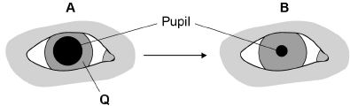
- Name one stimulus that would cause the pupil to change in size from A to B, as shown in Figure 1.
- Structure Q causes the change in size of the pupil. Name structure Q.
- Describe how structure Q causes the change in the size of the pupil from A to B

Figure 2 shows some structures involved in the coordination of a reflex action.

Figure 2

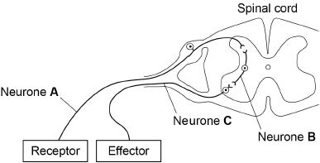
- Describe how the structures shown in Figure 2 help to coordinate a reflex action.

Human reaction time.

The time is takes the body to recognise a change and react to it is called the reaction time. The reaction times of human are all slightly different and can be affected by external factors. One of the factors that are thought to improve reaction times is caffeine. Caffeine is found in coffee, fizzy drinks and energy drinks. Below is a method for comparing reaction times.
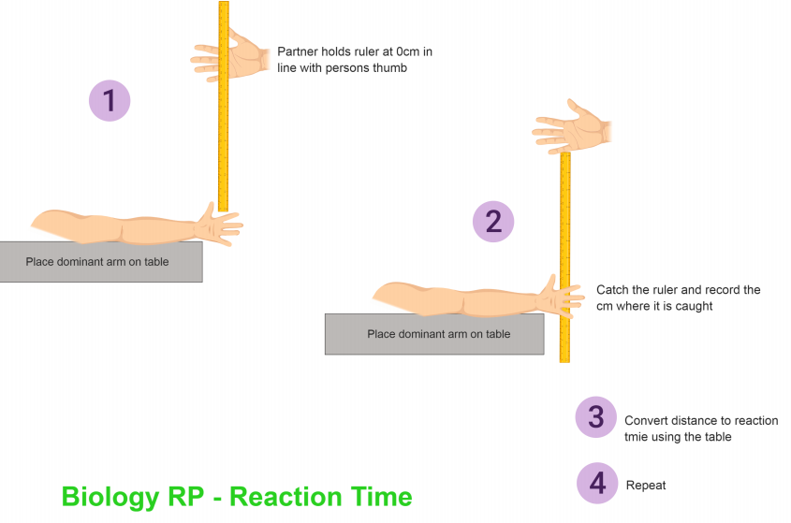
Comprehension questions – each question should be attempted first from memory. Every five questions get your green pen and use the text to check your answers.

- What was the independent variable in your investigation?
- What was the dependent variable in your investigation?
- Give two sources of error in the method and one possible way of reducing their impact on the results.
- Three students measured their reaction times. The students used a computer program. The image below shows the image displayed on the computer screen.



This is the method used:

1. Sit facing the computer screen.

2. Click the mouse button as quickly as possible when the computer screen turns green.

3. Record the time taken as shown on the computer screen.

4. Repeat steps 2 and 3 a further 9 times.

The table shows the students’ results.

Attempt number | Time in milliseconds
Attempt number | Student A | Student B | Student C
1 | 275 | 260 | 272
2 | 259 | 268 | 268
3 | 251 | 251 | 275
4 | 261 | 256 | 266
5 | 260 | 244 | 270
6 | 263 | 280 | 283
7 | 259 | 468 | 274
8 | 256 | 258 | 278
9 | 255 | 255 | 286
10 | 248 | 277 | 275
Mean | 259 | 282 | 275

(1 second = 1000 milliseconds)

(a) Suggest why measuring reaction time with a computer is more accurate than measuring reaction time with a stopwatch.

(b) The students measured 10 reaction times for each person rather than 3 reaction times. Explain why.

(c) Explain why the mean for student B has been calculated incorrectly. Use information from the table.

(d) Calculate the ratio of student C’s mean reaction time to student A’s mean reaction time.

Give your answer to 3 significant figures.

Ratio student C : student A = ____________________ : 1

(e) Student A wanted to present his mean result in seconds, in standard form.
What is the correct way of doing this? Choose from the answers below:
259 × 10⁻³ seconds 0.259 × 10⁻³ seconds 2.59 × 10⁻¹ seconds 0.259 × 10⁻⁴ seconds

(f) Student C said the results from this investigation showed that he had the fastest reactions.

Give two reasons why student C’s statement is not correct.

(g) The reaction the students investigated is not a reflex action. Give the reason why.

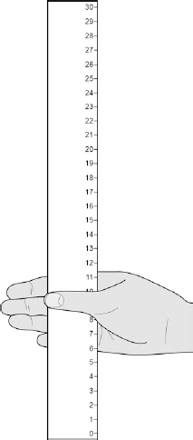
- Two students investigated reflex action times.

This is the method used.

1. Student A sits with her elbow resting on the edge of a table.

2. Student B holds a ruler with the bottom of the ruler level with the thumb of Student A.

3. Student B drops the ruler.

4. Student A catches the ruler and records the distance, as shown in the diagram below.

5. Steps 1 to 4 were then repeated.
Test Number | Distance ruler dropped in mm
1 | 117
2 | 120
3 | 115
4 | 106
5 | 123
6 | 125
7 | 106

(a) Suggest two ways the students could improve the method to make sure the test would give valid results.

(b) The table below shows Student A’s results.

What is the median result?

(c) The mean distance the ruler was dropped is 116 mm.

Calculate the mean reaction time.

Use the equation:

reaction time in s = 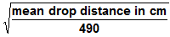 Give your answer to 3 significant figures

(d) The students then measured Student A’s reaction time using a computer program.

This is the method used.

1. The computer shows a red box at the start.

2. As soon as the box turns green the student has to press a key on the keyboard as fast as possible.

3. The test is repeated five times and a mean reaction time is displayed.

Student A’s mean reaction time was 110 ms.

Using a computer program to measure reaction times is likely to be more valid than the method using a dropped ruler.

Give two reasons why.

Part 3- The Brain (Triple only)

The human brain is approximately 2% of your body mass. It is responsible for all coordinating of complex behaviour as well as most of your homeostatic mechanisms. It is made of billions of interconnected neurones constantly sending and receiving signals to and from the rest of your body. Through examining people who have suffered brain injuries scientists have discovered that certain parts of the brain are specialised to perform certain tasks. Some of these are outlines below.

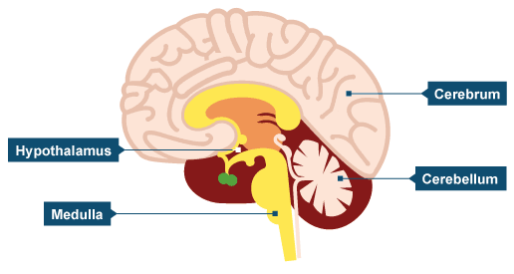

The medulla is the most primeval part of the brain; it is mainly responsible for controlling the life supporting functions life heart rate, blood pressure and breathing rate.

The cerebellum (“little brain”) sits at the back of the head above the neck. It is responsible for coordinating movement and balance.

The cerebrum is the large folded area at the top of the brain; It is responsible for intelligence, speech, memory, conscious muscle movement and decision making.

The hypothalamus is a tiny cherry-size area situated behind your eyes; It plays a large role in homeostasis.
Comprehension questions – each question should be attempted first from memory. Every five questions get your green pen and use the text to check your answers.
- What is the role of the brain?
- How did scientists learn about the different parts of the brain?
- What area of the brain is responsible for increasing your heart rate when you exercise?
- What area of the brain is responsible for thinking about what you want for your birthday?
- What area of the brain is responsible preventing you falling off a balance beam in PE?
- What area of the brain is responsible for you being able to speak and listen?
- What area of the brain is responsible for remembering your phone number?
- A woman has a head injury. Her symptoms include:

• finding it difficult to name familiar objects

• not being able to remember recent events.

Suggest which part of her brain has been damaged.
- A man has a head injury. He staggers and sways as he walks.

Suggest which part of his brain has been damaged.

Part 4- The Eye (TRIPLE ONLY)

The eye is a complex sense organ that can not only detect the amount of light but also the colours it has. This gives us the sense of vision. By combining the information we receive from our eyes with our knowledge of the world we can see what is happening around us. The main surface of the eye is covered in the protective layer called the Sclera. Below is a diagram that outlines the structure and function of the tissues in the eye.

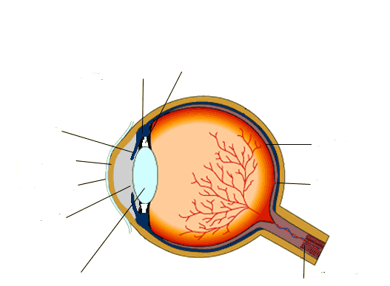
Lens: Flexible transparent tissue that can refract (bend) light
Optic nerve: Carries the signal from the retina to the brain
Conjunctiva: Protects the eye
Cornea: Transparent window that lets light through
Iris: A hole which light passes through to hit the lens
Iris: Ring of muscle which controls the amount of light entering the eye.
Ciliary muscles: These contract to change the shape of the lens. This helps you see near and distant objects
Suspensory ligaments: These connect the ciliary muscles to the lens
Fovea: Area where you see most of the colour
Retina: A layer of light receptors which detect the light that enters the eye

Comprehension questions – each question should be attempted first from memory. Every five questions get your green pen and use the text to check your answers.
- What it’s the function of the retina?
- What controls the size of the pupil?
- What is responsible for changing the shape of the lens?
- What type of cell is found in the optic nerve?
- List the tissues that must be transparent
Accommodation is the word used to describe the process of focussing on near and far objects.
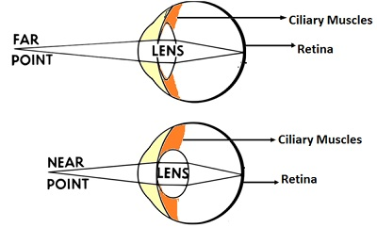
To look at a distant object:
- Ciliary muscles relax
- Suspensory ligaments get pulled tight
- Lens becomes thinner
- Light is refracted less
To look at a near object:
- Ciliary muscles contract
- Suspensory ligaments loosen
- Lens becomes fatter
- Light is refracted more
Eyesight problems
There are two common eyesight problems in humans. They are Myopia (short sightedness) and Hyperopia (long sightedness).
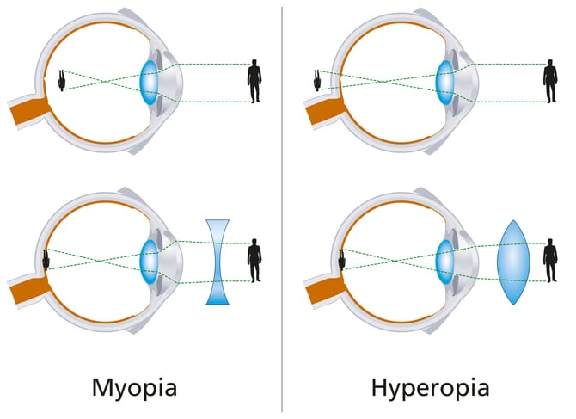
Myopia: This is when you find it hard to focus on distant images because the lens is too thick
Hyperopia: This is when you find it hard to focus on near objects because the lens is too thin
In both cases the problems are easily fixed by wearing glasses or contact lenses. More advanced treatments include laser eye surgery and lens replacement surgery.

Application questions – use your notes from this section and past sections to answer the questions below, but you should try from memory first.
- Complete the sentences below:

People with Hyperopia need to wear glasses because…..

People with Hyperopia need to wear glasses but…..

People with Hyperopia need to wear glasses so…..
- Figure 1 shows a reflex in the iris of the human eye in response to changes in light levels.

Figure 1
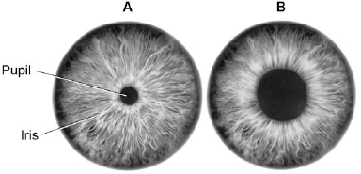
- Describe the changes in the pupil and iris going from A to B in Figure 1.

Explain how these changes occur.

Refer to the changes in light level in your answer.

(b) Some people wear glasses to improve their vision.

Figure 2 shows light entering the eye in a person with blurred vision.

Figure 3 shows how this condition is corrected with glasses.

Figure 2 Figure 3

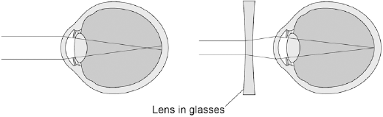

Compare Figure 2 and Figure 3.

Explain how the blurred vision is corrected.
- Diagram 1 shows cells from the light-sensitive layer in the eye.

Diagram 1

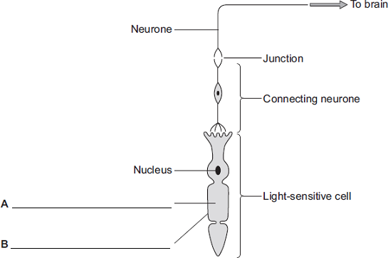

(a) On Diagram 1, add labels to name part A and part B of the light-sensitive cell.

(b) There is a junction between the connecting neurone and the neurone carrying the impulse to the brain.

(i) What name is given to the junction?

(ii) In what form is information passed across the junction?

(c) Diagram 2 shows a bee flying towards a man’s eye.

Diagram 2

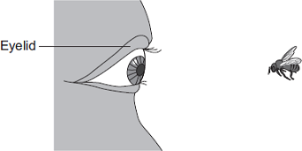
In the blink reflex , light from the bee reaches the light-sensitive cell in the eye.
The muscles in the eyelid shut the man’s eye before the bee hits the eye.

Describe the pathway taken by the nerve impulse in the blink reflex.

Part 5- The control of body temperature (TRIPLE ONLY)
As we mentioned earlier in the unit, Humans have to maintain a constant body temperature have to maintain a constant internal body temperature of 37ºC. If the temperature rises or falls more than a few degrees then the enzymes in our cells will denature and we will risk death.
If humans are so vulnerable to temperature changes how can they survive in both hot and cold climates? Fortunately, we have a thermoregulatory centre in the hypothalamus of the brain. The thermoregulatory centres job is to ensure the body’s core temperature remains constant.
The thermoregulatory centre constantly receives signals from temperature receptors of the skin via the nervous system. It also monitors the temperature of the blood to ensure the internal temperature is within the right range.
If the thermoregulatory centre detects that the core body temperature is too high:
- The blood vessels near the skin widen (vasodialtion) this lets more blood flow to the surface. The blood radiates heat to the surroundings, cooling the body
- Sweat glands begin to secrete sweat, which evaporates. This transfers energy to the surroundings, cooling the body.
Comprehension questions – each question should be attempted first from memory. Every five questions get your green pen and use the text to check your answers.
- Add labels to the diagram below to show the body’s response to an increase in core temperature. Include lines to show the radiation of thermal energy from the skin.
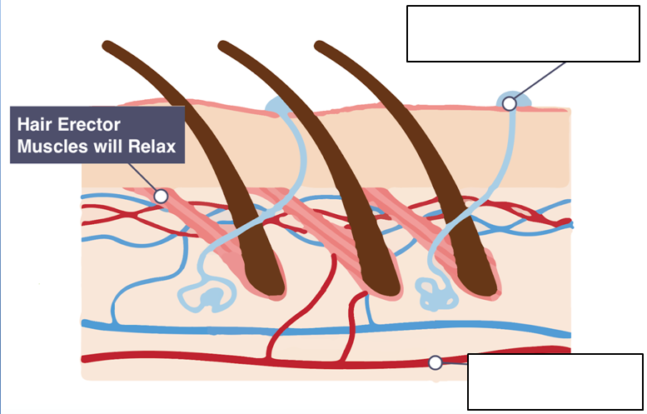
If the thermoregulatory centre detects that core body temperature is too low:
- The blood vessels near the surface constrict and less blood reaches the surface of the skin. This is called vasoconstriction and it prevents heat being lost form the blood by radiation
- The erector muscles in the skin cause the hairs to stand on end. The scientific name for this is piloerection, but you might have heard it called ‘goosebumps’. The aim is for the hairs to trap a layer of air to insulate the skin.
- Sweating stops to prevent heat loss by evaporation.
- The muscles of your body begin to shiver. These small contractions aim to increase the rate of respiration and generate some heat to raise your body temperature
- Add labels to the diagram below to show the body’s response to an increase in core temperature.
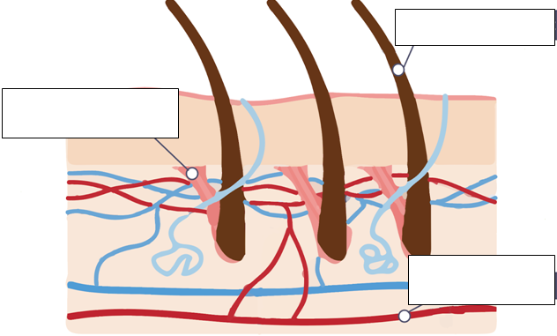
Frostbite is a condition that causes the death of the extremities, like the finger and toes, when exposed to extreme cold. The extremities fail to get enough blood supply due to the high levels of vasoconstriction they are experiencing. This means they get cold enough to freeze and they have so little glucose and oxygen they die. The result is hard black fingers and toes, which have to be amputated. Sometimes if it is bad enough they will fall off on their own! This is an extreme example of the lengths the body will go to keep the core body temperature high enough.
- State normal core body temperature
- What part of the brain coordinates the response to changes in body temperature?
- What is the name of the process for maintain constant internal conditions?
- Define ‘vasoconstriction’
- Define ‘vasodilation’
- How can you tell by looking that a person has vasodilation happening?
- Why do you shiver when you get cold?
Application questions – use your notes from this section and past sections to answer the questions below, but you should try from memory first.

- When a person gets frostbite their connective tissue in their skin freezes. Define ‘tissue’
- Complete the sentences below:
When body temperature rises you begin to sweat because….
When body temperature rises you begin to sweat but….
When body temperature rises you begin to sweat so….

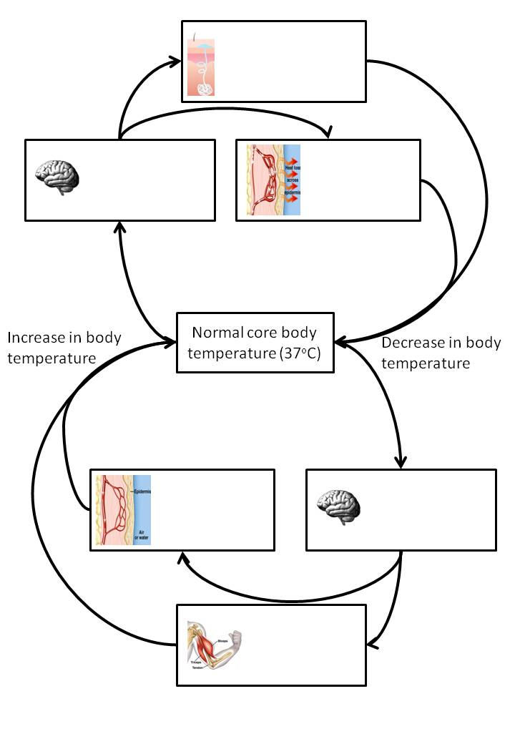
- Complete the flow diagram showing how thermoregulation works.

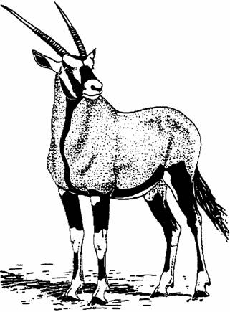
- The gemsbok is a large herbivore that lives in herds in desert areas of South Africa. Gemsboks feed on plants that are adapted to living in dry conditions. There are not many rivers, lakes or ponds that can provide drinking water for the animals. The desert areas are hot during the day but cool at night. As the air cools at night it becomes moist, and the plants absorb the moisture.

Although the gemsbok lives in hot conditions, it does not sweat. During the day its body temperature can rise, but it is important that blood reaching the brain does not rise above 40°C. The drawing shows how the blood system is adapted to cool the blood which flows to the brain.

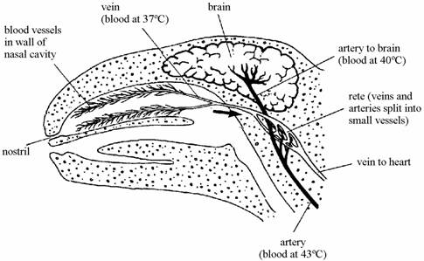

(i) Suggest an advantage to the gemsbok of not sweating.

(ii) Explain how the blood is cooled in the cavities of the nose.

(iii) How does the structure of the rete help in keeping the brain cool?
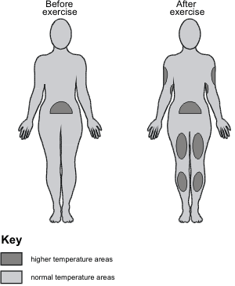
- The temperature at the surface of the skin can be measured by using a technique called thermography. Areas with higher temperature appear as a light shade on the thermographs. The drawings below show the results of an investigation in which thermographs were taken before and after exercise.

Explain, as fully as you can, the body mechanisms which affected the skin temperature to give the results shown in the drawings.

- (a) Each day, a boy ate food containing 12 000 kilojoules of energy. The boy’s body used 80 per cent of this energy to maintain his core temperature.

(i) Name the process which releases energy from food.

(ii) Calculate the amount of energy that the boy would use each day to maintain his core body temperature. Show clearly how you work out your final answer.

(b) The diagram shows a section through human skin.

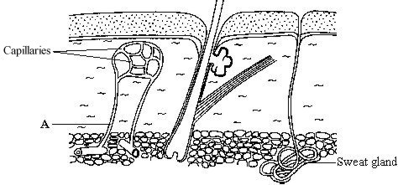

Explain how structure A helps to cool the body on a hot day.

(c) Body temperature is monitored and controlled by the thermoregulatory centre. Where in the body is the thermoregulatory centre?

Part 6- Hormonal coordination in humans
Hormones are chemical messengers that travel round the body. The endocrine system is the name of the series of organs and glands which coordinate changes in the body using hormones. A gland secretes a hormone into the blood. The hormone travels through blood stream until it reaches its target organ. The advantage of hormonal coordination is it can have a more long-lasting effect. The disadvantage is that it takes longer to work. A good example of this is puberty. Sex hormones (oestrogen and testosterone) are released from the sexual organs and cause the changes to the body over several years.
The endocrine system has a ‘master gland’ called the pituitary gland. It secretes several hormones which in turn affect other glands which secrete different hormones. It plays a large role in both homeostasis and our body’s stress response.
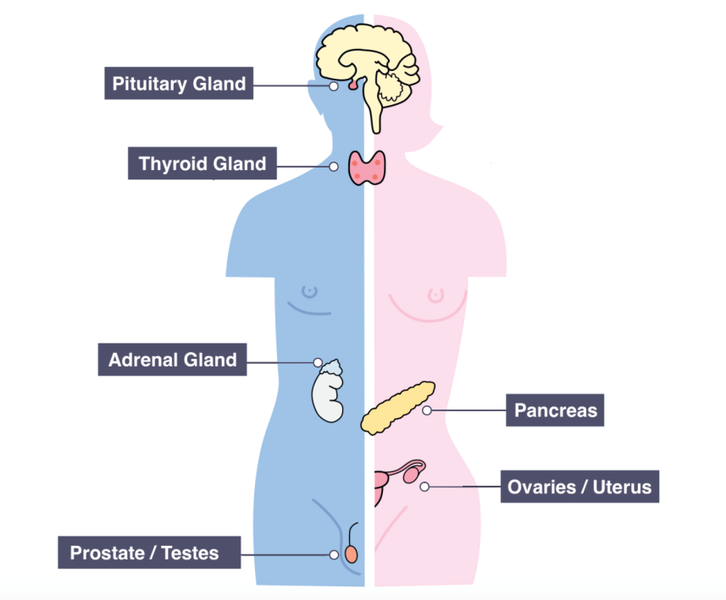
Below is a diagram showing the main organs of the endocrine system

Part 4- Blood glucose regulation
We need a supply of glucose in our blood so that our cells can respire efficiently. The problem is glucose is soluble so affects the osmotic potential of the blood plasma. If there is too much sugar in the blood then water will leave the red blood cells, by osmosis through the cell membrane. This causes the red blood cells to shrivel and become unable to carry oxygen. Conversely, if there is too little glucose in the plasma then the water will move from the plasma to the red blood cells by osmosis. This causes the red blood cells to swell and even burst. The endocrine system is responsible for maintaining a constant blood glucose level in the body.
The pancreas is the main organ responsible for detecting and controlling the blood glucose levels of the blood. The liver plays a role in the storing of glucose as insoluble glycogen.
When you eat your blood sugar rises:
- The pancreas detects the rise in blood glucose
- The pancreas secretes insulin into the blood stream
- The insulin travels to the liver
- The liver absorbs the glucose and converts it in to glycogen
- Blood glucose returns to normal
When you exercise your blood sugar falls:
- The pancreas detects the fall in blood glucose
- The pancreas secretes glucagon into the blood stream
- The glucagon travels to the liver
- The liver converts glycogen to glucose and releases it in to the blood
- Blood glucose returns to normal
Diabetes is a disorder where a person cannot control their blood glucose concentration on their own. It comes is two forms summarised below.
 | Type 1 | Type 2
Caused by | Body’s immune system accidently attacking pancreas cells | Poor diet and obesity over a long period of time
Effect | Pancreas no longer makes insulin | Liver is unable to recognise insulin in the blood
Consequence | Blood sugar rises | Blood sugar rises
Treated by | Injections of insulin | Carbohydrate controlled diet, exercise and medication
Comprehension questions – each question should be attempted first from memory. Every five questions get your green pen and use the text to check your answers.
- Use the information above to complete the flow diagram below to summarise how the pancreas and liver control blood glucose concentrations
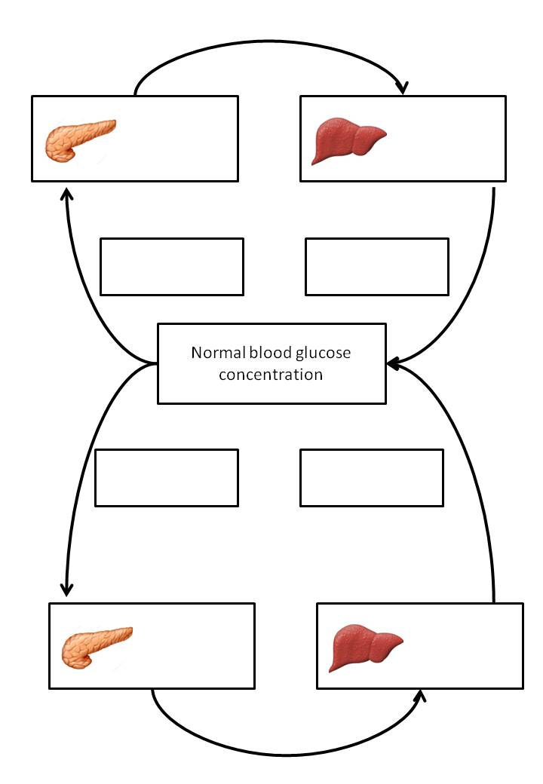
- Define ‘osmosis’
- What is the role of the pancreas in homeostasis?
- Ruby says “the liver is an organ because it has more than one function” is she correct? Give a reason.
- What are hormones?
- Name the system apart from the nervous system that coordinates the body.
- Where are hormones produced?
- How are hormones transported from one organ to another?
- Name the ‘master gland’ and describe how it brings about impact on the body.
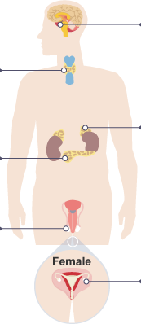
- Label the endocrine glands.
- Name the endocrine gland that controls blood glucose level (BGL).
- What is the effect of insulin on BGL?
- Name the hormone that increases BGL.
- Name the organ that secretes the two hormones to regulate BGL.
- When would a person’s BGL increase during a day (24hr)?
- Explain the primary reason why a person’s BGL would decrease eventually.
- Describe the actions of insulin – how does it lower BGL?
- Describe the actions of glucagon.
- Explain the importance of maintaining a stable blood glucose level.
- What is diabetes?
- Describe two differences between types 1 and 2 diabetes.
- State three symptoms of diabetes.

Application questions – use your notes from this section and past sections to answer the questions below, but you should try from memory first.
- Compare nervous coordination to hormonal coordination. How are they similar? How are they different?
- What is the food test for glucose?
- Explain why diabetic patients may lose weight.
- Suggest two risk factors for developing diabetes.
- State two ways to diagnose someone as diabetic.
- Compare the treatments of types 1 and 2 diabetes.
- One type of diabetes can be cured. State which one it is and explain how.
- Following the question above, suggest a problem with the treatment. What is a possible solution to this problem?
- Explain why insulin must be injected rather than taken by mouth.
- Explain why insulin injection is not an appropriate treatment for type 2 diabetes.
- It is important that the concentration of glucose (sugar) in the blood is controlled.

(a) (i) Which hormone controls the concentration of glucose in the blood?

(ii) Which organ produces this hormone?

(b) The concentration of glucose in the blood of two people, A and B, was measured every half an hour.

One hour after the start, both people drank a solution containing 50 g of glucose.

The graph shows the result.

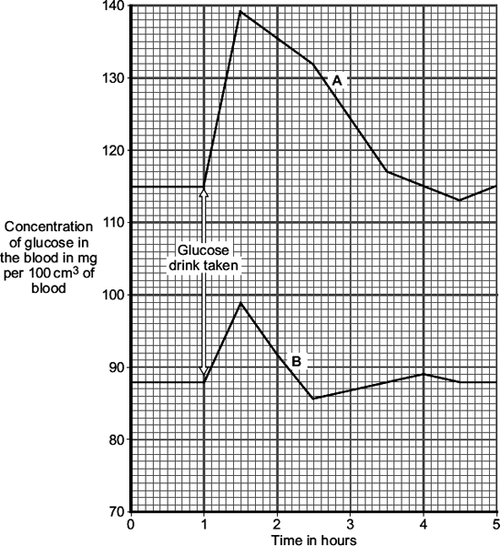

(i) By how much did the blood glucose concentration in person B rise after drinking the glucose drink?

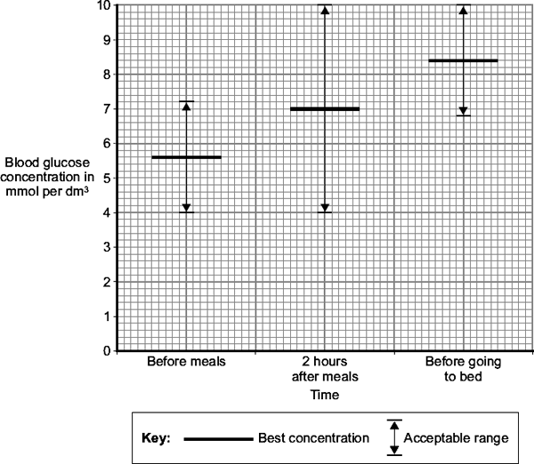
(ii) A doctor suggests that person A has diabetes.

Give two pieces of evidence from the graph to support this suggestion.

(iii) Give one reason for the fall in blood glucose concentration in person B, shown in the graph.

- In diabetics blood glucose concentrations are sometimes abnormal.

(a) Name the organ that monitors the concentration of glucose in the blood.

(b) Diabetics can measure their blood glucose concentration.

The graph shows the best blood glucose concentration and the acceptable range of blood glucose concentration at different times.

What is the acceptable range for the blood glucose concentration before meals?

(c) The amount of insulin a diabetic injects can be changed so that blood glucose concentration is kept near to the best level. Two hours after eating breakfast a diabetic measures his blood glucose concentration. His blood glucose concentration is 13 mmol per dm³.

He reads these instructions:

• for every 2 mmol per dm³ of blood glucose above the best concentration, inject 1 unit more of insulin

• for every 2 mmol per dm³ of blood glucose below the best concentration, inject 1 unit less of insulin.

How should he change his normal insulin injection to bring his blood glucose level to the best concentration?

- Diabetes is a disease in which a person’s blood glucose concentration rises to higher levels than normal. Diabetes is caused by insufficient insulin being produced.

(a) (i) Which organ monitors blood glucose concentration?

(ii) Insulin reduces the concentration of glucose in the blood. Describe how insulin does this.

(b) A person with diabetes can be monitored in three ways:
- measuring the blood glucose concentration after fasting (going without food for 12 hours)
- measuring the amount of glucose attached to red blood cells: this is a measure of the average blood glucose concentration over the previous three months
- measuring the concentration of insulin in the blood after fasting

The manufacturer of a new treatment for diabetes, called Diacure, publishes the following two claims.
98.6% of all people who used Diacure reported an improvement in their condition.
An independent study of 30 diabetic patients showed a significant reduction in blood glucose concentrations and a significant increase in insulin production, as shown by the graph.
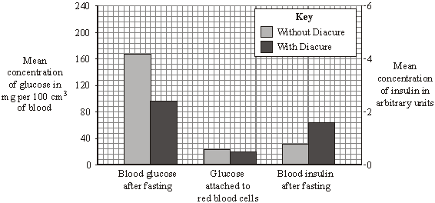

(i) Which of the manufacturer’s claims is not based on scientific evidence?

(ii) Why might the data in this study be unreliable?

(iii) The manufacturer did not draw attention to the data for the amount of glucose attached to red blood cells. Suggest an explanation for this.

(iv) The study of diabetic patients was carried out by an independent company. Why is it important that the study should be independent?

Part 7- The control of the body’s water levels (TRIPLE ONLY)
Just as your body needs to maintain a constant temperature and water levels, it also needs to maintain a constant water level. If your body has too much water it can affect the osmotic (water) potential of your cells and damage them. Conversely, if your water levels drop too low you could suffer from the effects of dehydration, which if not remedied can result in death.
Your body is constantly losing water. Your breath contains water vapour, your sweat and the water in your urine all contribute to the water loss from your body. The only way to increase the level of water in your body is through the food and drink you take.
HT ONLY: The digestion of proteins from the diet results in excess amino acids which need to be excreted safely. In the liver these amino acids are de-aminated to form ammonia. Ammonia is toxic and so it is immediately converted to urea for safe excretion.
The kidney is the organ responsible for filtering the blood. When the blood comes to the kidneys they:
- Filter out all of the waste Urea
- Filter out some of the ions (salts)
- Filter out some of the water
If you are slightly dehydrated the kidney will only filter out a small volume of water to ensure the body has enough water. This is called selective reabsorption. The product of the filtration is called urine and it is passed to the bladder for storage.
Comprehension questions – each question should be attempted first from memory. Every five questions get your green pen and use the text to check your answers.
- Which organ is responsible for filtering the blood?
- Define ‘selective reabsoprtion’
- What is the word used to describe the movement of water from an area of high concentration to an area of low concentration?
- What is never reabsorbed from the blood by the kidneys?
- Alan says “you get dehydrated because your kidneys remove all of the water from your blood” Explain why Alan is wrong and write the correct end to his sentence
- Which has a high concentration of water; a dilute solution or a concentrated solution
- Describe what the urine of someone suffering from dehydration would look like?
- What behaviour change will happen when the water levels of the body are low?
- Draw a diagram to illustrate the process of osmosis. Make sure you include the following labels: semi-permeable membrane, movement of water, hypertonic, hypotonic, water molecule, solute molecule, dilute solution, concentrated solution

The role of hormones in controlling water levels HT ONLY
The level of water in your body is controlled by anti-diuretic hormone (ADH). ADH is a hormone which works to reduce the volume of water lost in the urine. When the body’s water levels begin to drop, the pituitary gland releases ADH into the bloodstream. The ADH reaches the kidney’s tubules and makes them reabsorb more water back into the blood stream and the water level is returned to normal. Conversely, if you drink a large amount of water the pituitary gland lowers ADH levels in the blood and the kidneys reabsorb less water.
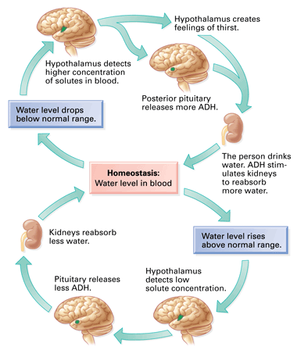
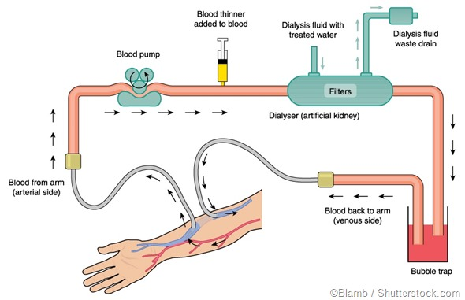
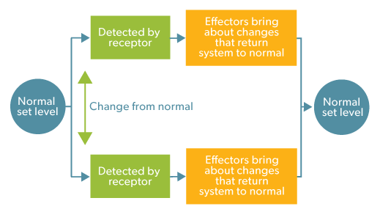
This is a good example of the principle of negative feedback. All homeostatic mechanisms follow the principle of negative feedback. When the body moves from the optimum level, a change occurs to move the body back to the optimum level. Once it reaches the optimum level the change is removed. This is why it is called negative feedback, the change the body makes inhibits itself once optimum levels are restored.
If a person’s kidneys become damaged, by injury or disease this can be a serious problem. The only cure currently available is a transplant. While a person is waiting for a suitable donor they can have dialysis to clean their blood. At the hospital the patient is connected to a machine. Their blood is pumped through a filter. The dialysis filters out the waste products returns the clean blood back to the body. With regular dialysis a person can live a long a healthy life.

Comprehension questions – each question should be attempted first from memory. Every five questions get your green pen and use the text to check your answers.

- Complete the diagram outlining the roles of ADH and the key organs in osmoregulation
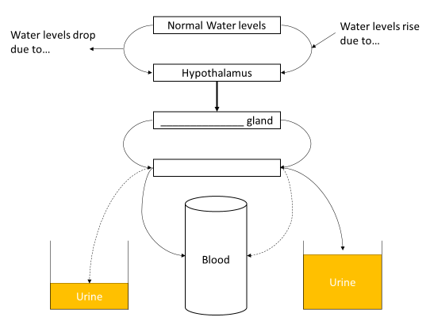
- What is the function of ADH?
- What gland secretes ADH?
- How does ADH travel to the kidneys?
- What happens in an organ transplant?
- What are the advantages and disadvantages of organ transplants
- What happens in dialysis?
- What are the advantages and disadvantages of dialysis
Application questions – use your notes from this section and past sections to answer the questions below, but you should try from memory first.
- Define osmosis
- Geoff is an elderly man with a weak heart. His kidneys have been damaged by some medication he was on. Explain why it is best for him to have dialysis over a transplant
- Suggest why the dialysis machine has a bubble trap
- Suggest why the dialysis machine adds a blood thinner to the blood. What part of the blood does the blood thinner act on?

- It is important that the amount of water in the body is controlled.

(a) The table below shows the main ways that a person takes in and loses water in one day.

Water taken in |  | Water lost
Method | Volume in cm³ | Method | Volume in cm³
Drink | 1450 | Urine | 1500
Food | 800 | Sweat | 600
Metabolic water | 350 | Breath
 |  | Faeces | 100
Total | 2600 | Total | 2600

(i) Calculate the volume of water lost from the body through breathing.

Use information from the table above.

Volume of water lost through breathing = ______________________ cm³

(ii) Metabolic water is water produced by aerobic respiration.

Complete the equation for aerobic respiration.

_____________ + oxygen _____________ + water (+ energy)

(iii) If the water intake stays the same, what will happen to the volumes of sweat and urine lost from the body on a much hotter day?

(b) The kidneys help to control the water content of the body and the concentrations of substances dissolved in the body fluids. The kidneys do this by filtering the blood and then reabsorbing back into the blood the substances needed by the body.

The table above shows typical concentrations of some of the substances dissolved in a person’s blood plasma, in the kidney filtrate, and in the urine.

Substance | Blood plasma in g per dm³ | Kidney filtrate in g per dm³ | Urine  in g per dm³
Protein | 70 | 0 | 0
Glucose | 1 | 1 | 0
Urea | 0.3 | 0.3 | 20
Sodium ions | 3 | 3 | 6

(i) The table below shows that sodium ions are twice as concentrated in the urine as in the blood plasma.

Calculate how many times more concentrated urea is in the urine compared to the blood plasma. Use information from the table.

(ii) What is the main cause of this increase in concentration of urea between the blood plasma and the urine?

(iii) The table shows that both protein and glucose are found in the blood plasma but not in the urine. Use your knowledge of kidney functioning to explain why.

(c) Some people have kidney failure.

The two main types of treatment for kidney failure are dialysis and a kidney transplant operation.

Suggest reasons why most doctors think that a kidney transplant is better than dialysis treatment.

Part 9- Human reproductive hormones
One of the most vital roles of the endocrine system is in coordinating the reproductive system. As mentioned before, during puberty testosterone is made in the testes in high levels. This causes males to develop the secondary sex characteristics of body hair, deeper voice, sperm production etc.. Likewise the ovaries secrete oestrogen which causes females to develop breasts, grow body hair, widen their hips and they begin to ovulate.
Hormones also play a vital role in coordinating the female menstrual cycle. The function of the menstrual cycle is to ensure the female body is prepared to conceive a baby at regular intervals. Most women have a menstrual cycle of 28 days although this can vary. The menstrual cycle is a complex system coordinated by 4 main hormones;
Follicle stimulating hormone (FSH): This causes an egg cell to mature in the ovaries
Luteinising hormone (LH): Stimulates the ovary to release the egg
Progesterone and Oestrogen: These maintain the uterus lining so a fertilised egg can be implanted and develop into an embryo.
If the egg is not fertilised the lining and egg are shed. This is noticed as a small volume of blood. This is called menstruation, although it is also know as a ‘period’
Comprehension questions – each question should be attempted first from memory. Every five questions get your green pen and use the text to check your answers.
- What is the function of the endocrine system?
- What is the name of the male sex hormone and where is it produced?
- What is the name of the female sex hormone and where is it produced?
- What hormone causes and egg to develop in the ovary?
- What hormone causes the egg cell to be released?
- What is the role of progesterone?
- Why might women with love levels of FSH find it hard to conceive a baby?

Controlling the menstrual cycle (HT ONLY)
The female reproductive hormones are synchronised to ensure the menstrual cycle follows a regular pattern. This is summarised in the diagram below
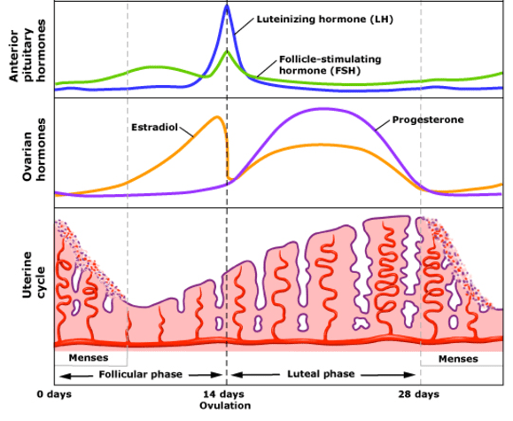
Oestrogen

The cycle starts with menstruation. The lining is shed because oestrogen and progesterone levels are low. At the same time FSH begins to rise slightly, triggering a new egg cell to begin developing. FSH stimulates Oestrogen production so oestrogen levels begin to rise and the lining of the uterus begins to re-grow.
A day or two before ovulation the levels of oestrogen, LH and FSH all reach their maximum. Once the egg is released they all begin to drop. Progesterone and oestrogen rise to maintain the lining of the uterus. If the egg is fertilised it will embed in the lining and progesterone and oestrogen will remain high. Oestrogen inhibits FSH and when combined with progesterone inhibits FSH. This prevents a second egg being released during the 9 months of a gestation. If the egg is not fertilised then progesterone drops and menstruation happens. The cycle repeats.
Comprehension questions – each question should be attempted first from memory. Every five questions get your green pen and use the text to check your answers.
- Which hormone stimulates the release of Oestrogen from the ovaries?
- What is the function of the uterus lining?
- What happens when FSH rises?
- What happens when FSH and LH rise suddenly
- Why does progesterone increase after ovulation?

Application questions – use your notes from this section and past sections to answer the questions below, but you should try from memory first.
- The human body produces many hormones.

(a) (i) What is a hormone?

(ii) Name an organ that produces a hormone.

(iii) How are hormones transported to their target organs?

(b) Describe how the hormones FSH, oestrogen and LH are involved in the control of the menstrual cycle.

122. The diagram shows changes in the uterus lining during 28 days of a menstrual cycle.

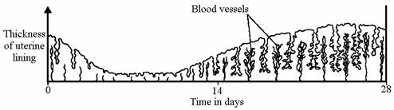

Describe how changes in the lining shown in the diagram adapt it for its function if an egg is fertilised.

(b) The concentration of a certain hormone in the blood of a woman was measured during her menstrual cycle. The woman's temperature was also measured each day during this cycle.

Graph 1 shows the results obtained for the measurement of the concentration of the hormone.

Graph 2 shows the results obtained for the measurement of her body temperature.

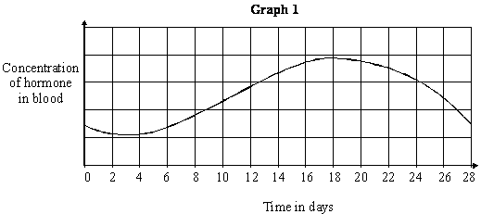

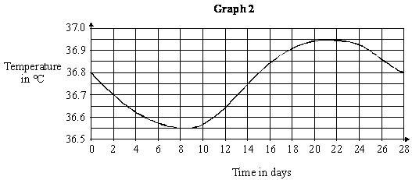

(i) What evidence is there that changes in the concentration of the hormone may be connected with changes in body temperature?

(ii) What is the difference between the minimum and maximum temperatures shown by Graph 2? Show your working.

Part 10- Contraception
It is hard to think of a world before contraception was available. Before contraception, every time a man and woman had sex there was a significant chance a baby would be conceived. Some forms of contraception have also helped to stop the spread of sexually transmitted diseases like syphilis, gonorrhoea, and HIV.
Contraception is the word used to describe any technology that prevents pregnancy. Type of contraception broadly fall into two main categories; Hormonal and Non-hormonal
Hormonal:
Give that we have just learnt about the complex roles the hormones play in the menstrual cycle it makes sense that we can manipulate them to trick the body and prevent pregnancy.
- Oral contraceptive pill: Contains oestrogen and progesterone to inhibit FSH. This prevents an egg maturing.
- Contraceptive implant: Contains a slow release version of progesterone. This ensures that an egg is not released from the ovary.
The balance of each hormone in an individual is similar but not identical. This means that pharmaceutical companies make a variety of mixtures of the hormones. The aim is to find a version which work for the woman without side effects.
Non-hormonal:
These are a broad range of very different strategies. Some only prevent pregnancy, others also provide protection from STI’s
- Barrier methods: Mainly the condom or the diaphragm. Both of these provide a physical barrier that prevents sperm entering the uterus. The condom has an added advantage of preventing the spread of STI’s. Correctly used a condom is 98% effective at preventing pregnancy, which is the best of all the methods available.

- Interuterine devices (IUD): Often called ‘the coil’ they are tiny plastic or metal devices that are inserted into the uterus. They aim to mimic an implanted embryo, stimulating progesterone and oestrogen and prevent a mature egg begin released.

- Spermacidal gels: These kill sperm on contact. Often added to barrier methods to improve their effectiveness. Does not prevent the spread of STI’s.

- Abstinence: Various apps are now available to monitor the menstrual cycle. By doing this they can predict when you will have a low chance of conceiving if you have sex. This is the least effective method as sperm can survive inside the oviduct for a number of days. Does not prevent the spread of STI’s.

- Surgical sterilisation: This is when a person is preventing from releasing sperm or eggs due to a small surgical procedure. In males a vasectomy involved the sperm ducts being stitched up to prevent the sperm made in the testes reaching the penis. In women the oviducts can have a similar procedure to prevent eggs travelling to meet the sperm. In both cases these are permanent procedures and come with some short term discomfort while you recover from the operation. They do not prevent the spread of STI’s.

Comprehension questions – each question should be attempted first from memory. Every five questions get your green pen and use the text to check your answers.
- What is the common purpose of all forms of contraception?
- What are the two main categories of contraception?
- Which forms of contraception also prevent STI’s?
- Which forms of contraception are permanent?
- Which hormone is in both hormonal contraceptive methods?
- Why would it still be recommended that a homosexual male wear a condom?
Application questions – use your notes from this section and past sections to answer the questions below, but you should try from memory first.
- Brad says “I can’t catch an STI because my girlfriend is on the pill” Is he right or wrong? Give a reason.
- Complete the sentences below:
The Abstinence method is not a very reliable method of contraception because..
The Abstinence method is not a very reliable method of contraception but..
The Abstinence method is not a very reliable method of contraception so..
- Duncan says “I don’t like the feeling of a condom, but my girlfriend has bad side effects on the pill. I’m not sure what to do?” What advice would you give Duncan? Make sure you include reasons for any advice you give.
- List two ways a sperm is adapted to its function
- What is the name of the process when a sperm and eggs nuclei fuse together?
- Why is the mid part of a sperm full of mitochondria?
- The graph below shows some changes that occur during the menstrual cycle.

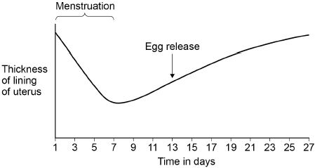

(a) The graph above shows that the lining of the uterus thickens between days 7 and 27.
What is the purpose of thickening the lining of the uterus?
Choose from:
- To allow implantation of the embryo
- To break down waste
- To prevent sperm reaching the egg

(b) Which hormone causes thickening of the lining of the uterus?

(c) On which day is fertilisation most likely to occur? Use information from the graph above.

Contraception can be used to lower the chance of pregnancy.

(d) Draw one line from each method of contraception to how the method works.

Method of contraception |  | How the method works
 |  | Barrier to prevent sperm reaching the egg
Contraceptive pill
 |  | Contains hormones to stop eggs maturing
Diaphragm
Kills
sperm
Spermicidal cream
 |  | Slows down sperm production

(e) The table below gives information about some different methods of contraception.

Method | Number of pregnancies per 100 women in one year | Possible Side effects
Diaphragm and spermicidal cream | 8 | Usually none, but can cause bladder infection in some women
Condom | 2 | None
Contraceptive pill | 1 | Mood swings, headaches, high blood pressure, blood clots, breast cancer

A man and a woman decide to use the condom as their method of contraception.

Suggest three reasons for this decision.

Use information from the table above and your own knowledge.

Part 11- Using hormones to treat infertility (HT ONLY)
It is a cruel twist of irony that while some people spend a lot of time ensuring they cannot fall pregnant during sex; others spend years desperately trying to have child and not succeeding.
Fortunately, scientific developments over the last 50 years have been able to help couples in this situation.
Fertility drugs: These are mixtures of FSH and LH taken over a series of days. The aim is to help the egg cells to mature and be released. The woman can then fall pregnant in a traditional fashion.
IVF: In-Vitro Fertilisation is a sophisticated process that can help a couple conceive.
- The woman is given a large dose of FSH and LH so she matures and releases many eggs
- The eggs are collected and fertilised by the sperm from the father. This is done in laboratory conditions. The words ‘in vitro’ mean ‘outside of the body’
- The embryos develop in the lab
- When the embryos are developed into a ball of cells they are implanted into the mother to be carried to term like a normal pregnancy.
About 60,000 of the 755,000 babies born last year were conceived via IVF. It is a vital service for some couples but it is not without its risks:
- It is physically and emotionally stressful on the woman
- Its success rates are also not very high (under 30%)
- There is a high chance of multiple births, which can put extra pressure on the mother and babies as they develop in the uterus. This increases the chance of complications during pregnancy.
IVF is also expensive; luckily it is available on the NHS in the UK for free.
Comprehension questions – each question should be attempted first from memory. Every five questions get your green pen and use the text to check your answers.
- Add labels to the diagram below to explain how IVF works
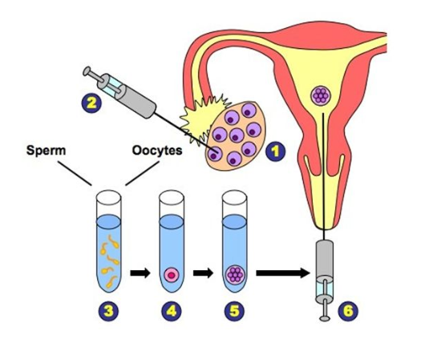

- Which hormones are in the fertility drugs? Why are they chosen?
- Define ‘fertilisation’
- List the risks of IVF
Application questions – use your notes from this section and past sections to answer the questions below, but you should try from memory first.
- What is the difference between sexual and asexual reproduction?
- Calculate the percentage of births in the UK which were as a result of IVF (hint: look in the test above for the numbers)
- Poppy says “IVF is not sexual reproduction because the couple don’t have sex” Is she right? give a reason for your answer
- Egg cells and sperm are gametes. Define ‘gametes’. Refer to the number of chromosomes in your answer.
- Why are women undergoing IVF more likely to have multiple babies developing simultaneously?
- Hormones are involved in controlling the menstrual cycle and fertility.

(a) (i) Use the correct answer from the box to complete the sentence.

A hormone produced by the pituitary gland is ____________________

(ii) Use the correct answer from the box to complete the sentence.

A hormone produced by the ovaries is ___________________________

(b) (i) Why are fertility drugs given to some women?

(ii) A doctor injects fertility drugs into a woman. After the injection, the hormones travel to the woman’s ovaries. How do the hormones travel to the ovaries?

(c) Which two hormones are used in contraceptive pills?

Tick (✔) two boxes.

FSH |  |  | oestrogen
LH |  |  | progesterone

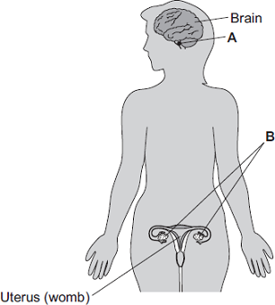
- The diagram shows the position of two glands, A and B, in a woman.

(a) (i) Name glands A and B.

(ii) Gland A produces the hormone Follicle Stimulating Hormone (FSH).

FSH controls changes in gland B.

How does FSH move from gland A to gland B?

(b) (i) A woman is not able to become pregnant. The woman does not produce mature eggs. The woman decides to have In Vitro Fertilisation (IVF) treatment.

Which two hormones will help the woman produce and release mature eggs?

(ii) Giving these hormones to the woman helps her to produce several mature eggs.
Doctors collect the mature eggs from the woman in an operation.

Describe how the mature eggs are used in IVF treatment so that the woman may become pregnant.

(iii) IVF clinics have been set a target to reduce multiple births.

At least 76% of IVF treatments should result in single babies and a maximum of 24% of treatments should result in multiple births.

Suggest one reason why the clinics have been set this target to reduce multiple births.

(c) Two clinics, R and S, used IVF treatment on women in 2007. Doctors at each clinic used the results of the treatments to predict the success rate of treatments in 2008.

The table shows the information.

 | Total number of IVF treatments in 2007 | Number of IVF treatments resulting in pregnancy in 2007 | Predicted percentage success rate in 2008
Clinic R | 1004 | 200 | 18–23
Clinic S | 98 | 20 | 3–56

(i) Compare the success rates of the two clinics in 2007.

(ii) The range of the predicted success rate in 2008 for clinic R is much smaller than the range of the predicted success rate for clinic S.

Suggest why.
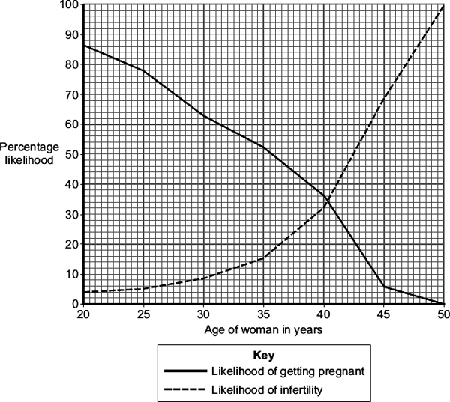
- The graph shows how the likelihood of getting pregnant and the likelihood of infertility change with a woman’s age.

The data is for healthy women who have unprotected sexual intercourse during one year.

(a)Use information from the graph to answer this question.

A woman in her mid-twenties is thinking about waiting until her late-thirties before she has children. A doctor advises the woman not to wait.

Explain why the doctor gives this advice.

(b)The hormones FSH and LH are used in fertility treatment.

Give the function in fertility treatment of FSH and LH

(c)In the first stage of in-vitro fertilisation (IVF), eggs from the mother are fertilised with sperm from the father. Describe the next stages of IVF.

Part 12-Illustrating Negative feedback: Adrenalin vs Thyroxin. (HT ONLY)
If you remember from the beginning of the homeostasis topic, we have come across various forms of negative feedback. Thermoregulation, the regulation of water levels and blood glucose regulation all demonstrate negative feedback. A negative feedback control system responds when conditions change from the ideal or set point and returns conditions to this set point. There is a continuous cycle of events in negative feedback because the change inhibits the signal (hormonal or nervous) causing the change.
Thyroxin is a hormone made in your thyroid gland. Its function is to stimulate the basal metabolic rate in your body. Basal means ‘base’ so the basal metabolic rate is your base level of all your chemical processes in all your cells, just to live. It is vital to growth and development. The release of thyroxin by the thyroid is itself controlled by the pituitary gland of the hypothalamus. If the metabolic rate gets too high, thyroxin levels in the blood drop and it lowers. If the basal metabolic rate gets too low the thyroid secretes more thyroxin and the metabolic rate increases. By using a negative feedback loop the body tries to have a stable basal metabolic rate that is just right.
Adrenalin does not follow a negative feedback loop. Adrenalin is a hormone secreted by the adrenal glands above the kidneys. It is release when the body is in danger. The ‘fight of flight’ situations occur when a threat is perceived. The glands flood the body with adrenalin, raising the heart rate, breathing rate and increasing blood supply to the muscles and brain. This is an evolved response to provide the best chance of escaping a dangerous situation.
Comprehension questions – each question should be attempted first from memory. Every five questions get your green pen and use the text to check your answers.
- Describe how negative feedback works.
- Suggest two hormonal controls that involve negative feedback.
- What does thyroxine control?
- Which organ secretes thyroxine?
- *Some people do not produce enough thyroxine. Suggest two possible reasons.
- Describe how the level of thyroxine is regulated in the body.
- Under what situation would adrenaline be released?
- *Describe three differences between thyroid glands and adrenal glands.
- Describe three effects of adrenaline.
Application questions – use your notes from this section and past sections to answer the questions below, but you should try from memory first.

- Explain why blood is directed to the brain and muscles and away from the digestive system when there is more adrenaline.
- What are the 4 components of the blood? Give a function for each
- Endocrine glands produce hormones.

(a) Hyperthyroidism is caused by an overactive thyroid gland.

Suggest what would happen in the body of a person with hyperthyroidism.

(b) Describe the roles of FSH and LH in the menstrual cycle.

(c) The combined pill is a contraceptive that contains progesterone and oestrogen.

The ‘mini-pill’:

• is a contraceptive that only contains the progesterone hormone

• has to be taken at the same time each day to prevent pregnancy.

The success rate of the mini-pill in preventing pregnancy is lower than that of the combined pill. Explain why missing a dose of the mini-pill would reduce the success rate of the mini-pill.

Part 13-Plant hormones (TRIPLE ONLY)

Just like animals, plants rely on chemical messengers to affect change in response to the environment. The plant does not have a special coordinator organ, like the brain so has to use simple, but effective automatic responses to ensure their survival. These have evolved over billions of years and require no conscious through or control, no neurones or blood stream. The way a plant responds to the environment is called a tropism. There are two main type of tropism; Geotropism and Phototropism. Both are the result of a hormone called auxin.

Geotropism: The ability for the shoots to grow up (negative geotropism) and the roots to grow down (positive geotropism)

Phototropism: The ability for shoots to grow towards light (positively phototropic) and roots to grow away from light (negatively phototropic)
- Complete the table below to summarise the different tropism
Type of tropism |  | Shoots | Roots
Geotropism | Positive of negative
Geotropism | Effect
Phototropism | Positive of negative
Phototropism | Effect
Auxins are a family of hormones found in plants. Auxins are mostly made in the tips of the shoots and roots, and can diffuse to other parts of the shoots or roots. They change the rate of elongation in plant cells, controlling how long they become.
Shoots and roots respond differently to high concentrations of auxins:
- cells in shoots grow more
- cells in roots grow less
Explaining geotropism: Gravity is a constant force on earth. It pulls everything to the centre of the earth. We generally call this ‘down’. Gravity pulls on the auxin causing it to gather at the bottom of roots and shoots that are running horizontally. Due to its opposite effects this causes the roots to grow down and the shoots to grow up.
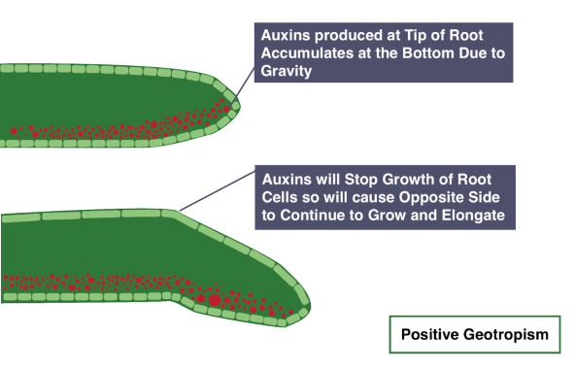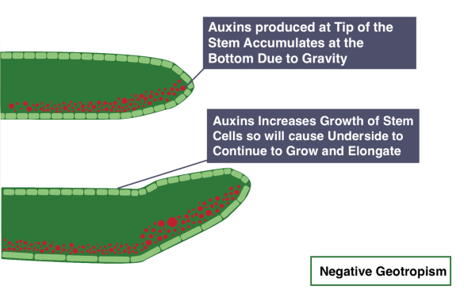
Explaining phototropism: Auxin also has another strange property, it builds up on the side of a plant that is away from the light source. This ensures the stem is always growing more on the shady side and tilting the leaves towards the sun.
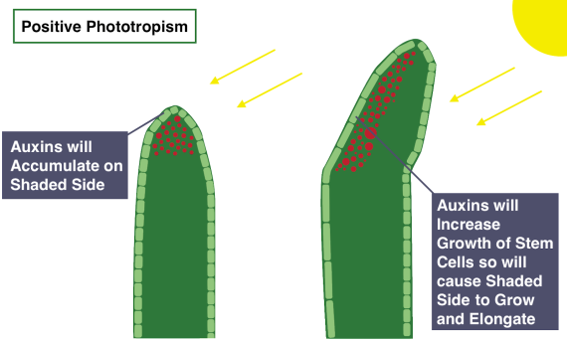

Industrial uses for auxin
Auxin can be used as rooting powder. By dipping a stem in auxin it can cause the stem cells to differentiate into root cells and begin to grow downwards (positive geotropism)
Auxin can also be used as a weed killer. Lots of weeds, especially those that grow in lawns like dandelions, have much broader leaves than the plants you want. By spraying auxin on to the lawn it is absorbed in greater concentrations by the weeds, causing them to grow so quickly they die.
Other useful plant hormones
Gibberellins are a group of plant hormones responsible for growth and development. They are important for initiating seed germination. Low concentrations can be used to increase the speed of germination, and they stimulate cell elongation so plants grow taller.
Gibberellins can be used to:
- end seed dormancy
- promote flowering
- increase fruit size
Ethene is used routinely within the food industry to provide controlled ripening during storage and transport or when fruit is displayed in shops, in sealed packages. Bananas are picked when they are green and unripened. Ethene is a hydrocarbon gas and it speeds up ripening in bananas and other fruit. The effect of ethene released from bananas is clearly visible if you keep them in a bowl with other fruit, as it causes other fruits to ripen very quickly.

Comprehension questions – each question should be attempted first from memory. Every five questions get your green pen and use the text to check your answers.
- Define ‘tropism’
- What is the difference between phototropism and geotropism?
- How does auxin affect shoots and roots differently?
- Describe what phototropism is.
- What is the name of the response of a plant to gravity?
- What causes tropism in plants?
- Explain the effect of phototropism in young shoots.
- Explain the effect of gravitropism in roots.
- *Compare the effects of auxins on shoot and root growth.
- Briefly describe an experimental set up to investigate the effect of light on plant growth.
- Plant hormones can be used in horticulture and agriculture. What is the difference between those two uses?

Application questions – use your notes from this section and past sections to answer the questions below, but you should try from memory first.
- Explain how auxin works effectively as a weed killer.
- Explain why gibberellins are used in agriculture.
- Ethene controls fruit ripening. Explain why this needs to be controlled.
- Hormones called auxins control plant growth.
- A student investigated plant growth responses in roots.

This is the method used.

1. Grow three bean seeds until their roots are 1 cm long.

2. Attach the three bean seeds to moist cotton wool in a Petri dish.

Each bean seed root should point in a different direction.

3. Fix the Petri dish vertically for 2 days in the dark.

Figure 1 shows the results.

Figure 1

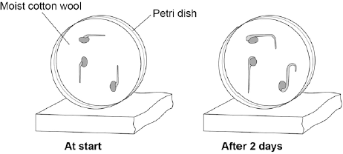

(a) Describe the direction of growth of the bean roots after 2 days.

Give one reason for this growth response.

(b) The student then noticed the shoots growing from the seeds.

He then:

1. put a light above the Petri dish but did not move the seeds

2. allowed the seeds to grow for 2 more days.

Predict the direction of growth of the bean shoots after 2 days. Give one reason for your prediction.

(c) Ethene is a plant hormone.

Ethene causes fruit to ripen.

Scientists measured the concentration of ethene found in fruit at different stages of ripeness.

Figure 2 shows the results.

Figure 2

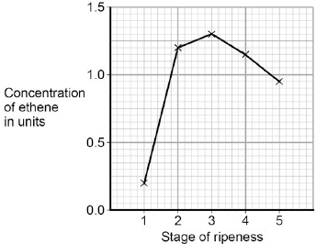

At which stage of ripeness is there most ethene?

(d) Suggest how the scientists can find out if the result for Stage 1 was an anomaly.

(e) Gibberellins are a different type of plant hormone.

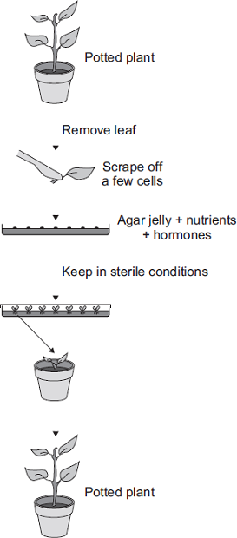
Farmers growing cotton plants in cold climates sometimes soak their seeds in a solution of gibberellins before planting the seeds.

Suggest an advantage of soaking seeds in a gibberellin solution in cold climates.

- Plant hormones are used in horticulture.

(a) Name one plant hormone.

(b) The diagram shows how new plants are produced using tissue culture.

(i) Tissue culture is a type of asexual reproduction .

Give the main features of asexual reproduction .

(ii) Another method of producing new plants is by taking cuttings.

Suggest one advantage of using tissue culture and not using cuttings to produce plants.

- Charles Darwin investigated tropisms in plants.

Some students did an investigation similar to Darwin’s investigation.

The students:

• grew seeds until short shoots had grown

• used black plastic to cover parts of some of the shoots

• put the shoots in light coming from one direction

• put boxes over the shoots to keep out other light.

The diagrams show how the investigation was set up.

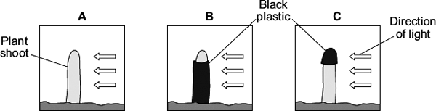

Two days later the students took off the black plastic covers and looked at the shoots.

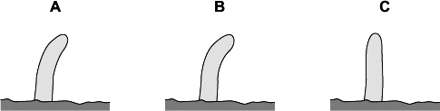
The diagrams show the results.

(a) Give two variables that the students should control in this investigation.

(b) Shoot A bent towards the light as it grew.

Explain how.

(c) What conclusions can be drawn from the results about:

(i) the detection of the light stimulus

(ii) where in the shoot the response to the light takes place.

Part 14- Topic review
Summary of hormones and endocrine glands
Complete the table by filling in the blank spaces.
Endocrine gland | Hormone produced | Role of hormone
 | Growth hormone | Controls growth in children
 | TSH | Stimulates thyroid gland to make …………………………
 |  | Affects amount of urine produced by kidneys
 | FSH | Stimulates ovaries to make ………………………… and eggs
 | LH | Stimulates testes to make testosterone and sperm
Thyroid | Thyroxine | Controls ………………………… …………………………
Pancreas | Insulin
Pancreas | Glucagon
 | Adrenaline | Prepares body for stressful situations – ‘fight or flight’ response
Ovaries | Oestrogen | - Trigger development of female secondary sexual characteristics  - Stimulates development of ………………………… …………………………  - ………………………… release of LH  - ………………………… release of FSH
Ovaries |  | - Maintains uterus lining  - ………………………… release of FSH and LH
Ovaries |  | Triggers ovulation
Testes |  | Trigger development of male secondary sexual characteristics

Goal free tasks. For each of the following graphs write as much information as you can to explain what is causing the changes.
- 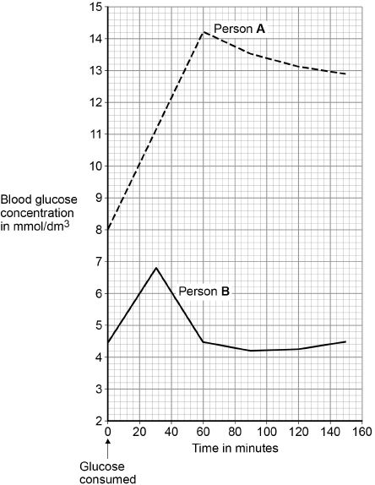

- Evaluate this data
Method | What it is | How it works | How long does it last? | Chances of getting pregnant | Side effects
Hormone implant | Rod containing slow-release hormone inserted under the skin | Stops ovaries releasing eggs | 3 years | Less than 1 in 1000 | Acne in some women
Hormone injection | Injection that slowly releases hormone | Stops ovaries releasing eggs | 12 weeks | Less than 4 in 1000 | Weight gain in some women
IUD | Small plastic and copper coil placed in womb | Stops fertilized eggs developing in womb | 5–10 years | Less than 20 in 1000 | Heavier or more painful periods in some women
IUS | Plastic device containing slow-release hormone placed in womb | Stops fertilized eggs developing in womb | 5 years | Less than 10 in 1000 | Irregular periods in some women

