B6 Inheritance, Variation and Evolution Mastery booklet
Part 1- Reproduction
Reproduction is a vital process of all living things. In fact, if we recall that a virus is not alive because it cannot reproduce independently, you could argue that it is the defining characteristic of life.
Reproduction comes in two main forms:
- Asexual: Where 1 parent provides all the genetic information. The offspring is an exact copy (clone) of the parent.
- Sexual: Where 2 parents provide the genetic information. A unique offspring is created
Humans only reproduce sexually. Bacteria only reproduce asexually. Most plants can reproduce both sexually and asexually.
Gametes
Gametes is the name given to sex cells. These are specialised cells which contain half the number of chromosomes needed to make a healthy offspring. Sperm and Egg cells are human gametes. Pollen and Ovum are the names of the gametes in flowering plants. Gametes are produced by a process called meiosis.
Asexual reproduction
For an organism to reproduce asexually it must divide by mitosis. If you recall from year 10, mitosis is a stage in the cell cycle. First the chromosomes and cell organelles are copied, then the chromosomes are pulled to opposite sides of the cell (mitosis) and the nucleus divides. Finally, the cytoplasm and cell membrane divides. Two identical ‘daughter cells’ are produced. Because they have identical genetic information to the parent cell, they are called clones.
Mitosis happens in humans when a tissue grows, but we do not use it to reproduce.
Sexual reproduction
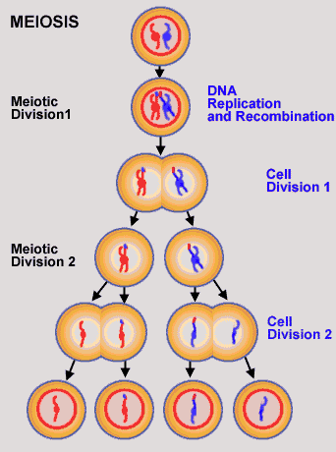
Sexual reproduction is defined by the fusion of gametes. This means the offspring will have a unique combination of genes from both parents. This leads to variation within the population.
Gametes are made by a process called meiosis. Meiosis is a special form of cell division that occurs in the sexual organs. Meiosis follows the same steps as mitosis to start (cell division 1), but once the daughter cells have formed, they undergo a second division. This results in 1 parent cell forming 4 gametes, each with half the number of chromosomes as an adult cell. We say these cells have a haploid nucleus because they have half the number of chromosomes. In humans the haploid number is 23.
Fertilisation
Fertilisation occurs when two gametes fuse (join). At this stage the first cell of a new organisms has been formed, with unique characteristics and the correct number of chromosomes (a Diploid nucleus, 46 chromosomes). This one cell then divides (by mitosis) before differentiating into all the specialised cells that make up an organism.
Comprehension questions – each question should be attempted first from memory. Every five questions get your green pen and use the text to check your answers.

- Write a definition for reproduction.
- Why is a virus not alive?
- Name the two types of reproduction
- Name a species which can reproduce in both ways.
- What is a gamete? Give an example.
- Where are gametes made?
- Define mitosis
- Define meiosis
- Monica says “Sperm and egg cells are made by mitosis. When a sperm meets and egg differentiation occurs. The sex cells fuse and make a new offspring. The offspring is unique because it has genes from both parents”. She has made some mistakes. Write out the correct version in your book.
- Define haploid. What type of cells have a haploid nucleus?
- Define diploid. What kind of cells have a diploid nucleus?
Application questions – use your notes from this section and past sections to answer the questions below, but you should try from memory first.
- A bacterium divides every 20 minutes by mitosis. How many bacteria will there be in 2 hours?
- Why is it important that gametes have half the number of chromosomes?

- Below is a diagram which shows the stages of the cell cycle in order. Add labels to the spaces from the information above
This normal body cell has four chromosomes in two pairs
Stage 3:
Stage 2:

Stage 1:

- What is a chromosome?
- Are chromosomes normally in pairs or single?
- What is Mitosis?
- What happens when cells differentiate?
- Why is Mitosis important?
- What does Asexual mean?
- What does unique mean?
- How many chromosomes does a normal body cell have?
- What happens in the first stage of Mitosis?
- Why is this stage important?
- What happens in the second stage of Mitosis?

- What happens in the third stage of mitosis?
- State the uses of mitosis.
- Complete the table below to compare mitosis and meiosis. The first row has been completed for you.
 | Mitosis | Meiosis
Do the chromosomes and organelles replicate at the start? | Yes | Yes
Do they chromosomes line up and get pulled apart?
How many times does the cell divide
How many daughter cells are produced?
What is the number of chromosomes in the daughter cells
Are the cells clones?
- The diagram shows three types of cells in a life history of a simple animal.

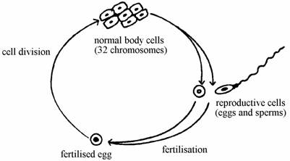
(a) How do the chromosomes of the body cells compare with the chromosomes in the fertilised egg from which they came?

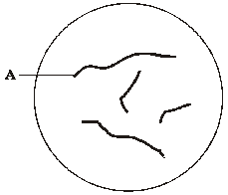
(b) Describe what happens to chromosomes in the nucleus of a body cell when it forms reproductive cells.
- Diagram 1 shows the nucleus of a cell at the start of meiosis.

(a) Name structure A.


(b) During meiosis, the nucleus shown in diagram 1 will divide twice to form four nuclei.

Complete diagram 2 to show the appearance of one of these nuclei.
- What organelle is responsible for making all the proteins in the cell.
- What is the function of the cell membrane?
- What organelle provides the extra energy needed for a cell to undergo meiosis?
- Name the organs where meiosis occurs in males and females.
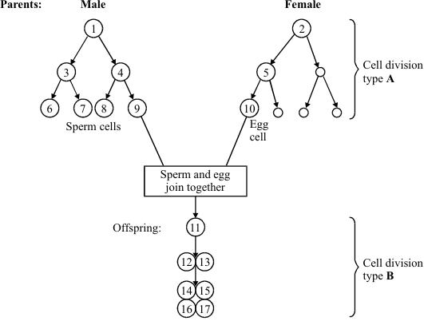
- How many chromosomes are in an egg cell?
- The diagram shows two patterns of cell division. Cell division type A is used in gamete formation. Cell division type B is used in normal growth.

(a) Name the two types of cell division, A and B, shown in the diagram.

(b) Name the process in which an egg and sperm join together.

(c) Cell 1 contains 46 chromosomes. How many chromosomes will there be in:

(i) cell 10? (ii) cell 14?

Part 2- Comparing sexual and asexual reproduction (TRIPLE ONLY)
Sexual reproduction takes a lot of energy. In animals’ energy will be transferred in the finding of a mate, competition with rivals and the production of gametes. Plants with transfer a large amount of energy making flower to attract pollinating insects and in the formation of seeds.
If organisms are transferring so much energy in these processes, then it must have certain advantages over asexual reproduction.
Like all aspects of biology there are always advantages and disadvantages to each approach. They are summarised below:
Asexual reproduction:
+ Fast and energy efficient. No time is needed to find a mate and to reproduce as only one parent. Lots of identical offspring can be made if conditions are favourable.
- No variation. This means the population is vulnerable to being destroyed by a change in the environment of a pathogen
Sexual reproduction:
+ Variation. This means the population can evolve by natural selection and survive environmental changes and pathogens. Humans can exploit this with selective breeding to increase food production
- Slow and energy intensive. Energy is needed to produce gametes and it takes time to find a mate.
The best solution is to be able to do both forms of reproduction. Some organisms can reproduce both sexually and asexually depending on the circumstances.
Malaria parasites reproduce asexually in humans and sexually in the mosquito. This allows them to divide quickly but also maintain variation. The variation helps them avoid the human immune system.
Fungi commonly reproduce asexually by spores. The spores are spread by the toadstools you commonly see in the ground and on trees. If conditions are not favourable, for example during drought, the fungi move to sexual reproduction. The new unique offspring might be better adapted to survive the harsh conditions.
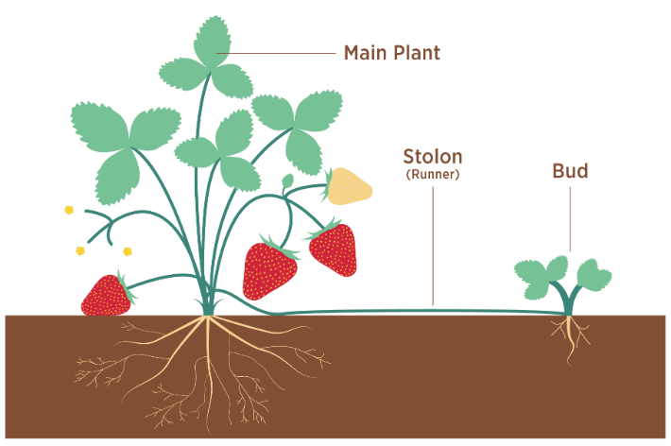
Plants are experts in using both forms of reproduction. For example, the strawberry plant produces seeds from sexual reproduction. It transports them by placing them in delicious fruits. Strawberry plants also make ‘runners’ which spread out and create a clone in a new area. This is asexual reproduction. Another good example is the daffodil, whose bulbs divide by asexual reproduction but can also produce seeds.
Comprehension questions – each question should be attempted first from memory. Every five questions get your green pen and use the text to check your answers.
- List 2 advantages of sexual reproduction
- List 2 advantages of asexual reproduction
- What type of reproduction does the malaria parasite perform in the mosquito?
- What advantage does this give the parasite when it enters the human?
- Why do fungi reproduce sexually when conditions are unfavourable?
- What is the name of the way strawberries reproduce asexually?
Application questions – use your notes from this section and past sections to answer the questions below, but you should try from memory first.
- All Banana plants are grown using asexual reproduction. In fact all bananas sold are clones of each other. A disease called Fusarium wilt infects banana plants. Explain why Fusarium wilt is major concern to the worlds crop of bananas.

- Cell division is needed for growth and for reproduction.

(a) The table below contains three statements about cell division.

Complete the table.Tick one box for each statement.

 | Statement is true for
Statement | Mitosis only | Meiosis only | Both mitosis and meiosis
All cells produced are genetically identical
In humans, at the end of cell division each cell contains 23 chromosomes
Involves DNA replication

Bluebell plants grow in woodlands in the UK.

• Bluebells can reproduce sexually by producing seeds.

• Bluebells can also reproduce asexually by making new bulbs.

(b) One advantage of asexual reproduction for bluebells is that only one parent is needed. Suggest two other advantages of asexual reproduction for bluebells.

(c) Explain why sexual reproduction is an advantage for bluebells.
- A child saved apple seeds from an apple she ate. She planted the seeds in the garden. A few years later the apple trees she had grown produced apples.

(a) The apples from the new trees did not taste like the original apple. Explain why.

(b) (i) Apple trees can be reproduced so that the apples from the new trees will taste the same as the apples from the parent trees. Give one method used to reproduce apple trees in this way.

(ii) Explain why the method you have suggested in part (b)(i) will produce apples that taste the same as the apples from the parent trees.

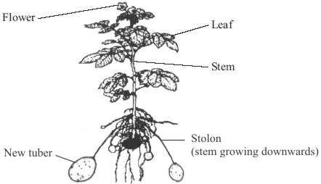
- The drawing shows a potato plant producing new tubers (potatoes). Buds on the stem of the parent plant produce stolons. The new tubers are formed at the ends of the stolons (stems that grow downwards).

(a) Explain why the new tubers are genetically identical to each other.

(b) Some of the tubers are used to produce potato plants. These new potato plants will not all grow to the same height. Give one reason why.
- The bean aphid is a type of black-fly which lives on broad bean plants in summer.
In the autumn, males and females mate and produce eggs.

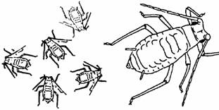
(a) Name the type of reproduction which produces the eggs.

(b) In spring these eggs hatch. The young aphids are all female.
Explain why they are all similar but not identical to each other.

(c) These females are then able to produce offspring without needing any males.

(i) Name the type of reproduction where females do not need males to produce offspring.

(ii) How will the offspring from one of these females compare with each other and compare with the offspring from other females?

Part 3- DNA and the genome

DNA is often described as the molecule of life. It is responsible for the instructions to make proteins and as such all life’s variation and complexity is written in its’ DNA. DNA stands for Deoxyribose nucleic acid, and no you don’t have to remember that!

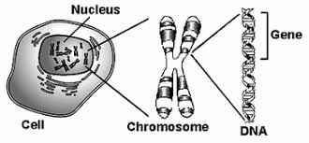
All the DNA is stored as long tightly wound strands called chromosomes. An organisms complete set of genetic material is called its genome.

In 1953 Rosalind Franklin managed to become the first person to prove the structure of DNA. It is a long chain molecule made of repeating units (a polymer). It exists as a double helix, formed of two strands which join up and are twisted. DNA is a code. It contains a sequence of base pairs which tell the ribosomes the order to place certain amino acids. By changing the order of amino acids, different proteins are made.

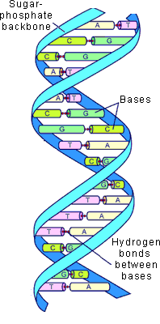
Each chromosome is split into sections called genes. A gene is a section of DNA which codes for a protein. We have now developed the technology to sequence an entire genome. This allows us to know the sequences of bases on each chromosome in an individuals nucleus. The human genome is over 3 billion base pairs long. So far we have used this technology to find genes that link to certain diseases, for example cancer or heart disease. We have also used it to improve our understanding of inherited disorders like cystic fibrosis. The migration of humans throughout history has also been possible. People who share common ancestors also share genes so we can trace the movment of early humans across the globe from their starting point in africe over 1 million years ago. There is hope that this technology will lead to future medical treatments, although as we learn more about the human genome we begin to realise how complex it is and how much more we need to learn.
Comprehension questions – each question should be attempted first from memory. Every five questions get your green pen and use the text to check your answers.
- Name the genetic material enclosed in a nucleus of a eukaryotic cell.
- Describe the structure of double helix.
- Name the structure the genetic material organised itself into.
- Define ‘gene’.
- Define ‘genome’.
- How many base pairs are found in the human genome?
- Name 3 uses for the sequenced human genome?
- What is a polymer?
Application questions – use your notes from this section and past sections to answer the questions below, but you should try from memory first.

- What organelle makes proteins from amino acids?
- Where is this genetic material found in a prokaryotic cell?
- Put the following structures in order of increasing size:
Organism, cell, nucleus, organ, tissue, DNA base, chromosome, gene, organ system

Part 4- DNA structure (TRIPLE ONLY)

DNA is a polymer. A polymer is a long chain compound made of many repeating units. Other examples of polymers are starch, cellulose and plastic. In DNA the units are called nucleotides. Nucleotides are made of a sugar (deoxyribose), a phosphate group and one of the four bases. The bases are the part that codes for the information in your genome.

The four bases are known as: A T G C.

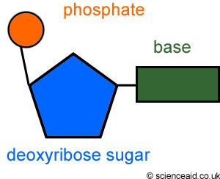
Three bases form a codon, which codes for a particular amino acid. For example, TCC codes for serine, but CGT codes for arginine. By changing the order of the bases we can code for different amino acids and change the resulting protein made.

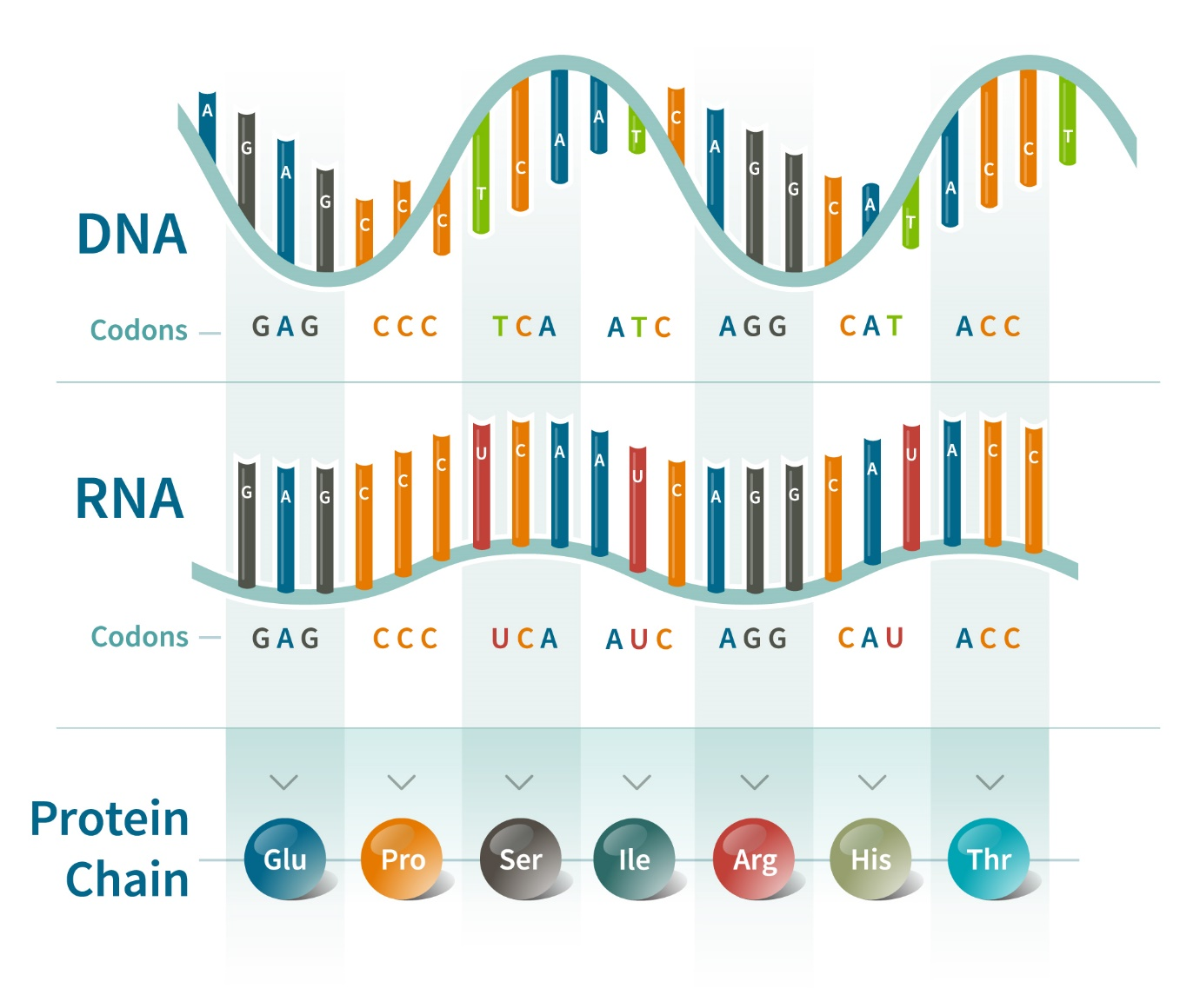
Comprehension questions – each question should be attempted first from memory. Every five questions get your green pen and use the text to check your answers.
- What is the repeating unit of DNA called?
- List the letters which correspond to the bases which form the DNA code?
- How many bases code for 1 amino acid?
- What is the name of the sugar in DNA?
- What is the name of the shape a DNA molecule forms?
- What is the name of the coiled structures that are made of DNA and found in the nucleus?

Part 5- Protein synthesis (TRIPLE HT ONLY)

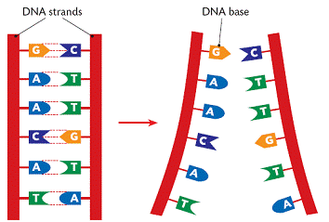
The two strands of the DNA molecule bond together in a specific way called complimentary base pairing.
- C always bonds to G
- T always bonds to A

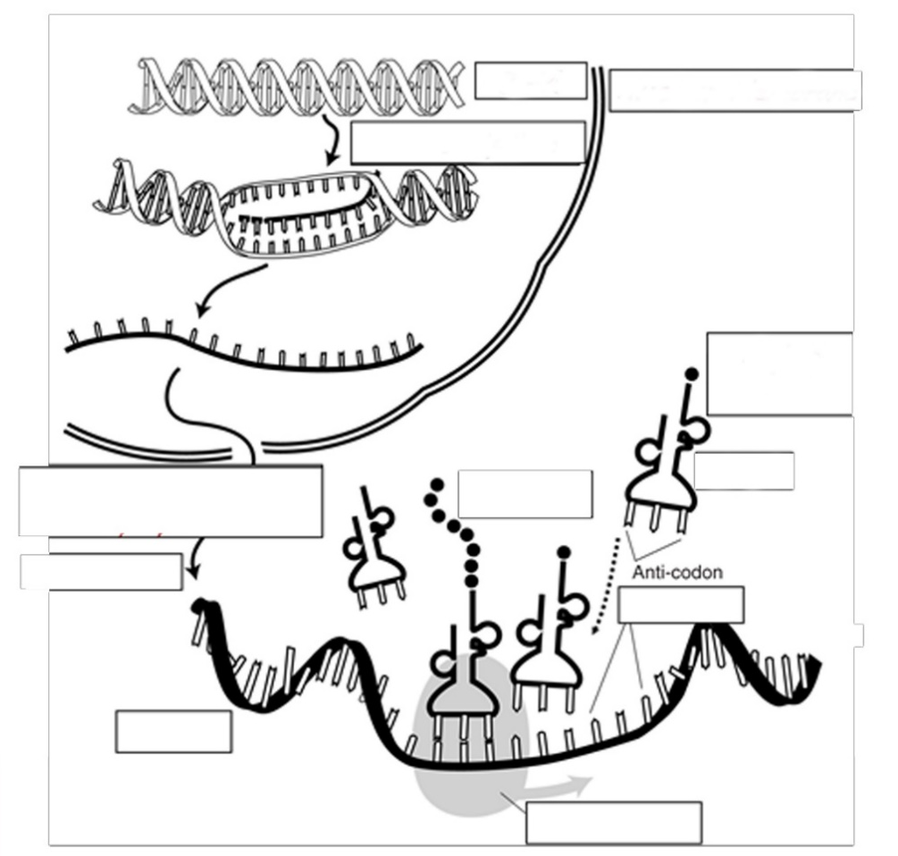
Protein synthesis starts with a template being made of the desired gene; this ensures the DNA is kept safe inside the nucleus. The template travels out of the nucleus and into the cytoplasm. The template meets ribosomes. The ribosomes allow carrier molecules to bring in specific amino acids that correspond to the three bases in the template (called the anticodon). As the ribosome moves along the template more amino acids are added, and the complex protein is formed. When the protein molecule is complete it folds up to form a unique shape. This enables it to perform a specific task e.g. enzyme, hormones or forming structures like collagen
cytoplasm
Comprehension questions – each question should be attempted first from memory. Every five questions get your green pen and use the text to check your answers.
- Use the passage above to label the diagram below

- Why does the cell make a template of the DNA instead of letting the DNA leave the cell?
- Why does the carrier molecule need to have a specific combination of 3 bases (anticodon)?
- What is the role of ribosomes in protein synthesis?
- Sometimes a template molecule has more than one ribosome bound to it. What is the advantage of this for the cell?
- Define ‘gene’
- What will happen to the protein sequence if the template is made of a different gene?

Mutations
Each gene has a different base pair sequence, which leads to a different template. The different template leads to a different order of carrier molecules delivering amino acids. This leads to a different protein sequence and therefore a different function of the protein.
Mutations are changes in the DNA base pair sequence. These can happen by accident during DNA replication, or as a result of damage from the environment (for example UV light). Mutations usually happen due to a single base being deleted or duplicated. Most of the time these mutations have no effect on your health, as a single change might not change the shape of that protein. Unfortunately, sometimes the mutation does occur in a key area. The enzymes’ active site might be altered, or the structural protein might lose its strength.
One method of protection is the large amount of non-coding DNA in our genome. This DNA does not code for a specific protein, so mutations in those areas have no effect. Recently scientists have discovered that non-coding DNA has a role in when a gene is turned on (gene expression). Mutations in these areas might change how easily a gene is expressed and this could have serious health consequences.
Comprehension questions – each question should be attempted first from memory. Every five questions get your green pen and use the text to check your answers.
- Define ‘mutation’
- What are two things that can happen to a base that can create a mutation?
- Why are some mutations harmless?
- What are two causes of mutations?
- Compare the two versions of the same of a gene below. What type mutation has occurred?
AATGCCATTA AATGGCCATTA
- Define ‘gene expression’
- Gareth says “mutation in non-coding DNA are always harmless” Is he correct? Give a reason
Application questions – use your notes from this section and past sections to answer the questions below, but you should try from memory first.
- Complete the sentences below
Mutations in your genome can cause health problems because….
Mutations in your genome can cause health problems but….
Mutations in your genome can cause health problems so….
- What part of the cell cycle does DNA replication occur?
- In the mid-20th century the structure of DNA was discovered. What is a section of DNA which codes for one specific protein called?
- Figure 1 shows one strand of DNA. The strand has a sequence of bases (A, C, G and T).

Figure 1

How many amino acids does the strand of DNA in Figure 1 code for?
- How many chromosomes are in a human adult cell?
- How many chromosomes are in a sperm cell?
- Sickle-cell anaemia is an inherited disease caused by a mutation in the haemoglobin gene.

Genes are small pieces of DNA. The DNA in a gene consists of a sequence of bases.

Figure 2 shows part of the base sequence in the DNA of a normal haemoglobin gene and the same section in the sickle-cell gene. A, C, G and T represent the different bases.

Normal gene |  | GGACTCCTC
Sickle-cell gene |  | GGACACCTC

Describe how the mutation causes a change in the shape of the haemoglobin protein molecule.
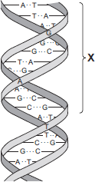
- The diagram shows part of a DNA molecule.

(a) (i) In which part of an animal cell is DNA found?

(ii) Complete the following sentence.

The letters A, C, G and T in the diagram represent four different compounds called ________________

(iii) One strand of the DNA, in the section labelled X, contains the following sequence of these compounds: T A T G G G T C T T C G How many amino acids would his section of the DNA code for?
- A certain gene codes for the production of an enzyme called ‘HEXA’.

One human genetic disorder causes damage to nerve cells in the brain.
This disorder is caused by a small change in the DNA of the HEXA gene.
People with this disorder make a changed HEXA enzyme that does not work.

(a) Explain how a change in the DNA of the HEXA gene can result in the production of a changed HEXA enzyme that does not work.

(b) The gene coding for the HEXA enzyme is found on chromosome number 15.

(i) How many chromosomes are there in the nucleus of a human nerve cell?
Part 6- Genetic inheritance
Individuals within a species all display variation. This is due to sexual reproduction. In sexual reproduction gametes fuse to form a unique offspring. They are unique because they have inherited half their chromosomes from their father and half from their mother. Each time a new offspring is conceived a different combination of the chromosomes combine; this is why you will resemble your brother/sister but are not identical to them.
Different forms of the same gene are known as alleles.
There are 2 copies of every chromosome in a body cell nucleus (1 copy inherited from the mother the other copy inherited from the father). Therefore, there are 2 copies of every gene. These copies may be different alleles and the combination of the 2 alleles (the genotype) determines the characteristic (the phenotype).
If the 2 alleles for a gene are the same, we call this combination homozygous, whereas if the 2 alleles are different, we call this combination heterozygous.
For most genes, one allele is said to be dominant and the other recessive. If a dominant allele is present, only its phenotype is expressed. This means individuals that have 2 dominant alleles (homozygous dominant) OR one dominant and one recessive allele (heterozygous) will express the dominant phenotype. Both alleles need to be recessive (homozygous recessive) for the recessive phenotype to be expressed. Due to this relationship, we often refer to the alleles using the same letter, the dominant in UPPER case and the recessive in lower case e.g. “B” is dominant, “b” is recessive.
For example: Consider a flowering plant that can have pink or white petals. Pink is the dominant allele, so our code is P= pink and p=white
- PP is the homozygous dominant, its phenotype is pink.
- Pp is heterozygous, its phenotype is also pink as pink is dominant to white.
- pp is homozygous recessive; its phenotype is white.
In our work we will be looking at characteristics that are controlled by one gene. In reality multiple genes work together to create the overall phenotype. A good analogy is that of an orchestra, with many different instruments working in harmony to create the music.
Comprehension questions – each question should be attempted first from memory. Every five questions get your green pen and use the text to check your answers.

- Define allele
- Define genotype
- Define phenotype
- Define dominant
- Define recessive
- Define homozygous
- Define heterozygous

The gene for flower colour in pea plants has 2 alleles, purple and white. The purple allele is represented by “R” and the white allele by “r”.
- What is the homozygous dominant genotype?
- What is the homozygous dominant phenotype?
- What is the homozygous recessive genotype?
- What is the homozygous recessive phenotype?
- What is the heterozygous genotype?
- What is the heterozygous phenotype?
Application questions – use your notes from this section and past sections to answer the questions below, but you should try from memory first.
- Define sexual reproduction
- Define gamete
- What happens during fertilisation?
- Define chromosomes

- Complete the table below. The first one has been done for you.
 | Homozygous dominant |  | Homozygous recessive |  | Heterozygous
Scenario | Genotype | phenotype | genotype | phenotype | genotype | phenotype
A. The gene for eye colour in humans has 2 alleles, blue and brown. The brown allele is represented by “B” and the blue allele by “b”. | BB | Brown | bb | Blue | Bb | Brown
B. The gene for plant height in sunflowers has 2 alleles, tall and dwarf. The dwarf allele is represented by “d” and the tall allele by “T”.
C.The gene for flower position in courgettes has 2 alleles, terminal (F) and axial (f).
D.The gene for coat colour in cows has 2 alleles, roan (g) and white (G).
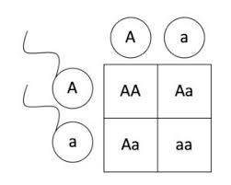
Punnett squares.
When examining the inheritance of alleles through multiple generations we use genetic cross diagrams or punnett squares.
The diagram shows the punnett square for the inheritance of recessive condition called Albinism.
Comprehension questions – each question should be attempted first from memory. Every five questions get your green pen and use the text to check your answers.
- Label the punnett square with the following labels: alleles from father, alleles from mother, possible genotypes
- What proportion of the possible genotypes is homozygous dominant?
- What proportion of the possible genotypes is heterozygous?
- What proportion of the possible genotypes is homozygous recessive?
- What proportion of the possible offspring will be healthy?
- What proportion of the possible offspring will have Albinism?
The gene for flower colour in pea plants has 2 alleles, purple and white. The purple allele is represented by “R” and the white allele by “r”.
For each of the questions below:
- Draw a Punnett square to show the 4 possible offspring genotypes from this breeding.
- For each offspring, label the phenotype.
- For each offspring, describe the genotype using the words homozygous, heterozygous, dominant and recessive.
- Calculate the probability of each phenotype.

- Two pea plants both with the genotype Rr breed.
- Rr x rr
- RR x rr
- Rr x RR

Part 7- Inherited disorders

Sometimes a mutation happens in the chromosomes of a gamete. In this case the faulty gene will be present in every cell of the body. In some very rare cases this can cause an inherited disorder. The disorder is inherited because there is a chance it can be passed down to the next generation. Some inherited disorders are dominant and other are recessive, we will look at an example of both.

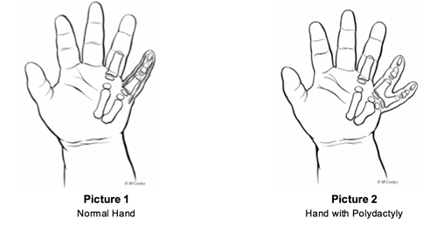
Polydactyly
Polydactyly is an inherited disorder that results in the child growing extra fingers or toes. It does not have any significant long term health problems. It is caused by a dominant allele. This means that only one parent needs to pass on the faulty allele for the child to suffer from polydactyly, So a homozygous dominant parent is guaranteed to have a polydactyly child and a heterozygous parents will have a chance of having one.
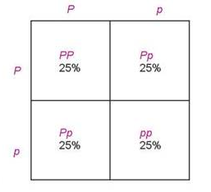
To the right is a punnett square showing the chances of having child with polydactyly when one parent with the disorder mates with a homozygous recessive partner.

In this example:
Genotypes
- 25% chance of the homozygous dominant PP
- 50% chance of the heterozygous Pp
- 25% chance of the homozygous recessive
Phenotypes
- 75% chance of having polydactyly (as it is dominant)
- 25% chance of being unaffected
Comprehension questions – each question should be attempted first from memory. Every five questions get your green pen and use the text to check your answers.
- Using the example above, draw a punnett square to show the outcomes of the following crosses:
- Pp x Pp
- A heterozygous father and a homozygous recessive mother
- Suggest why polydactyly is not considered a serious inherited disorder

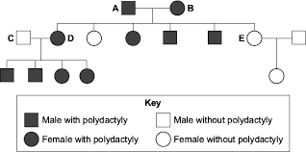
Another way of determining the dominant nature of polydactyly is through a family tree diagram. The clue to its dominant nature is the breeding between D and C. As their children all suffer from the disease there is a very strong chance the condition is dominant.

Cystic Fibrosis
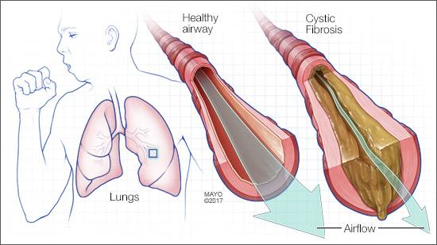
Cystic fibrosis is an inherited disorder which affects the mucus that lines the respiratory and digestive tract. Cystic fibrosis sufferers have much thicker mucus than normal. This makes breathing harder and increases their chance of chest infections. Their pancreatic duct can also be blocked, resulting in less digestive enzymes making their way into the small intestine. This can affect the amount of nutrients they get from their food. Currently the disorder is managed using a combination of physical therapy (to remove the mucus) and drugs (to improve the digestion). A more long term solution is for a heart and lung transplant.
Cystic fibrosis is caused by a recessive allele. This means that only homozygous recessive people are suffering from the disorder and heterozygous people are completely normal, but they have a chance of having a child which suffers from it. They are known as carriers. In the uk it is estimated that 1 in 25 people is a heterozygous carrier. Currently there are approximately 10,500 people with cystic fibrosis in the UK. This is about 1 in every 2500 babies born.

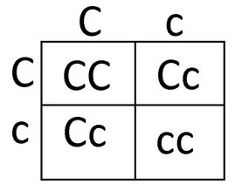
To the right is the punnett square for a cross between two heterozygous carriers. C= healthy, c= cystic fibrosis
In this example:
Genotypes
- 25% chance of the homozygous dominant CC
- 50% chance of the heterozygous Cc
- 25% chance of the homozygous recessive cc
Phenotypes
- 25% of being unaffected CC
- 50% of having no symptoms but being a carrier Cc
- 25% chance of suffering from cystic fibrosis cc
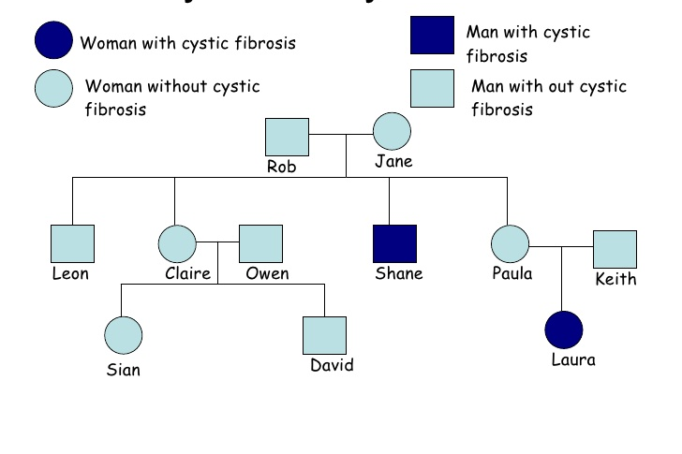
If we look at the family tree a key clue to it being a recessive condition can be seen.
Recessive inherited conditions have the ability to skip generations. Consider Rob and Jane. Both did not suffer from CF, but had a child (Shane) who did. This pattern is also repeated with Paula and Keith. In both cases it must be that they were both heterozygous carriers, a key defining factor of a recessive inherited condition.
Comprehension questions – each question should be attempted first from memory. Every five questions get your green pen and use the text to check your answers.
- Using the example above, draw a punnett square to show the outcomes of the following crosses:
- CC x cc
- A heterozygous father and a homozygous recessive mother
- If 1 in 25 people are carriers suggest why so few babies are born with cystic fibrosis?
- If the population of the UK is 6.6 x 10⁶ people how many people are carriers? Give your answer in standard form.

Genetic tests
Genetic testing involves analysis of a person's DNA to see if they carry alleles that cause genetic disorders. It can be done at any stage in a person's life.
- Antenatal testing is used to analyse an individual's DNA or chromosomes before they are born. This testing is offered to couples who may have an increased risk of producing a baby with an inherited disorder, but it cannot detect all the risks of inherited disorders.
- Neonatal testing known as the new born blood spot test involves analysing a sample of blood that is taken from pricking a baby's heel. It detects genetic disorders in order to treat them early.
- Pre-implantation genetic diagnosis (PGD) is also called embryo screening. It is used on embryos before implantation. Fertility drugs stimulate the release of several eggs. The eggs are collected and fertilised in a Petri dish. This is known as in vitro fertilisation (IVF). Once the embryos have reached the eight-cell stage, one cell is removed.
The cells are tested for the disorder causing alleles. Embryos that don't contain the disorder allele are implanted into the uterus.
Limits of genetic testing
Genetic tests are not available for every possible inherited disorder, and are not completely reliable. They may produce false positive or false negative results, which can have serious consequences for the parents involved.
False positives
A false positive is a genetic test that wrongly detected a certain allele or faulty chromosome. The individual could believe something is wrong, when it is actually fine.
False negatives
A false negative is a genetic test has failed to detect a certain allele or faulty chromosome. The parents may be wrongly reassured. These results can have a major impact on the lives of individuals, through pregnancy termination, future decisions and planning the level of care needed for children with inherited disorders.

On top of the technical problems, people can be against these tests for moral and spiritual reasons. Most of these stem from a strong belief that it is wrong to tamper with the natural process of reproduction. With embryo screening techniques some of the embryos are destroyed. Some people believe that this is the same as murder and so are against this process.
Comprehension questions – each question should be attempted first from memory. Every five questions get your green pen and use the text to check your answers.
- What is the meaning of ‘inherited disorder’?
- Mariana says “Measles is an inherited condition because my dad had it when he was young and now I’ve had it!” Explain why she is wrong.
- What medical treatment could Mariana’s parents have given her when she was young to prevent her catching measles?
- Explain the difference between a dominant and recessive inherited disorder.
- What are the symptoms of polydactyly?
- What are the symptoms of cystic fibrosis?
- What can you not be a carrier of polydactyly?
- What three ways are inherited disorders tested for?
- Why is every baby born given the heel prick test (neonatal), but only high risk pregnancies given antenatal testing?
- Why would a person who is against abortion refuse PGD?
- What is the difference between a false positive and a false negative? Which do you think is worse?
Application questions – use your notes from this section and past sections to answer the questions below, but you should try from memory first.
Huntington’s disease is a dominant inherited condition. It causes problems in a persons’ ability to use their muscles, including breathing and swallowing. There is no cure. Symptoms begin to show during a person’s 30’s and 40’s.
- Can you be a carrier for Huntington’s?
- Will the huntington’s allele be H or h?
- Draw a punnett square for a heterozygous and homozygous recessive breeding. Give the proportions of each genotype and phenotype.
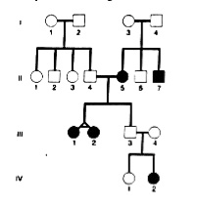
Thalassemia is an inherited disorder. It causes the red blood cells to twist into a different shape. This affects the person’s ability to get oxygen to their organs, causing fatigue, and a yellowing of the skins.
- Look at the family tree for Thalassemia. Is it a dominant or recessive inherited condition? Give a reason.
- Draw a punnett square for a heterozygous and a homozygous recessive. Give the proportions of the genotypes and the phenotypes.

- In humans, chromosome X and chromosome Y are the sex chromosomes.

(a) Most cells in the human body contain two sex chromosomes. Which type of cell does not have two sex chromosomes? Choose from Liver cell, Nerve cell, Red blood cell

(b) Apart from the sex chromosomes, how many other chromosomes are there in most human body cells?

Stickler syndrome is an inherited disorder that causes damage to the eye.

One of the symptoms of Stickler syndrome is that black spaces can appear in the visual image.

(c) Which part of the eye is affected by Stickler syndrome?

Stickler syndrome is caused by the inheritance of a dominant allele.

The diagram shows the inheritance of Stickler syndrome in two families.
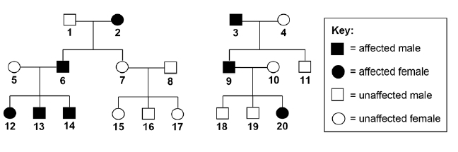

Use the following symbols in your answers to (d) and (e):

A = the dominant allele for Stickler syndrome

a = the recessive allele for unaffected vision.

(d) Explain why none of the children of persons 7 and 8 have Stickler syndrome.

(e) Person 12 marries person 18.

Use a Punnett square diagram to find the probability that their first child will be a female with Stickler syndrome.
- Mr and Mrs Smith both have a history of cystic fibrosis in their families. Neither of them has cystic fibrosis. Mr and Mrs Smith are concerned that they may have a child with cystic fibrosis.

(a) Use a genetic diagram to show how they could have a child with cystic fibrosis.

Use the symbol A for the dominant allele and the symbol a for the recessive allele.

(b) Mr and Mrs Smith decided to visit a genetic counsellor who discussed embryo screening.

Read the information which they received from the genetic counsellor.

• Five eggs will be removed from Mrs Smith's ovary while she is under an anaesthetic.
• The eggs will be fertilised in a dish using Mr Smith’s sperm cells.
• The embryos will be grown in the dish until each embryo has about thirty cells.
• One cell will be removed from each embryo and tested for cystic fibrosis.
• A suitable embryo will be placed into Mrs Smith’s uterus and she may become pregnant.
• Any unsuitable embryos will be destroyed.

(i) Suggest why it is helpful to take five eggs from the ovary and not just one egg.

(ii) Evaluate the use of embryo screening in this case. Remember to give a conclusion to your evaluation.

(c) In someone who has cystic fibrosis the person’s mucus becomes thick.

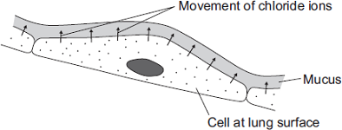
The diagram shows how, in a healthy person, cells at the lung surface move chloride ions into the mucus surrounding the air passages.

The movement of chloride ions causes water to pass out of the cells into the mucus.

Explain why.

Part 8 – Sex determination

Ordinary human body cells contain 23 pairs of chromosomes. 22 pairs control characteristics only, but one of the pairs carries the genes that determine sex.
 | X | X
X | XX | XX
Y | XY | XY

• In females the sex chromosomes are the same (XX).

• In males the chromosomes are different (XY).

In the punnett square it shows the possible gender outcomes of sexual reproduction.
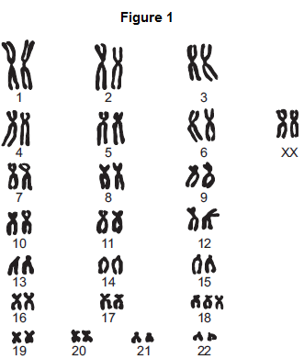
Comprehension questions – each question should be attempted first from memory. Every five questions get your green pen and use the text to check your answers.
- What is the percentage chance a baby is female.
- What are the possible genotypes of the sperm?
- How many chromosomes are in the nucleus of the sperm or egg cell?
Application questions – use your notes from this section and past sections to answer the questions below, but you should try from memory first.
- Genetic disorder E is a condition caused by a change in the chromosomes.

(a) Figure 1 shows the chromosomes from one cell of a person with genetic disorder E.

(i) How do you know this person is female? Use information from Figure 1.

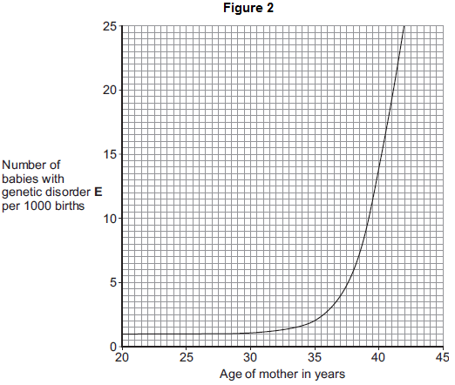
(ii) Describe how the chromosomes shown in Figure 1 are different from the chromosomes from a person who does not have genetic disorder E.

(b) As a woman gets older, the chance of her having a baby with genetic disorder E increases. Figure 2 shows this.

(i) The chance of a 35-year-old woman having a baby with genetic disorder E is 2 per 1000 births.

What is the chance of a 40-year-old woman having a baby with genetic disorder E?

(ii) A 40-year-old woman is more likely than a 35-year-old woman to have a baby with genetic disorder E. How many times more likely?

(c) A 41-year-old woman wants to have a baby. A 41-year-old woman has an increased chance of having a baby with genetic disorder E. Doctors can screen embryos for genetic disorder E. The table gives some information about two methods of embryo screening.

Method 1 | Method 2
1. The woman is given hormones to  cause the release of a few eggs.  The eggs are taken from her body  in a minor operation.  The eggs are fertilised in a glass  dish. | 1. The woman gets pregnant in the  normal way.
2. One cell is taken from each embryo  when the embryo is 3 days old. | 2. Cells are taken when the embryo is  10 weeks old.
3. Cells are screened for genetic  disorder E. | 3. Cells are screened for genetic  disorder E.
4. An unaffected embryo is placed in  the woman’s uterus.  Embryos that are not used are  destroyed or used in medical  research. | 4. An unaffected fetus is allowed to  develop.  If the fetus has genetic disorder  E, the woman can choose to have  an abortion.
5. This method costs about £6000. | 5. This method costs about £600.

Use information from the table to give two advantages and one disadvantage of Method 1compared with Method 2 for detecting genetic disorder E.

Part 9- Variation

Every living organism is different in some ways, even those within the same species. These different characteristics among different individuals are called variations. Variations can be caused by two key factors: genetics and environment. There are some characteristics that are caused purely by genetic factors or environmental factors, but quite a lot are caused by a mix of both. Here are some examples:
- Purely genetics: Gender, shape of earlobes, eye colour
- Purely environmental: It is rather rare that a variation is led purely by the environment. One possible example is scars, as they are formed only if you had an injury, although the “ability” to form scars is varied by genetics.
- Mix of both: Weight, height, skin colour, hair colour

Twin studies are carried out to investigate what the causes of certain variations may be. Scientists would compare four groups/pairs of adults and measure the differences (eg. Height, mass, IQ) between the pairs:
- Identical twins brought up together (same genes and environment)
- Separated identical twins (same genes, different environment)
- Non-identical twins brought up together (different genes, same environment)
- Same sex, non-twin siblings brought up together (different genes, same environment)

The measured differences indicate what characteristics are dominated by genetic factors, which are dominated by environmental factors.

These genetic and environmental variations can arise due to a variety of reasons. Here are some:
- Genetic variations:
- Random mutation: DNA changes spontaneously that lead to a different allele (a different version of the same gene) that can give a different characteristic. Eg. Dominant allele for brown eyes mutated into a recessive allele for blue eyes
- Meiosis: The chromosomes from the father and mother may mix to exchange alleles. Also they may split up differently that leads to a different combination of alleles, which could give the child a different characteristic compared to his/her parents.
- Environmental variations:
- Lifestyle: Diet and the amount of exercise could affect one’s physical appearance and fitness.
- Exposure to the sun: Change skin colour
- Dyeing your hair: Change hair colour
- Piercings
- Injuries: Lead to scar formation

Mutations happen all the time; mostly they have no effect on the organism. Sometimes they might influence the phenotype. Very rarely will they change the phenotype completely.
Comprehension questions – each question should be attempted first from memory. Every five questions get your green pen and use the text to check your answers.
- What is variation?
- Genes determine the phenotype of an organism – true or false?
- Within a population, there is normally very little genetic variation – true or false?
- What are the two factors that cause variation?
- Sort whether the following factors are influenced by genes, environment or both:
- a.) Height:
b.) Scars:
c.) Eye colour:
d.) Hair colour:

- Apart from the ones mentioned above, suggest one genetic factor and one influenced by both genes and environment that lead to variation.
- Genetic:
- Both:
- How are identical twins ‘identical’ to one another?
- In a pair of identical twins, one is taller than the other. Suggest why.
Application questions – use your notes from this section and past sections to answer the questions below, but you should try from memory first.
- How are identical twins formed?
- *How are non-identical twins formed?
- Define phenotype.
- What are the two main types of mutation?
- Name the four bases of DNA.
- (HT TRIPLE ONLY) What would be the complimentary code to bond with AGCGCTAA ?

Part 9- Evolution by natural selection

The organisms that exist nowadays are very different from those billions of years ago. Over time it appears that organisms have become more complex. This is due to evolution by natural selection.

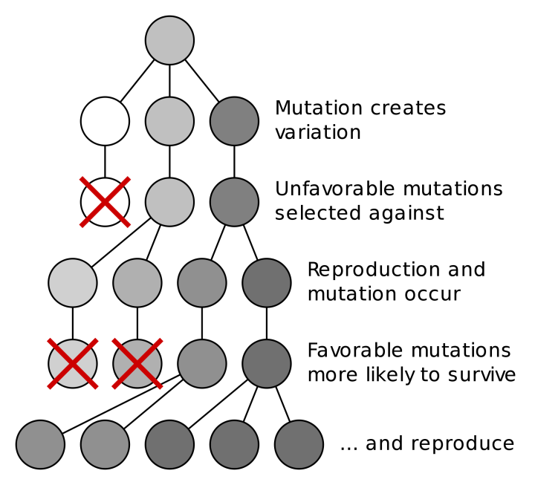
Natural selection is the process where nature selects what characteristics (controlled by genes) are best for organisms to survival in that specific environment and hence allows it to reproduce. In simple terms, this is the survival of the fittest, where “fittest” refers to those best adapted to their environment, but not necessarily the strongest. Evolution occurs after natural selection occurs over many generations. This is the process:
    - Individual organisms in a species have a range of pre-existing genetic variation due to random mutation.
    - Certain individuals may have certain adaptations (or phenotypes) that give them a survival advantage due to their advantageous/favourable alleles. (Those without the favourable allele are more likely to die before they could reproduce.)
    - Natural selection occurs: They are more likely to survive and reproduce, passing the favourable alleles on.
    - Overtime, more individuals within the population have those favourable alleles. If these variations accumulate, they may eventually evolve into a new species (speciation), where they can no longer interbreed to form fertile offspring.

Be careful: Avoid saying “organisms adapt to their environment” in your answer. Organisms cannot (choose to) adapt to a certain environment within their lifetime. Evolution must happen over many generations! And it is not by choice, but by natural selection.
Students find it hard to write answers to evolution question as there is a lot to remember. To help you, always remember the mnemonic My Valentine Always Sends Roses Adorably/Generously
Mutation
Variation
Advantageous characteristic
Survive
Reproduce
Alleles passed on to the next Generation

Comprehension questions – each question should be attempted first from memory. Every five questions get your green pen and use the text to check your answers.
- What causes genetic variation?
- Explain how the cause above can lead to variation in phenotype.
- State the theory of evolution by natural selection.
- What is a ‘species’?
- Define ‘natural selection’.
- What is evolution?
- Why can genetic mutation be beneficial to organisms in a changing environment?
- Pick one of the following. Would the best organism within a species to survive and reproduce be:
- the strongest?
- the one which reproduces the fastest?
- the best adapted to the environment?
Application questions – use your notes from this section and past sections to answer the questions below, but you should try from memory first.
- Describe the process of evolution by natural selection.
- Suggest how giraffes having long necks may be a result from evolution by natural selection.
- Figure 1 shows a type of camel called a dromedary (Camelus dromedarius). The dromedary lives in hot, dry deserts.

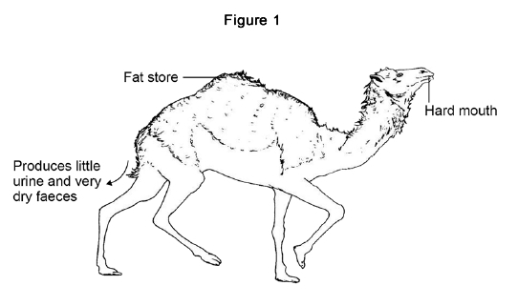
(a) One adaptation of the dromedary is ‘temperature tolerance’.

This means that the animal’s body temperature can rise by up to 6 °C before it starts to sweat.

Explain how temperature tolerance can help the dromedary to survive in the desert.

(b) Three more adaptations of the dromedary are given in Figure 1. Give a reason why each adaptation helps the animal survive in the desert. Fat store, Produces little urine and very dry faeces Hard mouth

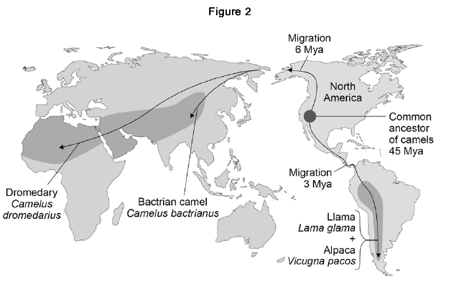
There are several species of the camel family alive today.

Scientists think these species evolved from a common ancestor that lived in North America about 45 million years ago (Mya).

Figure 2 shows:

• where four modern species of the camel family live today

• how the ancestors of these camels migrated from North America.

(c) Which two of the four modern species of camel do scientists believe to be most closely related to each other? Give the reason for your answer.

(d) Describe the type of evidence used for developing the theory of camel migration shown in Figure 2.

(e) Explain how several different species of camel could have evolved from a common ancestor over 45 million years.
- The diagram below shows changes in the foot bones of four ancestors of modern horses over the past 50 million years.

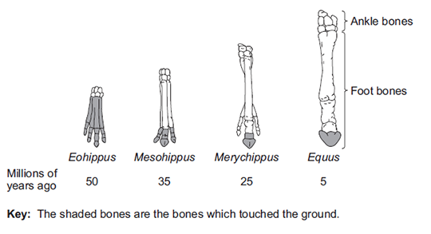
(a) Describe two changes to the bones in the feet of horses that have taken place over the past 50 million years.

(b) Eohippus lived in swampy areas with soft mud.

Since this time the ground in the habitat has become drier and harder.

All of the horse ancestors were preyed upon by other animals.

(i) Explain one advantage to Eohippus of the arrangement of bones in its feet.

(ii) The changes in the arrangement of the foot bones of horses support Darwin’s theory of evolution by natural selection.

Explain how the arrangement of the foot bones of Eohippus could have evolved into the arrangement of the foot bones of Equus.
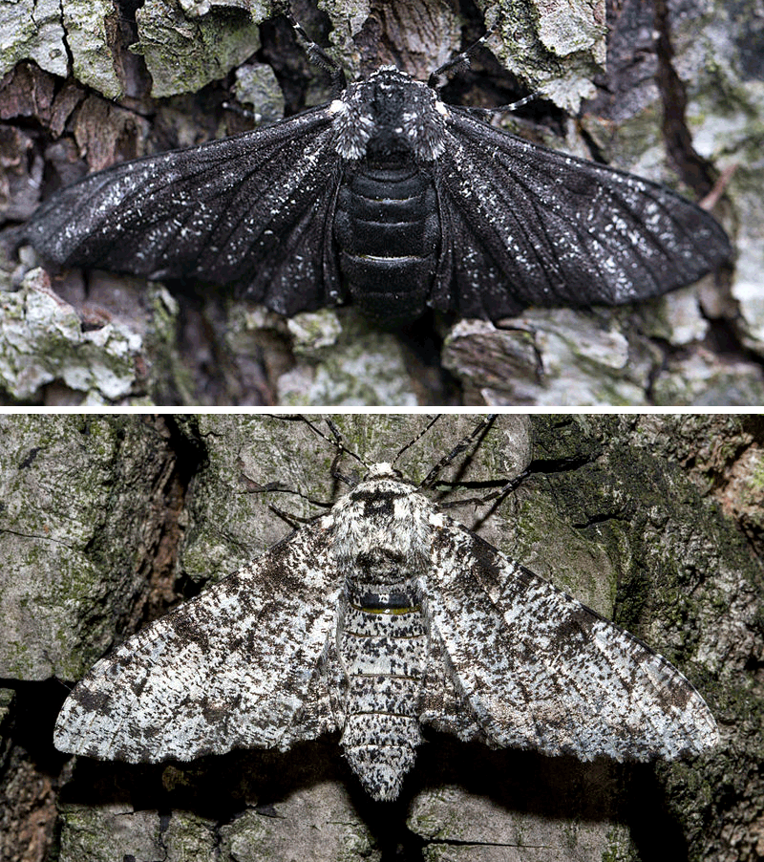
- In the beginning, there are more white peppered moths than black peppered moths living on trees. However, during and after the Industrial Revolution period, the number of black peppered moths drastically increased. Explain in detail.

Keywords to use: Black soot, natural selection, reproduce, survive, characteristics, variation, time.

Part 10- Selective breeding

Humans can speed up evolution by doing selective breeding (artificial selection). It is the process by which humans breed plants and animals for desired characteristics. Here is a list of desired characteristics (and quite often the advantages to selective breeding):
- Disease resistance
- Increased food production/crop yield
- Gentle nature of domestic animals (eg. Dogs)
- Heavily scented flowers

It is especially useful in agriculture, where farmers want all or most of their animals or plants to be resistant to diseases and can grow in size quickly, so they could farm and harvest as efficiently as possible for profit. This is the process of selective breeding:
- Choose two individuals with the desired characteristic(s) from a mixed population.
- Allow them to breed, which produces offspring with a range of characteristics.
- Choose the few offspring with the (most) desired trait(s) and allow them to breed.
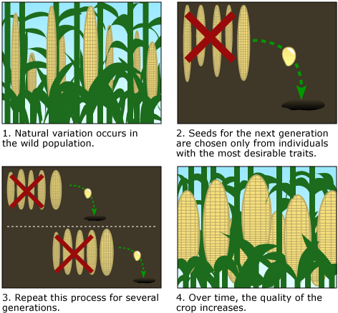
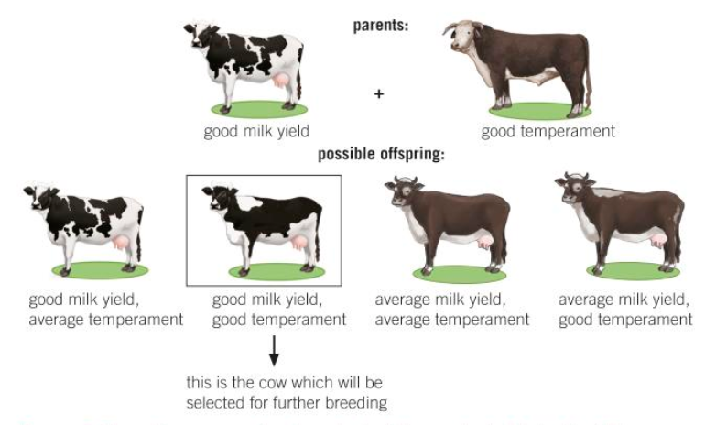
- Repeat this cross-breeding process over many generations until all the offspring show the desired characteristic.

There are pros and cons to selective breeding.
Advantages | Disadvantages
Disease resistance in food crops | Reduces genetic variation (lose allele variation) 🡪 less likely to be able to cope with major environmental changes 🡪 die out
Animals which produce more meat or milk | Inbreeding more prone to certain diseases/inherited conditions  (more likely to inherit homozygous recessive alleles recessive genetic disorders)

Domestic dogs with a gentle nature

Large or unusual flowers
Comprehension questions – each question should be attempted first from memory. Every five questions get your green pen and use the text to check your answers.
- Define ‘selective breeding’.
- What are the desired characteristics in farm animals? Explain.
- Describe the process of selective breeding.
- Name two historic examples of selective breeding.
- State four modern examples of selective breeding.
- How do breeders of domestic pets use selective breeding to produce many pets?
- Give two desirable characteristics in crops.

Application questions – use your notes from this section and past sections to answer the questions below, but you should try from memory first.
- Explain how selective breeding reduces genetic variation.
- Explain how selective breeding can lead to extinction of a species.
- State another problem with selective breeding and explain why that is a problem.
- Name the gametes of a cow
- Name the gametes of a maize plant
- A cow body cell has 60 chromosomes. How many will its gametes have?
- Calculate the percentage increase in chromosome number from human gametes to cow gametes.
- Selective breeding has increased milk production by 40%. If a modern cow produces approximately 23 liters of milk, how much milk did early cows produce?
- Many different types of animals are produced using selective breeding.

Some cats are selectively bred so that they do not cause allergies in people.

(a) Suggest two other reasons why people might selectively breed cats.

(b) Selective breeding could cause problems of inbreeding in cats. Describe one problem inbreeding causes.

(c) Many people have breathing problems because they are allergic to cats.

The allergy is caused by a chemical called Fel D1. Different cats produce different amounts of Fel D1. A cat has been bred so that it does not produce Fel D1.

The cat does not cause an allergic reaction. Explain how the cat has been produced using selective breeding.

Part 11- Genetic engineering

Genetic engineering is the process where a gene from an organism is transferred to the genome of another organism to give it a desired characteristic. Many organisms have been genetically modified (GM) for the benefits of humans, for example, GM crops becoming disease/pest-resistant and make bigger better fruits; GM bacteria producing human insulin to treat diabetes.
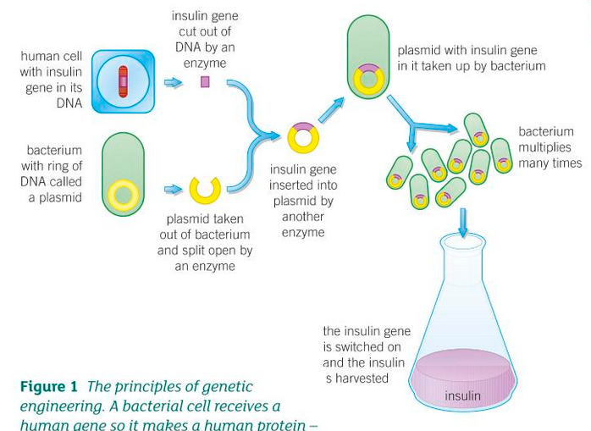

The process of genetic engineering (for making insulin) HT ONLY:
- Extract human DNA from human cell and the plasmid (vector) from bacteria
- Cut out desired gene (eg. Insulin gene) from human DNA using restriction enzyme
- Using the same restriction enzyme, cut the plasmid
- Insert desired gene into plasmid, becoming recombinant DNA
- Put recombinant DNA into bacteria, becoming a transgenic bacteria/organism
- Allow transgenic bacteria to multiply by mitosis. All GM bacteria make human insulin
- Extract human insulin to treat diabetes

Some pros and cons of genetic engineering:
Advantages | Disadvantages
Can mass produce desired proteins/products | Resistant genes could be transferred to natural populations (wildtype) this affects biodiversity
Can modify crops to be resistant to pests/diseases this increases crop yield | Expensive

Comprehension questions – each question should be attempted first from memory. Every five questions get your green pen and use the text to check your answers.
- What is genetic engineering?
- What is the term used to describe organisms that are genetically modified?
- Why is genetic engineering useful?
- Give two examples of vectors used in genetic engineering.
- Give two ways in which genetic engineering is useful in agriculture.
Application questions – use your notes from this section and past sections to answer the questions below, but you should try from memory first.
- Explain how genetic engineering is useful in treating diabetes.
- Suggest what genes could be engineered into crops to make them pest-resistant.
- How can genetically modified (GM) crops affect the growth and survival of natural (wildtype) crops/plants?
- Complete the sentences below:
Genetic engineering is useful for society because….
Genetic engineering is useful for society but….
Genetic engineering is useful for society so….

- HT ONLY How is a gene “cut out” from the genome of one species and inserted the genome of another? Into what is the gene inserted?

- HT ONLY Describe the process of genetic engineering. You may draw a diagram to help illustrate.

- HT ONLY Read the information.

Insects can be both useful and harmful to crop plants.
Insects such as bees pollinate the flowers of some crop plants. Pollination is needed for successful sexual reproduction of crop plants.
Some insects eat crops and other insects eat the insects that eat crops.
Corn borers are insects that eat maize plants.
A toxin produced by the bacterium Bacillus thuringiensis kills insects.
Scientists grow Bacillus thuringiensis in large containers. The toxin is collected from the containers and is sprayed over maize crops to kill corn borers.
A company has developed genetically modified (GM) maize plants. GM maize plants contain a gene from Bacillus thuringiensis. This gene changes the GM maize plants so that they produce the toxin.

(a) Describe how scientists can transfer the gene from Bacillus thuringiensis to maize plants.

(b) Would you advise farmers to grow GM maize plants?

Justify your answer by giving advantages and disadvantages of growing GM maize plants.

Use the information from the box and your own knowledge to help you.
- HT ONLY The diagram shows how genetic engineering can be used to produce human insulin from bacteria. Ampicillin and tetracycline are two types of antibiotic. Study the diagram carefully and answer the questions.

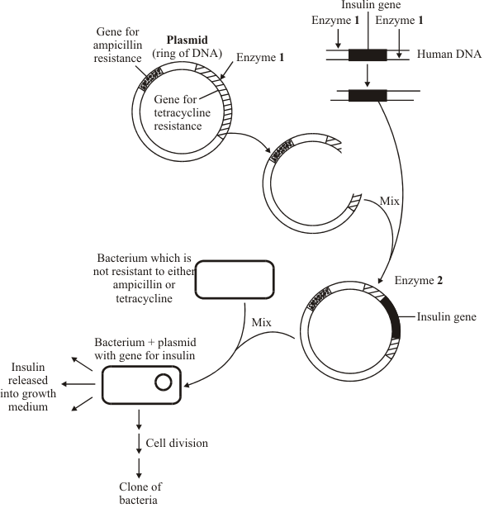
In experiments like these, some bacteria take up the plasmid (ring of DNA) containing the insulin gene. Other bacteria fail to take up a plasmid, or they take up an unmodified plasmid (a ring of DNA which has not been cut open and which does not contain the insulin gene).

(a) Complete the table by putting a tick () in the correct boxes to show which bacteria would be able to multiply in the presence of ampicillin and which bacteria would be able to multiply in the presence of tetracycline.

Bacterium can multiply in
the presence of
 | Ampicillin | Tetracycline
Bacterium + plasmid with the insulin gene
Bacterium without a plasmid
Bacterium with an unmodified plasmid

(b) The bacterium with the plasmid containing the insulin gene multiplies by cell division to form a clone of bacteria. Will all the bacteria in this clone be able to produce insulin? Explain your answer.

Part 12 Cloning + Adult cell cloning (TRIPLE ONLY)

A clone is an individual that has been produced through asexual reproduction and is genetically identical to the parent. Clones can be made by different methods, also dependent on if you are trying to clone plants or animals.

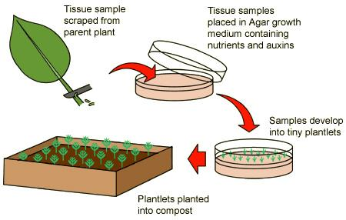
Plant cloning
Plant cuttings + Tissue culture:
- Part of the plant is cut out from parent plant
- The plant tissue is placed in growth medium with nutrients and plant hormones (eg. Auxins)
- It eventually grows into plantlets
- Plantlets are transferred to be planted in compost

Animal cloning
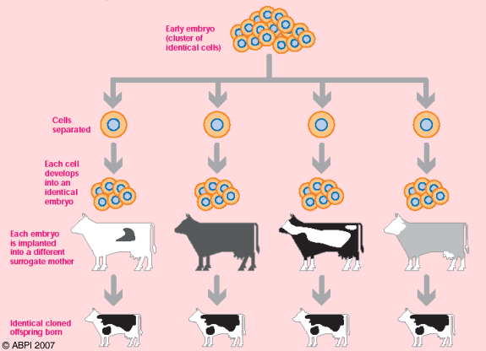
Method 1 – Embryo splitting:
- An embryo is made either by letting two individuals mate and wash out the embryo, or by artificial insemination/fertilisation in the lab
- Split the embryo into several individual cells
- Allow each cell to grow individually into identical embryos
- Transfer these embryos into host mothers and allow them to grow naturally into foetuses
- The cloned offspring are born and are genetically identical to each other, but not related to their host mothers

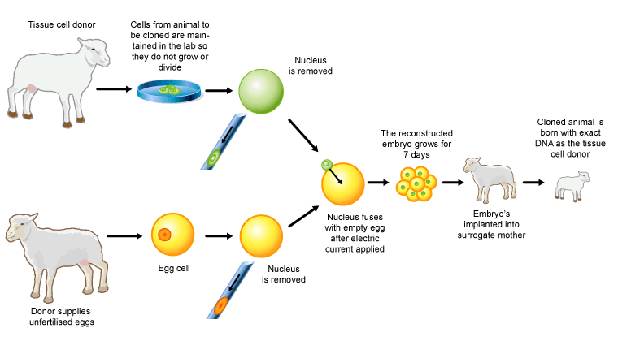
Method 2 – Adult cell cloning:
- Extract an adult body cell and an unfertilised egg cell (from different individuals)
- Remove the nucleus in the egg cell
- Extract the nucleus from the adult body cell and insert it into the empty egg cell
- Pass a small electric shock through to the egg cell, stimulating it to start dividing to form an embryo
- Insert the embryo into an adult female to continue its development into a fetus
- The offspring is genetically identical to the nucleus donor (ie. The donor of the adult body cell)

Some pros and cons of cloning:
Advantages | Disadvantages
Combine with genetic engineering to increase crop yield | Reduce genetic variety/Smaller gene pool  🡪 less likely to survive in changing environment
Save animals from extinction | Potential use in engineering human babies (ethical concerns)

Comprehension questions – each question should be attempted first from memory. Every five questions get your green pen and use the text to check your answers.
- Define ‘clone’.
- Name the traditional method of artificial plant cloning.
- Name the modern method of artificial plant cloning.
- What are “plant cuttings”?
- Describe the process of modern artificial plant cloning.
- Compare the offspring from embryo transplants with each other and with the parents.
- Explain why artificial plant cloning is useful.
Application questions – use your notes from this section and past sections to answer the questions below, but you should try from memory first.
- Suggest how genetic engineering and artificial plant cloning can be combined for agricultural benefits.
- Suggest a hormone that would be used in tissue culture.
- Among a batch of plants grown using the cloning method, one of them was checked to be genetically different from its parent and sibling plants. Suggest why.
- Describe in detail how a batch of top-quality cows can be produced by embryo cloning/transplants.
- In adult cell cloning, what is removed from the cloning target's cell, in order to create its clone?
- What type of cell is taken from the target clone in adult cell cloning?
- What has to be done to the egg cell in adult cell cloning?
- What is needed to stimulate the new egg cell to divide in adult cell cloning?
- Describe in detail how adult cell cloning is done.
- Compare the offspring in adult cell cloning to both its parents.
- Describe the two benefits and two risks of adult cell cloning.
- Compare the offspring from embryo cloning and adult cell cloning. Explain their difference. You could use a venn diagram to help
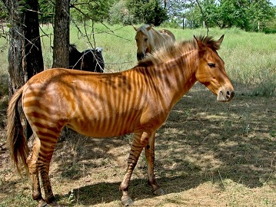
- The photograph shows a zorse.

A zorse is a cross between a male zebra and a female horse.
The zorse has characteristics of both parents.

(a) The zorse was produced by sexual reproduction.

(i) What is sexual reproduction?

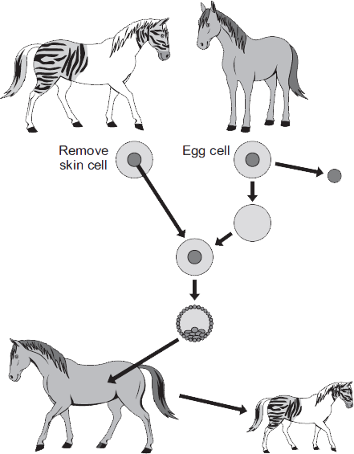
(ii) The zorse has characteristics of a zebra and a horse.
Why?

(b) Zorses are not able to breed.
Scientists could produce more zorses from this zorse by adult cell cloning. The diagram shows how the scientists might clone a zorse.

In this question you will be assessed on using good English, organising information clearly and using specialist terms where appropriate.

Use information from the diagram and your own knowledge to describe how adult cell cloning could be used to clone a zorse.

Part 13- Ethics of genetic technologies
When it comes to evaluating genetic technologies, we need to consider them in terms of four aspects: scientific, economic, social and ethical aspects.
Benefits | Concerns
Increase growth rate of plants and animals | Unsure of long-term effects
Increase food value (eg. Higher yield) | Unsure of effect of eating GM food on human  health
Designed to be resistant to poor environments  (eg. Dry, cold) | Affect wildtype organisms’ chances of survival
Designed to be pest/herbicide-resistant | Ethical concerns of potential human engineering

Comprehension questions – each question should be attempted first from memory. Every five questions get your green pen and use the text to check your answers.
- State two ways in which genetic engineering can be used in medicine.
- State two ways in which genetic engineering can be used in agriculture.
- Give one benefit of growing GM crops to humans.
- What are the two concerns people have on GM crops?
- Explain why people have ethical concerns about animal genetic engineering.

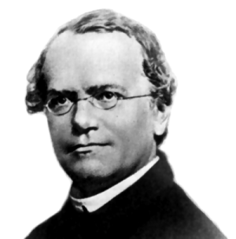
Part 14- The theory of evolution (TRIPLE ONLY)

In the mid-19th century Gregor Mendel carried out breeding experiments on peas (smooth vs. wrinkled; green vs. yellow). One of his observations was that the inheritance of each characteristic is determined by ‘units’ that are passed on to descendants unchanged. People did not recognise how important Mendel’s discovery was, as they did not understand his theory due to lack of knowledge on genes and chromosomes.
In the late 19th century behaviour of chromosomes during cell division was observed. In the early 20th century it was observed that chromosomes and Mendel’s ‘units’ behaved in similar ways. This led to the idea that the ‘units’, now called genes, were located on chromosomes. In the mid-20th century the structure of DNA was determined and the mechanism of gene function worked out. The double helix structure was found by Watson and Crick, using X-ray results from Franklin and Wilkins but without Franklin’s permission. This scientific work by many scientists led to the gene theory being developed.

Comprehension questions – each question should be attempted first from memory. Every five questions get your green pen and use the text to check your answers.

- Name the person who first discovered inherited characteristics are determined by 'units' passed on unchanged.
- Why were Mendel's ideas of inheritance not accepted during his time?
- Who published the double helix structure of DNA?
- Watson and Crick used whose work to find out the structure of DNA?
Application questions – use your notes from this section and past sections to answer the questions below, but you should try from memory first.
- What is the name for the structure of DNA?
- Name the 4 bases in DNA
- (HT) What is complimentary base pairing
- How many bases code for an amino acid
- What is the name for a long polymer of amino acids
- How many chromosomes are in a human gamete?

Part 13- Theories of evolution + Accepting Darwin’s ideas (TRIPLE only)

Charles Darwin, as a result of observations on a round-the-world expedition, backed by years of experimentation and discussion and linked to developing knowledge of geology and fossils, proposed the theory of evolution by natural selection.
• Individual organisms within a particular species show a wide range of variation for a characteristic.
• Individuals with characteristics most suited to the environment are more likely to survive and breed successfully.
• The characteristics that have enabled these individuals to survive are then passed on to the next generation.

Darwin published his ideas in On the Origin of Species (1859). There was much controversy surrounding these revolutionary new ideas. The theory of evolution by natural selection was only gradually accepted because:
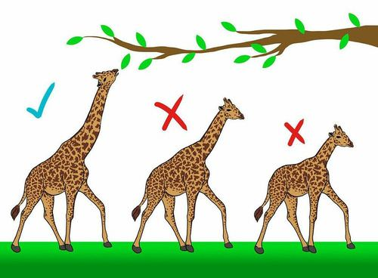
• The theory challenged the idea that God made all the animals and plants that live on Earth
• There was insufficient evidence at the time the theory was published to convince many scientists
• The mechanism of inheritance and variation was not known until 50 years after the theory was published.

Other theories, including that of Jean-Baptiste Lamarck, are based mainly on the idea that changes that occur in an organism during its lifetime can be inherited. We now know that in the vast majority of cases this type of inheritance cannot occur.
Comprehension questions – each question should be attempted first from memory. Every five questions get your green pen and use the text to check your answers.
- Name the person who proposed the theory of evolution.
- Name the person who suggested changes that occur in an organism during its lifetime can be inherited.
- On what mechanism is Darwin's theory of evolution based on?
- What is Darwin's theory of evolution by natural selection?
- State three reasons why Darwin’s ideas were only slowly accepted.

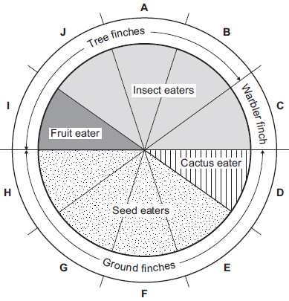
Application questions – use your notes from this section and past sections to answer the questions below, but you should try from memory first.
- Evolution take a long time to happen so organisms do not normally change during a persons’ lifetime. Explain why this can make it difficult to ‘prove’ evolution is happening.
- In the 1800s, Charles Darwin visited the Galapagos Islands. On the islands he found many different species of bird called finches. Darwin thought that all the different finch species had evolved from one species of finch that had reached the islands many years before.

(a) Complete the following sentence. Darwin suggested the theory of evolution by natural….

(b) The pie chart shows information about ten species of finch, A − J.

(i) How many of the species of finch eat insects?

(ii) Describe finch species G. Use only information from the pie chart.

(c) When Darwin returned to the UK very few people believed his theory of evolution.

A different scientist suggested that the changes that occur in an organism during its lifetime can be inherited by its offspring. What was the name of this scientist?

- The image below shows: Phiomia, an ancestor of elephants and a modern African elephant. Phiomia lived about 35 million years ago.

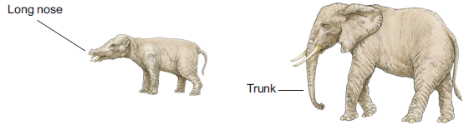
Phiomia African elephant

Both Phiomia and the African elephant reach up into trees to get leaves.

In the 1800s, Darwin and Lamarck had different theories about how the long nose of Phiomiaevolved into the trunk of the African elephant.

(a) (i) Use Darwin’s theory of natural selection to explain how the elephant’s trunk evolved.

(ii) Lamarck’s theory is different from Darwin’s theory. Use Lamarck’s theory to explain how the elephant’s trunk evolved.

(b) (i) In the 1800s, many scientists could not decide whether Lamarck’s theory or Darwin’s theory was the right one. Give two reasons why.

(ii) Before the 1800s, many people had a different idea to explain where all the living things on Earth came from. What idea was this?
- The photograph shows some flamingos.

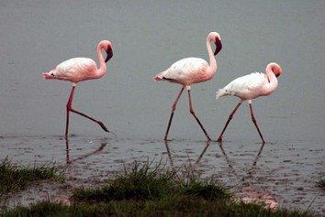
• Flamingos feed on organisms that live in mud at the bottom of lakes.

• Leopards prey on flamingos.

• Flamingos find it difficult to fly if their feathers get wet.

Flamingos have evolved very long legs.

How would each of the following theories explain the evolution of these long legs?

(a) Darwin’s theory (b) Lamarck’s theory.

Part 14- Evolution and speciation (TRIPLE only)

Alfred Russel Wallace independently proposed the theory of evolution by natural selection. He published joint writings with Darwin in 1858 which prompted Darwin to publish On the Origin of Species (1859) the following year. Wallace worked worldwide gathering evidence for evolutionary theory. He is best known for his work on warning colouration in animals and his theory of speciation.
Alfred Wallace did much pioneering work on speciation but more evidence over time has led to our current understanding of the theory of speciation.

Process of speciation:
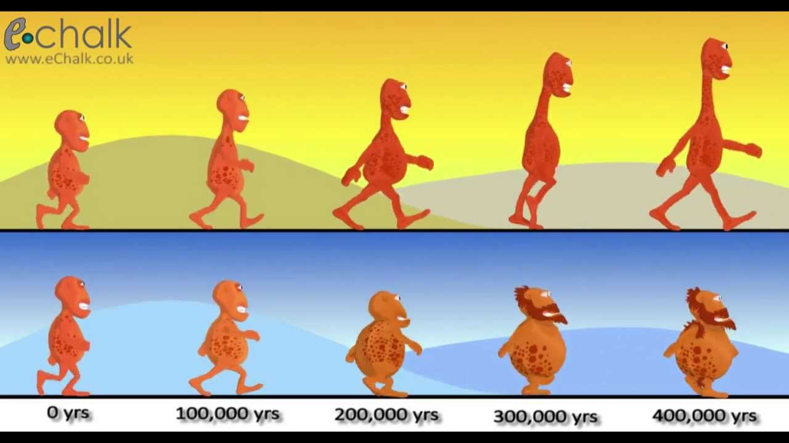
- Isolation occurs – when a species becomes separated into two populations
- Geographical (eg. new river/island) – caused by natural phenomenon (eg. earthquakes, volcanic eruption)
- Environmental (eg. climate change)
- Natural selection occurs:
- There is genetic variation within one species between individuals
- Alleles for characteristics favourable for survival and successful breeding in the new conditions will be selected
- Those with favourable alleles can survive and reproduce
pass on favourable alleles (genetic variation increases)
- Speciation occurs – eventually, the organisms change so much that they can no longer interbreed with the original organisms to produce fertile offspring
Comprehension questions – each question should be attempted first from memory. Every five questions get your green pen and use the text to check your answers.
- Who worked with Darwin to develop the theory of evolution?
- Apart from evolution, what are two other studies Wallace worked on?
- What is speciation?
- What needs to happen to a population of species in order for speciation to occur?
- Give the six steps in the process of speciation.
Application questions – use your notes from this section and past sections to answer the questions below, but you should try from memory first.
- The photographs show two species of gull.
Herring gull (Larus argentatus) | Lesser black-backed gull (Larus fuscus)
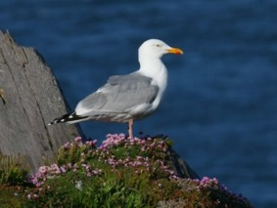 | 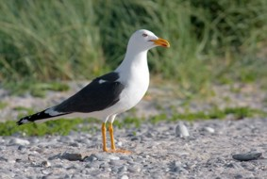

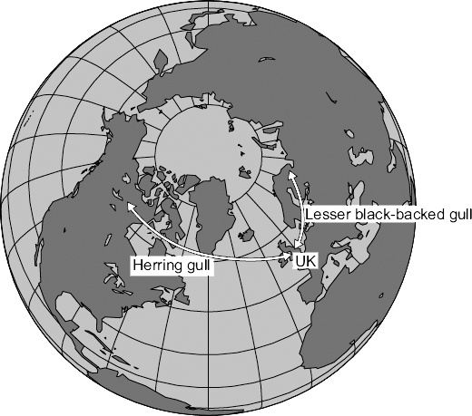
Both species are now found in the UK but the two species cannot interbreed with each other. Scientists believe that these two species have evolved from a common ancestor.

The map below shows a view of the Earth from above the North Pole.
The map also shows where these two species are found.

Suggest an explanation for the development of these different species.

- The illustration below shows two types of pistol shrimp.

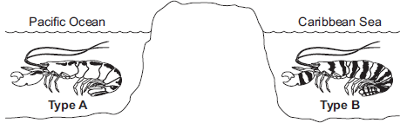
The shrimps live in shallow, tropical seas on opposite sides of Panama.

Not to scale

Scientists put one Type A shrimp and one Type B shrimp together in a tank of seawater.
The two types of shrimp snapped their claws aggressively at each other.
They did not mate.

The scientists said that this was evidence for the Type A and Type B shrimps being classified as two different species.

(i) Give one reason why the scientists’ opinion may be correct.

(ii) Suggest two reasons why the scientists’ opinion may not be correct.

(c) Panama is a narrow strip of land which today joins North America and South America.
It was formed by land moving up from beneath the sea. Panama has separated the Pacific Ocean and the Caribbean Sea for the past 3 million years.

Explain how two different species of pistol shrimp could have developed from an ancestral species of shrimp.
- Darwin’s theory of evolution states that all species of living things have evolved from simple life forms.

Darwin’s theory was published in 1859.

(a) Give two reasons why Darwin’s theory was only slowly accepted.

(b) Darwin observed birds called finches on the Galapagos Islands, 1000 km from the coast of South America.

He saw that the birds were similar to, but not the same as, birds he had seen on the mainland of South America.

Recent evidence suggests that 13 different species of finch on the islands evolved from 1 species of finch that arrived from the mainland about 1 million years ago.

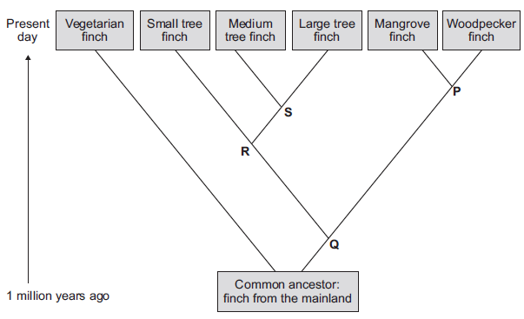
Describe how a new finch species may have evolved from the original species of finch that arrived from the mainland.

(c) The diagram below shows the evolutionary tree for some Galapagos finches.

(i) Which type of present-day finch is least closely related to all the others?

(ii) Which branching point, P, Q, R or S, on the diagram above shows the most recent common ancestor of all the tree finches?

(iii) Which two finches have the most recent common ancestor?

Part 15 - Evidence for evolution
The process of evolution is only a theory. It needs to be supported by evidence – fossils. Fossils are the remains of organisms from millions of years ago, preserved in the environment (eg. rock, ice). Through looking at fossil records, we can see how organisms are structurally adapted in the past. It also helps scientists to understand how they have changed since life developed on Earth, which can act as evidence for evolution by natural selection.
There are different forms of fossils, depending on how they are formed. A lack of decay is key to forming fossils. There are a few factors needed for decay:
- Bacteria (as decomposers – the nutrients inside organisms are their food source and raw material for respiration)
- Oxygen (for aerobic respiration of bacteria)
- Correct temperature (too hot – enzymes in bacteria denature, leading to their death; too cold – enzymes are inactive, leading to a lack of respiration)
It is nearly impossible to have no bacteria in the environment; hence the environment must be lacking in oxygen and/or at a wrong temperature in order for fossilisation to occur. For example:
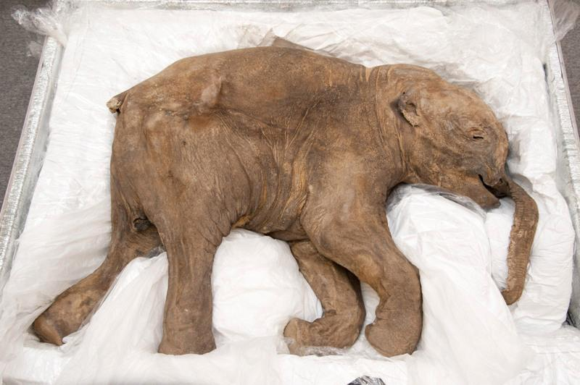
- Organisms not decay after death due to lack of decay conditions
Situation A: Organism drowned in water which froze relatively quickly
- There are decomposers, however there may be a lack of oxygen and it is very cold, meaning bacteria would die and their enzymes would be inactive anyway, hence decay cannot occur. The whole organism is intact.
- Eg. A whole baby mammoth (with muscles, blood, fur intact) was found frozen in ice

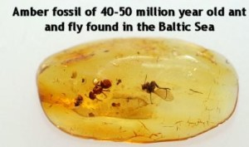
Situation B: Organisms (eg. flies, ants) trapped in tree sap
- There may be very few decomposers within the tree sap. Even though the temperature may be appropriate, the lack of oxygen means decay cannot occur as bacteria cannot respire aerobically.
- Overtime the tree sap hardens to become amber with insects trapped inside

- Preserved traces of organisms left behind
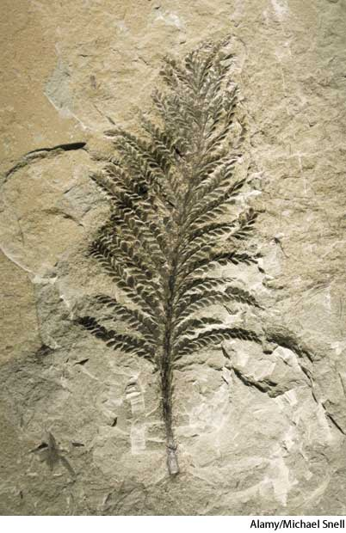
- Organisms left a particular imprint on wet mud, like a mould. Overtime, it dried out with the traces formed and hardened into rocks.
- Eg. Footprints, burrows, rootlet traces, droppings

- Harder parts of organisms (eg. Bones) replaced by minerals
- This is the most common form of fossils, like the ones you can see in museums

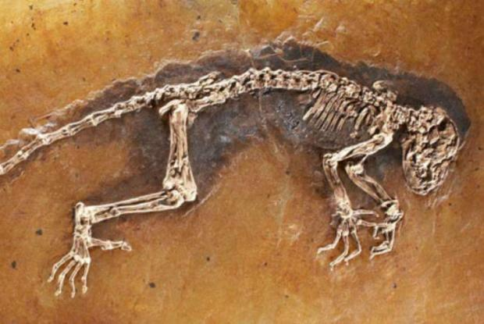
Process of fossilisation of skeletons
- Organism dies and falls to the ground
- Soft parts (eg. Flesh) decompose, leaving the bones behind as they are harder to decay
- The skeleton is then covered in sand/soil
- The skeleton becomes mineralised (bone tissue replaced by mineral ions) over millions of years turns to rock
It is important to remember that bone tissues can still decay as they are organic, but just takes a longer time to do so. If they get replaced by the minerals before they decay, meaning the minerals can form a mould of their shapes, then the fossil can be made.

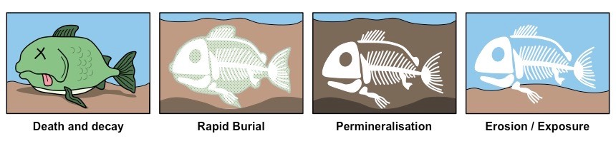
Even though fossils are a great way to support the theory of evolution, it is not enough as we do not have a complete fossil record. The reasons for this are as follows:
- Many early life forms are soft-bodied, which means they decay quickly and cannot be mineralised to form fossils
- Geological activity destroyed some fossils, such as earthquakes
- Most organisms did not become fossilised – the conditions for fossilisation are very rare, and any imprints made are washed away easily.
- Many undiscovered fossils – we do not know exactly how many fossils they are still buried, hence we may be missing parts of the record
Comprehension questions – each question should be attempted first from memory. Every five questions get your green pen and use the text to check your answers.

- What are fossils?
- What are the three criteria for decay to occur?
- Describe the five steps of fossilisation by mineralisation.
- Why is it harder for bones to decay?
- What are the three different types of fossils that can be formed?
- Fossils which are older often appear to be simpler organisms. What theory does this provided evidence to support?
- Complete the following sentences:
The fossil record is incomplete because…
The fossil record is incomplete but…
The fossil record is incomplete so…

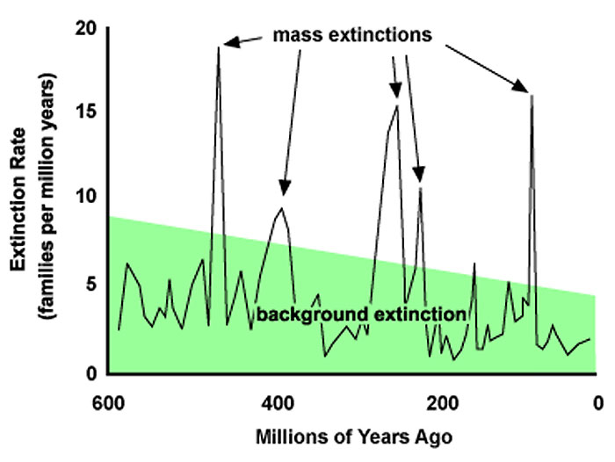
Part 16- Extinction
Extinction is the permanent loss of all members of one species. Mass extinction, on the other hand, is the loss of many or most species on Earth, and it usually happens over several million years. So far, there have been five mass extinction events, as seen on the five major peaks in the graph.
Extinctions can be caused by different factors.

Biotic causes of extinction
- New predators – organisms could not adapt quickly enough to survive the new predators and were all killed before they could reproduce and pass on favourable alleles
- Successful interspecific competition – the species that got outcompeted for food, territory/shelter etc. may become extinct overtime
- New diseases/pathogens – if the majority of the species could not (adapt to) survive the new disease then they may become extinct
Abiotic causes of extinction
- Climate change
- Single catastrophic event – eg. volcanic eruption, asteroid collision- Often link to climate change!

A single catastrophic event is perhaps the more common cause of mass extinction. The dinosaurs are believed to become extinct during one of the mass extinction events. One of the most supported theories is that an asteroid collision triggered it. The collision alone may kill many dinosaurs, but how may it caused them to become extinct (which usually requires a longer time)?
- Asteroid collision caused tectonic plates to shift
- This triggered earthquakes and tsunamis, which then subsequently triggered volcanic eruptions
- The lava itself could kill many organisms already. On top of that, the eruption(s) could produce a massive ash cloud which may cover a large portion (if not all) of the earth
- The ash cloud blocked out sunlight, preventing them from reaching the surface. This could then have two effects:
A.) Plants (producers) don’t get sunlight and cannot do photosynthesis. They then die out, which then affects the food chain
B.) Global temperature drops, eventually leading to the ice age
Comprehension questions – each question should be attempted first from memory. Every five questions get your green pen and use the text to check your answers.
- How is the fossil record helpful?
- Define 'extinction'.
- State three causes of extinction.
- What causes mass extinction? Suggest two examples of this cause.
- What is the difference between extinction and mass extinction?
Application questions – use your notes from this section and past sections to answer the questions below, but you should try from memory first.
- Suggest a chain of events initiated by an asteroid collision that could lead to the extinction of dinosaurs.
- Fossils give evidence about organisms that lived a long time ago.

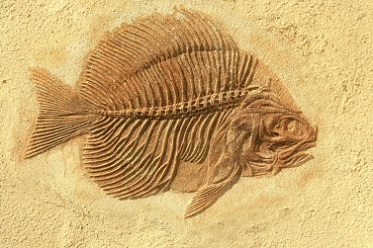
(a) Scientists have found very few fossils of the earliest life forms. Give one reason why.

This is a photograph of a fossilised fish.

(b) Suggest how the fossil in the photograph above was formed.

(c) The species of fish shown in the photograph above is now extinct.

Give two possible causes of extinction.

Modern fish species have evolved from fish that lived a long time ago.

Evolution is caused by mutation and natural selection.

(d) What is a mutation?

(e) Describe the process of natural selection.
- Over millions of years:

• new groups of organisms have evolved

• other groups of organisms have become extinct.

(a) If an asteroid collided with the Earth, large amounts of dust and water vapour would be thrown up into the air. This would mean less light and heat would reach the Earth’s surface from the Sun.

(i) A reduced amount of light and heat could have caused the extinction of plants. Suggest how.

(ii) How could the extinction of plants have caused the extinction of some animals?

(iii) Give two reasons, other than collision with an asteroid, why groups of animals may become extinct.

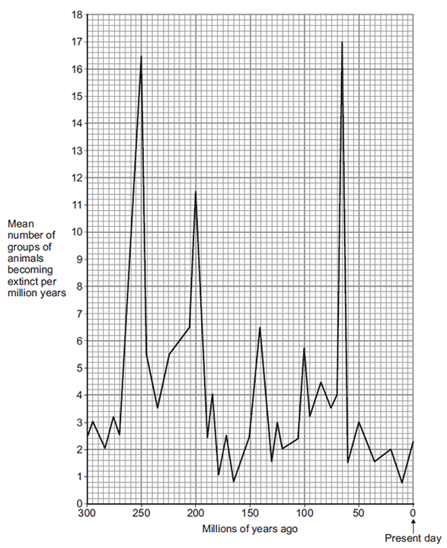
(b) The graph shows how the rate of extinction of groups of animals has varied over the past 300 million years.

(i) If more than 10 groups of animals become extinct in a 1 million year period, scientists call this a ‘mass extinction’.

How many mass extinctions occurred over the past 300 million years?

(ii) How do we know what types of animals lived hundreds of millions of years ago?

(c) Use information from the graph to answer part (i) and (ii).

(i) How many years ago did the most recent mass extinction of animals occur?

(ii) What was the mean number of groups of animals becoming extinct per million years in the most recent mass extinction?

(iii) Why are scientists not sure how many groups of animals became extinct in the most recent mass extinction?
- The photograph shows a fossil footprint. The fossil was found in a rock at the bottom of a shallow river.

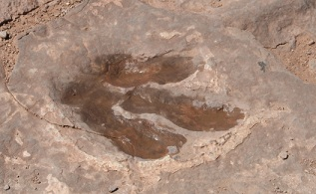
Scientists believe this is the footprint of a dinosaur. The dinosaur was alive 110 million years ago.

(a) (i) Suggest how the fossil shown in the photograph was formed.

(ii) Fossils may also be formed by other methods. Describe one other method of forming a fossil.

(b) Dinosaurs are now extinct. Give two factors that can cause extinction.

(c) How can fossils give evidence for evolution?

(d) Scientists are uncertain about how life began on Earth. Why?
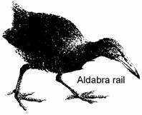
- Flightless birds called Rails once inhabited 20 islands in the Pacific Ocean. During the last two centuries they have disappeared from 15 of these islands. The Aldabra Rail, shown below, is one of the few survivors. The island which it lives on is very remote.

Suggest three reasons why Rails have disappeared from 15 of the 20 islands they once inhabited.

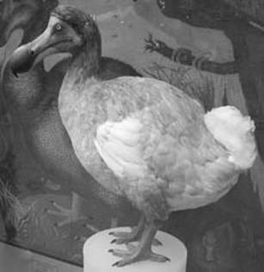
- The dodo is an extinct bird. The drawing shows an artist’s impression of the bird.

The dodo lived on a small island in the middle of the Indian Ocean. Its ancestors were pigeon-like birds which flew to the island millions of years ago. There were no predators on the island. There was a lot of fruit on the ground. This fruit became the main diet of the birds. Gradually, the birds became much heavier, lost their ability to fly and evolved into the dodo.

(a) Suggest an explanation for the evolution of the pigeon-like ancestor into the flightless dodo.

(b) The dodo became extinct about 80 years after Dutch sailors first discovered the island in the eighteenth century. Scientists are uncertain about the reasons for the dodo’s extinction. Suggest an explanation for this uncertainty.
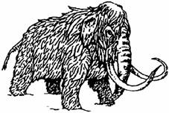
- When animals die, bacteria make them decay.
Warmth, moisture and oxygen are needed for this to happen.

(a) (i) In northern Russia whole bodies of mammoths have been found in the frozen soils.

Explain why they did not decay.

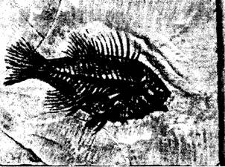
(ii) Fish fossils have been found in mudstone rock. Explain why they did not decay?

(b) Some of the mammoths had flint weapons in their bodies. Suggest two things that this tells us about human evolution.

(c) Mammoths are now extinct. Suggest two reasons for this.

Part 17 - Antibiotic resistant bacteria
Bacteria becoming resistant to certain antibiotics is an example of evolution, which happens at a comparatively much faster pace than evolution of multicellular organisms like animals and plants. The reason for this is because mutations occur much quicker in bacteria due to their rapid reproduction by binary fission, compared to how long it takes for animals/plants to reproduce. Mutation is a change in DNA (specifically alleles). It would need to be a mutation that favours survival that lead to successful evolution.
- Random mutation makes a bacterium within a population resistant to a particular antibiotic
- When the population is exposed to the antibiotic, the resistant strain outcompetes non-resistant strain – those original bacteria die, but the mutated bacterium can survive and reproduce by mitosis/binary fission
- This makes more bacteria with that particular antibiotic resistance gene, increasing its strain population
- The cycle may repeat starting with a new mutation, allowing them to become resistant to another antibiotic
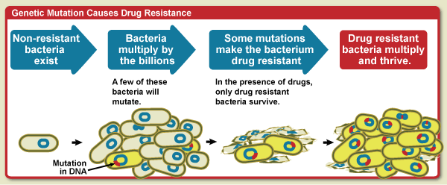
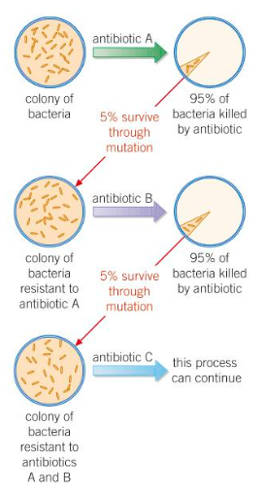
This is of particular concern in the current medical world, as more and more bacteria are becoming resistant to various antibiotics. This ultimately may lead to the rise of “superbugs”, which are bacteria strains that are resistant to almost all antibiotics. They pose a massive threat as it is a slow and expensive process to develop new antibiotics to counteract them. MRSA (methicillin-resistant Staphylococcus aureus) is the most classic example of superbugs. Therefore, it is important that we know how to prevent more bacteria from developing antibiotic resistance and to prevent their spread:
- Don’t overuse antibiotics – restrict its use only for severe bacterial infections
- Finish the course of antibiotics – ensure all bacteria strain are killed, none survive and reproduce (as seen in the diagram)
- Regulate agricultural use of antibiotics – some bacteria may affect both animals and humans
- Only use specific antibiotics for specific bacteria – limit exposure of unnecessary antibiotics to bacteria
- Maintain hygiene – personal and large-scale (hospital) level
- Isolation – isolate patients infected with antibiotic-resistant bacteria

Comprehension questions – each question should be attempted first from memory. Every five questions get your green pen and use the text to check your answers.
- What is antibiotic resistance?
- What causes antibiotic resistance?
- Describe the steps in which a bacteria strain develops resistance to an antibiotic.
- Why can bacteria evolve quicker than other organisms?
Application questions – use your notes from this section and past sections to answer the questions below, but you should try from memory first.

- Suggest 3 methods to prevent and slow down the development of antibiotic-resistant strains.
- Why must patients finish their course of antibiotics every time?
- Suggest 3 ways in which a hospital can reduce the spread of antibiotic-resistant strains.
- Why is it difficult to develop new antibiotics to combat the appearance of new antibiotic-resistant strains of bacteria?
- Why are bacteria prokaryotic organisms?
- Is binary fission sexual or asexual reproduction?
- What is the role of the DNA plasmid for bacteria?
- What type of cell in your blood fights infection?
- Define ‘pathogen’
- How does your body fight a bacterial infection?
- Define ‘allele’

- Sue says ‘antibiotic resistance isn’t a big deal, we can just make more antibiotics’ Do you agree? Give a reason.
- Why will your doctor not prescribe antibiotics for a cold?
- Antibiotics can be used to protect our bodies from pathogens.

(a) What is a pathogen?

(b) Bacteria may become resistant to antibiotics. How can doctors reduce the number of bacteria that become resistant to antibiotics?

(c) Scientists grow microorganisms in industrial conditions at a higher temperature than is used in school laboratories.

(i) Which temperature would be most suitable for growing bacteria in industrial conditions?

(ii) What is the advantage of using the temperature you gave in part (c)(i)?
- Many strains of bacteria have developed resistance to antibiotics.

The table shows the number of people infected with a resistant strain of one species of bacterium in the UK.

Year | 2004 | 2005 | 2006 | 2007 | 2008
Number of people infected  with the resistant strain | 3499 | 3553 | 3767 | 3809 | 4131

(a) Calculate the percentage increase in the number of people infected with the resistant strain between 2004 and 2008.

Show clearly how you work out your answer.

(b) Explain, in terms of natural selection, why the number of people infected with the resistant strain of the bacterium is increasing.

Pathogenic bacteria and viruses may make us feel ill if they enter our bodies.

(a) Why do bacteria and viruses make us feel ill?

(b) Most drugs that kill bacteria cannot be used to treat viral infections. Explain why.

(c) Antibiotic-resistant strains of bacteria are causing problems in most hospitals.

Explain, as fully as you can, why there has been a large increase in the number of antibiotic-resistant strains of bacteria.
- Some diseases can be tackled by using antibiotics and vaccination.
Explain fully why antibiotics cannot be used to cure viral diseases.

(ii) A recent study found that babies in 90 % of hospitals are infected with the MRSA bacterium. Explain how the MRSA bacterium has developed resistance to antibiotics.

(b) A person can be immunised against a disease by injecting them with an inactive form of a pathogen. Explain how this makes the person immune to the disease.

Part 17- Classification
Classification is the organisation of living organisms into groups according to similarities. Organisms are classified based on their structure and characteristics into a specific hierarchy. It is developed by Carl Linnaeus (a Swedish botanist), but was updated later on by Carl Woese and other scientists as we gain better understanding of living organisms.
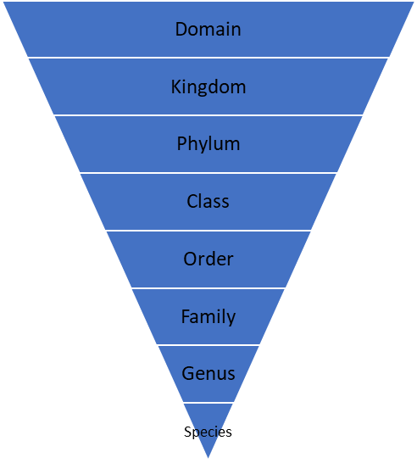The “updated” Linnaeus hierarchy
This is the original Linnaeus hierarchy
‘Domain’ was added later on by Carl Woese and others, as our understanding of the biochemistry of organisms increase.

You need to know the three domains, six kingdoms and what a species is.
Species refers to a group of organisms that can interbreed to produce fertile offspring.
Originally there were five kingdoms, but with more understanding there are distinct enough differences within the prokaryote kingdom that it was split into two kingdoms: archaebacteria and eubacteria.
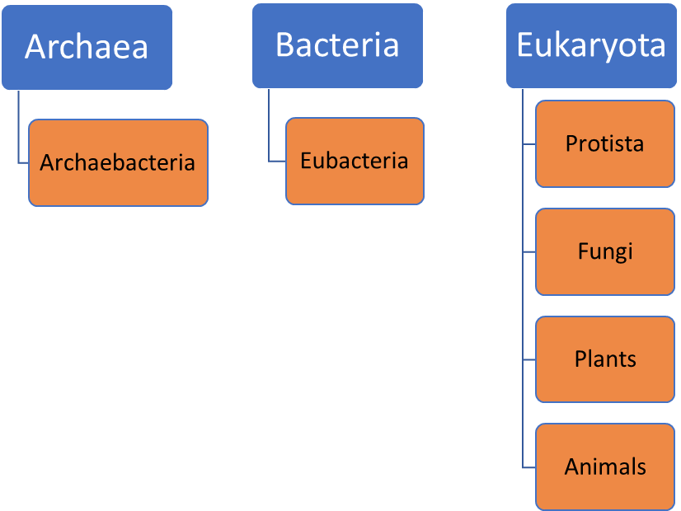
The three domains
The six kingdoms
“Archae-“ means ‘ancient’, therefore archaebacteria are ancient bacteria that existed since pre-historic times. In those days the environment is very harsh, so these archaebacteria are also extremophiles.
“Eu-“ means ‘true’. Eubacteria refers to all the bacteria found in everyday life.
Protista are protists. The one example you will need to know is the protist that causes malaria (see B5).

For example, humans are classified like so:
Classification | Human
Domain | Eukaryota
Kingdom | Animals
Phylum | Chordates
Class | Mammals
Order | Primates
Family | Hominids
Genus | Homo
Species | Sapiens

When talking about classification, we refer to humans as Homo sapiens. This type of naming is called binary naming. It is “binary”, as the name is made up of two words – the genus and species names. It is in Latin, as it is considered as the universal scientific language, so this helps scientists of different countries who speak different languages to understand each other better. Since it is in Latin, it needs to be written slightly differently. The fact that it uses genus and species to name particular organisms, it helps us see some basic information of their evolutionary relationships. If two organisms have the same genus name but different species name, we then know they are somewhat closely related just by looking at their names.

Rules of binary naming
- When typed, it needs to be in italics; when handwritten, it needs to be underlined
- The first letter of ‘genus’ must be in capital
- The first letter of ‘species’ must be in small letter

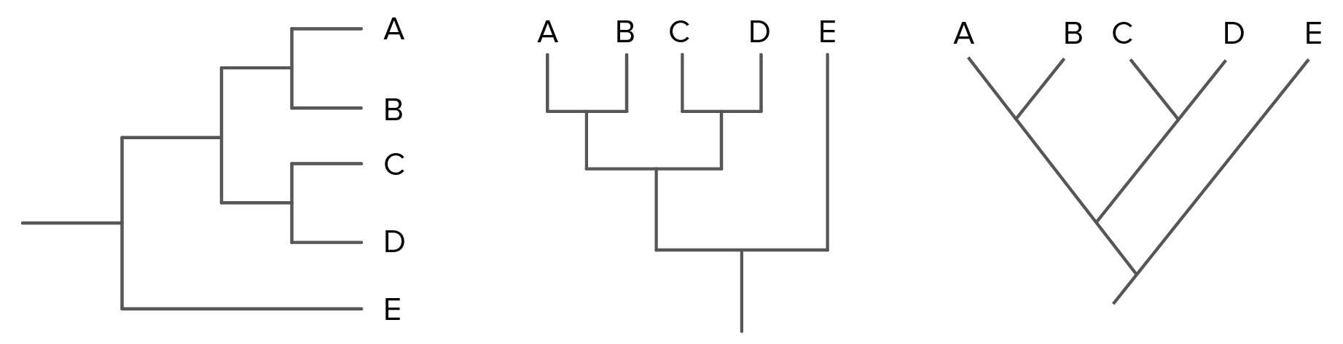We can use models like evolutionary trees to show relationships between organisms.
Although the above three trees look slightly different, they suggest the same relationships between organisms A-E. From the trees, we can tell that A is closely related to B, C is closely related to D, whereas E is not. However, they all originated from the same common ancestor.

Extension – Phylogenetic trees
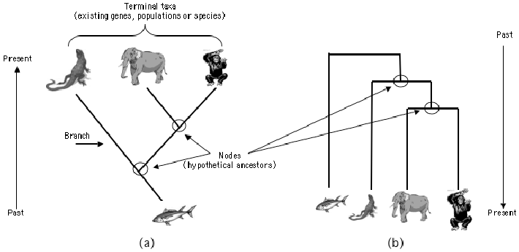
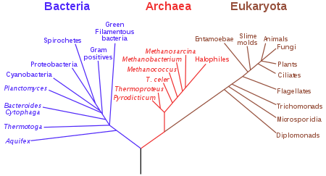
For the third tree, it is worth noting it can also be called a phylogenic tree. It is presented in such a way to also show the evolutionary timeline – the bottom of the tree is the beginning of time on Earth. As we go up the tree (or the arrow) we become closer to the present time. In some sense, the length of the lines extended from the bottom gives an estimation of their period of existence. Those that are not extended to the very top means they are already extinct. Below is another example of a phylogenetic tree, showing the suggested relationships between the organisms within the three domains. Do note that there are slightly different versions of phylogenetic trees when you do further reading or research online.

Comprehension questions – each question should be attempted first from memory. Every five questions get your green pen and use the text to check your answers.
- What does classification of organisms mean?
- Name the person who first developed the classification system.
- State the 7 hierarchical levels of the Linnaean classification system.
- Every organism has a scientific name using a binomial system. What does binomial mean?
- Which language does the binomial naming system use?
- The binomial name of an organism is made up of two words. What does each word represent of that organism?
- What are the three rules of writing a binomial scientific name of a species?
- Why do we use the binomial naming system?
- How many domains and kingdoms do scientists now consider in classification?
- Based on what knowledge were the three domains set?
- Who developed the three-domain system?
- What are the three domains?
- What are the six kingdoms?
- How is classification helpful?
- Name the type of models that are used to show how different organisms are related.
- How are evolutionary trees made?
- What aspects of knowledge would be considered when suggesting evolutionary relationships?
- Living organisms are classified into the following groups:

• Kingdom

• Phylum

• Class

• Order

• Family

• Genus

• Species

(a) Which scientist first suggested this type of classification system?
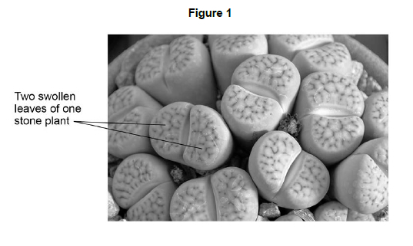

The stone plant, Lithops bromfieldi, is adapted to live in very dry deserts.

Figure 1 shows several stone plants.

(b) Give the genus to which the stone plant belongs.

(c) The stone plant has many adaptations that help it to survive in the desert.

Draw one line from each adaptation to how the adaptation helps the stone plant to survive.

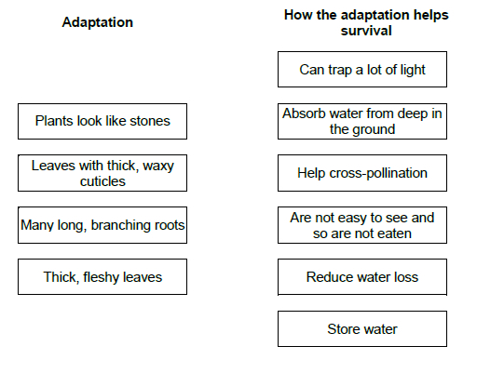

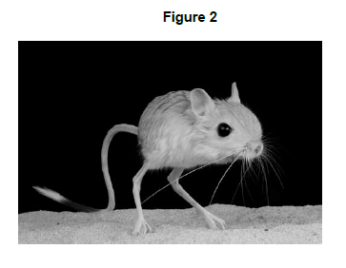
- The jerboa is a small desert animal.

Figure 2 shows a jerboa.

The jerboa is adapted for survival in the desert.

The jerboa spends the daytime in its underground burrow.

The jerboa only leaves its burrow to look for food during the night.

(d) Describe how these adaptations help the jerboa to survive in the desert.

(e) What type of adaptations are described in Question d)?
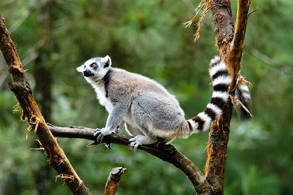
- Figure 1 shows a ring-tailed lemur.

Figure 1

The table below shows part of the classification of the ring-tailed lemur.

Classification group | Name
Kingdom | Animalia
Phylum | Chordata
 | Mammalia
 | Primates
 | Lemuroidea
Genus | Lemur
 | catta

(a) Complete the table above to give the names of the missing classification groups.

(b) Give the binomial name of the ring-tailed lemur.

Use information from the table above.

Lemurs are only found on the island of Madagascar. Madagascar is off the coast of Africa.

Scientists think that ancestors of modern lemurs evolved in Africa and reached Madagascar about 50-60 million years ago. Today there are many species of lemur living on Madagascar.

Figure 2 shows information about water currents. Figure 3 shows the distribution of three species of lemur on Madagascar.

Figure 2 | Figure 3
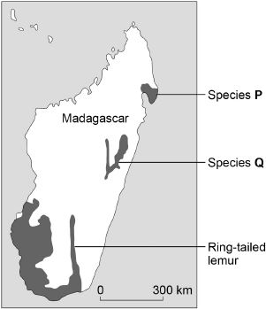
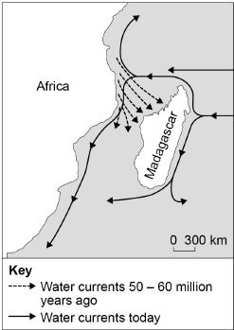

(c) Suggest how ancestors of modern lemurs reached Madagascar.

(d) Describe how the ancestors of modern lemurs may have evolved into the species shown in Figure 3.

