8BE: Ecological relationships
Lesson 1: Food chains and webs
Food chains and food webs describe feeding relationships. The population of species in a food chain is shown using a pyramid of numbers. Organisms in an ecosystem affect each other’s populations. The table describes some common terms used to describe living things in their environment:
Keyword | Definition
Environment | All the conditions that surround a living organism
Habitat | The place where an organism lives
Population | All the members of a single species that live in a habitat
Community | All the populations of different organisms that live together in a habitat
Ecosystem | A community and the habitat in which organisms live

A food chain shows the different species of an organisms in an ecosystem, and what eats what. A food chain always starts with a producer, an organism that makes food. This is usually a green plant, because plants can make their own food by photosynthesis. A food chain ends with a consumer, an animal that eats a plant or another animal. Here is an example of a simple food chain:
Grass rabbit fox
The arrows in food chains show the way in which energy is moving. They do not show what eats what. A consumer that only eats plants is called a herbivore, and a consumer that only eats other animals is called a carnivore. An omnivore is an animal that eats both plants and animals.
Examples of food chains:
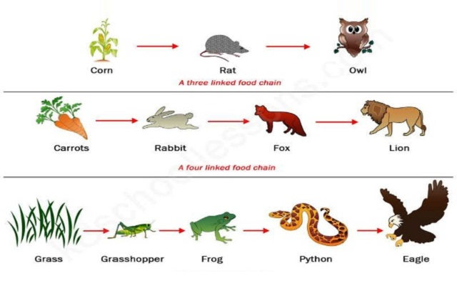

A predator is an animal that hunts and eats other animals, and the prey is the animal that gets eaten by the predator. In the food chain above, the fox is the predator and the rabbit is its prey.
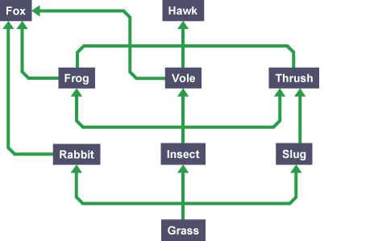
When all the food chains in an ecosystem are joined up together, they form a food web. Here is an example of a food web:

Although it looks complex, it is just several food chains joined together. Here are some of the food chains in this food web:
Grass insect vole hawk
Grass insect frog fox
Grass insect vole fox
Organisms in a food web depends on each other for nutrients. So, a change in one population leads to changes in others. The population of a species is affected by the number of its predators and prey, disease, pollution and competition between individuals for limited resources such as water and nutrients.
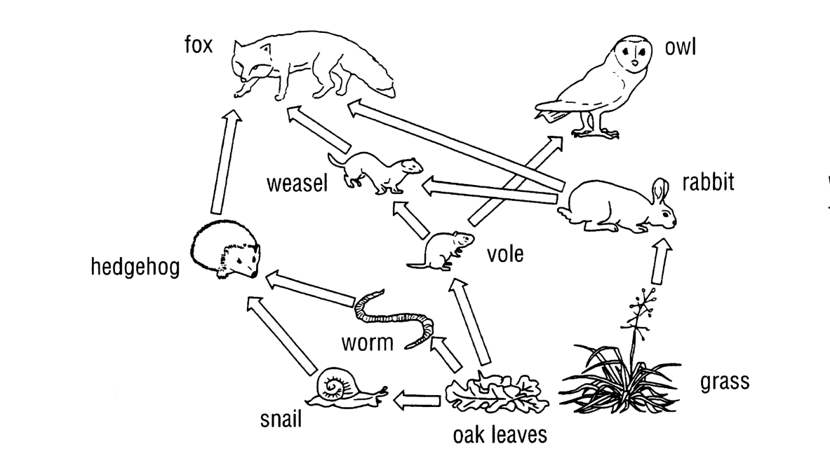
Task 1: Analysing a food web:
- Write out two separate food chains from the food web above
- What does a hedgehog eat?
- What do foxes eat?
- Which animals eat voles?
- Name the two producers
- Name all the predators
- Name three prey animals
- Name a carnivore
- Name a herbivore
- Describe how the animals show in the food web depend on each other for survival
- What will happen to the number of rabbits if the population of foxes decrease?
- What will happen to the number of weasels if the number of voles increase?
Comprehension questions:
- What is meant by a habitat?
- Define population
- What do the arrows in a food chain show?
- What is meant by a producer?
- How do plants make their food?
- What is a consumer?
- What is the difference between an omnivore and a herbivore?
- What do carnivores eat?
- What is the difference between predators and prey?
- What is a food web made up of?

Lesson 2: Pyramids of numbers
The population of each organism in a food chain can be shown in a type of bar chart called a pyramid of numbers. The bars are drawn to scale – the more organisms it represents, the wider the bar. The producer in the food chain always goes at the bottom of the pyramid of numbers. Think about this food chain:
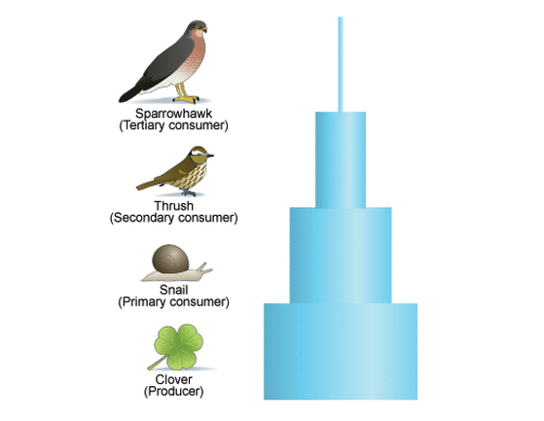
Clover snail thrush sparrowhawk

Clover is a plant and it is the producer in this food chain. Its bar goes at the bottom of the pyramid. Energy is lost to the surroundings as we go from one level to the next, so there are usually fewer organisms at each level in this food chain. A lot of clover is needed to support the snail population. A thrush eats lots of snails, and a hawk eats lots of thrushes, so the population of hawks is very small.
Sometimes the pyramid of numbers does not look like a pyramid at all. This could happen if the producer is a large plant such as a tree, or if one of the animals is very small.
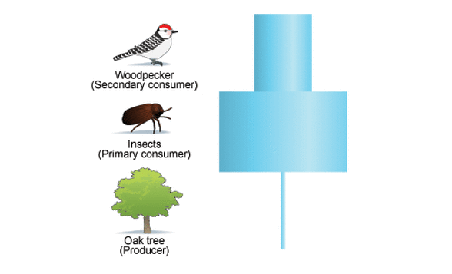

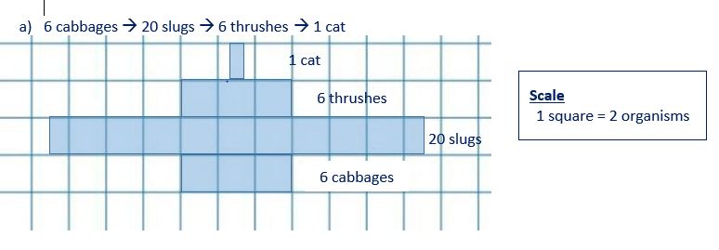

Task 1: Complete the pyramid of numbers below:
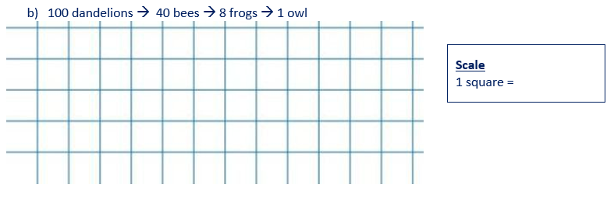
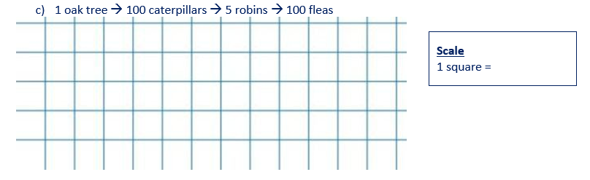

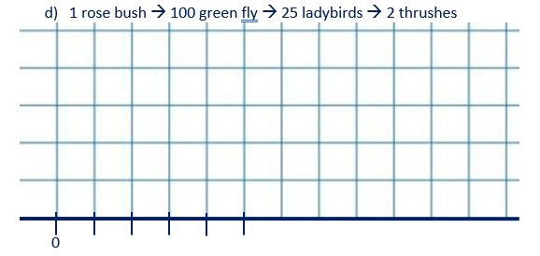

Comprehension questions:
- What do the arrows in a food chain show?
- What is meant by environment?
- Define ecosystem
- What is the difference between a producer and a consumer?
- Where in a pyramid of numbers will the producer always be?
- Where in a pyramid of numbers will the top predator always be?
- Why are there fewer organisms as you move up a pyramid of numbers?
- Give two reasons why a pyramid of numbers may not be a traditional pyramid shape

Lesson 3: Decay
Decay is the breaking down of dead animal and plant matter. It happens to all dead organisms because of decomposers. There are two types of decomposers – detritivores and microbes.
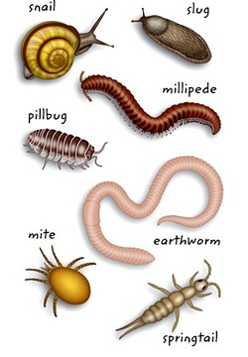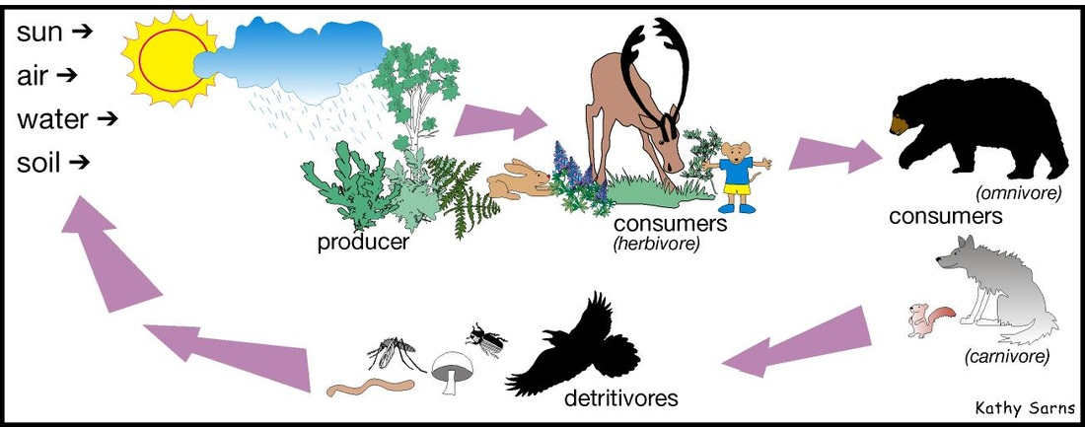
Firstly, the detritivores, such as maggots and woodlice, are responsible for breaking down the dead material into pieces which are small enough for microbes to digest, getting their nutrition along the way. The microbes, such as bacteria and fungi, are then able to break down those smaller pieces of dead matter even further whilst getting their nutrition for survival. During decay, the decomposers will release waste products that plants are able to use. These waste products are carbon dioxide, water, and nutrients.
The process of decay is very important because there is only a finite amount of nutrients on the Earth. When plants and animals die and decay, the nutrients released go back into the ground. These same nutrients can then be used for new plants to grow. Decay allows the nutrients on Earth to be naturally recycled.
Whilst decay can happen naturally at the pace nature intended, there are some things that we can do to make it happen faster:
- Ensure a good oxygen supply
- Increase the temperature
- Increase moisture levels
Increasing the temperature will only increase the rate of decay up to a certain point. This is because at too high a temperature, the microbes will die and not be able to carry out the decay process.
Compost bins are an example of decay in action. Some people keep them in their gardens to make nutrient filled compost from their household plant waste, such as vegetable peelings. The compost bins are designed to ensure that decay happens more quickly, and they work best when placed in a sunnier area of the garden. Compost bins are normally a dark colour so that they can absorb heat to keep the contents warm. The compost bin also has small holes all over to ensure that it has a good oxygen supply for the decomposers. Gardeners will in addition, add water at regular intervals to ensure that it remains damp inside the bin and regularly turn the contents with a fork to avoid the contents becoming compacted. The compost, which contains nutrients that were once in the waste plant material, can then be used to plant new seeds in. The compost will provide the nutrients needed for the new plant to grow.
Comprehension questions:
- What is decay?
- What are the two types of decomposers?
- What is the role of detritivores?
- What is the role of microbes?
- What waste products do decomposers release?
- Why is the process of decay important?
- What three factors can increase the rate of decay?
- Give a common example of decay in action
- Why are compost bins usually black?
- Compost bins will normally have small holes or gaps all over them. Explain why.
- Students were investigating the hypothesis ‘The rate of decay is affected by temperature.’ They stored apple samples at different temperatures and monitored the time taken for the apple to rot. The results are shown in the table:

Temperature (°C) | Time taken for apple to rot (days) |  |  | Mean (days)
0 | 28 | 24 | 23
10 | 31 | 22 | 20
20 | 14 | 15 | 16
30 | 12 | 14 | 13
40 | 3 | 2 | 4
50 | 0 | 1 | 2

- Calculate the mean time taken for the apple to rot at each temperature. Write your answers into the table
- Do their results support the hypothesis? Yes/No and explain your answer.

Lesson 4: Sampling
Ecologists study the distribution of living organisms in habitats to find out how healthy it is. They use many different sampling methods to provide quantitative data which is then analysed.
Quadrats are square frames of wire usually 0.25m2. These are placed on the ground to look at the plants or slow-moving animals within them. When looking at plants in a quadrat we usually count the total number of individuals of a species. Normally multiple random samples will be taken and then a mean can be calculated and multiplied up to the whole area.
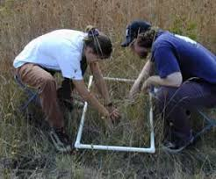

Activity: Estimating the Tiddlywink Population
Follow the instructions on the board and complete the results table below for the tiddlywink experiment.
Size of desk sample area: ___________ cm²
Size of quadrat area: ___________ cm²
Divide the area of the desk by the area of the quadrat to calculate the number of quadrats that will fit on to the desk.

Size of desk sample area: ___________ cm²
Size of quadrat area: ___________ cm^{2 = _____} (number of quadrats that will fit on the desk)

Quadrat number | 1 | 2 | 3 | 4 | 5 | Mean number of tiddlywinks
Number of tiddlywinks in quadrat
To calculate the mean number of tiddlywinks. Add up the numbers in quadrats 1 to 5 and then divide the total by 5.
Estimating the population
Multiply the mean number of tiddlywinks in 5 quadrats by the total number of quadrats that can fit on to the desk.
_____________ X ______________ = _________ (nearest whole number)

Lesson 6: Sampling required practical
Aim/introduction:
A quadrat is a frame – often 1m² – that can be used to estimate the number of organisms within a habitat.
The aim of your practical is to estimate the population of daisies on the field.
Method
…………………………………………………………………………………………………………………………………………………………….
…………………………………………………………………………………………………………………………………………………………….
…………………………………………………………………………………………………………………………………………………………….
…………………………………………………………………………………………………………………………………………………………….
…………………………………………………………………………………………………………………………………………………………….
…………………………………………………………………………………………………………………………………………………………….
…………………………………………………………………………………………………………………………………………………………….

Results
Area of sample site:
…………………………………………………………………………………………………………………………………………………………….
…………………………………………………………………………………………………………………………………………………………….

Table for daisy numbers :

Mean number of daisies per 1m²
…………………………………………………………………………………………………………………………………………………………….
…………………………………………………………………………………………………………………………………………………………….
Estimate of number of daisies in whole site
…………………………………………………………………………………………………………………………………………………………….
…………………………………………………………………………………………………………………………………………………………….
…………………………………………………………………………………………………………………………………………………………….
1. A student sampled a field of 50 metres by 60 metres for the number of daisies. She counted the number of daisies in each of 6 randomly thrown quadrats of 1m². Her results are shown below:
Sample number | Number of daisies
1 | 0
2 | 3
3 | 8
4 | 12
5 | 2
6 | 5

a) Calculate the mean number of daisies per m². Show your working.
…………………………………………………………………………………………………………………………………………………………….
…………………………………………………………………………………………………………………………………………………………….
…………………………………………………………………………………………………………………………………………………………….
b) Calculate the area of the field.
…………………………………………………………………………………………………………………………………………………………….
…………………………………………………………………………………………………………………………………………………………….
c) Estimate the total number of daisies in the field.
…………………………………………………………………………………………………………………………………………………………….
…………………………………………………………………………………………………………………………………………………………….
d) Give one way the student could improve the accuracy of her estimate
…………………………………………………………………………………………………………………………………………………………….
…………………………………………………………………………………………………………………………………………………………….
2. Some students were asked to investigate the distribution of clover in a field of grass. They noticed that the clover grew in patches amongst the grass. The students decided to use quadrats. The diagram shows one of the quadrats the students used.
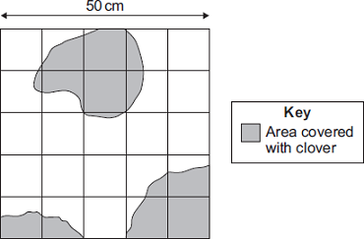

Estimate the number of squares of the quadrat covered with clover.
…………………………………………………………………………………………………………………………………………………………….
…………………………………………………………………………………………………………………………………………………………….
…………………………………………………………………………………………………………………………………………………………….
Number of squares = _______________

Lesson 6: Classification
Living organisms are classified into groups depending on their structure and characteristics. This system was developed in the 18th century by Carl Linnaeus. The classification of species allows the subdivision of living organisms into smaller and more specialized groups.
The first division of living organisms in the classification is to put them into one of five kingdoms. The five kingdoms are:
- Animals
- Plants
- Fungi
- Protists
- Prokaryotes
Living things can then be ranked according to phylum, class, order, family, genus and species. As you move from kingdom to species, the groups get smaller. Kingdoms are the largest groups and species are the smallest groups. A species is defined as a group of organisms which are able to reproduce and produce fertile offspring.
A mnemonic can be used to remember the order of classification. King prawn curry or fat greasy sausages:
- Kingdom
- Phylum
- Class
- Order
- Family
- Genus
- Species

- Which classification group will have the largest number of organisms?
- Which classification group will have the smallest number of organisms?
- What was the name of the person who invented thus classification system?
- Name the 5 kingdoms
- Can organisms in a genus be divided into a smaller group?
- What is a species?
- What mnemonic can be used to learn the order of classification?
- People say that lions and tigers can breed successfully. They are wrong because…
Lesson 7 and 8: Competition and adaptation

As each species forms part of a community in an ecosystem they often find themselves in competition for limited resources. Animals compete for food, territory, and mates. Plants compete for light, water, nutrients (minerals) and space. The organism that outcompetes its neighbours will increase its chances of survival and therefore reproducing. Organisms have evolved many complex ways of outcompeting other species, but it is also important to remember that within a species individuals will also compete. Compare the things animals and plants compete for by completed this Venn diagram

- List 3 things animals compete for
- List 4 things plants compete for
- Why do organisms compete?
- What is the reward for successful competition?
- Find the mean, median, mode and range of the following data set:
9,4,17,4,7,8,14
- A Stag is a male Deer. During the spring they grow large antlers from their head. They use them to fight each other. The winner becomes the alpha male of the group and can mate with the female deer. Explain why the Stag who uses the most energy to grow antlers will have the greatest chance of reproducing.
- Rhododendrons are a type of plant not native to the UK. They grow a very thick canopy of leaves which drop in the winter to cover the ground and take a long time to decompose. Explain why it is rare to find any other species competing to grow in the same area.
Adaptations are features that help organisms compete better and survive in their environment. All organisms are adapted to the habitat they live in. Most adaptations allow an organism to survive in an area other cannot. This prevents them from having to compete for space and territory. Other adaptations in plants are focussed on outcompeting other species for light, water or the ability to spread their seeds further. In hot climates plants try to reduce their surface area, increase the spread of their roots, or store water in their stem to prevent water loss.
Animal adaptations often involve attracting a mate. They also have many adaptations to allow them to eat certain food more efficiently. Herbivores have specially adapted teeth that are better at grinding up plant cells, whereas carnivores have sharper teeth to slice meat. Camouflage is often important for either predator and prey alike, as is the ability to maintain a constant internal body temperature in either hot or cold climates, which is often achieved via surface area to volume ratio. In general animals in colder climates have thick wide bodies and limbs to lower the surface area to volume ratio and reduce heat loss. Animals in hot climates will have thin limbs and long bodies to help lose heat by increasing their surface area to volume ratio.
- Compare the teeth of a carnivore and a herbivore
- What adaptation is important for most animals?
- What surface area to volume ratio is good for colder climates?
- Compare the adaptations of animals to hot and cold climates
Hot climates | Cold climates
- Some animals are adapted to survive in very cold conditions such as the Arctic.
Explain how the adaptations of Arctic animals help them to survive in cold conditions.
“ The arctic is a harsh climate because……animals have adapted to survive it by….this helps because…for example..”
Lesson 9: Natural selection

The organisms that exist nowadays are very different from those billions of years ago. Over time it appears that organisms have become more complex. This is due to evolution by natural selection.

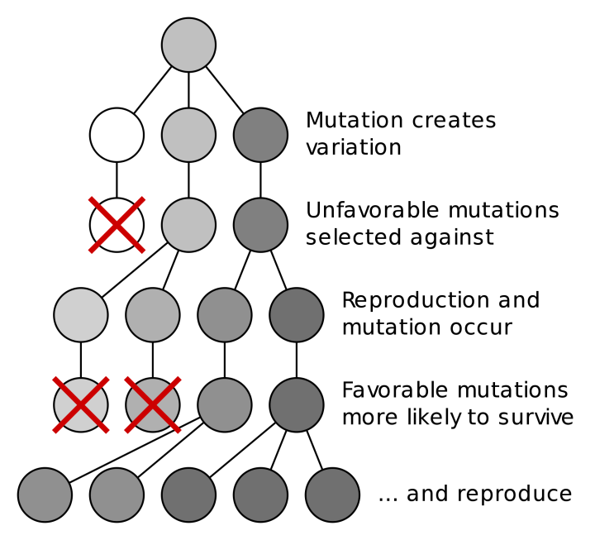
Natural selection is the process where nature selects what characteristics are best for organisms to survival in that particular environment and hence allows it to reproduce. In simple terms, this is the survival of the fittest, where “fittest” refers to those best adapted to their environment, but not necessarily the strongest. Evolution occurs after natural selection occurs over many generations. This is the process:
    - Individual organisms in a species have a range of pre-existing genetic variation due to random mutation.
    - Certain individuals may have certain adaptations that give them a survival advantage
    - Natural selection occurs: They are more likely to survive and reproduce, passing their characteristics onto their offspring
    - Overtime, more individuals within the population have those favourable traits. If these variations accumulate, they may eventually evolve into a new species (speciation), where they can no longer interbreed to form fertile offspring.

Be careful: Avoid saying “organisms adapt to their environment” in your answer. Organisms cannot (choose to) adapt to a certain environment within their lifetime. Evolution must happen over many generations! And it is not by choice, but by natural selection.
- What causes genetic variation?
- State the theory of evolution by natural selection.
- What is a ‘species’?
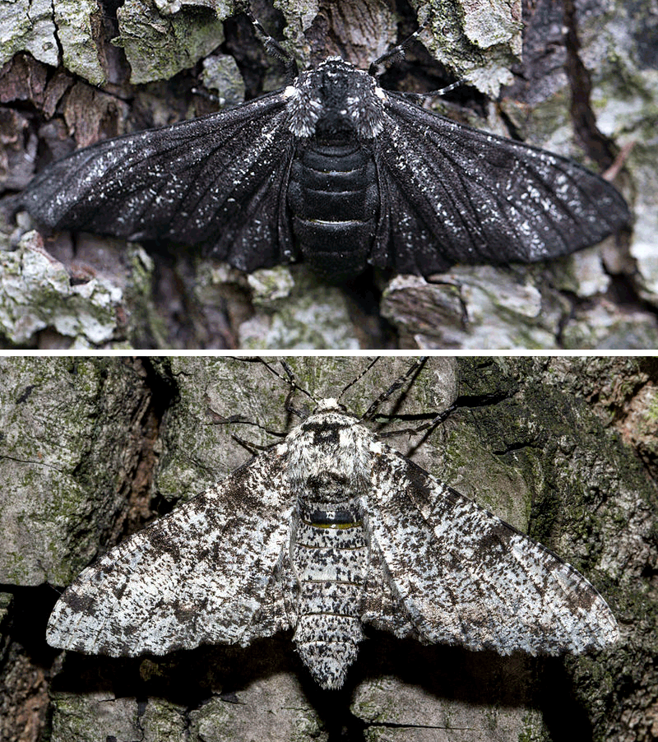
- Define ‘natural selection’.
- What is evolution?
- Why can genetic mutation be beneficial to organisms in a changing environment?
- Pick one of the following. Would the best organism within a species to survive and reproduce be:
- the strongest?
- the one which reproduces the fastest?
- the best adapted to the environment?
- *Describe the process of evolution by natural selection.
- Suggest how giraffes having long necks may be a result from evolution by natural selection.
- *In the beginning, there are more white peppered moths than black peppered moths living on trees. However, during and after the Industrial Revolution period, the number of black peppered moths drastically increased. Explain in detail.

Keywords to use: Black soot, natural selection, reproduce, survive, characteristics, variation, time.

Lesson 10: Evolution and extinction

The process of evolution is only a theory. It needs to be supported by evidence – fossils. Fossils are the remains of organisms from millions of years ago, preserved in the environment (eg. rock, ice). Through looking at fossil records, we can see how organisms are structurally adapted in the past. It also helps scientists to understand how they have changed since life developed on Earth, which can act as evidence for evolution by natural selection.
There are different forms of fossils, depending on how they are formed. A lack of decay is key to forming fossils. There are a few factors needed for decay:
- Bacteria (as decomposers – the nutrients inside organisms are their food source and raw material for respiration)
- Oxygen (for aerobic respiration of bacteria)
- Correct temperature (too hot – enzymes in bacteria denature, leading to their death; too cold – enzymes are inactive, leading to a lack of respiration)
It is nearly impossible to have no bacteria in the environment; hence the environment must be lacking in oxygen and/or at a wrong temperature in order for fossilisation to occur. For example:
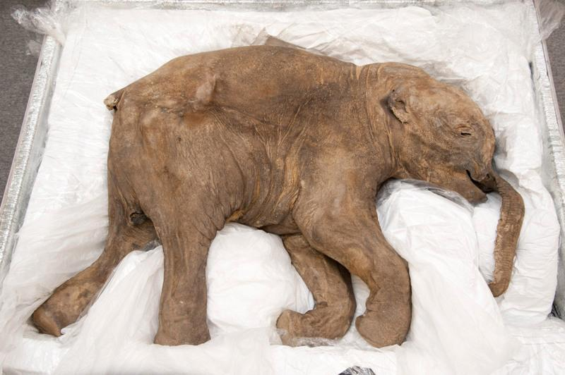
- Organisms not decay after death due to lack of decay conditions
Situation A: Organism drowned in water which froze relatively quickly
- There are decomposers, however there may be a lack of oxygen and it is very cold, meaning bacteria would die and their enzymes would be inactive anyway, hence decay cannot occur. The whole organism is intact.
- Eg. A whole baby mammoth (with muscles, blood, fur intact) was found frozen in ice

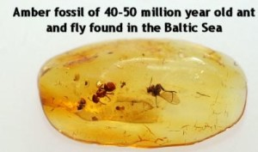
Situation B: Organisms (eg. flies, ants) trapped in tree sap
- There may be very few decomposers within the tree sap. Even though the temperature may be appropriate, the lack of oxygen means decay cannot occur as bacteria cannot respire aerobically.
- Overtime the tree sap hardens to become amber with insects trapped inside

- Preserved traces of organisms left behind
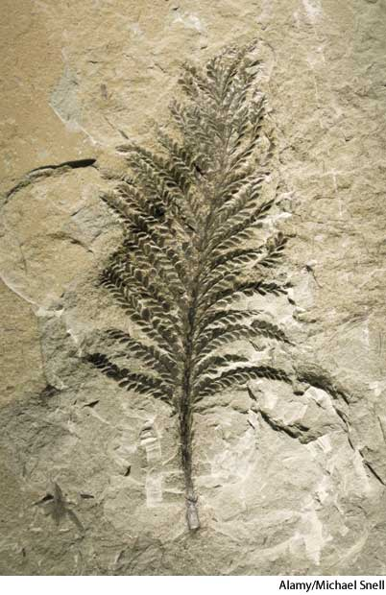
- Organisms left a particular imprint on wet mud, like a mould. Overtime, it dried out with the traces formed and hardened into rocks.
- Eg. Footprints, burrows, rootlet traces, droppings

- Harder parts of organisms (eg. Bones) replaced by minerals
- This is the most common form of fossils, like the ones you can see in museums

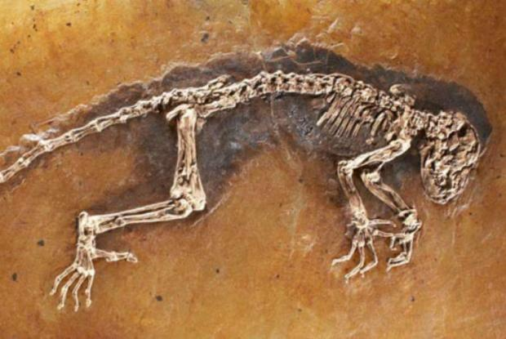
Process of fossilisation of skeletons
- Organism dies and falls to the ground
- Soft parts (eg. Flesh) decompose, leaving the bones behind as they are harder to decay
- The skeleton is then covered in sand/soil
- The skeleton becomes mineralised (bone tissue replaced by mineral ions) over millions of years turns to rock
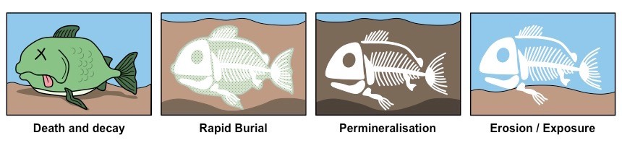
It is important to remember that bone tissues can still decay as they are organic, but just takes a longer time to do so. If they get replaced by the minerals before they decay, meaning the minerals can form a mould of their shapes, then the fossil can be made.
Even though fossils are a great way to support the theory of evolution, it is not enough as we do not have a complete fossil record. The reasons for this are as follows:
- Many early life forms are soft-bodied, which means they decay quickly and cannot be mineralised to form fossils
- Geological activity destroyed some fossils, such as earthquakes
- Most organisms did not become fossilised – the conditions for fossilisation are very rare, and any imprints made are washed away easily.
- Many undiscovered fossils – we do not know exactly how many fossils they are still buried, hence we may be missing parts of the record
- What are fossils?
- What are the three criteria for decay to occur?
- Describe the five steps of fossilisation by mineralisation.
- Why is it harder for bones to decay?
- What are the three different types of fossils that can be formed?
- Fossils which are older often appear to be simpler organisms. What theory does this provide evidence to support?
- Complete the following sentences:
The fossil record is incomplete because…
The fossil record is incomplete but…
The fossil record is incomplete so…

Lesson 11: Biodiversity

Modern humans have existed on earth for less than one million years. This is less than 0.02% of the entire time life has been on earth. Yet in that tiny fraction of time our actions have made huge and permanent changes to the earth.
Biodiversity is the measure of the variety of all species on earth, or in a particular ecosystem. In general, high biodiversity is good for the stability of ecosystems. It reduces the risk of collapse that would happen if an ecosystem was dependent on one species for food or shelter. The success of the earth to maintain viable for life is dependent on maintaining a high level of biodiversity.
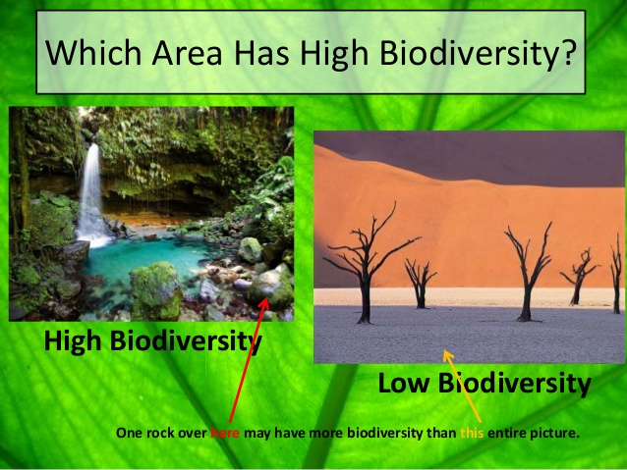

In 2019 there are 7.7 billion (7.7x10⁹) people on the earth, with an increase of 82 million (8.2x10⁷) people each year. This was not always the case 200 years ago the global population was under 1 billion people. The increase in the population is mainly due to the increase in medical technology and the availability of food. This had led to a large rise in life span and a huge reduction in infant mortality (the rate at which new born children die)
As the population has grown the demand humans place on the environment have increased. We have reduced biodiversity and destroyed ecosystems by using the land for:
- Building of houses, roads and other infrastructure.
- Farming to provide us with the plants and animals we eat.
- Mining to remove the vast quantities of oil and metal ores needed to build the modern world
Peat bogs are a good example of this. Humans remove the peat to use as a compost in their gardens. The peat bogs formed over thousands of years and once dug up it can take over 100 years to grow back. This destroys the habitat of peat-dwelling organisms, reducing biodiversity.
Palm oil is another example. Jungles are cut down to plant palm trees to sell the oil, reducing the size of the jungles in countries like Burma, which are home to Orangutans. The palm oil is used in foods and to make biofuels
Humans don’t just affect the environment by what we remove. Humans also release a huge amount of waste as sewage, litter and as a by-product of industrial processes. These can have a massive effect on ecosystems and biodiversity.
As the population rapidly increases it is becoming harder and harder to manage the amount of waste we produce. We risk damaging the water and air supply, affecting both the lives of the humans and the native species that reside in a particular habitat.
- Define the terms in bold
- Give three examples of ways humans reduce biodiversity
- List 5 ways the quality of life has improve in the last 200 years
- Give two examples of waste products that humans contribute to the environment that reduce biodiversity
- What will be the global population in 2020?
- Calculate the percentage increase in population from 2019 to 2020
- Use the graphic organiser below to illustrate the various ways humans can reduce biodiversity the first one has been done for you.

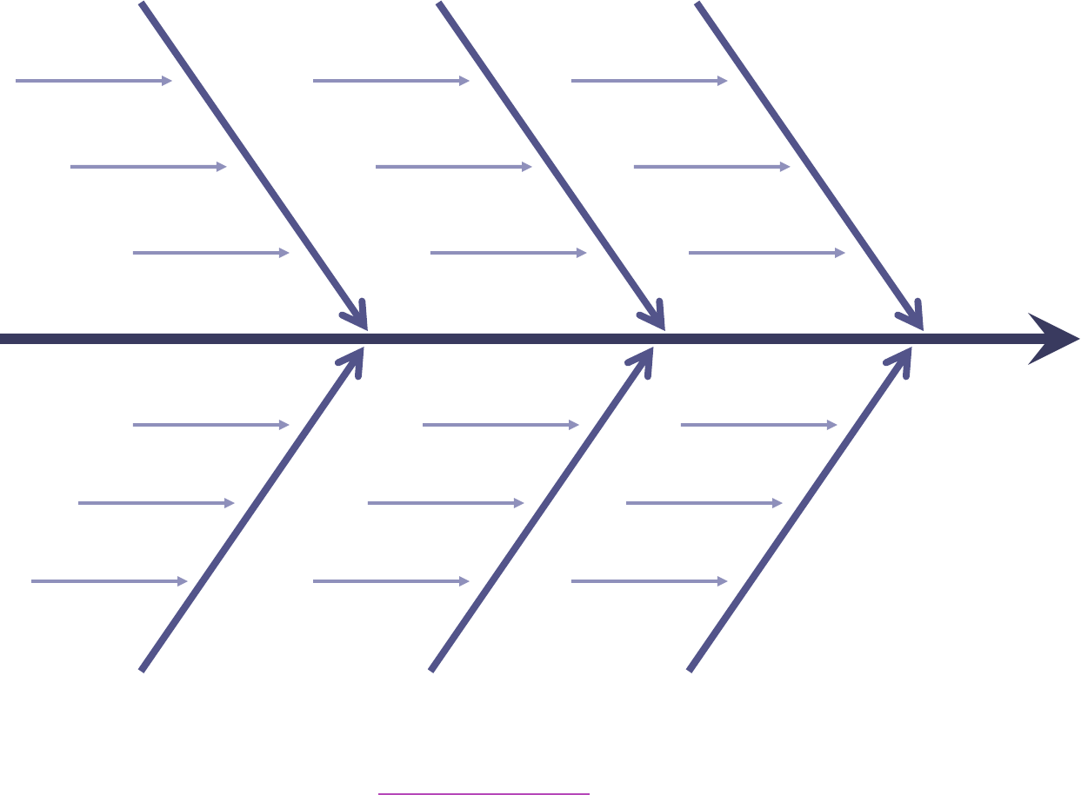
Farming:
Woods cut down

One type of crop grown
Use of pesticides

Reduced biodiversity

- Write a paragraph to explain the different ways humans reduce biodiversity. Include both the things we remove and the things we add to the environment.

